|  |
| --- |
| Andrew Burton |
| Comp 4 Project – Badges |
|  |

|  |
| --- |
|  |

Contents

Investigation 6

Introduction 6

Investigation methods 6

Questionnaires 8

Interview 12

Observation 14

Existing system documents 14

IOPS Chart for the existing system 25

Existing system flowchart 26

Document specification sheets 27

Analysis 42

Scope and Objectives 42

Tasks to be computerised 43

Proposed solutions 44

Constraints 45

New system design 47

Storage specification sheets 48

IOPS Chart for the new system 54

New system flowchart 61

Top down design for the new system 68

Interface designs 68

Database normalisation 72

Entity relationship diagrams 73

Storage media 73

Pseudo code 74

SQL statements 76

Validation 81

Security 81

Classes 82

Alpha testing Plan 83

Beta testing plan 88

Testing 90

Alpha testing 91

Systems Maintenance 104

Summary of packages used 104

Top down design 104

Classes 108

Attendance 110

BadgeDescribe 110

BadgeParts 110

Log 110

Meeting 110

Scout 111

StagedBadge 111

Forms 112

Delete meeting 112

Delete record 113

Edit record 114

Enter Attendance 116

Enter Badge Parts 118

Enter Badges 120

Enter Details 122

Enter Log 124

Enter Programme 126

Change staged badges 128

Get SQL 130

Loading SQL 131

Main form 132

View badges between date range 137

View individual record 139

View least achived badges 141

View Missed Meetings 143

Database 145

tblAttendance 145

tblBadgeDescribe 146

tblBadgePart 146

tblLog 147

tblMeeting 148

tblScout 148

SQL commands 150

Algorithms 153

Quicksort 153

View achieved badges 154

View least achieved badges 156

Calculate missed sessions 159

Display Attendance 160

Save Attendance 162

Badges User Manual 165

Introduction 167

System requirements: 167

Navigation 167

Installation instructions 173

Uninstallation instructions 176

Opening badges and connecting to the SQL server 177

Disconnecting from the SQL server 179

Closing forms 179

Adding badges 179

Stage badges 180

Non – staged badges 181

Adding Badge parts 181

Editing badges 182

Staged badges 182

Non – staged badges 182

Editing parts 182

Adding a meeting 183

Editing a meeting 185

Entering dates 186

Deleting meetings 186

Enter record 188

Editing a record 189

Delete record 190

View individual record 191

Enter register 192

Printing forms 193

Enter achieved badges 194

View achieved badges 195

View least achieved badges 196

View missed sessions 198

Error messages and troubleshooting 199

Quick Guides 201

Enter attendance 201

Create new record 203

View Achieved badges 204

Add a meeting 206

Appraisal 207

Comparison with original objectives 207

User Feedback 212

Analysis of user feedback 212

Future Improvements 213

Appendix A – Testing Screenshots 214

Appendix B – Developmental Testing 258

Appendix C – Program Code 314

Classes 314

Attendance 314

BadgeDescribe 314

BadgeParts 315

Log 316

Meeting 317

Scout 318

StagedBadge 319

Forms 320

Delete meeting 320

Delete record 321

Edit record 322

Enter Attendance 326

Enter Badge Parts 329

Enter Badges 332

Enter Details 334

Enter Log 337

Enter Programme 340

Change staged badges 343

Get SQL 347

Loading SQL 347

Main form 347

SQL commands 352

View badges between date range 364

View individual record 369

View least achived badges 373

View Missed Meetings 378

Investigation

# Introduction

The aim of this project is to create a system for West Byfleet Scout group to be able to handle their records, and allow the Scout leaders to view achieved badges. The Scout Association splits scouting into Beavers aged 6-8, Cubs aged 8 – 10 ½, Scouts aged 10½ -14, Explorers aged 14 – 18 and Network aged 18 - 25. The Scout group has approximately 20 Beavers, 30 Cubs and approximately 30 Scouts, with Explorers and Network being run by the district and meeting in different locations. The Scout group is one of 14 Scout groups in Woking district, which is one of 18 districts in Surrey County.

Currently the details of each person, along with the badges they have achieved and the number of camps they have been on (needed to award the Nights Away badges, which are awarded for spending a certain number of nights on camps over their time in scouting) are recorded by hand on paper forms. However, this can be time consuming to match attendance to the programme in order to work out who needs badges awarding to, since the programme is structured around badges. There is also the risk of paperwork being lost due to the fact that all of the records for a person are stored on a single piece of paper.

# Investigation methods

One of the ways that I will use to determine the specification and requirements by the end user for the programme is through face to face communication. The advantage of this is that it allows me to ask more about a problem based on the answers I receive, and allows me to ask more questions to get a better scope of the problem. However, this method of investigation can be time consuming, especially if a large number of people are involved and requires the findings of a conversation to be recorded, which may not be possible at the time of the conversation, and therefore could lead to some details being lost.

Another way that I will determine the scope of the project is through questionnaires. The advantage of these is that they allow responses from a large number of people to be received, and details are recorded, reducing the chance of people’s answers being lost. However, there is a greater chance that people may not return the surveys, and due to the fact that paper surveys are most likely to be used, there is a risk that surveys may be lost.

Another way that will be used is observation of the user using the current system. The advantage of this is that it allows be to be able to understand the issues with the system, meaning that I can ensure that the new system is particularly effective at solving these issues. However, this can be time consuming to conduct, and I may not be able to see the system in use over a period of time.

I will also inspect the existing records. This allows me to determine how the documents are dealt with, and the processes that are used when dealing with these documents. It will also mean that I will be able to determine the sort of data that will needed to be stored in the programme. However, due to the fact that these records may contain personal details, the organisation may not be able to legally allow me to view the records, due to the Data Protection Act.

I would hope to be able to view the records of the badges that have been achieved, in order to work out how it is currently handled, and the attendance register, in order to see how attendance is recorded. I will also use details of the badges and the types of badges, which is accessible via the Scouts website.

# Questionnaires

I will use the following questionnaire which will be given to the users of the system in order to determine the requirements for the new system. I will distribute these via e-mail to the scout leaders as it is the easiest way of distributing it.

1. Describe what the system does

Allows me to determine what the system is used for

1. What is the main issue with the existing system?

Allows me to determine why the user requires a new system, in order to ensure that it meets the user’s requirements

1. What sort of data is collected?

Allows me to determine the sort of data, so the new system will be able to store the same type of data

1. How is the data collected?

Allows me to determine how the data is collected so the user can easily give new data to the system

1. How is the data currently stored?

Allows me to determine whether the system is digitalised or on paper, in order to ensure that the new system will be compatible with the existing system.

1. What are the main requirements of the new system?

Allows me to determine what the users want the system to do in order to ensure that it suits their needs

1. How many computers will the new system be used on, and if there is more than 1 will data be transferred between computers?

Allows me to determine whether the end user will use the system on multiple PCs and if so if data will need to be shared between computers

1. Do you have an existing computer which the system would be able to run on? If so, does it run Windows?

Allows me to determine the type of computer the system will be used on in order to ensure that the system can be used by the end user.

1. Which sections is the system going to be used for?

Allows me to determine which sections of the Scout group are going to use the system

1. Will you be able to understand the new system easily?

Allows me to determine how easily the end user will be able to use the system, in order to work out how complex / easy to use the system will be, and how much documentation will be required

Questionnaire response from Lyn Blackman, Group Scout Leader / Cub Leader

1. Describe what the existing system does.

We have record cards that we complete when each child gains a badge for each section of the group. We also complete a register and then look at each week a child attends which tells us if they have gained a badge or not.

1. What is the main issue with the existing system?

We give each child a chance to gain several badges over a period of 3 - 4 weeks of each academic term. It takes a lot of time going through the register working out how many sessions each child has attended and what badges they have gained.

1. What sort of data is collected?

The dates each child has attended what sessions and what badges they have gained.

1. How is the data collected?

Record cards and the register

1. How is the data currently stored?

Held in a A4 folder at my house

1. What are the main requirements of the new system?

If we can have a system where we can enter the badges requirements into the register each term so that when we take the register each week the programme tells us which children have gained what badges

1. How many computers will the new system be used on, and if there is more than 1 will data be transferred between computers? 1
2. Do you have an existing computer which the system would be able to run on? If so, does it run Windows?

Yes windows 8

1. Which sections is the system going to be used for?

To start with cubs and then Scouts and Beavers

1. How much training will you require to use the new system?

Depends how complicated the system is going to be

# Interview

I also carried out an interview with the end user (Terry Newman, Assistant Group Scout Leader and Cub leader, and Emma Newman, another Cub Leader who was heavily involved in the badges system), in order to get a better idea of what they require from the system.

**How are the badges awarded?**

They have to fulfil some criteria attached to each badge, so it’s like they have to 3 parts out of 6, and these criteria are split into meetings, which then go into the programme.

**So how do you go through and see who has achieved the criteria?**

It’s done on paper at the moment. We meet each term, and we go through it and have the register and we have the programme, and we go down and say well he was there, so say in three weeks we did a badge, and someone was there for 2 of the weeks, he still wouldn’t get the badge because he wasn’t there for one of the weeks. We then record the badges and the date on the record sheet, and then each term or each couple of terms we will see who has achieved the badges, and then hand them out, and if they don’t achieve all of the criteria, then they don’t achieve the badge, and that’s why we run catch up sessions.

**Where is the paperwork stored?**

In a black folder somewhere.

**Would you use the system as well as the record cards, or would you look to replace the paper system completely?**

Instead, we would like to be able to print something off with all of the badge details, like the record card.

**Are you just going to use it for Cubs, or would you use it for all of the sections?**

Cubs to start with, but we would like to roll it out across the board eventually.

**Would you be prepared to enter the details for the badges for a different section if it could be done easily?**

Yes, that’s not a problem.

**How much training would you require to use the new system?**

Not a lot.

**What sort of PC would you run it on?**

Windows 8 PC.

**What is the main issue with the existing system?**

It’s paper, and is easily lost, and has to be filled out, and it takes a long time to match the register to the programme, whilst if we had a computer system, we could just open it up and enter who was there, and the computer would do the work.

**So, a sort of activity planning tool?**

Yes, that would be great.

# Observation

From my observations of the system, I have seen how the system is used. A programme is created at the start of each term, which details which badges are going to be achieved during the term and on what will be done towards these badges, and on which dates. An example of the programme can be seen on the next page.

At the start of each meeting, a register is taken to determine who is at the meeting. This register is then stored in a folder by the Scout leader. At the end of the term, the register is matched to the programme, in order to determine who was at all of the required meetings in order to achieve the badge. This process is done for all 30 Cubs, and is sometimes done for 4 or 5 separate badges, which can take a couple of hours.

If the Cubs have been working towards a staged activity badge (which run throughout scouting and build on the previous staged badge – e.g. the nights away badge), then the record cards are referred to in order to work out what stage has already been achieved. In the case of the nights away badges, the total number of nights away will be updated, so the record is accurate, and a badge will be awarded if the required number of nights away are met.

Once the number of badges is determined, the badge draws are then checked to ensure that there are enough of each badge, and if there are not, then more badges are ordered. If there are enough badges, then they are sorted into bags for each person, based on the list of achieved badges.

# Existing system documents

The next few pages contain documents from the existing system

**1st WEST BYFLEET SCOUT GROUP**

**Existing system – Programme** This contains details of which badges are being done at each meeting

**Charity Registration No. 305913**

**CUB SCOUT PACK**

**Wolves Programme – April - July 2013**

|  |  |
| --- | --- |
| **April** |  |
| **15th** | **Welcome Back**! |
|  | Games evening |
|  | Talk though the programme |
| **22nd** | **Community Challenge / Chefs badge / Sports enthusiast badge** |
|  | **Physical recreation** |
|  | We are going to split you in to 2 groups. Half of you will complete the last |
|  | few requirements for the Chef’s badge (this will also be a requirement for the |
|  | community challenge) while the other half will start the Sports enthusiasts |
|  | badge. |
|  | **Blue, Red and Green sixes** will be learning about hazards in the home and |
|  | Kitchen. |
|  | We are going to set up some hazards at HQ and you have to find them. You |
|  | will then tell us why they are a hazard and what you could do to stop them |
|  | being a hazard. |
|  | You will also be learning how to make an emergency 999 call and the new |
|  | 101 call for help. |
|  | **Black, Brown and White sixes** will be starting the Sports enthusiast badge. |
|  | Come in to cubs prepared to tell everyone about one sport that you regularly |
|  | take part in. This could be Swimming, cricket, football, tennis, karate, etc etc. |
|  | Bring in with you any special clothing or equipment you have to use for this |
|  | sport and know the rules. If your chosen sport requires a particular skill, be |
|  | prepared to show all the other cubs what you have to do. |
| **29th** | **Community Challenge / Chefs badge / Sports enthusiast badge** |
|  | **Physical Recreation** |

We are going to split you in to 2 groups. Half of you complete the last few requirements for the Chef’s badge (this will also be a requirement for the chefs community challenge) while the other half will start the Sports enthusiasts badge.

**Blue, Red and Green sixes** will be learning about hazards in the home andkitchen. We are going to set up some hazards at HQ and you have to find them. You will then tell us why they are a hazard and what you could do to stop them being a hazard.

Group Headquarters: Camphill Road, West Byfleet, Surrey KT14 6EF

Charity Registration No. 305813

**1st WEST BYFLEET SCOUT GROUP**

**Charity Registration No. 305913**

**CUB SCOUT PACK**

You will also be learning how to make an emergency 999 call and the new

101 call for help.

**Black, Brown and White sixes** will be starting the Sports enthusiast badge.

Come in to cubs prepared to tell everyone about one sport that you regularly

take part in. This could be Swimming, cricket, football, tennis, karate, etc etc.

Bring in with you any special clothing or equipment you have to use for this

sport and know the rules. If your chosen sport requires a particular skill, be

prepared to show all the other cubs what you have to do.

**May**

**6th** **Bank Holiday – No Pack Meeting**

**13th** **Community Challenge**

Visit to Painshill Fire Station. To be confirmed.

**20th** **Community Challenge / Gardening at HQ**

Green / White / Red sixes will be baking cakes to freeze for our cake sale on

the 10th June 2013

Black / Blue / Brown sixes Will be gardening at HQ. Please feel free to bring

a few plants to brighten up our garden and to plant in the big planter in the

front garden.

You will need gardening gloves, strong shoes and any small gardening

equipment you want to use. Parents, please feel free to come along and help,

we need your help too.

Please wear comfortable clothes and your group scarf.

**27th** **Half Term No Pack Meeting**

**June** **Community Challenge / Gardening at HQ**

**3rd**

Black / Blue / Brown sixes will be baking cakes to freeze for our cake sale on

the 10th June 2013

Green / White / Red sixes will be gardening at HQ. Please feel free to bring a

few plants to brighten up our garden and to plant in the big planter in the front

garden.

Group Headquarters: Camphill Road, West Byfleet, Surrey KT14 6EF

Charity Registration No. 305813

**1st WEST BYFLEET SCOUT GROUP**

**Charity Registration No. 305913**

**CUB SCOUT PACK**

You will need gardening gloves, strong shoes and any small gardening equipment you want to use. Parents, please feel free to come along and help.

Please wear comfortable clothes and your group scarf.

**10th** **Community Challenge**

We will be decorating more cakes for our cake sale to raise funds for a charity chosen by the Cubs. Families please arrive at 7.45 pm for the cake sale and buy a few cakes.

Any cakes left at the end of the sale will be sold at Scouts tomorrow night.

**17th** **Sports Enthusiast / Physical Recreation**

Please meet at West Byfleet Park at the usual time to do some training and learn how to play rounder’s. Have a look on the internet and see if you can find out some of the rules of the game.

We are also going to teach you how to play football rounder’s!

Wear comfortable sports clothes and your group scarf.

If it is raining, meet at HQ as normal

**24th** **Cyclist Badge**

**July**

**1st**

Please bring along a poster you have made promoting road safety to pedestrians or cyclists and your bike and helmet to Cubs tonight and a pump if you have one. We are going to have a busy night learning the following,

How to clean and oil your bicycle, how to pump up the tyres and how to mend a puncture. Talk about safety measures you should take if you ride in poor condition and show us you know how to get on and off your bike properly.

**Sports Enthusiast / Physical Recreation**

Please meet at West Byfleet Park for you rounder’s match against your parents. Please come and join us and help the cubs to complete the Sports enthusiast badge by having a rounder’s match against the Parents.

Wear comfortable sports clothes and your group scarf. If it is raining, meet at HQ as normal

Group Headquarters: Camphill Road, West Byfleet, Surrey KT14 6EF

Charity Registration No. 305813

**8th**

**15th**

**22nd**

**1st WEST BYFLEET SCOUT GROUP**

**Charity Registration No. 305913**

**CUB SCOUT PACK**

**Cyclist Badge Physical Recreation**

Cycle ride to Bridge Barn. We will need a huge amount of parental help for this activity. Without the help, this activity will not go ahead.

Please meet at HQ for the earlier time of 6.00 pm. All Cubs MUST have a suitable bike for their size and a helmet for this activity. If they do not have a helmet they will not be able to take part in the cycle ride.

**Snorkelling and Diving evening**

Baloo has arranged for a snorkelling instructor to come along and teach us all about Snorkelling and water safety

**Fitness Challenge and some fun for the end of term**

King-Louie has arranged an evening at Hoe Bridge Golf club for you all. Come along in your Cubs polo shirt and Scarf to enjoy the evening.

Group Headquarters: Camphill Road, West Byfleet, Surrey KT14 6EF

Charity Registration No. 30581

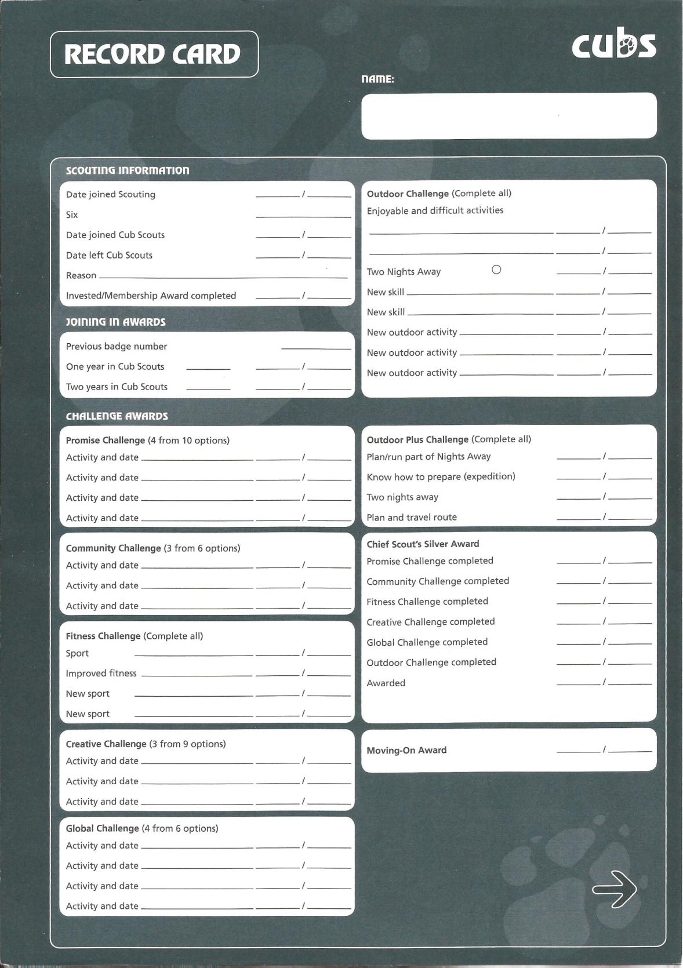

This contains details of the badges scouts have achieved

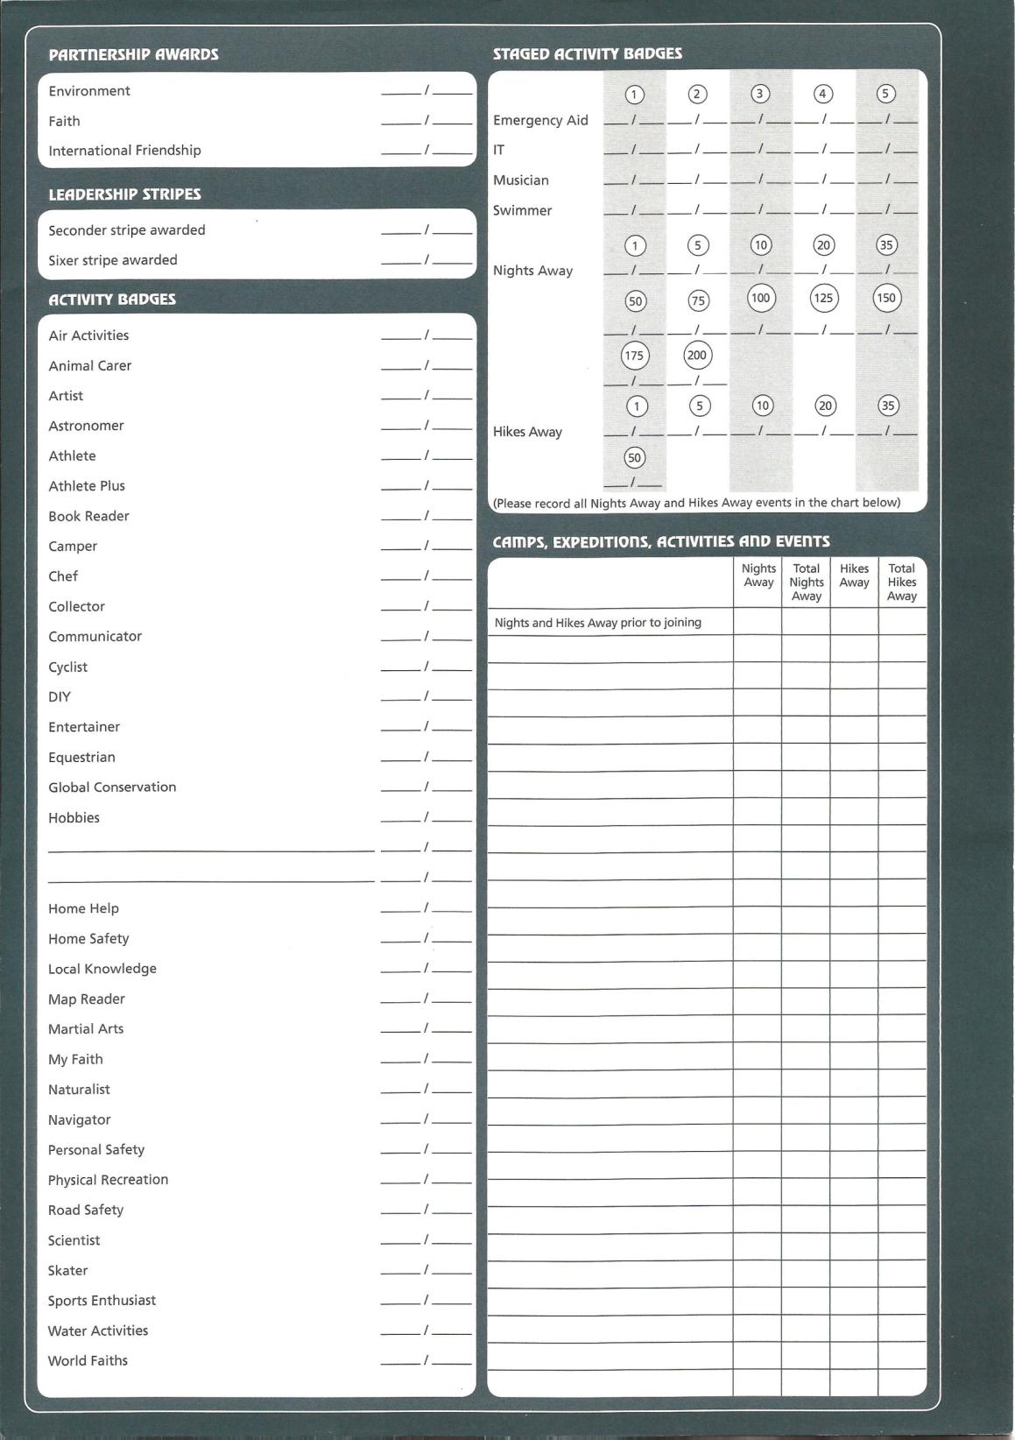

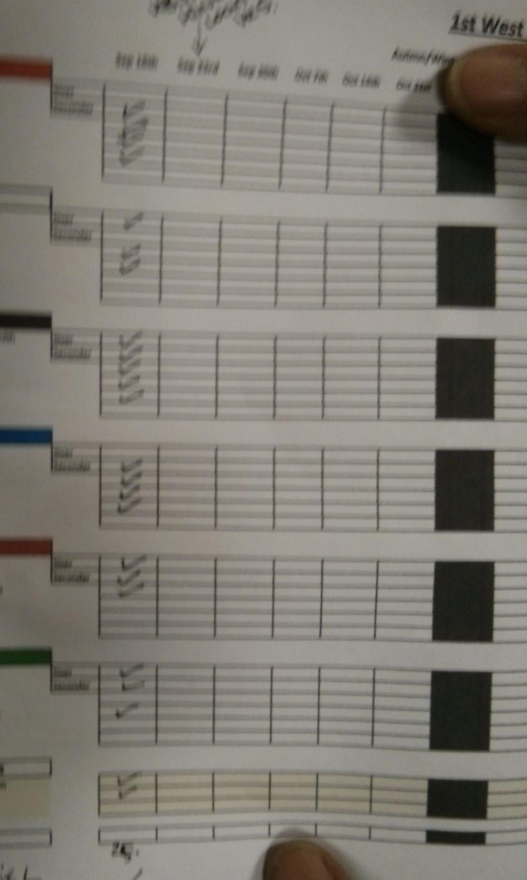

**Existing system – register** – This contains details of which Scouts attended each meeting

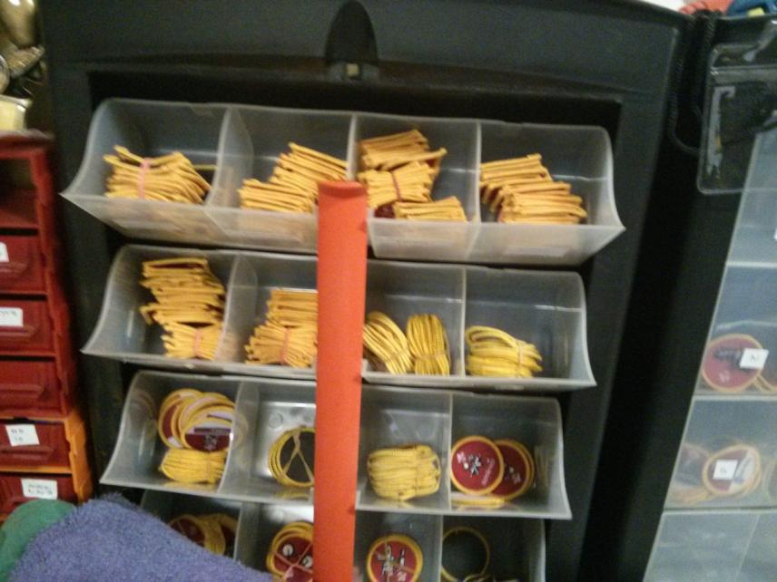

Badge stores

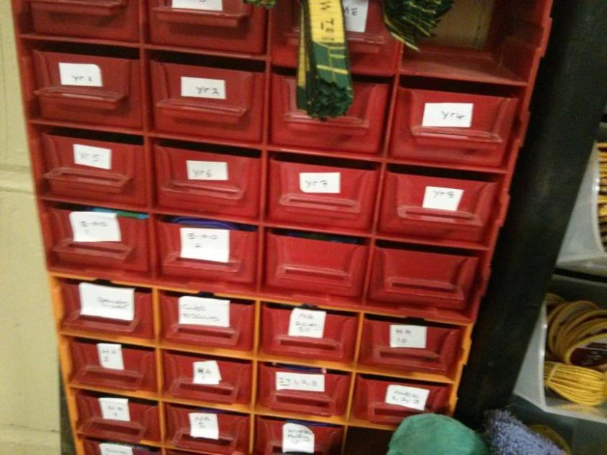

# IOPS Chart for the existing system

This chart shows the inputs, processes, storage and outputs for the existing system.

Input

• Register

• Programme

• Badge record

Process / decision

• Register taken

• Highest achieved stage determined if doing staged badges

• Register matched to programme

• Badges required determined

• Record cards updated

• List of achieved badges created

• Draws checked to ensure enough

• More badges ordered if needed

• Badges sorted into bags and handed out

Storage

• Record card

• Achieved badges

• Required badges

• Register

• Programme

Output

• Badges handed out

• Record card

# Existing system flowchart

This shows how the existing system works, including paperwork, processes and decisions.



# Document specification sheets

Over the next few pages I have included some document specification sheets. These contain details of all the existing paperwork, including how they are stored and the types of data they store.

Document Specification Sheet (existing programme)

|  |  |  |  |  |  |  |  |  |  |  |  |
| --- | --- | --- | --- | --- | --- | --- | --- | --- | --- | --- | --- |
| **Volumetrics** | | | | | | | | | | | |
| Document description | | | System | | | | Document | | Name | | Sheet |
| Programme | | | Badges | | | | 1 | | Andrew Burton | | 4 |
| Stationery ref. | | | Size | | | | Number of parts | | Method of preparation | | |
| Programme | | | A4 | | | | 1 | | Typed | | |
| Filing sequence | | | | | Medium | | | | Prepared by | | |
|  | | | | | Paper, Computer | | | | Scout leader | | |
| Frequency of preparation | | | | | Retention period | | | | Location of file | | |
| Once per term | | | | |  | | | | Scout leader PC and folder, Scout group website | | |
| Volume | Minimum | | | Maximum | | Av/Abs | | Growth rate/fluctuations | | | |
| 0 | | | 3 | | 3 | | No fluctuation | | | |
| Users/receipts | | Purpose | | | | | | | | Frequency of use | |
| Scout leaders | | Matching badges to programme | | | | | | | | Once per term | |
| **Data Dictionary** | | | | | | | | | | | |
| Ref | Name | Data Type | | | Length | | | Occurrence | | Source of data | |
| 1 | Scout group name | Z | | | 28 | | | Once per page | | Scout leader | |
| 2 | Charity no | Z | | | 31 | | | Top and bottom of each page | | Scout leader | |
| 3 | Section | A | | | 14 | | | Once per page | | Scout leader | |
| 4 | Title | Z | | | 36 | | | Top of programme | | Scout leader | |
| 5 | Date of meeting | A, 9 | | | 5, 2 | | | Per entry | | Scout leader | |
| 6 | Meeting title | A | | | Varies | | | Per entry | | Scout leader | |
| 7 | Meeting description | A | | | Varies | | | Per entry | | Scout leader | |
| 8 | Address | Z | | | 64 | | | Per entry | | Scout leader | |

**1st WEST BYFLEET SCOUT GROUP**

**Existing system - Programme**

**Charity Registration No. 305913**

**CUB SCOUT PACK**

1

3 2

**Wolves Programme – April - July 2013**

4

|  |  |
| --- | --- |
| **April** |  |
| **15th** | **Welcome Back**! 6 |
|  | Games evening 7 |
| 5 | Talk though the programme |
| **22nd** | **Community Challenge / Chefs badge / Sports enthusiast badge** |
|  | **Physical recreation** |
|  | We are going to split you in to 2 groups. Half of you will complete the last |
|  | few requirements for the Chef’s badge (this will also be a requirement for the |
|  | community challenge) while the other half will start the Sports enthusiasts |
|  | badge. |
|  | **Blue, Red and Green sixes** will be learning about hazards in the home and |
|  | Kitchen. |
|  | We are going to set up some hazards at HQ and you have to find them. You |
|  | will then tell us why they are a hazard and what you could do to stop them |
|  | being a hazard. |
|  | You will also be learning how to make an emergency 999 call and the new |
|  | 101 call for help. |
|  | **Black, Brown and White sixes** will be starting the Sports enthusiast badge. |
|  | Come in to cubs prepared to tell everyone about one sport that you regularly |
|  | take part in. This could be Swimming, cricket, football, tennis, karate, etc etc. |
|  | Bring in with you any special clothing or equipment you have to use for this |
|  | sport and know the rules. If your chosen sport requires a particular skill, be |
|  | prepared to show all the other cubs what you have to do. |
| **29th** | **Community Challenge / Chefs badge / Sports enthusiast badge** |
|  | **Physical Recreation** |

We are going to split you in to 2 groups. Half of you complete the last few requirements for the Chef’s badge (this will also be a requirement for the chefs community challenge) while the other half will start the Sports enthusiasts badge.

**Blue, Red and Green sixes** will be learning about hazards in the home andkitchen. We are going to set up some hazards at HQ and you have to find them. You will then tell us why they are a hazard and what you could do to stop them being a hazard.

Group Headquarters: Camphill Road, West Byfleet, Surrey KT14 6EF

Charity Registration No. 305813

**1st WEST BYFLEET SCOUT GROUP**

**Charity Registration No. 305913**

**CUB SCOUT PACK**

You will also be learning how to make an emergency 999 call and the new

101 call for help.

**Black, Brown and White sixes** will be starting the Sports enthusiast badge.

Come in to cubs prepared to tell everyone about one sport that you regularly

take part in. This could be Swimming, cricket, football, tennis, karate, etc etc.

Bring in with you any special clothing or equipment you have to use for this

sport and know the rules. If your chosen sport requires a particular skill, be

prepared to show all the other cubs what you have to do.

**May**

**6th** **Bank Holiday – No Pack Meeting**

**13th** **Community Challenge**

Visit to Painshill Fire Station. To be confirmed.

**20th** **Community Challenge / Gardening at HQ**

Green / White / Red sixes will be baking cakes to freeze for our cake sale on

the 10th June 2013

Black / Blue / Brown sixes Will be gardening at HQ. Please feel free to bring

a few plants to brighten up our garden and to plant in the big planter in the

front garden.

You will need gardening gloves, strong shoes and any small gardening

equipment you want to use. Parents, please feel free to come along and help,

we need your help too.

Please wear comfortable clothes and your group scarf.

**27th** **Half Term No Pack Meeting**

**June** **Community Challenge / Gardening at HQ**

**3rd**

Black / Blue / Brown sixes will be baking cakes to freeze for our cake sale on

the 10th June 2013

Green / White / Red sixes will be gardening at HQ. Please feel free to bring a

few plants to brighten up our garden and to plant in the big planter in the front

garden.

Group Headquarters: Camphill Road, West Byfleet, Surrey KT14 6EF

Charity Registration No. 305813

**1st WEST BYFLEET SCOUT GROUP**

**Charity Registration No. 305913**

**CUB SCOUT PACK**

You will need gardening gloves, strong shoes and any small gardening equipment you want to use. Parents, please feel free to come along and help.

Please wear comfortable clothes and your group scarf.

**10th** **Community Challenge**

We will be decorating more cakes for our cake sale to raise funds for a charity chosen by the Cubs. Families please arrive at 7.45 pm for the cake sale and buy a few cakes.

Any cakes left at the end of the sale will be sold at Scouts tomorrow night.

**17th** **Sports Enthusiast / Physical Recreation**

Please meet at West Byfleet Park at the usual time to do some training and learn how to play rounder’s. Have a look on the internet and see if you can find out some of the rules of the game.

We are also going to teach you how to play football rounder’s!

Wear comfortable sports clothes and your group scarf.

If it is raining, meet at HQ as normal

**24th** **Cyclist Badge**

**July**

**1st**

Please bring along a poster you have made promoting road safety to pedestrians or cyclists and your bike and helmet to Cubs tonight and a pump if you have one. We are going to have a busy night learning the following,

How to clean and oil your bicycle, how to pump up the tyres and how to mend a puncture. Talk about safety measures you should take if you ride in poor condition and show us you know how to get on and off your bike properly.

**Sports Enthusiast / Physical Recreation**

Please meet at West Byfleet Park for you rounder’s match against your parents. Please come and join us and help the cubs to complete the Sports enthusiast badge by having a rounder’s match against the Parents.

Wear comfortable sports clothes and your group scarf. If it is raining, meet at HQ as normal

8

Group Headquarters: Camphill Road, West Byfleet, Surrey KT14 6EF

Charity Registration No. 305813

**8th**

**15th**

**22nd**

**1st WEST BYFLEET SCOUT GROUP**

**Charity Registration No. 305913**

**CUB SCOUT PACK**

**Cyclist Badge Physical Recreation**

Cycle ride to Bridge Barn. We will need a huge amount of parental help for this activity. Without the help, this activity will not go ahead.

Please meet at HQ for the earlier time of 6.00 pm. All Cubs MUST have a suitable bike for their size and a helmet for this activity. If they do not have a helmet they will not be able to take part in the cycle ride.

**Snorkelling and Diving evening**

Baloo has arranged for a snorkelling instructor to come along and teach us all about Snorkelling and water safety

**Fitness Challenge and some fun for the end of term**

King-Louie has arranged an evening at Hoe Bridge Golf club for you all. Come along in your Cubs polo shirt and Scarf to enjoy the evening.

Group Headquarters: Camphill Road, West Byfleet, Surrey KT14 6EF

Charity Registration No. 30581

Document Specification Sheet (existing record card)

|  |  |  |  |  |  |  |  |  |  |  |  |
| --- | --- | --- | --- | --- | --- | --- | --- | --- | --- | --- | --- |
| **Volumetrics** | | | | | | | | | | | |
| Document description | | | System | | | | Document | | Name | | Sheet |
| Badges record | | | Badges | | | | 1 | | Andrew Burton | | 2 (2 sides) |
| Stationery ref. | | | Size | | | | Number of parts | | Method of preparation | | |
| Record Card | | | A4 | | | | 1 | | Record card provided by scout association, filled out by scout leader | | |
| Filing sequence | | | | | Medium | | | | Prepared by | | |
| A-Z | | | | | Paper | | | | Scout leader | | |
| Frequency of preparation | | | | | Retention period | | | | Location of file | | |
| Once per term | | | | | Whilst in cubs, staged details carried into scouts | | | | Leaders house | | |
| Volume | Minimum | | | Maximum | | Av/Abs | | Growth rate/fluctuations | | | |
| 0 | | | 1 per person | | 1 per person | | Depends on number of cubs | | | |
| Users/receipts | | Purpose | | | | | | | | Frequency of use | |
| Scout leader | | Adding achieved badges, determining stage achieved | | | | | | | | Once per term | |
| **Data Dictionary** | | | | | | | | | | | |
| Ref | Name | Data Type | | | Length | | | Occurrence | | Source of data | |
| 1 | Name | A | | | 40 | | | Once | | Scout leader | |
| 2 | Date Joined | 9,Z,9 | | | 2,1,2 | | | Once | | Scout leader | |
| 3 | Six | A | | | 8 | | | Once | | Scout leader | |
| 4 | Date Joined | 9,Z,9 | | | 2,1,2 | | | Once | | Scout leader | |
| 5 | Date left | 9,Z,9 | | | 2,1,2 | | | Once | | Scout leader | |
| 6 | Reason | A | | | 150 | | | Once | | Scout leader | |
| 7 | Invested | 9,Z,9 | | | 2,1,2 | | | Once | | Scout leader | |
| 8 | Previous badge no | 9 | | | 2 | | | Once | | Scout leader | |
| 9 | One year in cub scouts | A 9,Z,9 | | | 20 2,1,2 | | | Once | | Scout leader | |
| 10 | Two years in cub scouts | A 9,Z,9 | | | 20 2,1,2 | | | Once | | Scout leader | |
| 11 | Promise challenge Activity and date | A 9,Z,9 | | | 20 2,1,2 | | | Four times | | Scout leader | |
| 12 | Community challenge Activity and date | A 9,Z,9 | | | 20 2,1,2 | | | Three times | | Scout leader | |
| 13 | Fitness Challenge Sport | A 9,Z,9 | | | 20 2,1,2 | | | Once | | Scout leader | |
| 14 | Fitness Challenge improved fitness | A 9,Z,9 | | | 20 2,1,2 | | | Once | | Scout leader | |
| 15 | Fitness challenge new sport | A 9,Z,9 | | | 20 2,1,2 | | | Twice | | Scout leader | |
| 16 | Creative challenge | A 9,Z,9 | | | 20 2,1,2 | | | Three times | | Scout leader | |
| 17 | Global challenge | A 9,Z,9 | | | 20 2,1,2 | | | Four times | | Scout leader | |
| 18 | Outdoor challenge  Enjoyable and difficult activities | A 9,Z,9 | | | 40 2,1,2 | | | Twice | | Scout leader | |
| 19 | Outdoor challenge Two nights away | Z 9,Z,9 | | | 1 2,1,2 | | | Once | | Scout leader | |
| 20 | Outdoor challenge new skill | A 9,Z,9 | | | 40 2,1,2 | | | Twice | | Scout leader | |
| 21 | Outdoor Challenge new outdoor activity | A 9,Z,9 | | | 20 2,1,2 | | | Three times | | Scout leader | |
| 22 | Outdoor plus Plan/run part of nights away | 9,Z,9 | | | 2,1,2 | | | Once | | Scout leader | |
| 23 | Outdoor plus Know how to prepare (expedition) | 9,Z,9 | | | 2,1,2 | | | Once | | Scout leader | |
| 24 | Outdoor plus Two nights away | 9,Z,9 | | | 2,1,2 | | | Once | | Scout leader | |
| 25 | Outdoor plus plan and travel route | 9,Z,9 | | | 2,1,2 | | | Once | | Scout leader | |
| 26 | Chief scouts silver Promise challenge completed | 9,Z,9 | | | 2,1,2 | | | Once | | Scout leader | |
| 27 | Chief scouts silver community challenge completed | 9,Z,9 | | | 2,1,2 | | | Once | | Scout leader | |
| 28 | Chief scouts silver fitness challenge completed | 9,Z,9 | | | 2,1,2 | | | Once | | Scout leader | |
| 29 | Chief scouts silver Creative challenge completed | 9,Z,9 | | | 2,1,2 | | | Once | | Scout leader | |
| 30 | Chief scouts silver Global challenge completed | 9,Z,9 | | | 2,1,2 | | | Once | | Scout leader | |
| 31 | Chief scouts silver outdoor challenge completed | 9,Z,9 | | | 2,1,2 | | | Once | | Scout leader | |
| 32 | Chief scouts silver awarded | 9,Z,9 | | | 2,1,2 | | | Once | | Scout leader | |
| 33 | Moving on award | 9,Z,9 | | | 2,1,2 | | | Once | | Scout leader | |
| 34 | Partnership award Environment | 9,Z,9 | | | 2,1,2 | | | Once | | Scout leader | |
| 35 | Partnership award Faith | 9,Z,9 | | | 2,1,2 | | | Once | | Scout leader | |
| 36 | International friendship | 9,Z,9 | | | 2,1,2 | | | Once | | Scout leader | |
| 37 | Seconder stripe awarded | 9,Z,9 | | | 2,1,2 | | | Once | | Scout leader | |
| 38 | Sixer stripe awarded | 9,Z,9 | | | 2,1,2 | | | Once | | Scout leader | |
| 39 | Activity badge | 9,Z,9 | | | 2,1,2 | | | 33 times | | Scout leader | |
| 40 | Stage 1 | 9,Z,9 | | | 2,1,2 | | | 4 times | | Scout leader | |
| 41 | Stage 2 | 9,Z,9 | | | 2,1,2 | | | 4 times | | Scout leader | |
| 42 | Stage 3 | 9,Z,9 | | | 2,1,2 | | | 4 times | | Scout leader | |
| 43 | Stage 4 | 9,Z,9 | | | 2,1,2 | | | 4 times | | Scout leader | |
| 44 | Stage 5 | 9,Z,9 | | | 2,1,2 | | | 4 times | | Scout leader | |
| (1) | 1 night away | 9,Z,9 | | | 2,1,2 | | | Once | | Scout leader | |
| (5) | 5 nights away | 9,Z,9 | | | 2,1,2 | | | Once | | Scout leader | |
| (10) | 10 nights away | 9,Z,9 | | | 2,1,2 | | | Once | | Scout leader | |
| (20) | 20 nights away | 9,Z,9 | | | 2,1,2 | | | Once | | Scout leader | |
| (35) | 35 nights away | 9,Z,9 | | | 2,1,2 | | | Once | | Scout leader | |
| (50) | 50 nights away | 9,Z,9 | | | 2,1,2 | | | Once | | Scout leader | |
| (75) | 75 nights away | 9,Z,9 | | | 2,1,2 | | | Once | | Scout leader | |
| (100) | 100 nights away | 9,Z,9 | | | 2,1,2 | | | Once | | Scout leader | |
| (125) | 125 nights away | 9,Z,9 | | | 2,1,2 | | | Once | | Scout leader | |
| (150) | 150 nights away | 9,Z,9 | | | 2,1,2 | | | Once | | Scout leader | |
| (175) | 175 nights away | 9,Z,9 | | | 2,1,2 | | | Once | | Scout leader | |
| (200) | 200 nights away | 9,Z,9 | | | 2,1,2 | | | Once | | Scout leader | |
| “1” | 1 hike away | 9,Z,9 | | | 2,1,2 | | | Once | | Scout leader | |
| “5” | 5 hikes away | 9,Z,9 | | | 2,1,2 | | | Once | | Scout leader | |
| “10” | 10 hikes away | 9,Z,9 | | | 2,1,2 | | | Once | | Scout leader | |
| “20” | 20 hikes away | 9,Z,9 | | | 2,1,2 | | | Once | | Scout leader | |
| “35” | 35 hikes away | 9,Z,9 | | | 2,1,2 | | | Once | | Scout leader | |
| “50” | 50 hikes away | 9,Z,9 | | | 2,1,2 | | | Once | | Scout leader | |
| 45 | Nights away | 9,Z,9 | | | 2,1,2 | | | Once per entry | | Scout leader | |
| 46 | Total nights away | 9,Z,9 | | | 2,1,2 | | | Once per entry | | Scout leader | |
| 47 | Hikes away | 9,Z,9 | | | 2,1,2 | | | Once per entry | | Scout leader | |
| 48 | Total hikes away | 9,Z,9 | | | 2,1,2 | | | Once per entry | | Scout leader | |
|  |  |  | | |  | | |  | |  | |



1

2

3

4

5

6

7

8

9

10

11

12

**Existing system – Record card**

33 Selection.MoveRight Unit:=wdCell4

32 Selection.MoveRight Unit:=wdCell4

31 Selection.MoveRight Unit:=wdCell4

30 Selection.MoveRight Unit:=wdCell4

29 Selection.MoveRight Unit:=wdCell4

28 Selection.MoveRight Unit:=wdCell4

27 Selection.MoveRight Unit:=wdCell4

26  Selection.MoveRight Unit:=wdCell4

25 Selection.MoveRight Unit:=wdCell4

234

24 Selection.MoveRight Unit:=wdCell4

224

214

204

194

184

174

164

154

144

13

Badge record card (front)



Badge record card (back)

34 Selection.MoveRight Unit:=wdCell4

35 Selection.MoveRight Unit:=wdCell4

36 Selection.MoveRight Unit:=wdCell4

37Selection.MoveRight Unit:=wdCell4

38 Selection.MoveRight Unit:=wdCell4

39 Selection.MoveRight Unit:=wdCell4

40 Selection.MoveRight Unit:=wdCell4

41 Selection.MoveRight Unit:=wdCell4

42 Selection.MoveRight Unit:=wdCell4

43 Selection.MoveRight Unit:=wdCell4

44 Selection.MoveRight Unit:=wdCell4

Labelled as (stage) on spec sheet

Labelled as “stage” on spec sheet

45

46

47

48

Document Specification Sheet (existing register)

|  |  |  |  |  |  |  |  |  |  |  |  |
| --- | --- | --- | --- | --- | --- | --- | --- | --- | --- | --- | --- |
| **Volumetrics** | | | | | | | | | | | |
| Document description | | | System | | | | Document | | Name | | Sheet |
| Register | | | Badges | | | | 1 | | Andrew Burton | | 1 |
| Stationery ref. | | | Size | | | | Number of parts | | Method of preparation | | |
| Register | | | A4 | | | | 1 | | Typed, filled in by hand | | |
| Filing sequence | | | | | Medium | | | | Prepared by | | |
| Placed in folder | | | | | Paper | | | | Scout leader | | |
| Frequency of preparation | | | | | Retention period | | | | Location of file | | |
| Once per term | | | | | 1 term | | | | Leader’s house | | |
| Volume | Minimum | | | Maximum | | Av/Abs | | Growth rate/fluctuations | | | |
| 0 | | | 1 per meeting | | 1 per meeting | | None - register taken each meeting | | | |
| Users/receipts | | Purpose | | | | | | | | Frequency of use | |
| Scout leaders | | Used to track attendance | | | | | | | | Once per meeting | |
| **Data Dictionary** | | | | | | | | | | | |
| Ref | Name | Data Type | | | Length | | | Occurrence | | Source of data | |
| 1 | Name | A | | | 30 | | | 30 times | | Scout leader | |
| 2 | Six | A | | | 10 | | | 6 times | | Scout leader | |
| 3 | Date of meeting | 9,Z,9 | | | 2,1,2 | | | 12 times | | Scout leader | |
| 4 | Attendance | Z | | | 1 | | | 30 times | | Scout leader | |

**Existing system - register**



Date of meeting (3)

Names (1)

Six (2)

Attendance (4)

Analysis

From my investigation, I have seen how the existing badges system works. From my investigation, I have determined that the best solution to the end users problem is to create a program to digitally store attendance data, along with details of which badges have been awarded. At the end of the term, the end user will be able to see which Scouts have achieved which badges, and view who has missed meetings in order to schedule catch up sessions. The end user also stated that they would like the system to be able to assist in planning the programme, based on which sessions have been done.

# Scope and Objectives

1. To be easily useable
   1. The end user must be able to navigate to all of the functions within 4 mouse clicks.
   2. Inputs need to provide instruction and validation to ensure the system doesn’t crash
   3. There must be adequate documentation in order to ensure that this happens. This must be ready at the same time as the program.
2. To be able to store the attendance data
   1. The end user must be able to enter the attendance data into the system with no more than 2 clicks per record
   2. This data must then be stored for future use as soon as the user presses save
3. To be able to store details of the achieved badges
   1. The end user must be able to enter in the achieved badges
   2. This will then need to be stored with the persons record as soon as the end user presses save
4. To be able to see which badges have been achieved based on attendance
   1. The end user must be able to enter the attendance register each meeting
   2. The system must be able to determine the attendance for each session, along with the parts of badges within 15 seconds of the end user loading the section
   3. The system must then be able to produce an achieved badges list which the user can then print
5. To be able to print achieved badges lists
   1. The system must be able to produce an achieved badge list for the end user
   2. The end user must then be able to print this list for reference if they want to
6. To be able to view and print record cards
   1. The end user must be able to view a list of all the badges each person has achieved similar to the record card used in the existing system
   2. The end user must then be able to print it
7. To see which sessions have been missed in order to work out which stages to run

7.1 The system must be able to work out which Scouts missed meetings between a date ranges. The system must be able to calculate this within 15 seconds

7.2 The system must then be able to determine which badges were being done on those dates and produce a list of people who missed the sessions sorted by date

1. To see which parts of a badge have not been achieved in order to assist in programme planning
   1. The system must be able to produce a list of the badges sorted by number of achieved times based on the badges database
2. To be able to modify the badges to enable new badges to be entered / requirements to be updated

9.1 The end user must be able to modify the badge details as well as being able to add and remove badges. This must be able to be done within the main programme

1. To be able to be easily adapted for use with Scouts and Beavers

10.1 The end user must be able to modify the badges and the records in order to use it with the other sections of Scouts. This must be able to be done within the program

1. To be able to access the main functions of the program quickly
   1. The end user must be able to use the program without needing any external help

# Tasks to be computerised

* Register
* Individual badge records
* Matching register to programme
* Determining highest stage achieved if staged badges
* Producing list of badges based on criteria being met
* Determining what needs doing for catch up sessions
* Determining which parts need doing for programme planning

# Proposed solutions

This section contains details of 3 possible solutions. I will then analyse the advantages and disadvantages of each possible solution, and then decide which one is the best one.

1)

A partly computerised system using the existing record cards and register. This would use either a Microsoft Access database or an Excel spreadsheet with macros to enable the user to enter the achieved badge parts from the paper register, and view which badges have been achieved. The user will then be able to record this into the existing record card.

The advantage of this system is that it will be easier for me to create, since I have used Access and Excel in the past, and it should also be easy to use. However, due to the fact that the paper register and record cards are still used, it does not meet the end users requirements of having a system to completely replace the paper record cards. It also has less functionality than the other solutions, such as lacking the ability to view missed sessions since it does not store attendance data, and will only work with one user since it has to be stored on the user’s computer

2)

A fully computerised system with a custom badge record program written in VB.NET, with a database backend, either on a remote server such as MySQL or on a local Access database. This system would completely replace the existing record cards and register, as the user would be able to enter the register and achieved badges directly into the system. The system would then be able to display achieved badges, as well as other things such as missed sessions and least achieved badges, since it is storing all of the attendance and badge data. If a remote server was used, it could also be used with multiple users, although it would require an internet connection.

This system would be harder for the user to use, due to the fact that it has more functionality, and be harder to create, although I have had some experience with databases and already have a basic understanding of VB.NET from my AS level. It would also meet all of the end users requirements, due to the fact that it would completely eliminate the need for paper, and instead fully computerise the system. However, it would require the end user to bring a computer or use a piece of paper to enter the register for each session in order to take the register.

3) A fully computerised system with a custom mobile application with the database stored on a remote server. The advantage of this is that it would meet the requirements of having a fully computerised system to manage the attendance and badge records, and the end user would not need to bring a computer to each meeting in order to use the application. It could also be installed on multiple devices, which could mean that multiple users can use the system. However, this would require me to do a large amount of learning, since I do not have experience with mobile apps, and would require multiple apps for multiple operating systems since the different leaders have different phones running different OS’s. It would also make the program harder to use.

Chosen solution:

I have chosen to go for the second option of a fully computerised system with a custom badge record program written in VB.NET using a MySQL server to store the data. The reason for this is because it meets all of the end users requirements of being able to have a completely computerised system to manage the records and badges and register. At the same time it will also mean that I won’t have to learn a huge amount, due to the fact that I have had some experience with VB.NET. The MySQL server means that multiple users can use the program, since the database is stored on a remote server, although this will require me to learn how to use SQL commands.

# Constraints

Technical:

The main technical constraint will be my programming skills, due to the fact that I have not yet done a programming project of this size before, and I have had little experience with object oriented programming, however I am sure that I will be able to bring my skills up to the level needed to complete the project and meet all of the end users objectives. I will also need to include maintenance documentation since the program may need to be changed in the future by another programmer. The end user also needs to be able to do some basic maintenance within the program. The end user will also need a computer which is capable of running the program, although they stated in the questionnaire that they have a Laptop running Windows 8 so this should not be an issue.

Economic:

The main cost to the user will be if any IT equipment needs replacing, although as mentioned above this is unlikely. Since there is no budget for this project, this is a major constraint. They will also need a printer if they wish to print anything, although there is already one in the Scout hut so this is not a major constraint.

Legal:

The main legal issue is due to the fact that due to the fact that the organisation will be processing data electronically they will need to pay attention to the Data Protection Act. However, due to the fact that some data is already processed electronically using Excel, and the Scout Association has data protection guidelines, they should be aware of this already. Only authorised users will be allowed to access the system, so I will implement password protection using the SQL username and password and levels of access so users will only be able to edit the database, not other user’s details.

Overall, I believe that that despite these constraints the project should be feasible, although I will need to do some work on my programming skills to ensure that it meets all of the end users requirements.

New system design

This section shows the design for the new system. In order to design the new system, I will first determine what needs to be stored into the new system, using the existing document specification sheets to help me. I will then create a process diagram to show how the program will work, and based on that I will then be able to create a mock-up of the user interface. I will then work out how the databases I will use need to be normalised, and finally I will determine how the program will function using pseudo code.

# Storage specification sheets

Over the next few pages I have included some document specification sheets. These contain details of all the data which is going to be stored in the new system, including the types of data.

Storage Specification (Programme)

|  |  |  |  |  |  |  |  |  |  |  |  |
| --- | --- | --- | --- | --- | --- | --- | --- | --- | --- | --- | --- |
| **Volumetrics** | | | | | | | | | | | |
| Document description | | | System | | | | Document | | Name | | Sheet |
| Programme | | | Badges | | | | 1 | | Andrew Burton | |  |
| Stationery ref. | | | Size | | | | Number of parts | | Method of preparation | | |
| Programme | | |  | | | | 1 | | Typed | | |
| Filing sequence | | | | | Medium | | | | Prepared by | | |
|  | | | | | Computer – entered from version distributed to parents into system | | | | Scout leader | | |
| Frequency of preparation | | | | | Retention period | | | | Location of file | | |
| Once per term | | | | |  | | | | Database in program | | |
| Volume | Minimum | | | Maximum | | Av/Abs | | Growth rate/fluctuations | | | |
| 0 | | | 3 | | 3 | | No fluctuation | | | |
| Users/receipts | | Purpose | | | | | | | | Frequency of use | |
| Scout leaders | | Matching badges to programme | | | | | | | | Once per term | |
| **Data Dictionary** | | | | | | | | | | | |
| Ref | Name | Data Type | | | Length | | | Occurrence | | Source of data | |
| 1 | Date of meeting | A, 9 | | | 5, 2 | | | Per entry | | Scout leader | |
| 2 | Meeting title | A | | | Varies | | | Per entry | | Scout leader | |
| 3 | Parts of badges being done in meeting | A | | | Varies | | | Per entry | | Scout leader | |

Storage Specification (Register)

|  |  |  |  |  |  |  |  |  |  |  |  |
| --- | --- | --- | --- | --- | --- | --- | --- | --- | --- | --- | --- |
| **Volumetrics** | | | | | | | | | | | |
| Document description | | | System | | | | Document | | Name | | Sheet |
| Register | | | Badges | | | | 1 | | Andrew Burton | | 1 |
| Stationery ref. | | | Size | | | | Number of parts | | Method of preparation | | |
| Register | | |  | | | | 1 | | Typed, filled in by hand | | |
| Filing sequence | | | | | Medium | | | | Prepared by | | |
|  | | | | | Computer – register taken at the start of meeting | | | | Scout leader | | |
| Frequency of preparation | | | | | Retention period | | | | Location of file | | |
| Once per term | | | | | 1 term | | | | Database in Program | | |
| Volume | Minimum | | | Maximum | | Av/Abs | | Growth rate/fluctuations | | | |
| 0 | | | 1 per meeting | | 1 per meeting | | None - register taken each meeting | | | |
| Users/receipts | | Purpose | | | | | | | | Frequency of use | |
| Scout leaders | | Used to track attendance | | | | | | | | Once per meeting | |
| **Data Dictionary** | | | | | | | | | | | |
| Ref | Name | Data Type | | | Length | | | Occurrence | | Source of data | |
| 1 | Name | A | | | 30 | | | 30 times | | Scout leader | |
| 2 | Six | A | | | 10 | | | 6 times | | Scout leader | |
| 3 | Date of meeting | 9,Z,9 | | | 2,1,2 | | | 12 times | | Scout leader | |
| 4 | Attendance | Z | | | 1 | | | 30 times | | Scout leader | |

Storage Specification (Record)

|  |  |  |  |  |  |  |  |  |  |  |  |
| --- | --- | --- | --- | --- | --- | --- | --- | --- | --- | --- | --- |
| **Volumetrics** | | | | | | | | | | | |
| Document description | | | System | | | | Document | | Name | | Sheet |
| Badges record | | | Badges | | | | 1 | | Andrew Burton | | 2 (2 sides) |
| Stationery ref. | | | Size | | | | Number of parts | | Method of preparation | | |
| Record Card | | |  | | | | 1 | | Record generated automatically, scout leader fills in details | | |
| Filing sequence | | | | | Medium | | | | Prepared by | | |
| A-Z | | | | | Computer | | | | Scout leader | | |
| Frequency of preparation | | | | | Retention period | | | | Location of file | | |
| Once per term | | | | | Whilst in cubs, staged details carried into scouts | | | | Database in computer system | | |
| Volume | Minimum | | | Maximum | | Av/Abs | | Growth rate/fluctuations | | | |
| 0 | | | 1 per person | | 1 per person | | Depends on number of cubs | | | |
| Users/receipts | | Purpose | | | | | | | | Frequency of use | |
| Scout leader | | Adding achieved badges, determining stage achieved | | | | | | | | Once per term | |
| **Data Dictionary** | | | | | | | | | | | |
| Ref | Name | Data Type | | | Length | | | Occurrence | | Source of data | |
| 1 | Name | A | | | 40 | | | Once | | Scout leader | |
| 2 | Date Joined | 9,Z,9 | | | 2,1,2 | | | Once | | Scout leader | |
| 3 | Six | A | | | 8 | | | Once | | Scout leader | |
| 4 | Date Joined | 9,Z,9 | | | 2,1,2 | | | Once | | Scout leader | |
| 5 | Date left | 9,Z,9 | | | 2,1,2 | | | Once | | Scout leader | |
| 6 | Reason | A | | | 150 | | | Once | | Scout leader | |
| 7 | Invested | 9,Z,9 | | | 2,1,2 | | | Once | | Scout leader | |
| 8 | Previous badge no | 9 | | | 2 | | | Once | | Scout leader | |
| 9 | One year in cub scouts | A 9,Z,9 | | | 20 2,1,2 | | | Once | | Scout leader | |
| 10 | Two years in cub scouts | A 9,Z,9 | | | 20 2,1,2 | | | Once | | Scout leader | |
| 11 | Promise challenge Activity and date | A 9,Z,9 | | | 20 2,1,2 | | | Four times | | Scout leader | |
| 12 | Community challenge Activity and date | A 9,Z,9 | | | 20 2,1,2 | | | Three times | | Scout leader | |
| 13 | Fitness Challenge Sport | A 9,Z,9 | | | 20 2,1,2 | | | Once | | Scout leader | |
| 14 | Fitness Challenge improved fitness | A 9,Z,9 | | | 20 2,1,2 | | | Once | | Scout leader | |
| 15 | Fitness challenge new sport | A 9,Z,9 | | | 20 2,1,2 | | | Twice | | Scout leader | |
| 16 | Creative challenge | A 9,Z,9 | | | 20 2,1,2 | | | Three times | | Scout leader | |
| 17 | Global challenge | A 9,Z,9 | | | 20 2,1,2 | | | Four times | | Scout leader | |
| 18 | Outdoor challenge  Enjoyable and difficult activities | A 9,Z,9 | | | 40 2,1,2 | | | Twice | | Scout leader | |
| 19 | Outdoor challenge Two nights away | Z 9,Z,9 | | | 1 2,1,2 | | | Once | | Scout leader | |
| 20 | Outdoor challenge new skill | A 9,Z,9 | | | 40 2,1,2 | | | Twice | | Scout leader | |
| 21 | Outdoor Challenge new outdoor activity | A 9,Z,9 | | | 20 2,1,2 | | | Three times | | Scout leader | |
| 22 | Outdoor plus Plan/run part of nights away | 9,Z,9 | | | 2,1,2 | | | Once | | Scout leader | |
| 23 | Outdoor plus Know how to prepare (expedition) | 9,Z,9 | | | 2,1,2 | | | Once | | Scout leader | |
| 24 | Outdoor plus Two nights away | 9,Z,9 | | | 2,1,2 | | | Once | | Scout leader | |
| 25 | Outdoor plus plan and travel route | 9,Z,9 | | | 2,1,2 | | | Once | | Scout leader | |
| 26 | Chief scouts silver Promise challenge completed | 9,Z,9 | | | 2,1,2 | | | Once | | Scout leader | |
| 27 | Chief scouts silver community challenge completed | 9,Z,9 | | | 2,1,2 | | | Once | | Scout leader | |
| 28 | Chief scouts silver fitness challenge completed | 9,Z,9 | | | 2,1,2 | | | Once | | Scout leader | |
| 29 | Chief scouts silver Creative challenge completed | 9,Z,9 | | | 2,1,2 | | | Once | | Scout leader | |
| 30 | Chief scouts silver Global challenge completed | 9,Z,9 | | | 2,1,2 | | | Once | | Scout leader | |
| 31 | Chief scouts silver outdoor challenge completed | 9,Z,9 | | | 2,1,2 | | | Once | | Scout leader | |
| 32 | Chief scouts silver awarded | 9,Z,9 | | | 2,1,2 | | | Once | | Scout leader | |
| 33 | Moving on award | 9,Z,9 | | | 2,1,2 | | | Once | | Scout leader | |
| 34 | Partnership award Environment | 9,Z,9 | | | 2,1,2 | | | Once | | Scout leader | |
| 35 | Partnership award Faith | 9,Z,9 | | | 2,1,2 | | | Once | | Scout leader | |
| 36 | International friendship | 9,Z,9 | | | 2,1,2 | | | Once | | Scout leader | |
| 37 | Seconder stripe awarded | 9,Z,9 | | | 2,1,2 | | | Once | | Scout leader | |
| 38 | Sixer stripe awarded | 9,Z,9 | | | 2,1,2 | | | Once | | Scout leader | |
| 39 | Activity badge | 9,Z,9 | | | 2,1,2 | | | 33 times | | Scout leader | |
| 40 | Stage 1 | 9,Z,9 | | | 2,1,2 | | | 4 times | | Scout leader | |
| 41 | Stage 2 | 9,Z,9 | | | 2,1,2 | | | 4 times | | Scout leader | |
| 42 | Stage 3 | 9,Z,9 | | | 2,1,2 | | | 4 times | | Scout leader | |
| 43 | Stage 4 | 9,Z,9 | | | 2,1,2 | | | 4 times | | Scout leader | |
| 44 | Stage 5 | 9,Z,9 | | | 2,1,2 | | | 4 times | | Scout leader | |
| (1) | 1 night away | 9,Z,9 | | | 2,1,2 | | | Once | | Scout leader | |
| (5) | 5 nights away | 9,Z,9 | | | 2,1,2 | | | Once | | Scout leader | |
| (10) | 10 nights away | 9,Z,9 | | | 2,1,2 | | | Once | | Scout leader | |
| (20) | 20 nights away | 9,Z,9 | | | 2,1,2 | | | Once | | Scout leader | |
| (35) | 35 nights away | 9,Z,9 | | | 2,1,2 | | | Once | | Scout leader | |
| (50) | 50 nights away | 9,Z,9 | | | 2,1,2 | | | Once | | Scout leader | |
| (75) | 75 nights away | 9,Z,9 | | | 2,1,2 | | | Once | | Scout leader | |
| (100) | 100 nights away | 9,Z,9 | | | 2,1,2 | | | Once | | Scout leader | |
| (125) | 125 nights away | 9,Z,9 | | | 2,1,2 | | | Once | | Scout leader | |
| (150) | 150 nights away | 9,Z,9 | | | 2,1,2 | | | Once | | Scout leader | |
| (175) | 175 nights away | 9,Z,9 | | | 2,1,2 | | | Once | | Scout leader | |
| (200) | 200 nights away | 9,Z,9 | | | 2,1,2 | | | Once | | Scout leader | |
| “1” | 1 hike away | 9,Z,9 | | | 2,1,2 | | | Once | | Scout leader | |
| “5” | 5 hikes away | 9,Z,9 | | | 2,1,2 | | | Once | | Scout leader | |
| “10” | 10 hikes away | 9,Z,9 | | | 2,1,2 | | | Once | | Scout leader | |
| “20” | 20 hikes away | 9,Z,9 | | | 2,1,2 | | | Once | | Scout leader | |
| “35” | 35 hikes away | 9,Z,9 | | | 2,1,2 | | | Once | | Scout leader | |
| “50” | 50 hikes away | 9,Z,9 | | | 2,1,2 | | | Once | | Scout leader | |
| 45 | Nights away | 9,Z,9 | | | 2,1,2 | | | Once per entry | | Scout leader | |
| 46 | Total nights away | 9,Z,9 | | | 2,1,2 | | | Once per entry | | Scout leader | |
| 47 | Hikes away | 9,Z,9 | | | 2,1,2 | | | Once per entry | | Scout leader | |
| 48 | Total hikes away | 9,Z,9 | | | 2,1,2 | | | Once per entry | | Scout leader | |
|  |  |  | | |  | | |  | |  | |

# IOPS Chart for the new system

These charts show the inputs, processes, storage and outputs for the new system.

Input

• Attendance (yes or no)

Process / decision

• attendance entered into system

• System matches attendance to programme, calculates badges achieved during meeting – if person there then badge part done

• Database updated

Storage

• Programme

• Attendance

• Achived badges log

Output

• Confirmation register saved

**Register**

The attendance is entered into the new system, which then matches to the programme and stores the badge parts achieved in the database

**View individual record**

Input

•Name

Process / decision

• name entered into system

• achieved badges retrieved from database

• Achieved badges displayed

User can choose to print record

If edit button pressed, all of values changed to input boxes

When user presses save databases updated

Storage

• Achieved badges log

Badges and descriptions

Scout details

Output

• Badge record for individual

Printout of badge record if needed

The user enters the name into the system, which then presents them with a record card for that person. If they choose to, they can edit it or they can print it.

**View achieved badges**

Input

• Date range

Sort by

Process / decision

• date entered into system

• achieved badges between date and name retrieved from database

• Achieved badges displayed sorted by users selection (date/badge/scout etc)

User can choose to print record

Storage

• Achieved badges log

Scout details

Badges and descriptions

Output

• List of achieved badges

Printout of achieved badges if needed

The user enters the date range into the system, which then presents them with a list of badges for between the date ranges. If they choose to, they can then print it.

**Sessions missed over date range**

Input

• Date range

Process / decision

• date entered into system

• achieved badges between date and name retrieved from database

• Missed sessions displayed along with badge

User can choose to print record

Storage

• Achieved badges log

Scout details

Badges and descriptions

Output

• List of missed sessions

Printout of missed sessions if needed

The user enters the date range into the system, which then presents them with a list of missed sessions and names for between the date ranges. If they choose to, they can then print it.

**View least achieved badges**

The user enters the date range into the system, which then presents them with a list of least achieved badges along with the date last achieved for between the date ranges. If they choose to, they can then print it.

Input

• Sort order

Current / previous scouts

Date range

Process / decision

• User selects sort order

• achieved badges between date range, name of badge and date last awarded retrieved from database

• No of times awarded and date displayed next to badge name

User can choose to print record

Storage

• Achieved badges log

Scout details

Badges and descriptions

Output

• List of least achieved badges

Printout of least achieved badges if needed

**Change badges**

The user inputs the badge name, along with the number of parts. When they press save, the database is updated. If they press delete, then the badge record is deleted along with references to it in the log table.

Input

• Badge description

No of parts

Process / decision

• User inputs badge name / description

• badge name and parts assigned ID if new badge

Otherwise existing details updated

If delete pressed then details removed from log table and badges table

Storage

• Badges and descriptions

Output

• Confirmation of save

**Enter new programme**

Input

• Meeting date

Badge part

Process / decision

• User inputs meeting date and badge part

• badge part and date stored in database

If delete pressed then details removed from meeting table

Storage

• programme table

Output

• Confirmation of save

The user inputs the meeting date, along with the badge parts. When they press save, the database is updated. If they press delete, then the meeting record is deleted

# New system flowchart

These shows the process for the different parts of the new system

**Enter register**



**View individual record**



**Achieved badges**



**Sessions missed over date range**



**Least achieved badges**



**Change badges**



**Enter new programme**



# Top down design for the new system

This shows the menu layout for the new system, and what each function will do. As can be seen below, there are 6 main functions. The register function allows the user to enter the register into the new system. The view individual record function allows the user to see a record card similar to the one in the new system. The view achieved badges function allows the end user to view the achieved badges between a date range. The programme planning function allows the end user to view missed sessions and least achieved badges. The enter programme details / change details allows the user to change the badge details and the programme details. Mock ups of the UI can be seen on the next page for the labelled sections.



# Interface designs

I have created some mock ups of the interface which can be seen below. The diagram numbers refer to the numbers on the menu chart on the previous page.

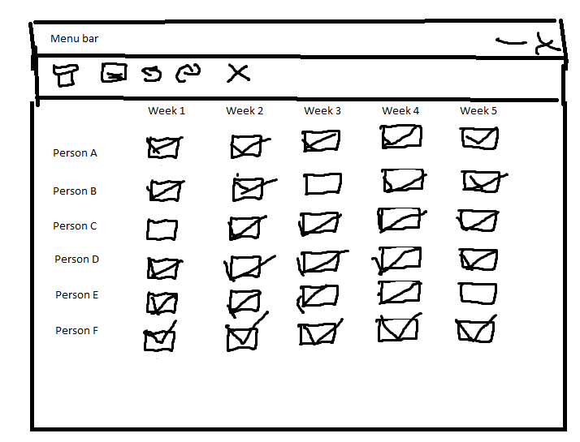Diagram (1) (Register)

Menu bar with links to rest of program

Weeks and names as text (generated from database)

Tick box for each person and meeting (there = ticked, away = unchecked)

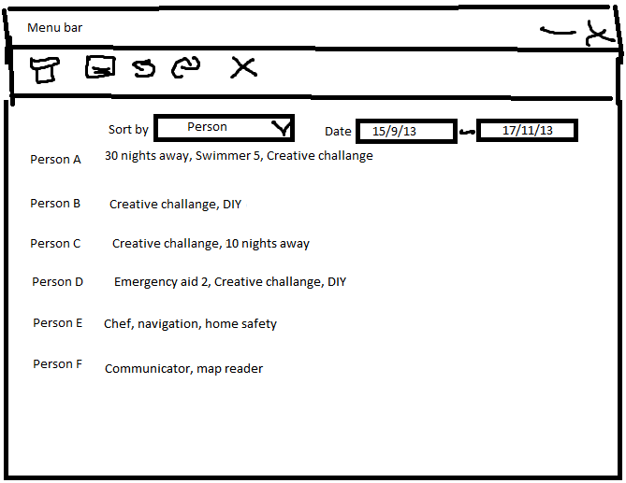Diagram (2) (Badges achieved between date range)

Menu bar with links to rest of program

Drop down list to sort by name / badge

Date entry (click to show calendar view)

Names and badges as text (generated from database)

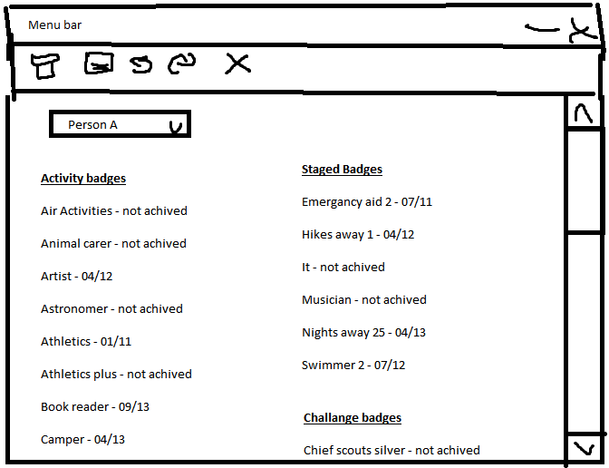Diagram (3) (view / print record)

Menu bar with links to rest of program

Drop down list to sort by person (user can also type name in)

Names of badges and dates as text (generated from database)

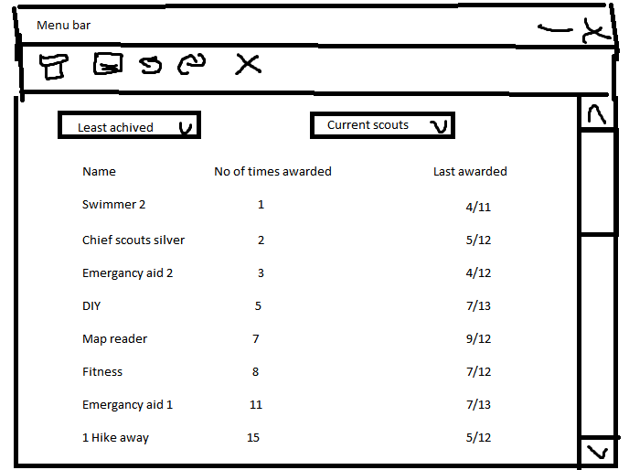Diagram (4) (View least achieved badges)

Menu bar with links to rest of program

Drop down list to sort view (least / most achieved)

Drop down list to show current / all Scouts

Names of badges, no of times awarded and last awarded as text (generated from database)

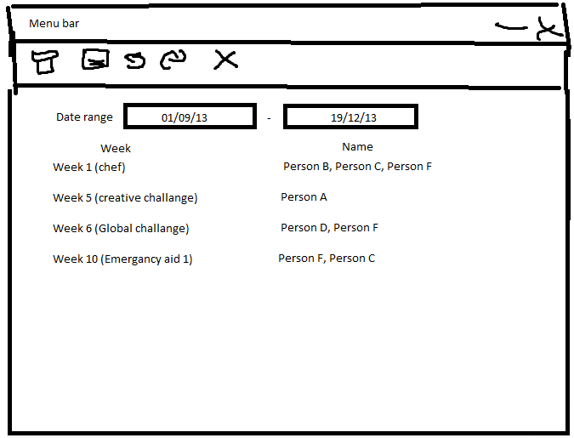Diagram (5) (View missed sessions)

Menu bar with links to rest of program

Date entry (click to show calendar view)

Names of badges, weeks and names as text (generated from database)

# Database normalisation

I have normalised the database to 3rd normal form. This will mean that the data will be easier to work with in the database.

|  |  |  |  |
| --- | --- | --- | --- |
| Un normalised form | 1st normalised form | 2nd normalised form | 3rd Normalised form |
| * ¬ Scout ID * First Name * Last Name * Attendance * Meeting date * Patrol * Join Date * DOB * Meeting title * Badge Name * Parts * Date achived | tblScout   * ¬ Scout ID * First Name * Last Name * Attendance * Meeting date * Patrol * Join date * DOB * Meeting title | tblRegister   * *Scout ID * ¬Meeting date * Attendance * Meeting title * Badge name | tblAttendance   * ¬Meeting Date * *Scout ID * Attendance |
| tblMeeting   * ¬Meeting Date * Meeting title * Badge part ID |
| tblBadges   * ¬Badge name * Date achieved * Parts completed / stage * *Scout ID |
| tblScouts   * ¬Scout ID * Name * DOB * Join Date * Patrol |
| tblBadges   * ¬ Name * Parts achieved * Date achieved * * Scout ID |
| tblPerson   * ¬Scout ID * First Name * Last Name * DOB * Patrol |
| tblBadgePart   * Badge Id * ¬Part ID |
| tblLog   * *Scout ID * Date * Part ID |
| tblBadgeDescribe   * Badge ID * Description |

**Key:**

¬ = key, * = foreign key

# Entity relationship diagrams

These show the relationship between the database tables

Key: One to many relationship

Many to one relationship

One to one relationship

Many to many relationship

tblLog

tblScout

tblBadgeDescribe

tblBadgePart

tblAttendance

tblMeeting

# Storage media

Since I am using a MySQL server, the data will be stored on the server. The user then has the option of creating a duplicate database on the server for backup purposes using a piece of database management software, or can export the data onto their PC for backup purposes.

# Pseudo code

I have created the pseudo code to give me an idea of how each part of the program will function when I come to code it.

**Enter register**

Select Names from Scout database

Input week

Select date from Meeting database

Display names and meetings

Input attendance

If attendance marked then there = true

Else there = false

On save click

Select badge part from database

Store attendance in tblAttendance

If scouts attend then part done = true

If badgepart = true then store date in tblLog

**Enter stage badges**

Input name

Input badge and stage achieved

Store badge details in tblLog

**View individual record**

Input name

Select name, DOB, Join date and six from tblScouts

Select Badges and date from tblLog

Display achieved badges

Display Name, DOB, join date and six

**Edit / Delete / create new record**

Input name / click new

If name input

Select name, DOB, Join date and patrol from tblScouts

Select Badges and date from tblLog

Display achieved badges

Display Name, DOB, join date and six

User presses edit

Replace labels with textboxes containing data for user to enter data

If user presses delete

Delete record

Else

User presses save

Amend tables

Else

Create new record

**View achieved badges between date range**

Input start date

Input end date

Select weeks and badge parts from tblMeeting

Select scouts attendance from tblAttendance

Get badge parts done between dates from tblLog

If all badge parts achieved

Display name next to other names and badge

Print or save output

**Calculate missed sessions over a period of time**

Input start date

Input end date

Select weeks and badge parts from tblMeeting

Select scouts attendance from tblAttendance

Get badge parts done between dates from tblLog

If scout not there for meeting

Display name next to other missing names and badge part

Print or save output

**View least achieved badges**

Input start date

Input end date

For each scout

Get badges done parts done between dates from tblLog and add to badge count

Display badge name and count sorted by date

Print or save output

**Enter new badge**

Select badge parts from tblBadgePart

Display badges and parts

User enters new badge / amends badge / deletes badge and badge parts

Update tblBadgePart

**Enter new programme**

Select weeks and badge parts from tblMeeting

User inputs date of meeting and parts of badges (if applicable) into system

tblMeeting updated

# SQL statements

Below are the SQL statements I will use in my programme in order to create and use the databases.

**Enter Register**

Select First Name, Last Name, ID from tblScouts

Select * from tblMeeting where Date=Date input

Update Attendance Set Attendance = entered attendance Where Date = date entered

Update tbllog Set date and ID where Partid=part id for meeting

**Enter stage badges**

Update tblLog

Set date and partID and badge id where ID = ID

**View individual record**

Select * from tblScouts

Select * from tblLog where ID = ID

**Edit record**

Select * from tblScouts where name = name input

Select * from tblLog where id = id

Update tblScouts Set Name and DOB and join date & patrol

Update tblLog Set Date and partID and badge ID

**Delete record**

Select ID from tblScouts where name = name input

Delete * from tblScouts where ID = ID

Delete * from tblLog where ID = ID

Delete * from tblAttendance where ID = ID

**Create record**

Insert into tblScouts (Name, DOB, Join Date, Patrol) Values (Input values)

Insert into Attendance (ID)

Insert into tblLog (ID)

**View achieved badges**

Select Date and badge part Id from tblMeeting where date > early date and < last date

Select * from tbl attendance where date = > early date and < last date

Select Part ID, Badge ID, ID from tblLog where date = > early date and < last date

**Calculate missed sessions over time**

Select Date and badge part Id from tblMeeting where date > early date and < last date

Select * from tbl attendance where date = > early date and < last date

Select Part ID, Badge ID, ID from tblLog where date = > early date and < last date

**Least achieved badges**

Select Part ID, Badge ID, ID from tblLog where date = > early date and < last date

**Edit badge**

Select * from tblBadgePart

Update tblBadgePart Set badgeID and partID and description with entered data

**New badge**

Select * from tblBadgePart

Insert into tblBadgePart (BadgeID, PartID, Description)

**Delete badge**

Select * from tblBadgePart

Delete * from tblBadgePart where BadgeID = BadgeID

**Update Programme**

Select * from tblMeeting

Update tblMeeting set date and badgepart and title = values input

**Delete programme**

Select * from tblMeeting

Delete * from tblMeeting

**Enter new programme**

Insert into tblMeeting (date, badge part id, meeting title)

**SQL create table statements**

I will use the following SQL commands to create the database:

**Create database**

This statement creates the database

CREATE DATABASE scouts;

**tblAttendance**

This statement creates tblAttendance and adds a MeetingDate, Id and Attendance column

CREATE TABLE tblAttendance

(

MeetingDate Date PRIMARY_KEY NOT NULL,

ID int FOREIGN_KEY,

Attendance Boolean,

);

**tblMeeting**

This statement creates tblMeeting and adds a MeetingDate, Meeting title and BadgePartID column

CREATE TABLE tblMeeting

(

MeetingDate Date PRIMARY_KEY NOT NULL,

Meeting title varchar(255),

BadgePartID integer,

);

**tblScouts**

This statement creates tblScouts and adds a FirstName, LastName, DOB, JoinDate, and patrol column

CREATE TABLE tblScouts

(

ID integer PRIMARY_KEY NOT NULL,

FirstName varchar(255),

LastName varchar(255),

DOB Date,

JoinDate Date,

Patrol varchar(255),

);

**tblBadgePart**

This statement creates tblBadgePart and adds a BadgeID and PartID column

CREATE TABLE tblBadgePart

(

BadgeID integer,

PartID integer PRIMARY_KEY NOT NULL,

);

**tblLog**

This statement creates tblLog and adds a Id, date, partID and badgeID column

CREATE TABLE tblLog

(

Id integer,

Date Date PRIMARY_KEY NOT NULL,

PartID integer,

BadgeID integer,

);

**tblBadgeDescribe**

This statement creates tblBadgeDescribe and adds a BadgeID and Description column

CREATE TABLE IF NOT EXISTS tblBadgeDescribe

(BadgeID integer PRIMARY_KEY NOT NULL,

Description varcar(255),

);

# Validation

In order to ensure that the user enters the correct data, I will need to validate it. This will help with the integrity of the data, since all of the data will need to match the validation rules before being stored, rather than just being stored, which should help to reduce errors. There are a number of ways that I will do this:

**Dates**

In order to ensure that the user enters a correct date, I will validate it using the following Regex notation to ensure that only days between 1 and 31, months between 1 and 12 and years between 00 and 99 and / in the correct places can be input. This will block invalid characters such as F.

^[1-31]|[/]|[1-12]|[/]|[00-99]$

**IDs**

In order to ensure that the correct ID is chosen, the programme will automatically assign an ID

**Text (meeting titles, names etc)**

Due to the fact that these can vary in length and content, I will place a 255 character limit on these fields to ensure that the user does not accidently insert a large number of characters, and a lower limit of 50 characters for patrols. I will also use the following regex notation for names and patrols in order to ensure that a value is entered, and that it only contains A-Z or a – z

^[a-z|A-Z]+$

I will use the following regex notation for meeting titles since they can contain numbers and spaces. This will still block invalid characters such as £ which will not be used in the meeting title. This will also ensure that a value is entered

^[a-z|A-Z|0-9| ]+$

# Security

Since I am not storing highly sensitive data, I feel that I do not need to encrypt the data, however some steps still need to be taken to ensure the data is secure. First, I will recommend that the end user sets a password for the SQL user which data is stored on (and the PC the server is running on if they are running it themselves), and backs up the data in a secure location.

# Classes

Below I have created a diagram which shows all of the classes, their properties and how they relate to each other.



# Alpha testing Plan

The chart below details how the types of data I will use to test the system, as well as the expected outcome. I will input three kinds of data into the system to ensure that it functions correctly – Typical data, which would be expected (e.g. inserting 01/02/13 into a date field), Erroneous data which would not be expected and could cause errors (e.g. typing hello into a date field) and Extreme data which would be at the range of what would be expected (E.g. having a 50 nights away badge), which may be valid depending the value and the validation in use.

**Key:**

Green Data – typical data – this is the type of data which should be accepted by the system, and would be commonly be expected (Such as Bob in the name field).

Red Data – Erroneous data – this is the type of the data which would be invalid and should be rejected by the system without causing any errors (Such as 9543 in the name field).

Blue data – Extreme data – this is the type of the data which would be on the limit of what would be expected (such as Avery-LongNameOrSomethingLikeThisOrSomethingIveRunOutOfWords)

Dataset:

**New record**

TNR1: Fred Bob, 01/08/2002, 08/07/2011, Red

ENR1: 543dff, 31/12/02, 44/52/02, Somesortofthinghere:-)

XNR1: Someonewithaverylongname, Tue, 21st feb 2002, mon 21st march 2011, Maroon

**Stage badges**

TSB1: Fred Bob, Emergency Aid 1

ESB1: wewor9, 864567 w

XSB1: Someonewithaverylongname, emergency aid stage one of five

**Badge**

TBD1: 1, Make a table

EBD1: o, 32po4iref

XSB1: 99, Part 2 of make a table

**Test Number Key:**

ER – Enter register

NR – New records

DT: Dates

SB: Stage badges

IN: Name input

ENB: Enter new badge

BCM: Main menu button clicked

|  |  |  |  |  |  |  |  |
| --- | --- | --- | --- | --- | --- | --- | --- |
| **Test No** | **Test Name** | **Purpose of test** | **Data / action**  **Typical**  **Erroneous** **Extreme**  **(TEX)** | **Expected outcome** | **Actual Outcome** | **Corrective Outcome** | **Comments** |
| ER1 | Enter register | To ensure that the system accepts the register | Ticked / Unticked | Accepted |  |  |  |
| ER2 | Save register | To ensure that the system saves the register when the button is pressed | Left hand click on save tab to save right hand click on save | Saves, highlights save, Does nothing |  |  |  |
| NR1 | New Record | To ensure that New record is accepted | TNR1, ENR1, XNR1 | Saves, Rejected, Rejected |  |  |  |
| NR2 | Edit record | To Ensure that the edited record is saved | TNR1, ENR1, XNR1 | Saves, Rejected, Rejected |  |  |  |
| DT1 | Input dates | To ensure that date ranges apply when input | 01/07/11, 37/2/1, Tuesday 27th march 2011 | Applies, Rejected, Rejected |  |  |  |
| SB1 | Stage Badges | To ensure that the stage badges can only be entered correctly | TSB1, ESB1, XSB1 | Saves, Rejected, Rejected |  |  |  |
| IN1 | Input Name | To ensure that only a correct name is input | Fred Bob, fep5roi324, Someonewithaverylongname | Saves, Rejected, Saves |  |  |  |
| ENB1 | Enter / amend badge | To ensure that only correct badge data is stored | TBD1, EBD1, XBD1 | Saves, Rejected, Saves |  |  |  |
| ENP1 | Enter new programme | To ensure that only correct programme data is stored | 21/2/13, Emergancy aid 1,  2/26/2013, etu934ui  29/2/13, No badge | Saves, Rejected, Saves |  |  |  |
| BCM1 | Register button clicked | To ensure that the register button works | Left hand click on button tab to button right hand click on button | Runs button command, Highlights button, Does nothing |  |  |  |
| BCM2 | View individual record button clicked | To ensure that the view individual record button works | Left hand click on button tab to button right hand click on button | Runs button command, Highlights button, Does nothing |  |  |  |
| BCM3 | View achieved badges button clicked | To ensure that the view achieved badges button works | Left hand click on button tab to button right hand click on button | Runs button command, Highlights button, Does nothing |  |  |  |
| BCM4 | Programme planning button clicked | To ensure that the programme planning button works | Left hand click on button tab to button right hand click on button | Runs button command, Highlights button, Does nothing |  |  |  |
| BCM5 | Enter programme details / change details button clicked | To ensure that the enter programme details / change details button works | Left hand click on button tab to button right hand click on button | Runs button command, Highlights button, Does nothing |  |  |  |
| ER3 | Tick box for register | To ensure that the tick boxes for the register works | Left hand click on box tab to box right hand click on box | Ticks box, Highlights box, Does nothing |  |  |  |
| IN2 | View record button clicked | To ensure that the view record button works | Left hand click on button tab to button right hand click on button | Runs button command, Highlights button, Does nothing |  |  |  |
| DT2 | View date range button | To ensure that the view date range button works | Left hand click on button tab to button right hand click on button | Runs button command, Highlights button, Does nothing |  |  |  |

# Beta testing plan

In order to conduct the beta testing, I will give the following questionnaire to the end user

Did you encounter any issues with the program (circle as appropriate)

Yes No

If yes describe the issues below

___________________________________________________________________________

___________________________________________________________________________

___________________________________________________________________________

___________________________________________________________________________

___________________________________________________________________________

___________________________________________________________________________

Does the program meet your requirements?

Yes No

How would you rate the interface?

1(Awful) 2 3 4 5 6 7 8 9 10(Perfect)

How easy did you find the program to use?

1(Awful) 2 3 4 5 6 7 8 9 10(Perfect)

What did you like about the program?

___________________________________________________________________________

___________________________________________________________________________

___________________________________________________________________________

How could the program be improved?

___________________________________________________________________________

___________________________________________________________________________

___________________________________________________________________________

If you have any other comments, please write them in the space below

___________________________________________________________________________

___________________________________________________________________________

___________________________________________________________________________

___________________________________________________________________________

___________________________________________________________________________

___________________________________________________________________________

___________________________________________________________________________

___________________________________________________________________________

___________________________________________________________________________

___________________________________________________________________________

___________________________________________________________________________

___________________________________________________________________________

Testing

In order to ensure that the new system works, I will use several testing methods including alpha and beta testing, to ensure that the program functions as required and to try to remove as many bugs as possible. In order to do this, I have decided to use black box testing, which involves testing all of the functions of the program to ensure that the program functions correctly. I have also carried out white box testing during development which can be seen in developmental testing (Appendix B)

# Alpha testing

The chart below details how the types of data I will use to test the system, as well as the expected outcome. I will input three kinds of data into the system to ensure that it functions correctly – Typical data, which would be expected (e.g. inserting 01/02/13 into a date field), Erroneous data which would not be expected and could cause errors (e.g. typing hello into a date field) and Extreme data which would be at the range of what would be expected (E.g. having a 50 nights away badge), which may be valid depending the value and the validation in use. This chart is similar to the plan, although I have split it into sections and modified it due to the fact that some of the forms have changed.

**Key:**

Green Data – typical data – this is the type of data which should be accepted by the system, and would be commonly be expected (Such as Bob in the name field).

Red Data – Erroneous data – this is the type of the data which would be invalid and should be rejected by the system without causing any errors (Such as 9543 in the name field).

Blue data – Extreme data – this is the type of the data which would be on the limit of what would be expected (such as Avery-LongNameOrSomethingLikeThisOrSomethingIveRunOutOfWords)

**New record**

NRT: Fred Bob, 01/08/2002, 08/07/2011, Red

NRE: 543 dff, 31/12/02, 44/52/02, Somesortofthinghere:-)

NRX: Someonewith averylongname, Tue, 21st feb 2002, mon 21st march 2011, Maroon

**Achived Badges**

ABT: Fred Bob, Emergency Aid 1

ABE: wewor9, 864567 w

ABX: Someonewithaverylongname, emergency aid stage one of five

**Stage Badges**

SBT: 1, Make a table - Parts – Chop Wood, Assemble, Paint

SBE: o, 32po4iref£ - Parts- ererr9£4 3, EWR324”, reoi4£

SBX: 50, nights away – Parts – 50 nights away from home on camps

**Badges:**

BDT: Chef – Parts – Meal Planning, Cooking, Washing up

BDE: e902!£ - Parts - $££”, WER”£d,

BDX – Acting badge – Parts – Plan performance 1, plan performance 2, perform play

**Meetings:**

MTT: 03 Feb 2014, Chef, Meal Planning

MTE: 01/13/2013, No badge name selected, no badge part selected

MTX: 28 feb 2014, Nights away, 50 nights away from home on camps

**Testing evidence**

The numbers in brackets next to the actual outcome and in the Corrective outcome boxes (such as accepted (1)) relate to the screenshot numbers in Appendix A.

|  |  |  |  |  |  |  |  |  |  |  |  |  |  |
| --- | --- | --- | --- | --- | --- | --- | --- | --- | --- | --- | --- | --- | --- |
| **Test No** | | **Test Name** | **Purpose of test** | | **Data / action**  **Typical**  **Erroneous** **Extreme**  **(TEX)** | | **Expected outcome** | **Actual Outcome** | | | **Corrective Outcome** | | **Comments** |
| **Connection** | | | | | | | | | | | | | |
|  | Connect to SQL server | | | To ensure that the system connects to the SQL server with the correct details | | Localhost, Root, (no password) , Scout, 1 Server lane, Woking, Surrey, user, Who Needs A Password, data, 192.168.0.20, scout, *******, scout | Connects, Error, Connects, | | Connects(1), Error (2), Connects (3) | N/A | | Password for Extreme replaced with * (works with password) | |
| **Register** | | | | | | | | | | | | | |
|  | | View date range | To ensure the system views the register between the input date range | | 01 December 2013 – 01 March 2013, empty values, 18 Feb. 14, 18 Feb. 14 | | Views, Rejected, Views | Views (58) , Impossible to enter due to date boxes (59), Views | | |  | |  |
|  | | Enter / edit register | To ensure that the system accepts the register | | Ticked / Unticked, R Key pressed, | | Ticks / unticks, Does nothing, Highlights box | Ticks / unticks (129), Does nothing (130), Highlights box (131) | | |  | | Ticks for each person |
|  | | Save register | To ensure that the system saves the register when the button is pressed | | Left hand click on save tab to save right hand click on save | | Saves, highlights save, Does nothing | Saves (61), highlights save (62), Does nothing (63) | | |  | | Saves register when button pressed |
|  | | Enter Achived badges | To ensure that only valid achived badges can be entered | | Sam Smith, Make A Table, Chop Wood, nothing selected for any box, Emma Flowers, Acting Badge, Plan perfromence 1 | | Saves, Rejected, Saves | Saves (68), Crashes (69), Saves (70) | | | Added check to ensure that select boxes contain something (71) – seen working in 72 | |  |
| **Records** | | | | | | | | | | | | | |
|  | | New Record | To ensure that New record is accepted | | NRT, NRE, NRX | | Saves, Rejected, Saves | Saves (4), Rejected (5) , Saves (sort of – see comment) (6) | | |  | | Not possible to enter Mon due to date forms |
|  | | Edit record | To Ensure that the edited record is saved | | NRT, NRE, NRX | | Saves, Rejected, Saves | Saves (7), Rejected (8), Saves (9) | | |  | | Not possible to enter Mon due to date forms |
| 1. (applies to other parts as well) | | Input dates | To ensure that date ranges apply when input | | 01/07/11, 37/2/1, Tuesday 22nd march 2011 | | Applies, Rejected, Applies | Applies (10) ,  Rejected (ends up with value in screenshot in box) (11),  Applies (12) | | |  | | Not possible to enter Tuesday due to date forms |
|  | | Delete Record | To ensure that only the selected record is deleted | | Fred Bob, No name selected, SomeoneWith AVeryLongName | | Deletes, Rejected, Deletes | Deletes (53), Rejected (54), Deletes (55) | | | Added if statement to check that selDelete contains something (56) – Seen working in (57) | |  |
|  | | View individual Record | Ensures that the correct record and date range are shown when entered | | Sam Smith, 01/01/14, 01/03/14, No name selected, 18/1/11, 18/1/11  Emma Flowers, 18/2/14, 18/2/14 | | Displays record, Rejected, Displays record | Displays record (63), Crashes (64), Displays record (65) | | | Added a seatement to ensure that the name box contains something (66), seen working in (67) | |  |
| **Badges** | | | | | | | | | | | | | |
|  | | Stage Badges | To ensure that the stage badges can only be entered correctly | | SBT, SBE, SBX | | Saves, Rejected, Saves | Saves (13), Rejected (14), Rejected (15) | | | Changed regex from ^[1-5]+$ to ^[0-9]+$ (16) – seen working in (17) | | Despite some staged badges only going 1-5, nights away and hikes away go up in multiples (up to over 50) |
|  | | Stage badge parts | To ensure that the stage badge parts can only be entered correctly | | SBT (parts), SBE (parts), SBX (parts) | | Saves, Rejected, Saves | Saves (18), Rejected (19), Saves(20) | | |  | | Had to use SBT for Extreme badge since SBE badge wont save |
|  | | Badges (not staged) | To ensure that the badges can only be entered correctly | | BDT, BDE, BDX | | Saves, Rejected, Saves | Saves (21), Rejected (22), Saves (23) | | |  | |  |
|  | | Badge parts (not staged) | To ensure that the badge parts canonly be entered correctly | | BDT (parts), BDE (parts), BDX (parts) | | Saves, Rejected, Saves | Saves (24), Rejected (25), Saves (26), | | |  | | Had to use BDX for Extreme badge since BDE badge wont save |
|  | | Edit badge | To ensure that only correct badge data is stored | | BDT, BDE, BDX | | Saves, Rejected, Saves | Saves (27), Rejected (28), Saves (29) but duplicates itself in list (30) | | | Added LoadBadgeDescribe() to loadlist (31) to reload database – seen working in (32) | |  |
|  | | Edit Stage | To ensure that only correct stage badge data is stored | | SBT, SBE, SBX | | Saves, Rejected, Saves | Saves (33), Rejected (34), Saves (35) | | |  | |  |
|  | | Edit Parts | To ensure that only correct part data is stored | | BDT (parts), BDE (parts), BDX (parts) | | Saves, Rejected, Saves | Saves (36), Rejected (37), Saves (38) | | |  | | Staged badges and badges use same form |
|  | | | | | | | | | | | | | |
| **Test No** | | **Test Name** | **Purpose of test** | | **Data / action**  **Typical**  **Erroneous** **Extreme**  **(TEX)** | | **Expected outcome** | **Actual Outcome** | | | **Corrective Outcome** | | **Comments** |
| **Meetings** | | | | | | | | | | | | | |
|  | | Enter Meeting | To ensure that only correct meeting data is stored | | MTT, MTE, MTX | | Saves , Rejected, Saves | Saves (39), Saves (40), Saves (41) | | | Added if statement to btnSave_click to ensure badge boxes contain something (43) – seen working in (44) | | See date test in record for dates |
|  | | Edit meeting | To ensure that only correct programme data is stored | | MTT, MTE, MTX | | Saves, Rejected, Saves | Saves (45) , Impossible to enter due to lists (46), Saves (47) | | |  | |  |
|  | | Delete Meeting | To ensure that only the correct meeting is deleted | | MTT (date), Nothing selected, MTX (date) | | Deletes, Rejected, Deletes | Deletes (48), Crashes (49), Deletes (50) | | | Added check to ensure that box has value (51) – seen working in (52) | |  |
| **Achievements** | | | | | | | | | | | | | |
|  | | View Achieved Badges between date range | To ensure that only badges between date range are displayed | | 01/01/14 – 01/03/14, 29/2/11 – empty value, 18/2/14 – 18/2/14 | | Displays, Rejected, Displays | Displays (72), Impossible to enter due to date form (73), Displays (74) | | |  | |  |
|  | | View least achieved badges | To ensure that only achievements between date range are displayed | | 01/01/14 – 01/03/14, 29/2/11 – empty value, 18/2/14 – 18/2/14 | | Displays, Rejected, Displays | Displays (75), Impossible to enter due to date form (76), Displays (77) | | |  | |  |
|  | | View missed meetings | To ensure that only missed meetings between date range are displayed | | 01/01/14 – 01/03/14, 29/2/11 – empty value, 18/2/14 – 18/2/14 | | Displays, Rejected, Displays | Displays (78), Impossible to enter due to date form (79), Displays (80) | | |  | |  |
| **Navigation** | | | | | | | | | | | | | |
|  | | Connection -> Connect to SQL Server clicked | To ensures that the connect to SQL server form is displayed when clicked | | Left hand click on button, right hand click on button, tab to button and press enter | | Runs connection sub, Does nothing Runs connection sub | Runs connection sub (81), Does nothing (82) Runs connection sub (83) | | |  | |  |
|  | | Connection -> Disconnect to SQL server clicked | To ensure that the disconnect from SQL server code is run when clicked | | Left hand click on button, right hand click on button, tab to button and press enter | | Runs disconnect sub, Does nothing Runs disconnect sub | Runs disconnect sub (84), Does nothing (85), Runs disconnect sub (86) | | |  | |  |
|  | | Connection -> Exit clicked | To ensure that the program closes when the exist button is pressed | | Left hand click on button, right hand click on button, tab to button and press enter | | Closes program, Does nothing, Closes Program | Closes program (87), Does nothing (88), Closes Program (89) | | |  | |  |
|  | | Register -> Enter Register button clicked | To ensure that the register button works | | Left hand click on button, right hand click on button, tab to button and press enter | | Runs button command, Does nothing Runs button command | Runs button command (90), Does nothing (91) Runs button command (92) | | |  | |  |
|  | | Register -> Enter Achieved badges clicked | To ensure that the enter achieved badges button works | | Left hand click on button, right hand click on button, tab to button and press enter | | Runs button command, Does nothing Runs button command | Runs button command (93), Does nothing (94) Runs button command (95) | | |  | |  |
|  | | Record -> Create new record clicked | To ensure that the create new record button works | | Left hand click on button, right hand click on button, tab to button and press enter | | Runs button command, Does nothing Runs button command | Runs button command (96), Does nothing (97) Runs button command (98) | | |  | |  |
|  | | Record -> View individual record button clicked | To ensure that the view individual record button works | | Left hand click on button, right hand click on button, tab to button and press enter | | Runs button command, Does nothing Runs button command | Runs button command (99), Does nothing (100) Runs button command (101) | | |  | |  |
|  | | Record -> Edit record button clicked | To ensure that the edit record button works | | Left hand click on button, right hand click on button, tab to button and press enter | | Runs button command, Does nothing Runs button command | Runs button command (102) , Does nothing (103) Runs button command (104) | | |  | |  |
| **Test No** | | **Test Name** | **Purpose of test** | | **Data / action**  **Typical**  **Erroneous** **Extreme**  **(TEX)** | | **Expected outcome** | **Actual Outcome** | | | **Corrective Outcome** | | **Comments** |
|  | | Record -> Delete Record button clicked | To ensure that delete record button is pressed | | Left hand click on button, right hand click on button, tab to button and press enter | | Runs button command, Does nothing, Runs button command | Runs button command (105), Does nothing (106), Runs button command (107) | | |  | |  |
|  | | Achievements -> View achieved badges button clicked | To ensure that the view achieved badges button works | | Left hand click on button right hand click on button tab to button and press enter | | Runs button command, Does nothing Runs button command | Runs button command (108), Does nothing (109) Runs button command (110) | | |  | |  |
|  | | Achievements -> view least achieved badges clicked | To ensure that the view least achieved badges button works | | Left hand click on button right hand click on button tab to button and press enter | | Runs button command, Does nothing Runs button command | Runs button command (111), Does nothing (112) Runs button command (113) | | |  | |  |
|  | | Achievements -> view missed sessions | To ensure that the view missed sessions button works | | Left hand click on button right hand click on button tab to button and press enter | | Runs button command, Does nothing Runs button command | Runs button command (114), Does nothing (115) Runs button command (116) | | |  | |  |
|  | | Meetings -> Edit meetings button clicked | To ensure that the Edit Meetings button works | | Left hand click on button right hand click on button tab to button and press enter | | Runs button command, Does nothing Runs button command | Runs button command (117), Does nothing (118) Runs button command (119) | | |  | |  |
|  | | Meetings -> delete meetings button clicked | To ensure that the delete meetings button works | | Left hand click on button right hand click on button tab to button and press enter | | Runs button command, Does nothing Runs button command | Runs button command (120), Does nothing (121) Runs button command (122) | | |  | |  |
|  | | Badges – Edit / Add new staged badge clicked | To ensure the edit / add new staged badge button works | | Left hand click on button right hand click on button tab to button and press enter | | Runs button command, Does nothing Runs button command | Runs button command (123), Does nothing (124) Runs button command (125) | | |  | |  |
|  | | Badges – Edit / add new activity or challenge badge clicked | To ensure that the Edit / Add new activity or challenge badge button works | | Left hand click on button right hand click on button tab to button and press enter | | Runs button command, Does nothing Runs button command | Runs button command (126), Does nothing (127) Runs button command (128) | | |  | |  |

Systems Maintenance

This system allows a scout leader to register and view badges which have been achieved by the Scouts. They can also view which Scouts were away during meetings, and view the badges which have been achieved the least in order to assist with programme planning.

# Summary of packages used

The program is written in VB.NET using Visual Studio Express 2013. The reason for this is because VB.NET is the programming language I have the most experience with, and it supports object oriented programming. The program also uses MySQL for the database, since it is one of the most popular free database servers available. Whilst developing the system I used XAMPP, with phpMyAdmin to troubleshoot the database whilst creating this, although I have tested it with a standalone SQL server as well.

I have also used the MySQL VB.NET connector DLL, which is included in the program in order to allow the program to communicate with the database server. As a result, this program requires .Net framework 4.5 and Visual Studio Express 2013 (at a minimum). I have also used the VB.NET power packs in order to provide printing function, since it is the easiest way to print a form. The documentation and the user guide have been written in Microsoft Word 2010, since it is one of the best word processing packages available for windows, although some of the diagrams are done in Microsoft Visio 2013, since it is one of the easiest ways of creating flowcharts.

# Top down design

The layout of the system from the user’s point of view, can be seen in the diagram over the next three pages







# Classes

These are the various classes which are used throughout the program, which are:

Attendance

BadgeDescribe

BadgeParts

Log

Meeting

Scout

StagedBadge (inherits badgedescribe)

The code for the classes can be seen in appendix C

**A diagram for the classes can be seen below:**

**BadgeParts**

Fields: Methods:

PartID GetPartID

BadgeID SetPartID

PartDescription GetBadgeID

BadgeDescription SetBadgeID

Position GetBadgeDescription

SetBadgeDescription

GetPosition

SetPosition

GetPartDescription

SetPartDescription

**Attendance**

Fields: Methods:

Attendance SetAttendance

MeetingDate GetAttendance

ScoutID SetScoutID

GetScoutID

SetMeetingDate

GetMeetingDate

**Meeting**

Fields: Methods:

BadgeID GetBadgeID

MeetingDate SetBadgeID

PlannedBadgePart GetMeetingDate

Position SetMeetingDate

GetPosition

SetPosition

SetPlannedBadgePart

GetPlannedBadgePart

**Log**

Fields: Methods:

BadgeID GetBadgeID

PartID SetBadgeID

ScoutID GetPartID

DateAchived SetPartID

GetScoutID

SetScoutID

GetDateAchived

SetDateAchived

**Scout**

Fields: Methods:

FirstName GetFirstName

LastName SetFirstName

DOB GetLastName

JoinDate SetLastName

Patrol GetDOB

ScoutID SetDOB

GetJoinDate

SetJoinDate

GetPatrol SetPatrol

GetScoutID

SetScoutID

**StagedBadge**

**Inherits the following fields and methods from BadgeDescribe**

Fields: Methods:

BadgeID GetBadgeID

BadgeDescription SetBadgeID

Position GetBadgeDescription

SetBadgeDescription

GetPosition

SetPosition

**And has the following additional fields and methods**

Fields: Methods:

Stage GetStage SetStage

**BadgeDescribe**

Fields: Methods:

BadgeID GetBadgeID

BadgeDescription SetBadgeID

Position GetBadgeDescription

SetBadgeDescription

GetPosition

SetPosition

## Attendance

This contains Scout’s attendance for the register

Attendance – Boolean – Contains Scout’s attendance

MeetingDate – Date – Contains date of the meeting

ScoutID – Integer – Contains ID for the Scout the attendance relates to

## BadgeDescribe

This class contains the details of the badge

BadgeID – Integer – Contains a unique number assigned to the badge

BadgeDescription – String – Contains the name of the badge

Position – Integer – Contains the position of the data in the list

## BadgeParts

This contains the details of the badge parts which make up a badge

Part ID – Integer – Contains a unique ID for each part

Badge ID – Integer – Contains the badge ID

PartDescription – String – Contains a description of the badge part

Position – Integer – Contains the position of the data in the list

BadgeDescription – contains the description of the badge

## Log

This contains the achieved badge parts

ScoutID – Integer – Contains scout ID

Part ID – Integer – Contains badge part ID

DateAchived – Date – Contains date part achived

BadgeID – Integer – Contains BadgeID

## Meeting

This contains details of meetings

MeetingDate – Date – Contains date of meeting

PlannedBadgePart – Integer – Contains badge part

BadgeID – Integer – Contains Badge ID

Position – Integer – Contains position of data in list

## Scout

This contains details of Scouts

FirstName – String – Contains Scout’s first name

LastName – String – Contains Scout’s last name

DOB – Date – Contains Scout’s date of birth

ScoutID – Integer – Contains a unique id for each scout

JoinDate – Date – Contains Scout’s join date

Patrol – String – Contains Scout’s patrol / six

## StagedBadge

This contains the details of the staged badges

Inherits BadgeDescribe – gives it the properties of BadgeDescribe and also has the following:

Stage – Integer – Contains stage of badge

# Forms

This details the forms in alphabetical order. The code for the forms can be seen in Appendix C

## Delete meeting

This form allows the end user to select a meeting and delete it from the database. The interface can be seen below:

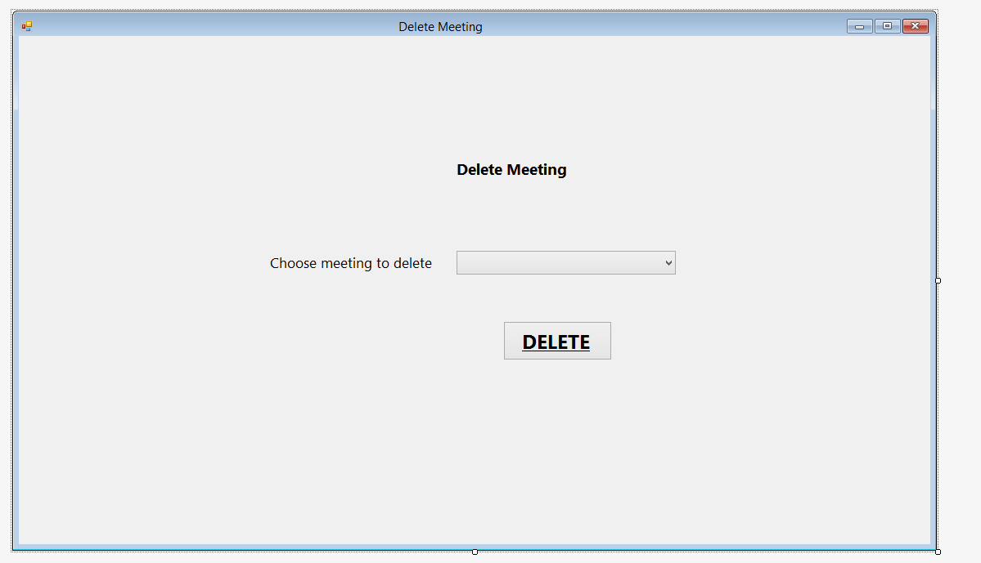

btnDelete

SelDelete

LblChooseMeetingDelete

LblDeleteMeeting

**Buttons for Delete meeting:**

SelDelete – populated from loadlist

btnDelete – runs sub to detete meeting from database

**Subs**

DeleteMeeting_Load – loads the meeting list when the form opens

btnDelete_Click – Asks for confirmation and then deletes meeting

LoadList – Gets the dates from meetings

DeleteValues – Deletes the meeting from the database, reloads lists and reloads the list of meetings

**Variables**

MeetingDate – Date – Local variable within DeleteValues used to hold the meetingdate the user selected

## Delete record

This form allows the user to delete a Scout’s record

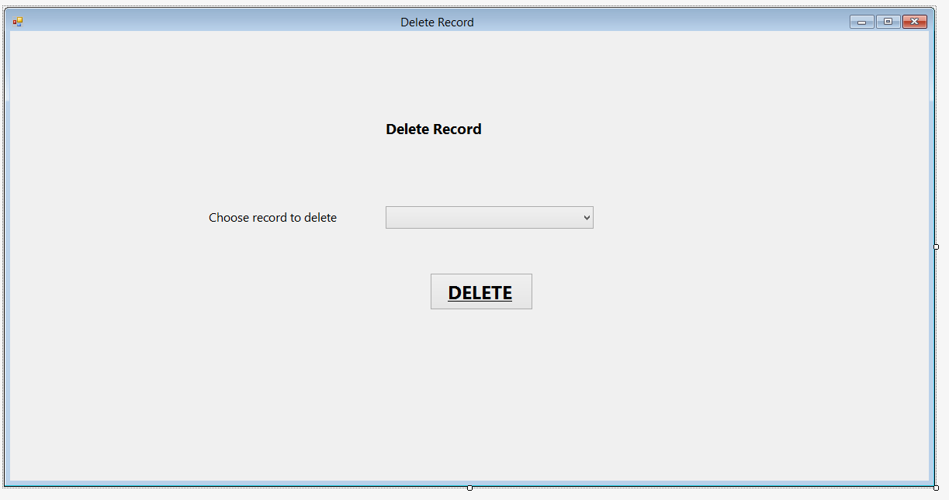

lblChooseRecordDelete

btnDelete

SelDelete

lblDeleteRecord

**Buttons for Delete record:**

SelDelete – populated from loadlist

btnDelete – runs sub to delete record from database

**Subs for Delete record:**

DeleteRecord_Load – populates SelDelete with scout names when form opens

btnDelete_Click – Displays confirmation and deletes record from database

LoadList – adds names to drop down list

DeleteValues – deletes record from database and then reloads databases and list

**Variables used in delete record**

NameInput(2) – 1D string array with 2 elements – Local variable declared within delete values – used to hold split name

FirstName – String - Local variable declared within DeleteValues - used to hold selected Scout’s first name

LastName – String – Local variable declared within DeleteValues – used to hold selected Scout’s last name

ScoutID – integer – local variable declared within DeleteValues – used to hold scoutID for selected Scout

## Edit record

lblSELName

lblDetails

lblJoinDate

SelName

dtJoin

btnChange

txtFirstName

lblDOB

lblLastName

lblValid

lblFirstName

**Buttons / textboxes for edit record:**

lblPatrolValidate

dtDOB

btnSave

lblPatrol

txtPatrol

lblValidateLastName

txtLast

SelName – allows user to select name to edit

btnChange – invokes get values – populates text boxes with scouts details

txtFirstName – Allows user to edit first name – invokes txtFirstName_TextChanged when changed

txtLast – Allows user to edit last name – Invokes txtLast_TextChanged when text changed

dtDob – Allows user to edit DOB

dtJoin – Allows user to edit join date

txtPatrol – Allows user to edit patrol – invokes txtPatrol_TextChanged when text changed

btnSave – Saves changes – invokes btnSave_Click

lblValid – displays whether txtFirstName is valid

lblValidateLastName – displays whether txtLastName is valid

lblPatrolValidate – displays whether PatrolValidate is valid

**Subs for edit record:**

EditRecord_Load – sets date boxes to today’s date and loads list when form loads

LoadList – loads list with scout names

btnChange_Click – Runs GetValues when btnChange clicked

GetValues – Populates textboxes and date boxes with chosen scouts data

btnSave_Click – Updates database if inputs valid

txtFirstName_TextChanged – checks that first name is valid when changed (invokes FirstValidate)

FirstValidate – checks that firstname is valid

txtLast_TextChanged – Checks that lastname is valid when changed (invokes LastValidate)

LastValidate – checks that lastname is valid

txtPatrol_TextChanged – checks that patrol is valid (invokes PatrolValidate)

PatrolValidate – checks that patrol is valid

**Variables for edit record**

ScoutID – Private integer – Used throughout the form to hold the Scout ID

Validate – Private Regex – used to validate text boxes using regex

## Enter Attendance

btnView

lblEndDate

btnPrint

dtEnd

dtStart

lblStartDate

btnSave

grdAttendance

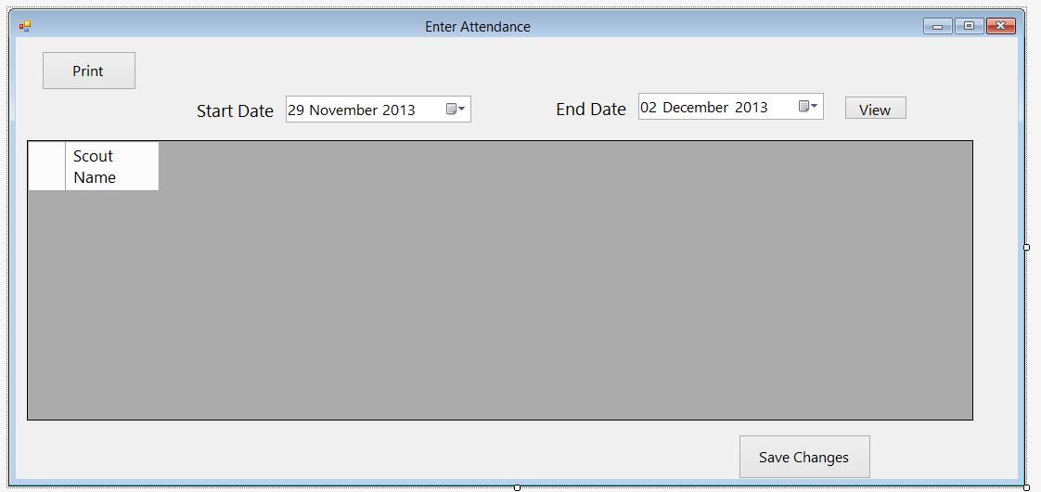This form allows the user to entrer the register. Overall, this form functions the same as it was in the design stage, although the print and view range buttons have been added so the user is not presented with all of the attendance in the database, and the sort by dropdown has been removed

**Buttons / textboxes used for enter attendance**

btnPrint – calls btnPrint_Click – Prints form

dtStart – Allows user to enter start date

dtEnd – allows user to enter end date

btnView – allows user to view attendance – calls LoadAttendance, LoadViewMeeting and DisplayAttend

grdAttendance –displays and allows user to enter attendance

btnSave – runs btnSave_Click – Saves the grid to the database

**Subs used for enter attendance**

EnterAttendance_Load – sets date boxes to todays date and loads databases

DisplayAttend – Displays attendance in grdAttendance

GetName – Returns name from scout ID

GetID – returns scout ID from name

btnView_Click – loads database and calls display attend when clicked

btnSave_Click – saves changes to attendance grid to database

GetMeetingDetails – gets badgeID and part from meeting date

SaveBadge – saves badge details in log

btnPrint_Click – prints view when btnPrint clicked

**Variables for enter attendance**

BadgeID – Private integer – contains badge id

PartID – Private integer – con tains badge part ID

Name – Local string within displayattend – contains scout name

Position – Local integer within DisplayAttend – contains position of column

ObjDate – Local Date within DisplayAttend – contains date from list

ClmDate – Local Date within DisplayAttend – contains date from column

Splitname – Local string array (2 elements) within getID – contains name when split into first and last

ExistingAttend – local Boolean within btnSave_click – contains weather entered attendance was modified or newly entered

AttendCount – local integer within btnSave_click – contains number of values in attend

Position – local integer within SaveBadge – contains number of values in logs

Print – local printdialogue in btnPrint_Click – used to print view

## Enter Badge Parts

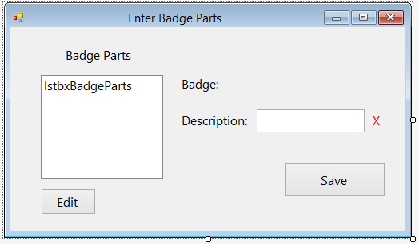

lblBadge

lblBadgeParts

btnSave

lblPartValidate

lblBadgeName (assigned text in code)

txtDescription

lblDescription

btnEdit

lstbxBadgeParts

This form allows the user to enter the parts of the badge. Originally, this was intended to just be a “number of parts” box on the enter parts form, however it was not practical to do that due to the need to assign parts to meetings. As a result this form was created, which is given the name of the badge and displays the existing parts, allowing the user to enter new or edit existing parts. It is called from the enter badge screen, and appears as a pop up window.

**Buttons / textboxes used for enter badge parts**

lstbxBadgeParts – allows user to select existing badge parts – populated by loadlist

lblBadgeName – contains the name of the badge and the stage – populated by lblBadge_load when form loads

txtDescription – allows user to enter part description – runs txtDescription_TextChanged when changed

lblPartValidate – displays whether description is valid or not

btnEdit - runs btnEdit_Click when clicked – allows user to edit selected part

btnSave – runs btnSave_Click when clicked – saves badge part to database

**Subs used for enter badge parts**

lblBadge_Load – Sets lblBadge to badge name (and stage if applicable) when form opens

SetValues – Sets local variables before form opens

LoadList – Adds badgeparts to list

btnEdit_Click – sets txtDescription to selected part description so user can edit it

btnSave_Click – saves badge part to database and reloads list

txtDescription_TextChanged – Validates txtDescription when changed, calls part validate – changes lblPartValidate

PartValidate – Validates txtDescription – changes lblPartValidate

**Variables used for EnterBadgeParts**

BadgeID – private integer – contains ID for badge

BadgeName – private string – contains name of badge

PartID – private integer – contains ID for part

ExistingPart – Private Boolean – set to true if user presses edit for existing part

Position – private integer – contains position of item in list

Stage – private integer - contains stage if staged badge

Validate – Private Regex – contains regex for validation

PartDescribe – local string within btnEdit_Click – contains entered part description

BadgePostion – local integer within btnSave_Click – contains position to put part in badgelist

Valid – local Boolean in partvalidate – contains whether text is valid

## Enter Badges

lblChangeBadgeDetails

Button1

selBadge

lblChooseBadge

txtBadgeName

lblBadgeNameValidate

btnParts

lblBadgeName

btnSave

This form allows the user to enter or edit a badge. It is similar to the design, however the parts section has been moved to a different form (see above).

**Buttons used for enter badges**

selBadge – allows user to select badge

Button 1 – runs Button1_Click – allows user to edit name and parts for selected badge

txtBadgeName – allow user to enter badge name

lblBadgeNameValidate – displays whether badgename is valid

btnSave – runs btnSave_Click

btnParts – runs btnParts_Click

**Subs used for enter badges**

Button1_Click - allows user to edit selected badge

btnChange_Load – runs loadlist when form opens

SaveChanges – saves changes to badge

SaveNew – saves new badge if no badge edited

btnSave_Click – saves new / existing badge when btnSave clicked

LoadList – puts names of badges into list

btnParts_Click – Shows enter badge parts form

txtBadgeName_TextChanged – validates txtBadgeName when changed – calls BadgeValidate

BadgeValidate – validates badgename – changes lblBadgeNameValidate

**Variables used for enter badges**

ID – private integer – contains badgeID

ExistingBadge – private Boolean – contains weather edit badge has been pressed

Position – private integer – contains position in list

Validate – private regex – validates inputs

Saved – private Boolean – contains weather changes have been saved

ChosenBadge – local string in Button1_Click – contains badge chosen from list

Match – local Boolean in Button1_Click – contains if found

ExistingDescribe – local integer in SaveNew – contains id to assign to badge

PositionInList – local integer in SaveNew – contains position of value in list

Valid – local Boolean in badgevalidate – contains whether badge name is valid

## Enter Details

This form allows the user to enter details for a new Scout. Overall it is similar to the design, however the edit and delete Scout sections have been moved to different forms to make it easier to use.

dtJoin

lblDetails

lblLastName

txtPatrol

lblJoinDate

txtFirstName

lblValidateLastName

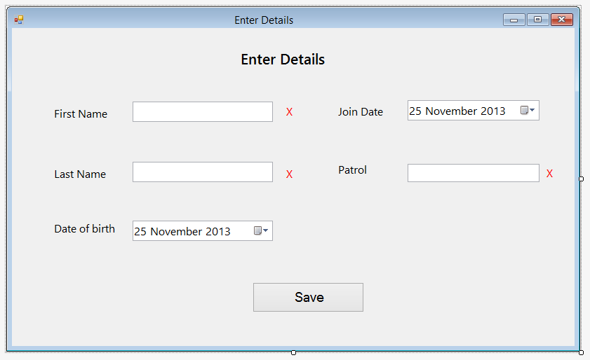

lblPatrol

lblPatrolValidate

dtDOB

btnSave

txtLast

lblDOB

lblValid

lblFirstName

**Enter details textboxes / buttons**

txtFirstName – allows user to enter Scout’s first name – runs txtFirstName_TextChanged when changed

lblValid – displays whether txtFirstName is valid

dtJoin – Allows user to enter join date

txtLast – Allows user to enter Scout’s last name – runs txtLast_TextChanged when changed

lblValidateLastName – displays whether txtLast is valid

txtPatrol – allows user to enter patrol – runs txtPatrol_TextChanged when changed

lblPatrolValidate – displays whether patrol is valid

dtDOB – allows user to enter Scout’s DOB

btnSave – Allows user to save details in database – runs btnSave_Click_1 when clicked

**Subs used for enter details**

EnterDetails_Load – sets date to todays dates when form loads

btnSave_Click_1 – saves details in database when btnSave clicked

txtFirstName_TextChanged – Validates txtFirstname when changed – runs FirstValidate

FirstValidate – Validates txtFirstname

txtLast_TextChanged – validates txtLast when changed – runs lastValidate

LastValidate – validates txtlast

txtPatrol_TextChanged – validates txtpatrol when changed – runs patrolValidate

PatrolValidate – validates patrol

**Variables used for enter details**

Validate – private regex – used to validate inputs

Valid – local variable in FirstValidate, LastValidate and PatrolValidate (they use the same regex method) – used to validate inputs

## Enter Log

SelName

lblName

lblBadgeName

SelBadgeName

lblEnterLog

lblPartName

selBadgePart

btnSave

This form allows the user to enter other badges, such as if a Scout chooses to do a part of a badge at home. Overall it is the same as the design, however it now works with all types of badges, instead of just stage badges.

**Buttons used in Enter log**

SelName – Allows user to select Scout name

SelBadgeName – allows user to select badge name – runs selBadgeName_SelectedIndexChanged

SelBadgePart – allows user to select badge part

btnSave – saves input to database – runs btnSave_Click when clicked

**Subs used in enter log**

Enter_Log_Load – runs listload when form opens

ListLoad – puts badges and names in lists

btnSave_Click - saves log when button pressed - runs Savebadge

GetID – gets Scout ID from Scout name

SaveBadge – Saves entry to database

selBadgeName_SelectedIndexChanged – reloads partlist when badge selected badge changed

GetPartNo – gets part ID

GetPartName – gets part name from part id

FindBadgeID – gets badgeid from badgedescription

**Variables used for enter log**

ID – private integer – contains scout ID

Badge ID – private integer – contains badge id

partID – private integer – contains part id

SelectedName – local variable in GetID – contains selectedName

SplitName – 1D local integer array in getID – contains name split into first and last name

Position – local integer in savebadge – contains number of items in logs

Name – local string in FindBadgeID – contains badge name

Found – local boolean in FindBadgeID – contains whether found in lstbadges

## Enter Programme

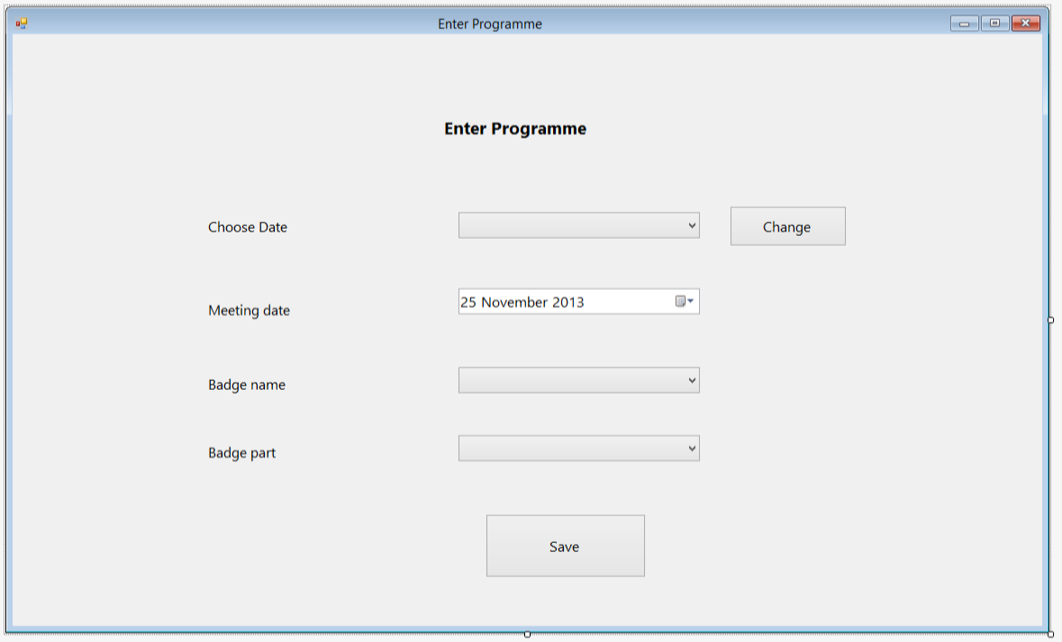

dtMeeting

lblMeetingDate

chgDate

lblEnterProgramme

lblDateChoose

selDate

This form allows the user to enter a new meeting date and badge, or edit an existing one. It also allows the user to edit an existing meeting date. Overall this is the same as the design, although the user can edit meetings as well as add new ones

lblBadgePart

btnSave

selBadgePart

selBadgeDescribe

lblBadgeName

**Buttons / textboxes used for enter programme**

selDate – allows user to select existing meeting date

chgDate – allows user to change details of existing meeting date – runs chgDate_Click

dtMeeting – allows user to enter / edit the date of the meeting

selBadgeDescribe – allows user to enter / edit the badge – runs selBadgeDescribe_SelectedIndexChanged

selBadgePart – allows user to enter / edit the padge part

btnSave – allows the user to save new meeting / changes

**Subs used for enter programme**

chgDate_Click – populates boxes with selected meeting details when pressed

GetBadgeName – gets badge name from badge id

GetPartNo – gets part id from part description

LoadList – loads badges and meeting dates into lists

Enter_Programme_Load – sets meeting date to today and runs loadlist when form loads

btnSave_Click – saves changes / new badge when btnSave clicked

SaveChanges – updates database with changes to meeting

SaveNew – saved new meeting to database

FindBadgeID – finds badgeID from badge description

selBadgeDescribe_SelectedIndexChanged – loads parts for badge when selected badge changed

**Variables used for enter programme**

ChosenDate – private date – contains chosen meeting date to edit

badgeID – private integer – contains ID for chosen badge

StagedBadge – private boolean – contains whether chosen badge is staged or not

Part id – private integer – contains ID for chosen part

Position – private integer - contains position of meeting in list

Match – private boolean – contains whether meeting is new or existing

GotName – local boolean for GetBadgeName – contains wheteher name was in badgelist so stagedbadgelist doenst need to be searched

ExistingMeetingNo – local integer for SaveNew – contains number of meetings in list

Name – local string for findbadgeID – contains name of selected badge

Found - local boolean for findbadgeID – contains whether ID was found in lstbadges

**Enter programme code:**

## Change staged badges

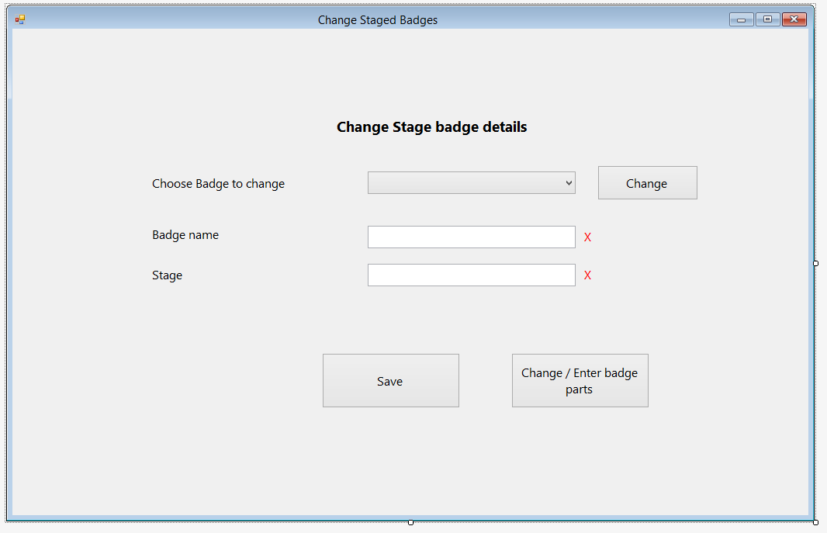

lblChangeBadgeDetails

lblChooseBadge

txtBadgeName

lblBadgeName

btnSave

btnEnterParts

lblStageValidate

lblBadgeNameValidate

Button1

selBadge

txtChangeStageBadge

This form allows the user to enter badges which are staged. Originally, this was designed to be part of the a simple textbox form for the user to enter a badge name and stage each time a staged badge was achieved, however I decided to implement stage badges in a similar way to badges in order to make the programme more functional, however a manual “enter badges” screen still exists.

**Buttons / textboxes used for change staged badges:**

selBadge – contains existing badges – allows user to select one to edit

Button1 – allows user to edit selected badge – runs Button1_Click

txtBadgeName – allows user to enter badge name – runs txtBadgeName_TextChanged when changed

lblBadgeNameValidate – displays if badgename is valid

txtChangeStageBadge – allows user to enter stage – runs txtChangeStageBadge_TextChanged when changes

lblStageValidate – displays if stage is valid

btnSave – allows user to save badge / changes to database – runs btnSave_Click when clicked

btnEnterParts – shows enter parts form – runs btnEnterParts_Click when clicked

**Subs used for change staged badges:**

Button1_Click – populates boxes with selected badges data

btnChange_Load – Runs loadlist when form opens

SaveChanges – saves changes to database

SaveNew – saves new badge to database

btnSave_Click – saves badge when save button pressed

LoadList – adds staged badges to list

btnEnterParts_Click – shows enterbadgeparts form

txtBadgeName_TextChanged – validates badge name when changed – runs BadgeValidate

BadgeValidate – validates badge name

txtChangeStageBadge_TextChanged – validates stagebadge when changed – runs StageValidate

StageValidate – validates stagebadge

**Variables used for change stage badges**

ID – Private Integer – contains badge ID

ExistingBadge – private Boolean – contains whether badges is a new or edited one

NoParts – Private Integer – contains number of parts

Stage ID – Private Integer – contains stage of badge

Position ID – Private Integer – contains position of stgbadge in list

Validate – private regex – used to validate inputs

Saved – private Boolean – contains whether changes have been saved

ChosenBadge – Local string in Button1_Click – contains chosen badge name

Match – local Boolean in Button1_Click – contains whether chosen badge is found

ExistingDescribe – local integer in SaveNew – contains BadgeID

NostageBagde – contains number of items in stgbadge

Valid – local Boolean for BadgeValidate and StageValidate – contains whether input is valid

## Get SQL

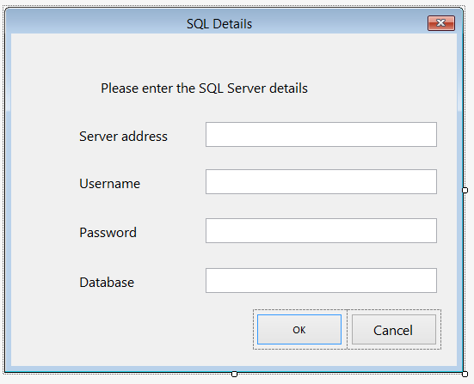

OK_Button

lblInfo

lblServerAddress

txtAddress

txtUsername

lblUserName

txtPassword

lblPassword

txtDatabase

lblDatabase

Cancel_Button

This form allows the user to enter the details of the SQL server they wish to connect to. Originally, this was not included in the design, however I have decided to create this in order to make the program more flexible, since it will now work with any MySQL server. This form is called when the user presses connect to SQL server in the menu bar, and if the OK button is pressed the program will connect to the server with the details given.

**SQL Details buttons / textboxes**

txtAddress – Allows user to enter server address

txtUserName – allows user to enter SQL username

txtPassword – allow user to enter password

txtDatabase – allows user to enter database name

OK_Button – connects to SQL server with those details

Cancel_Button – cancels connection

**SQL details subs:**

OK_button_click – returns ok result

Cancel_button_click – returns cancel result

## Loading SQL

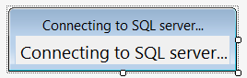

lblConnect

**Code for Loading SQL**

This form is shown by the main form whilst connecting to the SQL server, and is hidden once the connection is complete

## Main form

BadgesToolStripMenuItem

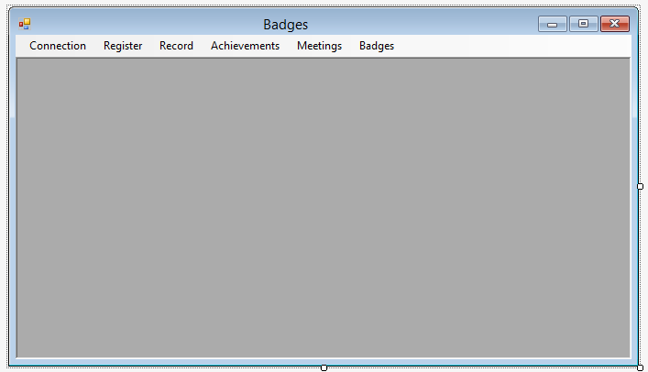

RecordToolStripMenuItem

ConnectionToolStripMenuItem

RegisterToolStripMenuItem

AchivementsToolStripMenuItem

MeetingsToolStripMenuItem

MenuStrip1

Connection menu item

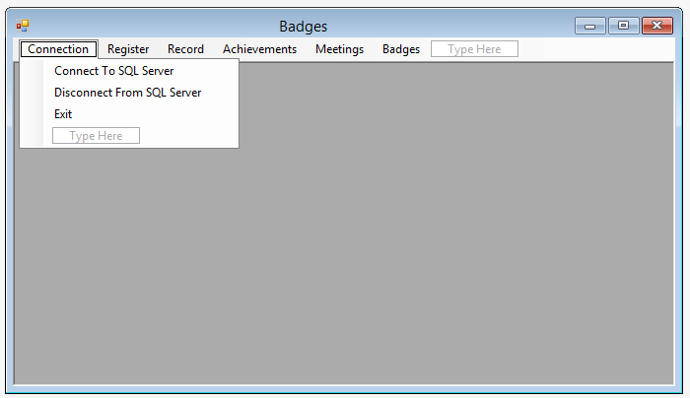

ConnectToSQLServerToolStripMenuItem

ExitToolStripMenuItem

DisconnectFromSQLServerToolStripMenuItem

Register menu item

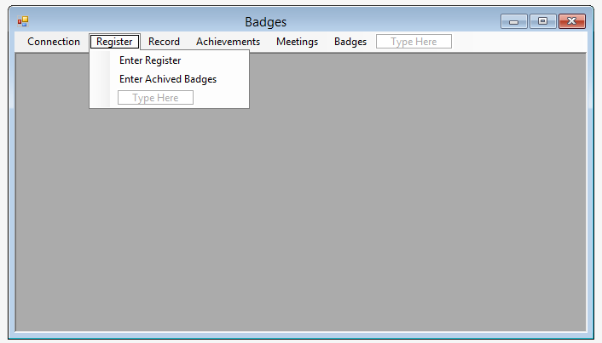

EnterRegisterToolStripMenuItem

EnterLogToolStripMenuItem

Record menu item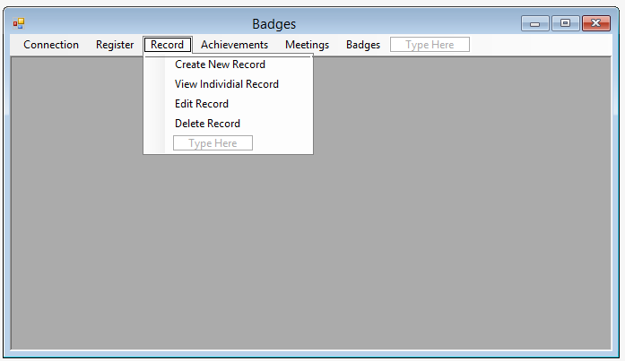

ViewIndividialRecordToolStripMenuItem

EditRecordToolStripMenuItem

DeleteRecordToolStripMenuItem

CreateNewRecordToolStripMenuItem

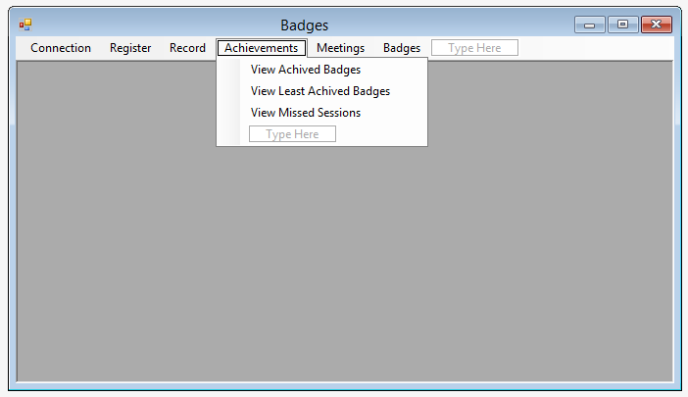Achievements menu item

BetweenDateRangeToolStripMenuItem

ViewLeastAchivedBadgesToolStripMenuItem

ViewMissedSessionsToolStripMenuItem

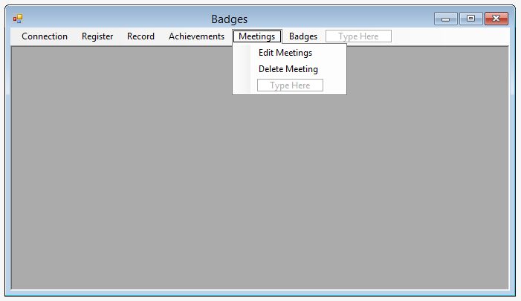Meetings menu item

EnterNewProgrammeToolStripMenuItem

DeleteMeetingToolStripMenuItem

Badges menu item

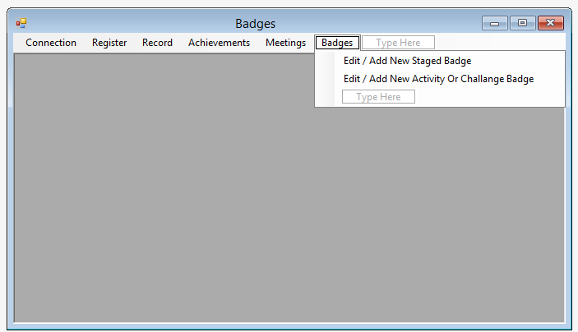

ChangeActivityChallengeBadgesToolStripMenuItem

ChangeSagedBadgesToolStripMenuItem

This form is the main form in which other forms are shown. Originally, this was designed to have buttons to control the individual forms, such as undo and print, however I found that this was impractical. The layout of this form can be seen in the flowchart at the start of systems maintenance.

**Subs / Buttons for main form (buttons show first)**

ConnectToSQLServerToolStripMenuItem – runs ConnectToSQLServerToolStripMenuItem_Click – connects to SQL server

DisconnectFromSQLServerToolStripMenuItem – runs DisconnectFromSQLServerToolStripMenuItem_Click – disconnects from SQL server

ExitToolStripMenuItem– runs ExitToolStripMenuItem_Click – closes program

EnterRegisterToolStripMenuItem – runs EnterRegisterToolStripMenuItem_Click – shows enter register form

EnterLogToolStripMenuItem – runs EnterLogToolStripMenuItem_Click – shows enter log form

CreateNewRecordToolStripMenuItem – runs CreateNewRecordToolStripMenuItem_Click – shows create new record

ViewIndividialRecordToolStripMenuItem – runs ViewIndividialRecordToolStripMenuItem_Click – shows view individual record

EditRecordToolStripMenuItem – runs EditRecordToolStripMenuItem_Click – shows editrecord

DeleteRecordToolStripMenuItem – runs DeleteRecordToolStripMenuItem_Click – shows delete record

BetweenDateRangeToolStripMenuItem – runs BetweenDateRangeToolStripMenuItem_Click – shows ViewBadgesBetweenDateRange

EnterNewProgrammeToolStripMenuItem – runs EnterNewProgrammeToolStripMenuItem_Click – shows enternewprogramme

ViewLeastAchivedBadgesToolStripMenuItem – runs ViewLeastAchivedBadgesToolStripMenuItem_Click – shows viewleastachivedbadges

ViewMissedSessionsToolStripMenuItem – runs ViewMissedSessionsToolStripMenuItem_Click – shows viewmissedsessions

DeleteMeetingToolStripMenuItem – runs DeleteMeetingToolStripMenuItem_Click – shows delete meeting

ChangeSagedBadgesToolStripMenuItem – runs ChangeSagedBadgesToolStripMenuItem_Click – shows enterstagedbadges

ChangeActivityChallengeBadgesToolStripMenuItem – runs ChangeActivityChallengeBadgesToolStripMenuItem_Click – shows enterbadges

**SQL commands**

The main form also contains the SQL commands (see SQL commands section for more on this). Overall the DDL is similar to the design, however the individual SQL commands have changed significantly.

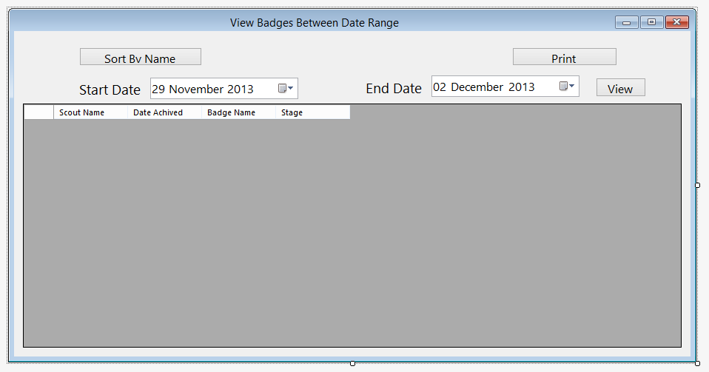

btnQuickSort

## View badges between date range

btnView

btnPrint

dtEnd

lblEndDate

dtStart

lblStartDate

ViewGrid

This form allows the user to view achived badges between date range. It is similar to the design, however the sort by dropdown has been replaced by a button, and it shows a line for each achived badge, and not for each person. The print button has also been moved to the form from the toolbar

**Buttons used for view achived badges**

btnPrint – runs btnPrint_Click – prints form

dtStart – allows user to enter start date to view

dtEnd – allows user to enter last date to view

btnView – runs btnView_Click – views record

btnQuickSort – runs btnQuickSort_Click – sorts by name

**Subs used for view achieved badges**

btnView_Click – views achived badges when btnView pressed

LoadStagedBadges – Gets achived staged badges between date range

ViewBadgesBetweenDateRange_Load – sets date to today and loads view on form load

LoadBadges – Gets achived badges between date range

QuickSortNumbers – Quicksort for numbers (used for sorting parts)

Quicksort – Quicksort for string – used for sorting names

btnPrint_Click – prints form when btnPrint pressed

btnQuickSort_Click – sorts viewgrid by scout name

**Variables used for view achived badges**

Position – local integer in LoadStagedBadges and LoadBadges – contains position of badge id in list

Firstname - local string in LoadStagedBadges and LoadBadges – contains scouts first name

Lastname - local string in LoadStagedBadges and LoadBadges – contains scouts last name

BadgeName - local string in LoadStagedBadges and LoadBadges – contains name of badge

HighDate – local date in LoadStagedBadges and LoadBadges – contains highest date achived

Valid - local Boolean in LoadStagedBadges and LoadBadges – contains whether parts are valid

Stg – local boolean in LoadStagedBadges – contains stage

Parts – local list of integer in LoadStagedBadges and LoadBadges – contains parts for sorting

Achived Parts – local list of integer in LoadStagedBadges and LoadBadges – contains parts for sorting

A – local integer in quicksorts – value for quicksort

B – local integer in quicksorts – value for quicksort

Mid – local integer in quicksortnumbers, string in quicksort – midpoint for quicksort

Tempvalue – local integer in quicksortnumbers, string in quicksort – value for quicksort

Tempgroup – local list of scout in btnQuickSort_click – temp group for name quicksort

GotValue – local Boolean in btnQuickSort_click – contains whether value found

Currentposition – local integer in btnQuickSort_click – contains position in list

## View individual record

lblEndDate

btnView

btnPrint

SelName

dtEnd

dtStart

lblName

This form allows the user to view an indivudual record. It has changed from the desugn tue to the fact that it is in a gridview instead of textboxes, and it is not possible to edit the view in this mode, however it still performs the same function as intended.

lblStartDate

ViewGrid

**Buttons used in view individual record**

SelName – allows user to select scout name

btnPrint – runs btnPrint_Click – prints form

dtStart – allows user to enter start date to view

dtEnd – allows user to enter last date to view

btnView – runs btnView_Click – views record

**Subs used for view individual record**

btnView_Click – views recors when btnView pressed

LoadStagedBadges – Gets achived staged badges between date range

ViewIndividualRecord_Load – sets date to today and loads view on fomr load

LoadBadges – Gets achived badges between date range

QuickSortNumbers – Quicksort for numbers (used for sorting parts)

GetID – returns scout ID

btnPrint_Click – prints form when btnPrint pressed

**Variables used for view individual record**

ScoutID – Private integer – contains scout Id

Position – local integer in LoadStagedBadges and LoadBadges – contains position of badge id in list

Firstname - local string in LoadStagedBadges and LoadBadges – contains scouts first name

Lastname - local string in LoadStagedBadges and LoadBadges – contains scouts last name

BadgeName - local string in LoadStagedBadges and LoadBadges – contains name of badge

HighDate – local date in LoadStagedBadges and LoadBadges – contains highest date achived

Valid - local Boolean in LoadStagedBadges and LoadBadges – contains whether parts are valid

Stg – local boolean in LoadStagedBadges – contains stage

Pos – Local integer in loadStagedBadges and LoadBadges – contains position of scout

Parts – local list of integer in LoadStagedBadges and LoadBadges – contains parts for sorting

Achived Parts – local list of integer in LoadStagedBadges and LoadBadges – contains parts for sorting

SelectedName – local string in get id – contains selected name

Splitname – 1D array – contains name split into first and last name

A – local integer in quicksort – value for quicksort

B – local integer in quicksort – value for quicksrt

Mid – local integer in quicksort – midpoint for quicksort

Tempvalue – local integer in quicksort – value for quicksort

**View individual record code:**

## View least achived badges

btnView

dtEnd

lblEndDate

dtStart

lblStartDate

btnPrint

ViewGrid

This form allows the user to see which badges have been achived the least in order to assist with programme planning. It is very similar to the design, however the current Scout’s dropdown has been replaced with a date range to filter out old results if needed, and the sort view drop down has been removed. A column for the stage of the badge has also been added

**Buttons used for view least achived badges**

btnPrint – runs btnPrint_Click – prints form

dtStart – allows user to enter start date to view

dtEnd – allows user to enter last date to view

btnView – runs btnView_Click – views badges

**Subs for view least achived badges**

ViewBadgesBetweenDateRange_Load -– sets date to today and loads view on form load

LoadBadges – Gets least achived badges between date range

LoadStagedBadges – Gets least achived staged badges between date range

btnView_Click – views least achived badges when btnView pressed

QuickSortNumbers – Quicksort for numbers (used for sorting parts)

Quicksort – Quicksort for string – used for sorting names

btnPrint_Click – prints form when btnPrint pressed

**Variables for view least achived badges**

HighDate – local date in LoadStagedBadges and LoadBadges – contains highest date achived

Valid - local Boolean in LoadStagedBadges and LoadBadges – contains whether parts are valid

Position – local integer in LoadStagedBadges and LoadBadges – contains position of badge id in list

Parts – local list of integer in LoadStagedBadges and LoadBadges – contains parts for sorting

Achived Parts – local list of integer in LoadStagedBadges and LoadBadges – contains parts for sorting

A – local integer in quicksorts – value for quicksort

B – local integer in quicksorts – value for quicksort

Mid – local integer in quicksortnumbers, string in quicksort – midpoint for quicksort

Tempvalue – local integer in quicksortnumbers, string in quicksort – value for quicksort

Tempgroup – local list of scout in btnQuickSort_click – temp group for name quicksort

HighDate – Local date in loadbadges and loadstgbadges– contains highest achived date

Noachived – Local integer in loadbadges and loadstgbadges – contains number of times achived

## View Missed Meetings

lblEndDate

dtStart

lblStartDate

btnPrint

btnView

dtEnd

ViewGrid

This form allows the user to see which meetings have been missed and by which Scouts. It is the same as the design, although a stage and part column have been added, along with a view and print button.

**Buttons used for view missed meetings**

btnPrint – runs btnPrint_Click – prints form

dtStart – allows user to enter start date to view

dtEnd – allows user to enter last date to view

btnView – runs btnView_Click – views missed meetings

**Subs used for view missed meetings**

ViewMissedMeetings_Load - sets date to today and loads view on form load

CalculateMissedSessions – calculates missed sessions between date range

GetBadgeName – gets badgename from badge id

GetStage – Gets stage from badgeID

GetPart – Gets part description from partID

btnView_Click – shows missed meeting when btn_View clicked

btnPrint_Click – prints form when btnPrint pressed

**Variables used for view missed meetings**

MissedNames – local string in calculate missed sessions – contains names that have missed meeting

MeetAttend – local Boolean in CalculateMisssedSessions – contains attencance for a meeting

# Database

The program uses a MySQL database to store the data. This is made up of the following tables:

tblAttendance

tblBadgeDescribe

tblBadgePart

tblLog

tblMeeting

tblScout

## tblAttendance

This table contains details of which Scouts have attended which meetings

MeetingDate – Date

ScoutID – int(11)

Attendance – tinyint(1)

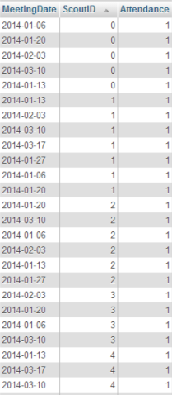A screenshot of some data in this table in phpMyAdmin can be seen below

## tblBadgeDescribe

This table contains the badgeID, along with the description and stage if applicable

BadgeID – int(11)

BadgeDescription – varchar (100)

Stage – int(11)

A screenshot of some data in this table in phpMyAdmin can be seen below

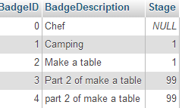

## tblBadgePart

This table contains details of the badgeparts

PartID – int(11)

BadgeID – int(11)

PartDescription – varchar(11)

A screenshot of some data in this table in phpMyAdmin can be seen below

## tblLog

This table contains details of achived badge parts

ScoutID – int(11)

Date – date

PartID – int(11)

BadgeID – int(11)

A screenshot of some data in this table in phpMyAdmin can be seen below

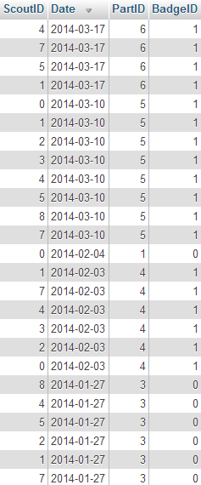

## tblMeeting

This table contains details of the meeting and badges for meeting

MeetingDate – date

BadgePartID – int(11)

BadgeID – int(11)

A screenshot of some data in this table in phpMyAdmin can be seen below

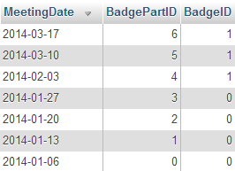

## tblScout

This contains details of each Scout

ScoutID – int(11)

Firstname – varchar(255)

LastName – varchar(255)

DOB – Date

JoinDate – date

Patrol – varchar(255)

A screenshot of some data in this table in phpMyAdmin can be seen below

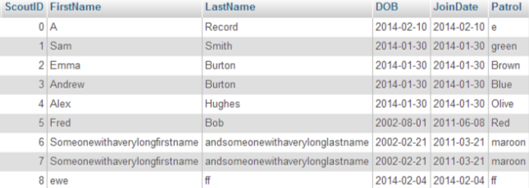

# SQL commands

The following SQL commands (in MainForm) can be seen below along with the corresponding sub

Table creation:

These commands in SQLConnect create the tables and assign the coloums if they don’t exist.

Create Table If Not Exists tblAttendance(MeetingDate Date , ScoutID int, Attendance Boolean); - Creates tblAttendance if it doesn’t exist with a meetingdate, scoutID and attendance coloum

Create Table If Not Exists tblMeeting (MeetingDate Date PRIMARY KEY NOT NULL, BadgePartID integer, BadgeID Integer); - Creates tblMeeting if it doesn’t exist with a MeetingDate, BadgePartID and BadgeID coloum

Create Table If Not Exists tblScout (ScoutID integer PRIMARY KEY NOT NULL, FirstName varchar(255), LastName varchar(255), DOB Date, JoinDate Date, Patrol varchar(255)); - creates tblScout if it doesn’t exist with ScoutID, FirstName, LastName, DOB and patrol coloum

Create Table If Not Exists tblBadgePart (PartID integer PRIMARY KEY NOT NULL, BadgeID integer, PartDescription varchar(100)); - Creates tblBagdePart if it doesn’t exist with PartID, BadgeID and PartDescription coloums

Create Table If Not Exists tblLog (ScoutID integer, Date Date NOT NULL, PartID integer, BadgeID integer); - Creates tblLog if it doesn’t exist with ScoutID, Date, PartID and BadgeID coloums

Create Table If Not Exists tblBadgeDescribe(BadgeID integer PRIMARY KEY NOT NULL, BadgeDescription varchar(100), Stage integer) – Creates tblBadgeDescribe if it doesn’t exist with badgeID, BadgeDescription and Stage coloums

Select / Insert / Delete / Update statements

select * from tblScout – LoadValues - Selects scout info

SELECT tblLog.ScoutID, tblLog.Date, tblLog.PartID, tblLog.BadgeID FROM tblLog INNER JOIN tblScout WHERE tblScout.ScoutID = tblLog.ScoutID – LoadLog – Selects achived badges info

select tblBadgePart.BadgeID, tblBadgePart.PartID, tblBadgePart.PartDescription, tblBadgeDescribe.BadgeDescription from tblBadgePart INNER JOIN tblBadgeDescribe where tblBadgePart.BadgeID = tblBadgeDescribe.BadgeID – LoadBadges – Selects badge part info

select tblBadgeDescribe.BadgeID, tblBadgeDescribe.BadgeDescription, tblBadgeDescribe.Stage from tblBadgeDescribe Where tblBadgeDescribe.Stage IS NOT NULL – LoadStageBadges – Selects stage badges

SELECT tblMeeting.MeetingDate, tblMeeting.BadgePartID, tblMeeting.BadgeID from tblMeeting inner join tblBadgeDescribe where tblMeeting.BadgeID = tblBadgeDescribe.BadgeID – LoadMeeting – Selects meeting info

SELECT * FROM tblAttendance INNER JOIN tblScout WHEREtblScout.ScoutID = tblAttendance.ScoutID AND tblAttendance.MeetingDate BETWEEN '" & VBDateToSQL(FirstDate) & "' AND '" & VBDateToSQL(LastDate) & "' – LoadAttendance – selects attendance between date range

SELECT * FROM tblMeeting WHERE tblMeeting.MeetingDate BETWEEN '" & VBDateToSQL(FirstDate) & "' AND '" & VBDateToSQL(LastDate) & "' ORDER BY MeetingDate; - LoadViewMeeting – Selects meetings between date range

Select * from tblLog where scoutID = " & ScoutID & " and tblLog.badgeID = " & BadgeID & " And tblLog.Date Between '" & VBDateToSQL(startdate) & "' and '" & VBDateToSQL(EndDate) & "'; - LoadView – Selects individual item from tblLog

Select * from tblBadgeDescribe Where tblBadgeDescribe.Stage IS NULL; - LoadBadgeDescribe – Selects badge details

INSERT INTO `tblScout`(`ScoutID`, `FirstName`, `LastName`, `DOB`, `JoinDate`, `Patrol`) VALUES (" & ID & ", '" & FirstName & "', '" & LastName & "', '" & SQLDOB & "', '" & SQLJoinDate & "', '" & Patrol & "') – InsertData - inserts details into tblScout

INSERT INTO `tblAttendance`(`MeetingDate`, `ScoutID`, `Attendance`) VALUES ('" & USDateToSQL(MeetingDate) & "', '" & ScoutID & "', " & Attendance & "); - AddAttendance – inserts Attendance into database

INSERT INTO `tblBadgePart`(`BadgeID`, `PartID`, `PartDescription`) VALUES (" & BadgeID & ", '" & PartID & "', '" & PartDescription & "'); - AddBadgePart – Adds badgePart to database

Insert into `tblBadgeDescribe` (`BadgeID`, `BadgeDescription`) VALUES ( " & BadgeID & ", '" & BadgeDescription & "'); - AddBadge – Adds badge to database

Update `tblBadgeDescribe` Set BadgeDescription='" & BadgeDescribe & "' Where BadgeID=" & BadgeID & "; - UpdateBadgeDescribe – updates badge info

Update `tblBadgePart` Set PartDescription='" & PartDescribe & "' Where PartID=" & PartID & "; - UpdateBadgePart – Updates part info

insert into `tblBadgeDescribe`(`BadgeID`,`BadgeDescription`, `Stage`) Values (" & BadgeID & ", '" & BadgeDescription & "', " & Stage & "); - AddStageBadge – adds Stage badge to database

UPDATE `tblBadgeDescribe` SET `BadgeDescription`='" & BadgeDescribe & "',`Stage`='" & Stage & "' WHERE `BadgeID`='" & BadgeID & "'; - UpdateStageBadgeDescribe – updates stage badge info

INSERT INTO `tblMeeting`(`MeetingDate`, `BadgePartID`, `BadgeID`) VALUES ('" & VBDateToSQL(MeetingDate) & "', " & Parts & ", " & ID & "); - SaveNewProgramme – Adds new meeting to database

Update `tblMeeting` Set MeetingDate='" & VBDateToSQL(MeetingDate) & "', BadgeID='" & ID & "', BadgePartID='" & Part & "' Where MeetingDate='" & VBDateToSQL(ExistingDate) & "'; - UpdateProgramme – updates meeting details

INSERT INTO `tblLog`(`BadgeID`, `PartID`, `Date`, `ScoutID`) VALUES (" & BadgeID & ", '" & PartID & "', '" & DateSave & "', " & ScoutID & "); - SaveLog – inserts Achived badge info into log

DELETE FROM `tblScout` WHERE tblScout.ScoutID = " & ScoutID & "; DELETE From `tblLog` WHERE tblLog.ScoutID = " & ScoutID & "; DELETE FROM `tblAttendance` WHERE tblAttendance.ScoutID = " & ScoutID & "; - DelRecord – Deletes scout record

"DELETE From `tblLog` WHERE ScoutID = " & ScoutID & " AND Date='" & USDateToSQL(MeetDate) & "' AND BadgeID=" & BadgeID & " AND PartID =" & PartID & "; DELETE From `tblAttendance` WHERE ScoutID=" & ScoutID & " AND MeetingDate ='" & USDateToSQL(MeetDate) & "'; - DeleteAttendance – Deletes attendance from database

DELETE FROM `tblMeeting` WHERE tblMeeting.MeetingDate = '" & VBDateToSQL(MeetingDate) & "'; - DelMeeting – Deletes meeting details

UPDATE `tblScout` SET `FirstName`='" & FirstName & "',`LastName`='" & LastName & "',`DOB`='" & VBDateToSQL(DOB) & "',`JoinDate`='" & VBDateToSQL(JoinDate) & "',`Patrol`='" & Patrol & "' WHERE scoutid = " & ScoutID & "; - UpdateRecord – Updates scout details

UPDATE `tblAttendance` SET `Attendance`=" & Attendance & " WHERE scoutid = " & ScoutID & " and MeetingDate='" & USDateToSQL(MeetingDate) & "'; - UpdateAttend – Updates attendance for scout

SELECT MAX(BadgeID) AS BadgeID FROM tblBadgeDescribe – GetMaxID – gets highest badge ID

# Algorithms

Quicksort – used in ViewLeastAchivedBadges, ViewBadgesBetweenDateRange, ViewIndividualRecord

This sorts the numbers or strings in an array into order of size

## Quicksort

Psudeocode for quicksort

Procedure Quicksort (List, First, Last)

If First > large

Then

PivotValue <- List [First]

LeftPointer <- First + 1

RightPointer <- Last

While LeftPointer <= RightPointer

While List[LeftPointer] < PivotValue AND LeftPointer <= RightPointer

LeftPointer <- LeftPointer + 1

EndWhile

While List [RightPointer] > PivotValue AND LeftPointer <=RightPointer

RightPointer <- RightPointer -1

EndWhile

If Left < Right

Then Swap (List[LeftPointer], List[RightPointer])

EndIf

End While

Pivot <- RightPointer

Swap (List[First], List[Pivot])

EndIf

QuickSort (List, First, Pivot -1)

QuickSort (List, Pivot +1, Last)

End If

End Procedure

VB.NET implementation

Public Sub QuickSortNumbers(ByVal ThingsToSort() As Integer, Low As Integer, Max As Integer)

'Quicksort'

Dim A As Integer

Dim B As Integer

Dim Mid As Integer

Dim TempValue As Integer

A = Low

B = Max

Mid = ThingsToSort(Int((A + B) / 2))

Do While A <= B

Do While ThingsToSort(A) < Mid

A = A + 1

Loop

Do While Mid < ThingsToSort(B)

B = B - 1

Loop

If A <= B Then

TempValue = ThingsToSort(A)

ThingsToSort(A) = ThingsToSort(B)

ThingsToSort(B) = TempValue

A = A + 1

B = B - 1

End If

Loop

If Low < B Then Call QuickSortNumbers(ThingsToSort, Low, B)

If Max > A Then Call QuickSortNumbers(ThingsToSort, A, Max)

End Sub

## View achieved badges

This algorithm determines which badges have been achived from badge parts. This is used in ViewBadgesBetweenDateRange. There is a version of this for badges and staged badges, with the only difference being a line to get the stage and a line to add the stage to the viewgrid. ViewIndividualRecord also uses the same algorithm, although the For each obje in group is replaced with a static position.

Psuedocode

Sub LoadBadges()

For Each obj In LstBadges

For Each obje In Group

Position As Integer <- 0

FirstName As String

LastName As String

BadgeName As String

HighDate As Date

Valid As Boolean = True

LoadView(obje.GetID, obj.GetBadgeID)

If ViewList.Count > 0 Then

Parts As New List(Of Integer)

For Each objec In BadgeList

If objec.GetBadgeID <- obj.GetBadgeID Then

Parts.Add(New Integer)

Parts(Position) <- objec.GetPartID

Position <- Position + 1

End If

Next

Dim AchivedParts As New List(Of Integer)

For Each item In ViewList

AchivedParts.Add(New Integer)

AchivedParts(AchivedParts.Count - 1) <- item.GetPartID

Next

QuickSortNumbers(Parts.ToArray, 0, Parts.Count - 1)

QuickSortNumbers(AchivedParts.ToArray, 0, AchivedParts.Count - 1)

If Parts.Count <- AchivedParts.Count Then

For counter <- 0 To Parts.Count - 1

If Parts(counter) = AchivedParts(counter) Then

Valid <- True

Else

Valid <- False

End If

Next

Else

Valid <- False

End If

If Valid Then

For Each vwlst In ViewList

If vwlst.GetDateAchived > HighDate Then HighDate <- vwlst.GetDateAchived

Next

FirstName <- obje.GetFirstName

LastName <- obje.GetLastName

BadgeName <- obj.GetBadgeDescription

ViewGrid.Rows.Add(FirstName & " " & LastName, HighDate, BadgeName)

End If

End If

Next

Next

End Sub

VB.NET Implementation

Private Sub LoadBadges()

'returns what badges have been achived by which scout within a date range

'For each item in list of badges'

For Each obj In LstBadges

'for each scout

For Each obje In Group

Dim Position As Integer = 0

Dim FirstName As String

Dim LastName As String

Dim BadgeName As String

Dim HighDate As Date

Dim Valid As Boolean = True

'SQL load'

LoadView(obje.GetID, obj.GetBadgeID)

If ViewList.Count > 0 Then

Dim Parts As New List(Of Integer)

'For number of items in viewlist, stick badgeparts into array

For Each objec In BadgeList

If objec.GetBadgeID = obj.GetBadgeID Then

Parts.Add(New Integer)

Parts(Position) = objec.GetPartID

Position = Position + 1

End If

Next

Dim AchivedParts As New List(Of Integer)

For Each item In ViewList

AchivedParts.Add(New Integer)

AchivedParts(AchivedParts.Count - 1) = item.GetPartID

Next

QuickSortNumbers(Parts.ToArray, 0, Parts.Count - 1)

QuickSortNumbers(AchivedParts.ToArray, 0, AchivedParts.Count - 1)

If Parts.Count = AchivedParts.Count Then

For counter = 0 To Parts.Count - 1

If Parts(counter) = AchivedParts(counter) Then

Valid = True

Else

Valid = False

End If

Next

Else

Valid = False

End If

'If valid then if number of items in partsachived = number of parts, valid = true and stick in list'

If Valid Then

For Each vwlst In ViewList

If vwlst.GetDateAchived > HighDate Then HighDate = vwlst.GetDateAchived

Next

FirstName = obje.GetFirstName

LastName = obje.GetLastName

BadgeName = obj.GetBadgeDescription

ViewGrid.Rows.Add(FirstName & " " & LastName, HighDate, BadgeName)

End If

End If

Next

Next

End Sub

## View least achieved badges

This algorithm performs a similar function to the one above, however it returns the number of times a badge has been achieved and the last date it was achieved, rather than who achieved a badge.

Psuedocode

Sub LoadBadges

For Each obj In LstBadges

Dim HighDate As Date

Dim NoAchived As Integer

For Each obje In Group

Position As Integer <- 0

Valid As Boolean = True

LoadView(obje.GetID, obj.GetBadgeID)

If ViewList.Count > 0 Then

Parts As New List(Of Integer)

For Each objec In BadgeList

If objec.GetBadgeID <- obj.GetBadgeID Then

Parts.Add(New Integer)

Parts(Position) <- objec.GetPartID

Position <- Position + 1

End If

Next

AchivedParts As New List(Of Integer)

For Each item In ViewList

AchivedParts.Add(New Integer)

AchivedParts(AchivedParts.Count - 1) <- item.GetPartID

Next

QuickSortNumbers(Parts.ToArray, 0, Parts.Count - 1)

QuickSortNumbers(AchivedParts.ToArray, 0, AchivedParts.Count - 1)

If Parts.Count <- AchivedParts.Count Then

For counter <- 0 To Parts.Count - 1

If Parts(counter) <- AchivedParts(counter) Then

Valid <- True

Else

Valid = False

End If

Next

Else

Valid <- False

End If

If Valid Then

For Each vwlst In ViewList

If vwlst.GetDateAchived > HighDate Then HighDate <- vwlst.GetDateAchived

Next

NoAchived <- NoAchived + 1

End If

End If

Next

If NoAchived > 0 Then

ViewGrid.Rows.Add(obj.GetBadgeDescription, "", HighDate, NoAchived)

Else

ViewGrid.Rows.Add(obj.GetBadgeDescription, "", "", NoAchived)

End If

Next

End Sub

VB.NET implementation

Private Sub LoadBadges()

'For each item in list of badges'

For Each obj In LstBadges

Dim HighDate As Date

Dim NoAchived As Integer

'for each scout

'for each scout

For Each obje In Group

Dim Position As Integer = 0

Dim Valid As Boolean = True

'varible

'SQL load'

LoadView(obje.GetID, obj.GetBadgeID)

If ViewList.Count > 0 Then

Dim Parts As New List(Of Integer)

'For number of items in viewlist, stick badgeparts into array

For Each objec In BadgeList

If objec.GetBadgeID = obj.GetBadgeID Then

Parts.Add(New Integer)

Parts(Position) = objec.GetPartID

Position = Position + 1

End If

Next

Dim AchivedParts As New List(Of Integer)

For Each item In ViewList

AchivedParts.Add(New Integer)

AchivedParts(AchivedParts.Count - 1) = item.GetPartID

Next

QuickSortNumbers(Parts.ToArray, 0, Parts.Count - 1)

QuickSortNumbers(AchivedParts.ToArray, 0, AchivedParts.Count - 1)

If Parts.Count = AchivedParts.Count Then

For counter = 0 To Parts.Count - 1

If Parts(counter) = AchivedParts(counter) Then

Valid = True

Else

Valid = False

End If

Next

Else

Valid = False

End If

'If valid then if number of items in partsachived = number of parts, valid = true and stick in list'

If Valid Then

For Each vwlst In ViewList

If vwlst.GetDateAchived > HighDate Then HighDate = vwlst.GetDateAchived

Next

NoAchived = NoAchived + 1

End If

End If

Next

If NoAchived > 0 Then

'Display badge with date'

ViewGrid.Rows.Add(obj.GetBadgeDescription, "", HighDate, NoAchived)

Else

'ohthewise date = ""'

ViewGrid.Rows.Add(obj.GetBadgeDescription, "", "", NoAchived)

End If

Next

End Sub

## Calculate missed sessions

This algorithm in view missed sessions determines from attendance which Scouts were absent for meetings, and then outputs the meeting date, badge name and a list of names for absent Scouts.

Psuedocode

Sub CalculateMissedSessions

For Each Meet In ViewMeeting

MissedNames As String <- ""

For Each obje In Group

MeetAttend As Boolean <- False

For Each obj In Attend

If obj.GetMeetingDate <- Meet.GetMetingDate Then

If obj.GetScoutID <- obje.GetID Then

MeetAttend <- True

End If

End If

Next

If MeetAttend <- False Then

MissedNames <- MissedNames & obje.GetFirstName & " " & obje.GetLastName & ", "

End If

Next

If MissedNames.Count > 0 Then

ViewGrid.Rows.Add()

ViewGrid.Rows(ViewGrid.Rows.Count - 1).SetValues(Meet.GetMetingDate, GetBadgeName(Meet.GetPlannedBadgeID), GetStage(Meet.GetPlannedBadgeID), GetPart(Meet.GetPlannedBadgePart), MissedNames)

End If

Next

End Sub

VB.NET implementation

Private Sub CalculateMissedSessions()

'For each meeting'

For Each Meet In ViewMeeting

Dim MissedNames As String = ""

'For each scout'

For Each obje In Group

Dim MeetAttend As Boolean = False

'And each attend

For Each obj In Attend

'if meetingDate = meetingDate meeting table'

If obj.GetMeetingDate = Meet.GetMetingDate Then

'If scoutID = getscoutID'

If obj.GetScoutID = obje.GetID Then

'Set meetattend to true'

MeetAttend = True

End If

End If

Next

'If not attended

If MeetAttend = False Then

MissedNames = MissedNames & obje.GetFirstName & " " & obje.GetLastName & ", "

End If

Next

'if there are missed names Adds meeting info (meetingdate, badgename, stage, part description, missed names to grid)

If MissedNames.Count > 0 Then

ViewGrid.Rows.Add()

ViewGrid.Rows(ViewGrid.Rows.Count - 1).SetValues(Meet.GetMetingDate, GetBadgeName(Meet.GetPlannedBadgeID), GetStage(Meet.GetPlannedBadgeID), GetPart(Meet.GetPlannedBadgePart), MissedNames)

End If

Next

End Sub

## Display Attendance

This algorithm displays the attendance in a grid for each Scout and each meeting. The number of columns and rows are changed depending on the date range.

Pseudocode

Sub DisplayAttend()

Name As String

GrdAttendance.Clear

GrdAttendance.AddNewColoum

grdAttendance.Columns(0).HeaderText <- "Scout Name"

grdAttendance.Columns(0).ReadOnly <- True

grdAttendance.Columns(0).Width <- 140

For Each obj In Group

grdAttendance.Rows.Add(obj.GetFirstName & " " & obj.GetLastName)

Next

Position As Integer

For Each obj In ViewMeeting

Position = grdAttendance.Columns.Count

grdAttendance.Columns.Add(New DataGridViewCheckBoxColumn)

grdAttendance.Columns(Position).HeaderText <- obj.GetMetingDate

grdAttendance.Columns(Position).SortMode <- DataGridViewColumnSortMode.Automatic

Next

For Each obj In Attend

For count <- 1 To grdAttendance.Columns.Count - 1

Dim ObjDate As Date <- obj.GetMeetingDate

Dim ClmDate As Date <- CDate(grdAttendance.Columns(count).HeaderText)

If ClmDate <- ObjDate Then

Name <- GetName(obj.GetScoutID)

For counter <- 0 To grdAttendance.Rows.Count - 1

If grdAttendance(0, counter).Value <- Name Then

For ColCount <- 1 To grdAttendance.Columns.Count - 1

If CDate(grdAttendance.Columns(ColCount).HeaderText).Date <- ObjDate Then

grdAttendance(ColCount, counter).Value <- obj.GetAttendance

End If

Next

End If

Next

End If

Next

Next

VB.NET implementation

Private Sub DisplayAttend()

Dim Name As String

'ClearsGrid'

grdAttendance.Columns.Clear()

'Adds Name column'

grdAttendance.Columns.Add(New DataGridViewTextBoxColumn)

'Sets header to scout name'

grdAttendance.Columns(0).HeaderText = "Scout Name"

'Makes it readonly'

grdAttendance.Columns(0).ReadOnly = True

'And set the with to 60

grdAttendance.Columns(0).Width = 140

'Adds rows for each scout'

For Each obj In Group

grdAttendance.Rows.Add(obj.GetFirstName & " " & obj.GetLastName)

Next

Dim Position As Integer

'Adds coloum for each meeting'

For Each obj In ViewMeeting

Position = grdAttendance.Columns.Count

grdAttendance.Columns.Add(New DataGridViewCheckBoxColumn)

'And sets the heading to the meetingdate'

grdAttendance.Columns(Position).HeaderText = obj.GetMetingDate

grdAttendance.Columns(Position).SortMode = DataGridViewColumnSortMode.Automatic

Next

For Each obj In Attend

For count = 1 To grdAttendance.Columns.Count - 1

Dim ObjDate As Date = obj.GetMeetingDate

Dim ClmDate As Date = CDate(grdAttendance.Columns(count).HeaderText)

If ClmDate = ObjDate Then

'And obj.GetAttendance = True

Name = GetName(obj.GetScoutID)

For counter = 0 To grdAttendance.Rows.Count - 1

If grdAttendance(0, counter).Value = Name Then

For ColCount = 1 To grdAttendance.Columns.Count - 1

If CDate(grdAttendance.Columns(ColCount).HeaderText).Date = ObjDate Then

grdAttendance(ColCount, counter).Value = obj.GetAttendance

End If

Next

End If

Next

End If

Next

Next

## Save Attendance

This algorithm works out who attended which meeting from the input and then updates the Log and attendance database.

Psuedocode

Sub Save()

For ColCount <- 1 To grdAttendance.Columns.Count - 1

For RowCount <- 0 To grdAttendance.Rows.Count - 1

ExistingAttend As Boolean = False

For Each obj In Attend

If scoutid <- getID and meetingDate <- meetingDate from coloum heading then

ExistingAttend = True

If grdAttendance(ColCount, RowCount).Value <- False Then

GetMeetingDetails(grdAttendance.Columns(ColCount).HeaderText)

DeleteAttendance(obj.GetScoutID, obj.GetMeetingDate, BadgeID, BadgePart)

End If

End If

Next

If ExistingAttend <- False Then

If grdAttendance(ColCount, RowCount).Value <- True Then

Dim AttendCount As Integer = Attend.Count

Attend.Add(New Attendance)

With Attend(AttendCount)

.SetScoutID(GetID(grdAttendance(0, RowCount).Value))

.SetMeetingDate(CDate(grdAttendance.Columns(ColCount).HeaderText))

.SetAttendance(grdAttendance(ColCount, RowCount).Value)

AddAttendance(.GetScoutID, .GetMeetingDate, .GetAttendance)

GetMeetingDetails(grdAttendance.Columns(ColCount).HeaderText)

SaveBadge(.GetScoutID, grdAttendance.Columns(ColCount).HeaderText)

End With

End If

End If

Next

Next

MsgBox("Saved")

End Sub

VB.NET Implementation

Private Sub btnSave_Click(sender As Object, e As EventArgs) Handles btnSave.Click

'For each coloum (except the name one)'

For ColCount = 1 To grdAttendance.Columns.Count - 1

'And for each row'

For RowCount = 0 To grdAttendance.Rows.Count - 1

Dim ExistingAttend As Boolean = False

'And each attendance'

For Each obj In Attend

'If scoutid = getID and meetingDate = meetingDate from coloum heading'

If obj.GetScoutID = GetID(grdAttendance(0, RowCount).Value) And obj.GetMeetingDate = CDate(grdAttendance.Columns(ColCount).HeaderText) Then

ExistingAttend = True

If grdAttendance(ColCount, RowCount).Value = False Then

'If attendance false then get meeting details'

GetMeetingDetails(grdAttendance.Columns(ColCount).HeaderText)

'And delete log'

DeleteAttendance(obj.GetScoutID, obj.GetMeetingDate, BadgeID, BadgePart)

End If

End If

Next

'If existing attend = false then add new attendance'

If ExistingAttend = False Then

'If Attendance is true

If grdAttendance(ColCount, RowCount).Value = True Then

'Assigns the number of values in attend to attendcount

Dim AttendCount As Integer = Attend.Count

'Adds new attendance'

Attend.Add(New Attendance)

'Sets values

With Attend(AttendCount)

'Sets scout ID (gets ID based on name'

.SetScoutID(GetID(grdAttendance(0, RowCount).Value))

'Sets Meeting Date (gets date from coloum heading)

.SetMeetingDate(CDate(grdAttendance.Columns(ColCount).HeaderText))

'Sets Attendance

.SetAttendance(grdAttendance(ColCount, RowCount).Value)

'Update database'

AddAttendance(.GetScoutID, .GetMeetingDate, .GetAttendance)

'Get meeting details'

GetMeetingDetails(grdAttendance.Columns(ColCount).HeaderText)

'Save Badge'

SaveBadge(.GetScoutID, grdAttendance.Columns(ColCount).HeaderText)

End With

End If

End If

Next

Next

'Then Display confirmation'

MsgBox("Saved")

End Sub

Badges User Manual

Contents

Introduction 167

System requirements: 167

Navigation 167

Installation instructions 173

Uninstallation instructions 176

Opening badges and connecting to the SQL server 177

Disconnecting from the SQL server 179

Closing forms 179

Adding badges 179

Stage badges 180

Non – staged badges 181

Adding Badge parts 181

Editing badges 182

Staged badges 182

Non – staged badges 182

Editing parts 182

Adding a meeting 183

Editing a meeting 185

Entering dates 186

Deleting meetings 186

Enter record 188

Editing a record 189

Delete record 190

View individual record 191

Enter register 192

Printing forms 193

Enter achieved badges 194

View achieved badges 195

View least achieved badges 196

View missed sessions 198

Error messages and troubleshooting 199

Quick Guides 201

Enter attendance 201

Create new record 203

View Achieved badges 204

Add a meeting 206

Introduction

This system allows you to register and view badges which have been achieved by the Scouts. You can also view which Scouts were away during meetings, and view the badges which have been achieved the least in order to assist with programme planning.

System requirements:

The minimum requirements for this program are:

OS: Windows Vista SP2 or newer

Processor: 1GHz or faster

RAM: 512 MB minimum

Disk space: 5 MB (and between 1 – 2 GB for .NET framework 4.5 if it is not installed)

Screen Resolution: 1024 x 786 or higher

Internet Connection

MySQL server

Navigation

The program has a navigation bar along the top, which provides easy access to all of the functions of the program



Connection menu

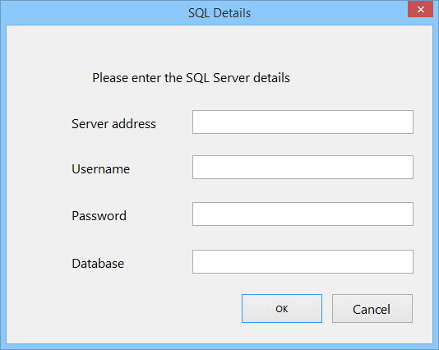The layout of the connection menu, along with the corresponding forms can be seen below

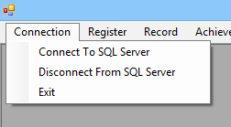

Closes program

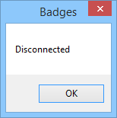

Register menu

The register menu and the corresponding forms can be seen below

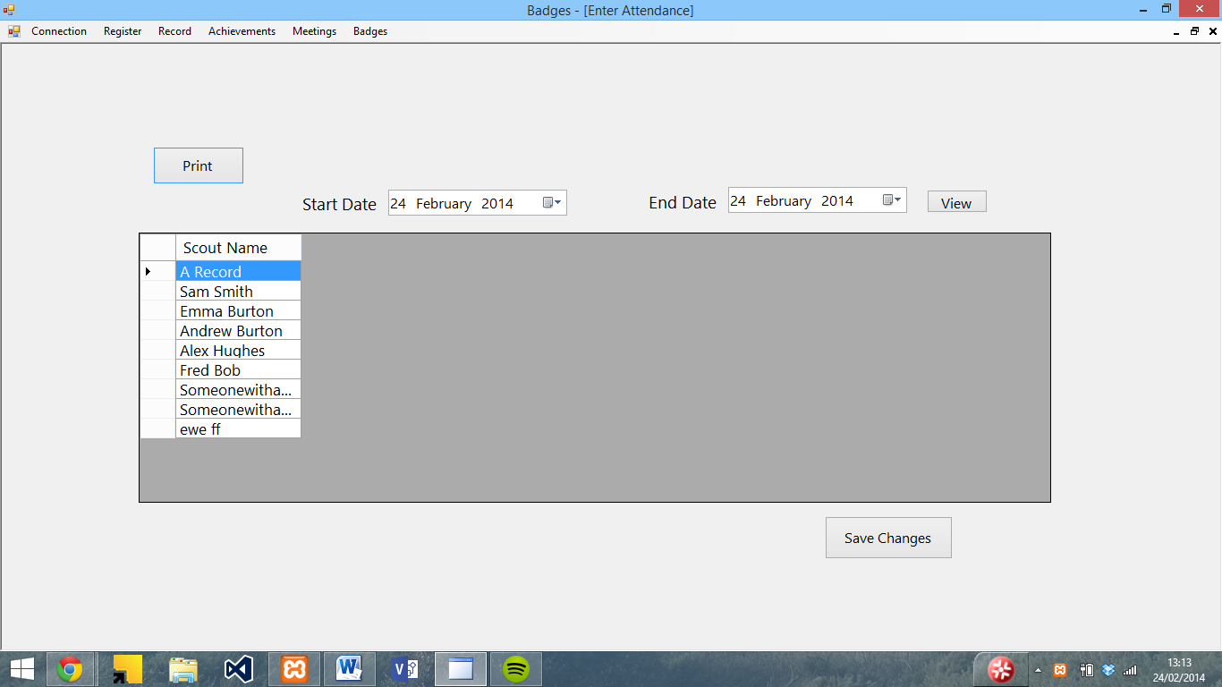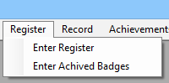

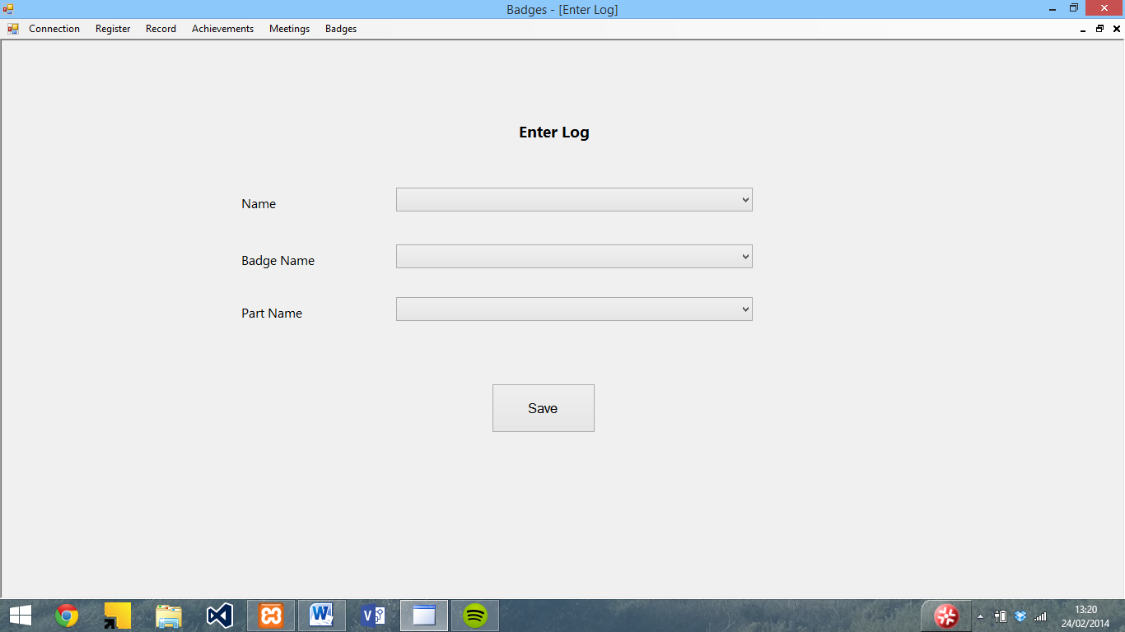

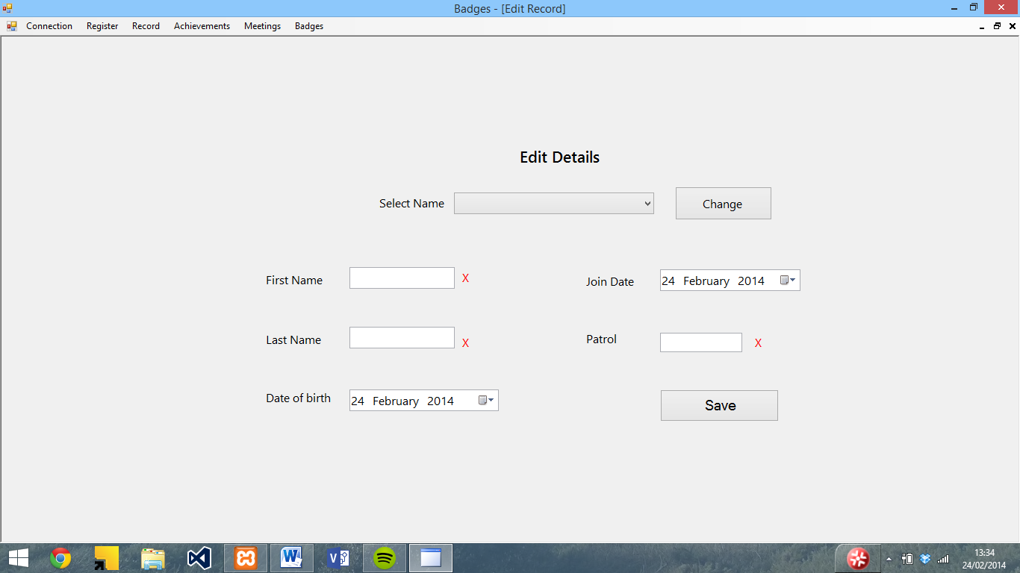Record menu

The record menu and corresponding forms can be seen below

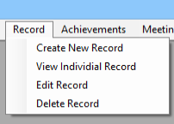

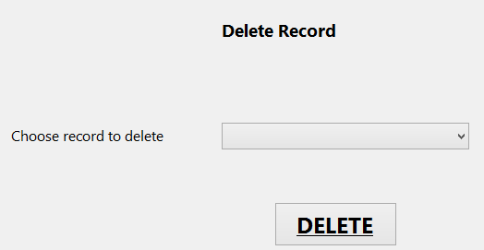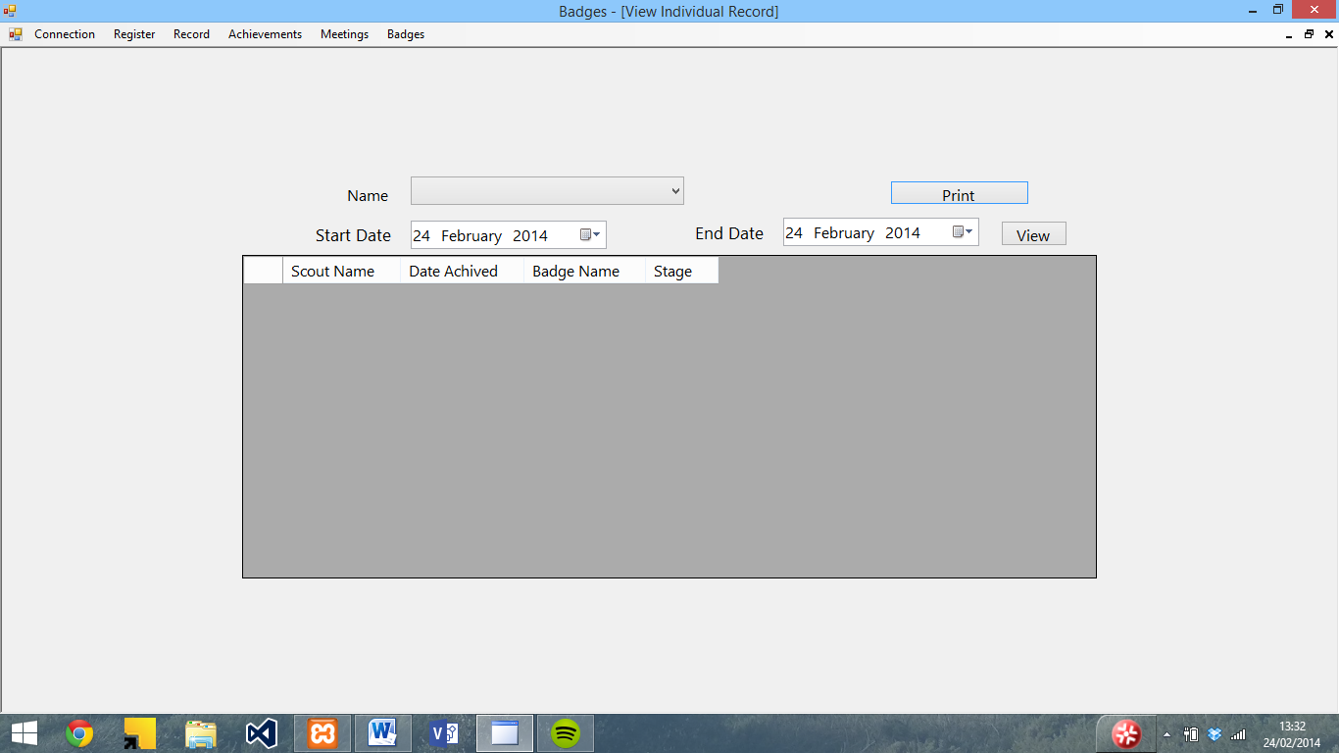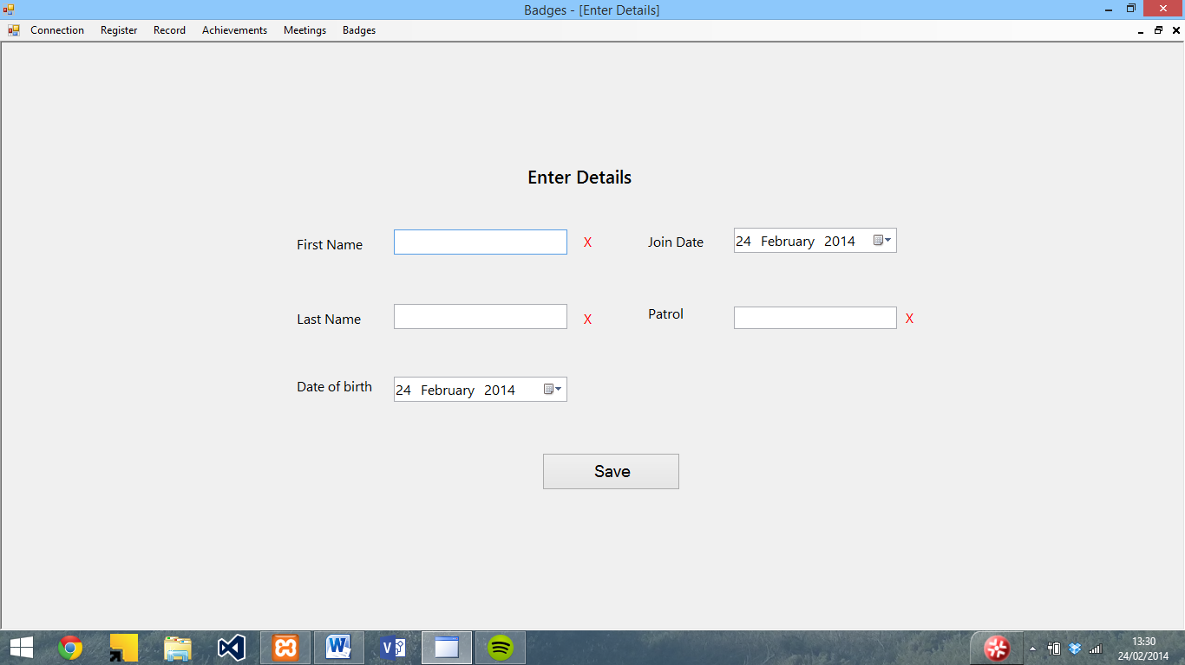

Achievements

The achievements menu and corresponding forms can be seen below

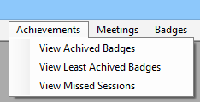

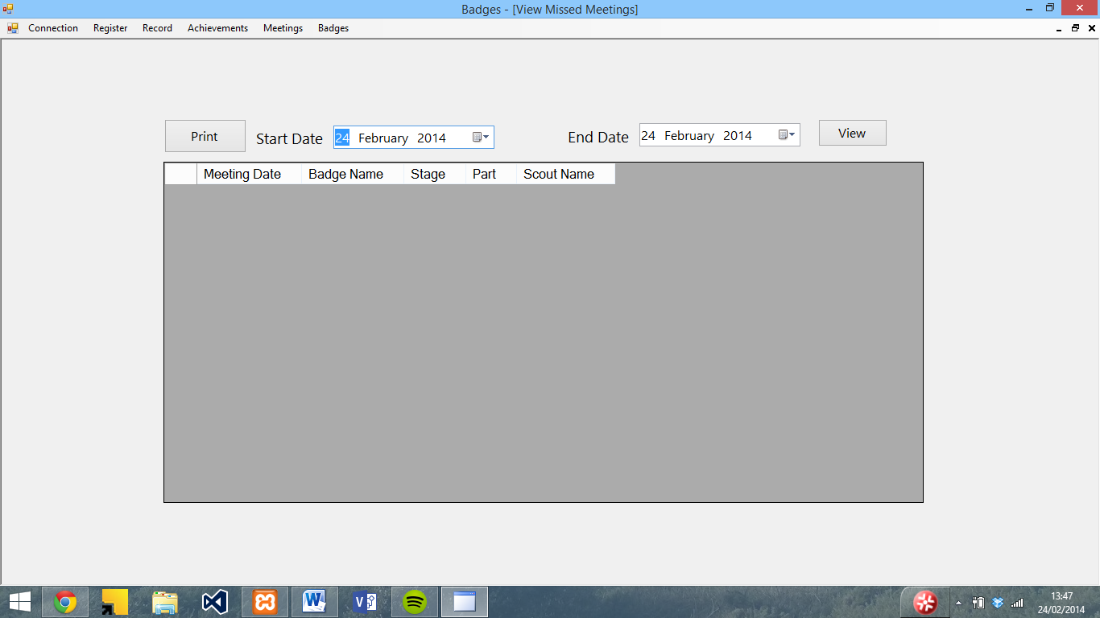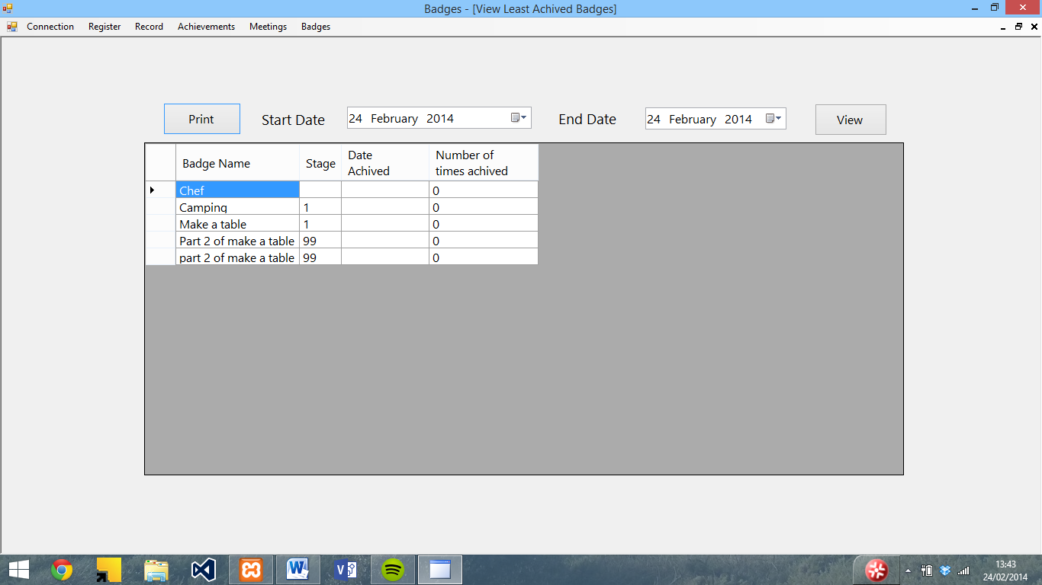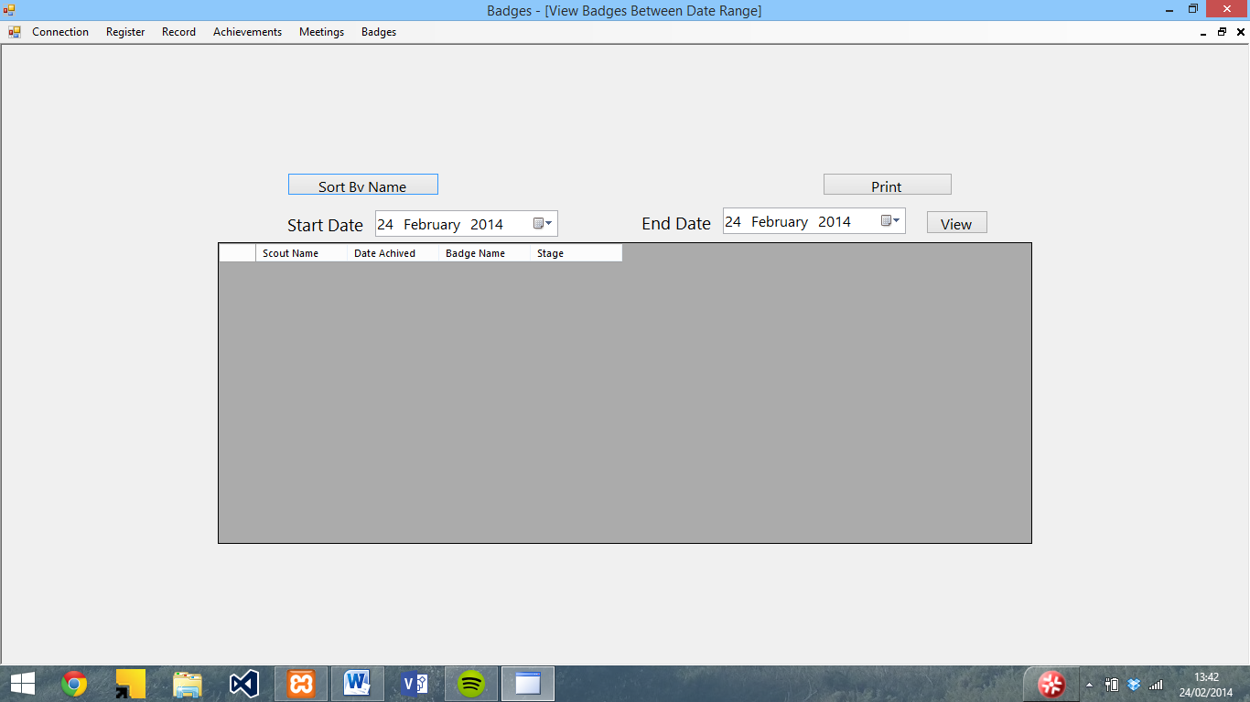

Meetings

The meetings menu and corresponding forms can be seen below

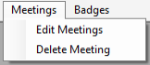

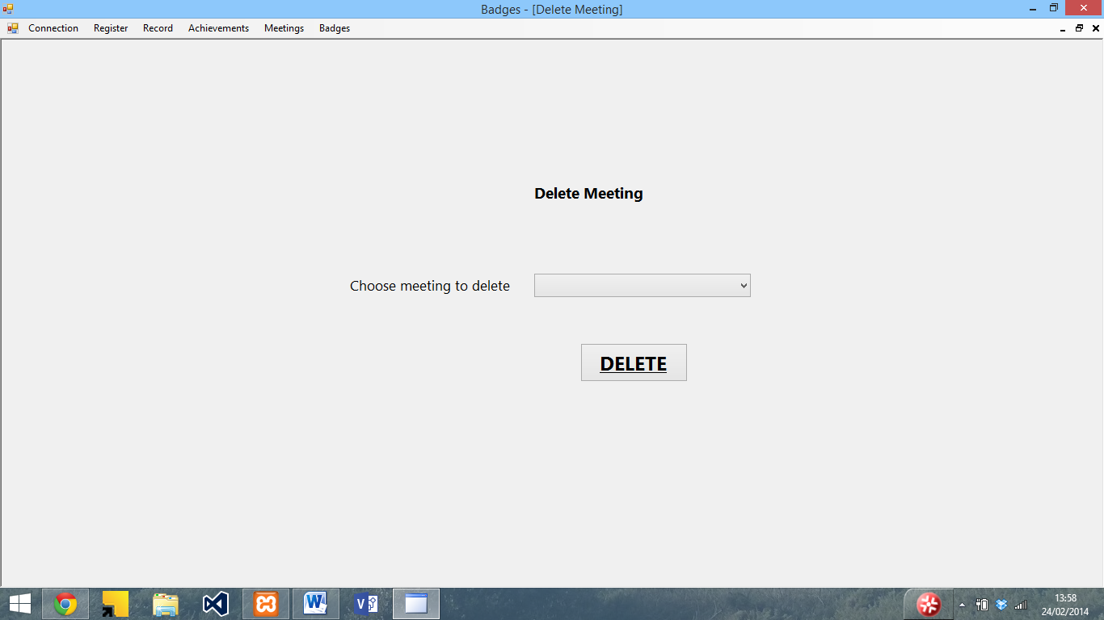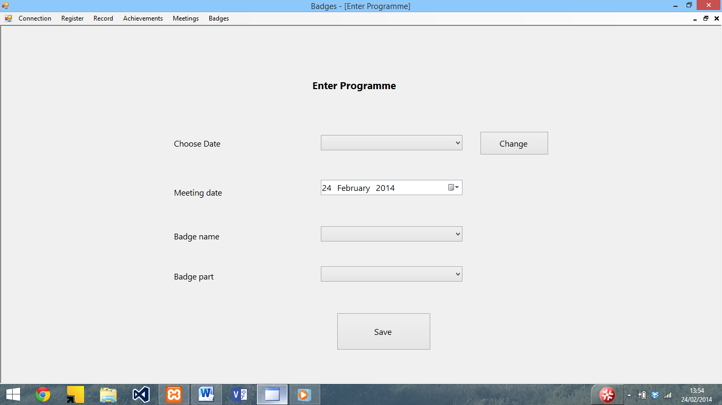

Badges

The badges menu and corresponding forms can be seen below

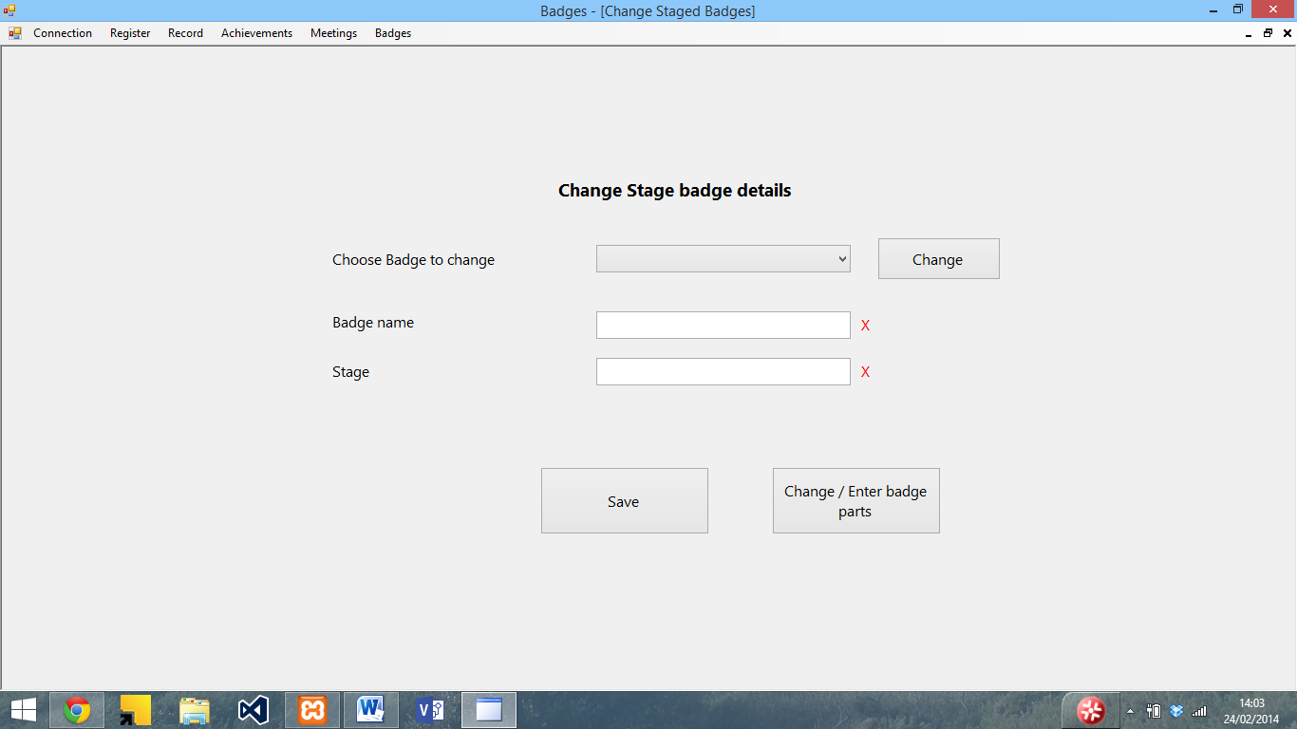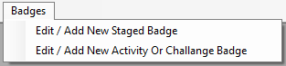

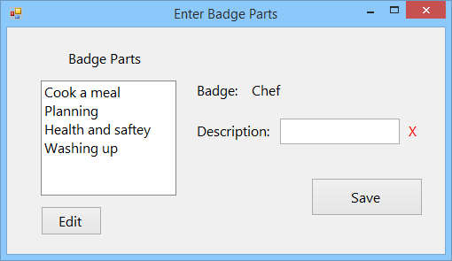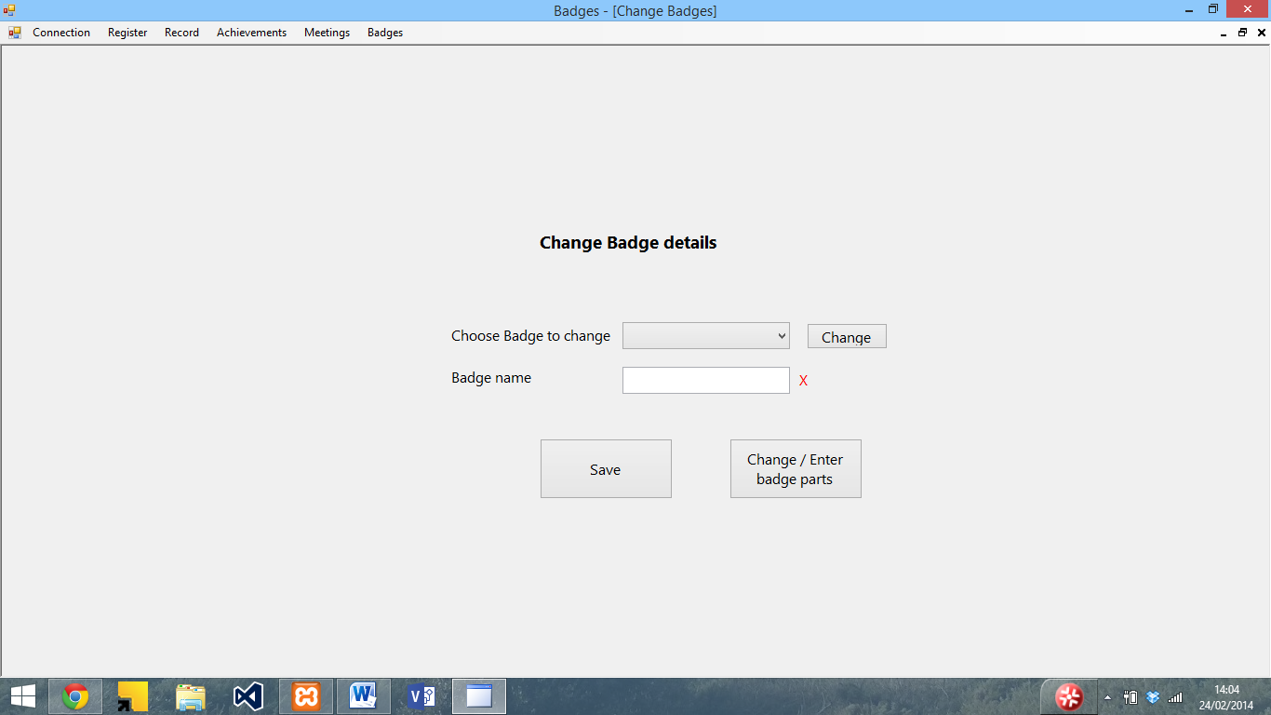

Installation instructions

Step 1: Disable your antivirus software temporarily. Although instructions for this vary, generally by right hand clicking on the logo in the bottom right hand corner, and then pressing shield control and then disable will disable it. (Whilst this software is not a virus, it tends to trigger antivirus software during installation as it is not a common program)

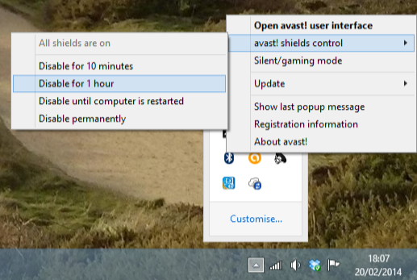

Step 2: Insert the installation CD into your computer and open the file browser (either labelled as Computer or This PC (depending on the version of windows you are running) and double click on the CD drive labelled badges. This will automatically run setup.

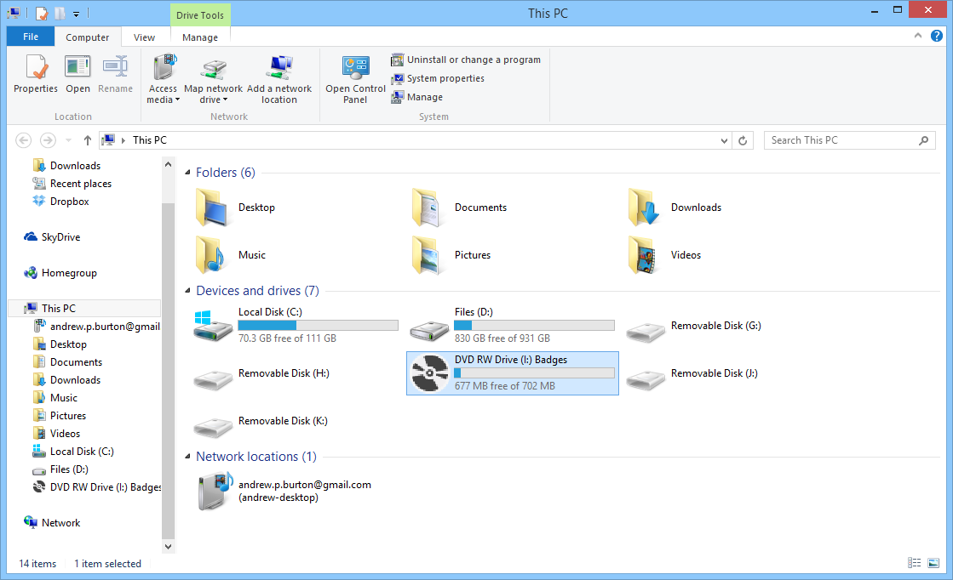

Step 3: (If you don’t see this, skip to step 4) When setup opens, you will be asked to accept the licence agreement for .NET framework. Read though this and if you accept press accept.

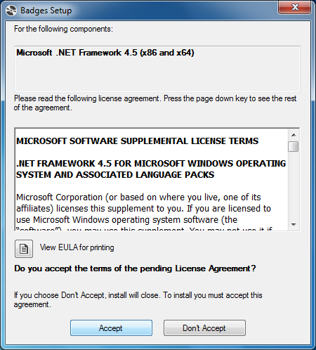

You will then be presented with a screen similar to the one below whilst the installer downloads and installs .NET framework. If you see a prompt asking if it can make changes to your computer, press Accept.

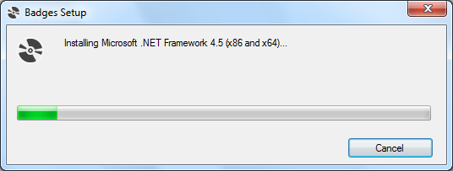

Step 4: Press install at the screen asking if you wish to run the application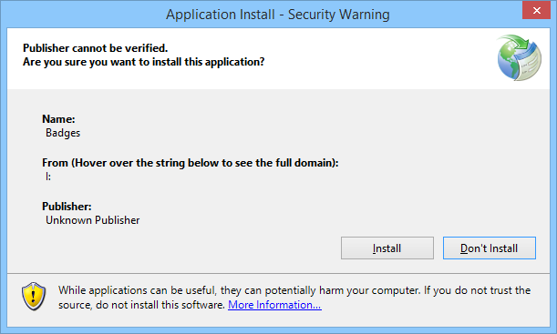

Step 5: The program will then install and then open. 

Step 6: Re–enable your antivirus by right hand clicking on it, and choosing enable (instructions vary depending on package used)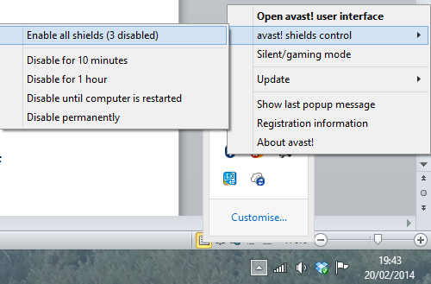

Uninstallation instructions

Step 1: Open the uninstall a program screen (steps to open this vary between versions of Windows) and double click badges from the list.

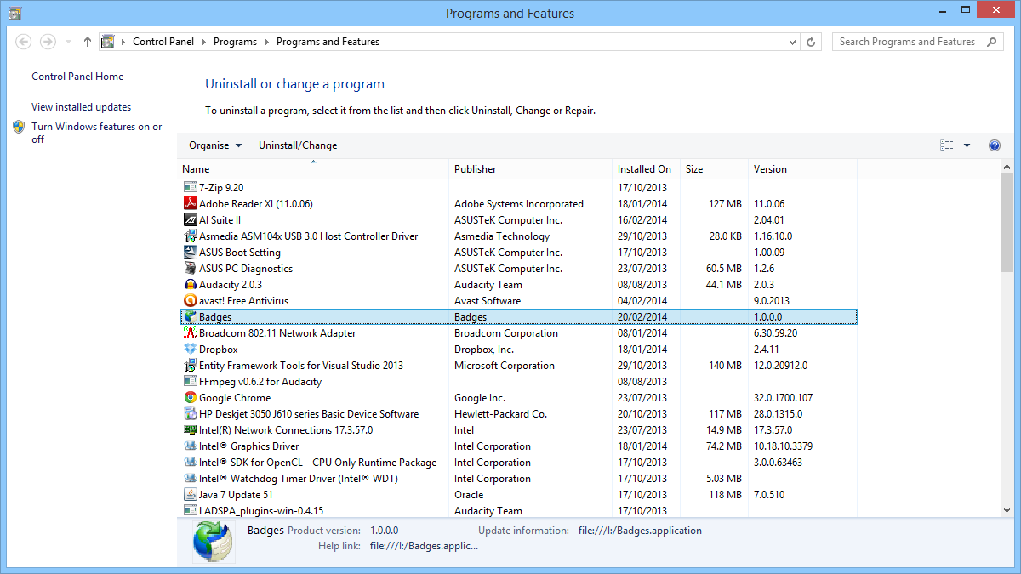

Step 2: On the screen which opens, select uninstall and press OK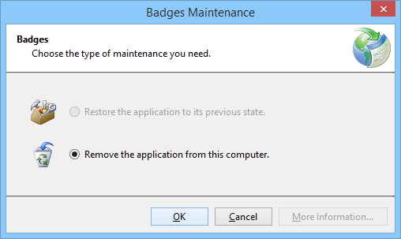

This will then completely uninstall Badges.

Opening badges and connecting to the SQL server

To open Badges, either double click on the shortcut on the desktop which will be created during install or open it from the badges folder in the programs menu

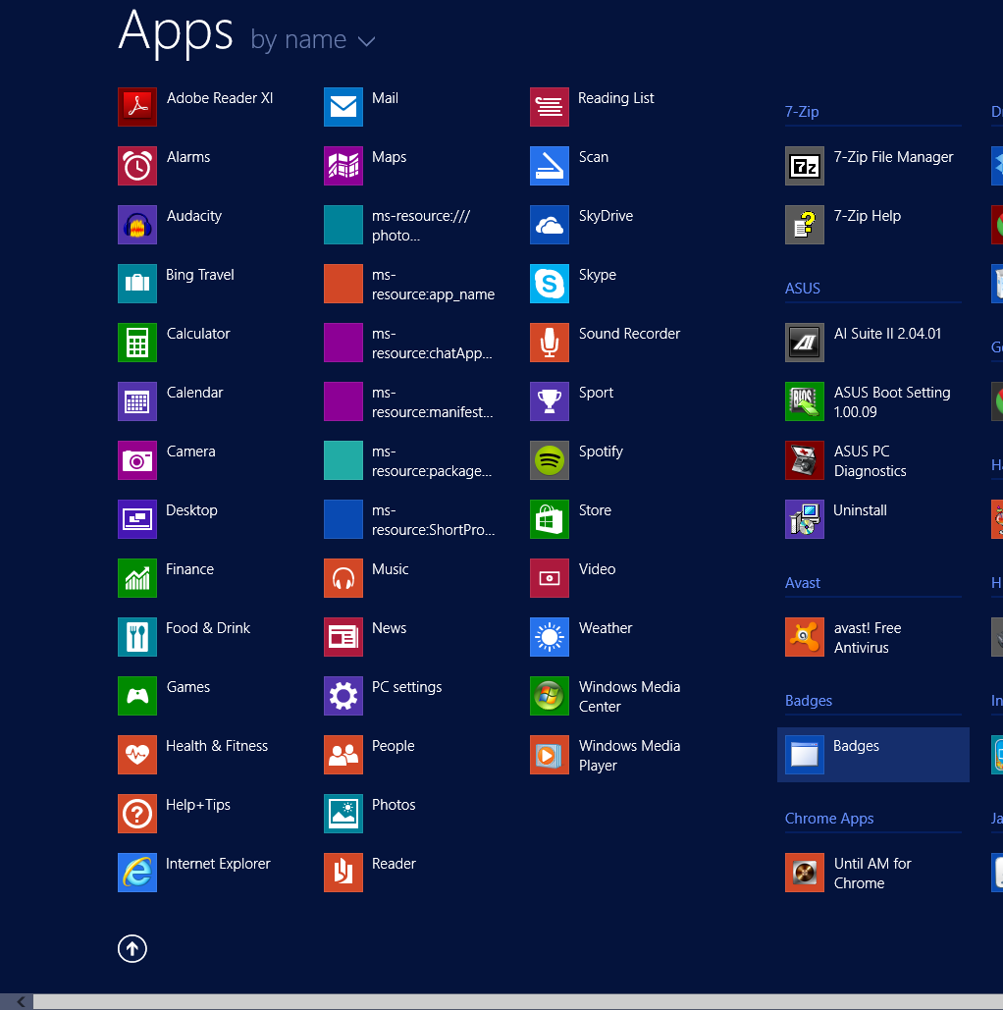

This will then open the main screen of the program.

This is the main screen for the program. Along the top is a file menu consisting of a Connection, Register, Record, Meetings and Badges.

Click on the Connection menu, and then press Connect to SQL server to connect to the server. You will then be presented with the following screen, in which you need to enter the details of the database server. Once these details have been entered, press OK

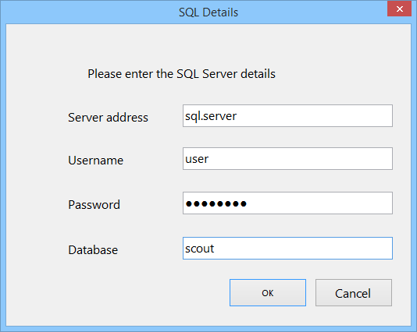

The program will then connect to the SQL server and display a confirmation once it has successfully connected.

Note: it is possible to have multiple databases for each user (the program will automatically create a database if the input one does not exist) and to have multiple users for each database

Disconnecting from the SQL server

To disconnect from the SQL server, choose disconnect from SQL server from the connection menu. This will display the following confirmation.



The program will also automatically disconnect when the Exit button from the connection menu is pressed or when the program closes.

Closing forms

This program uses forms within the main form. To close a form after use without closing the main program, use the little x in the top right hand corner

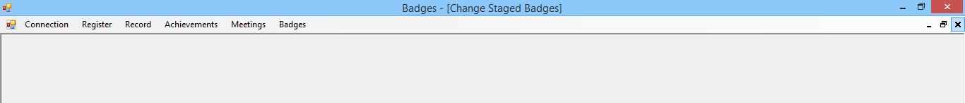

Adding badges

To add a badge to the system, from the badges menu choose either Edit / Add new Staged Badge or Edit / Add new Activity or challenge badge depending on the badge type.

Stage badges

If you press staged badge, you will be presented with the following screen.

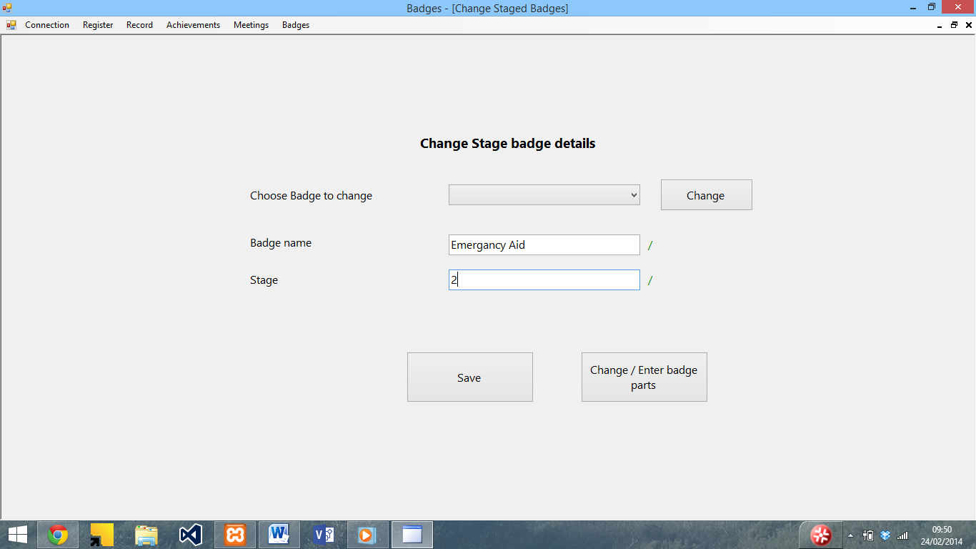

To add a new badge, enter the badge name into the badge name box and the stage into the stage box. The / or x to the right of the box will let you know if the input is valid (Characters which are not a-z or 0-9 are not allowed for the name and only numbers are allowed for the stage).

Once you have input the details of the badge, press the save button to save the badge, and a confirmation will be displayed.

Non – staged badges

Similarly to the staged badge screen, upon pressing the Edit / Add new Activity or challenge badge button the following screen will be displayed.

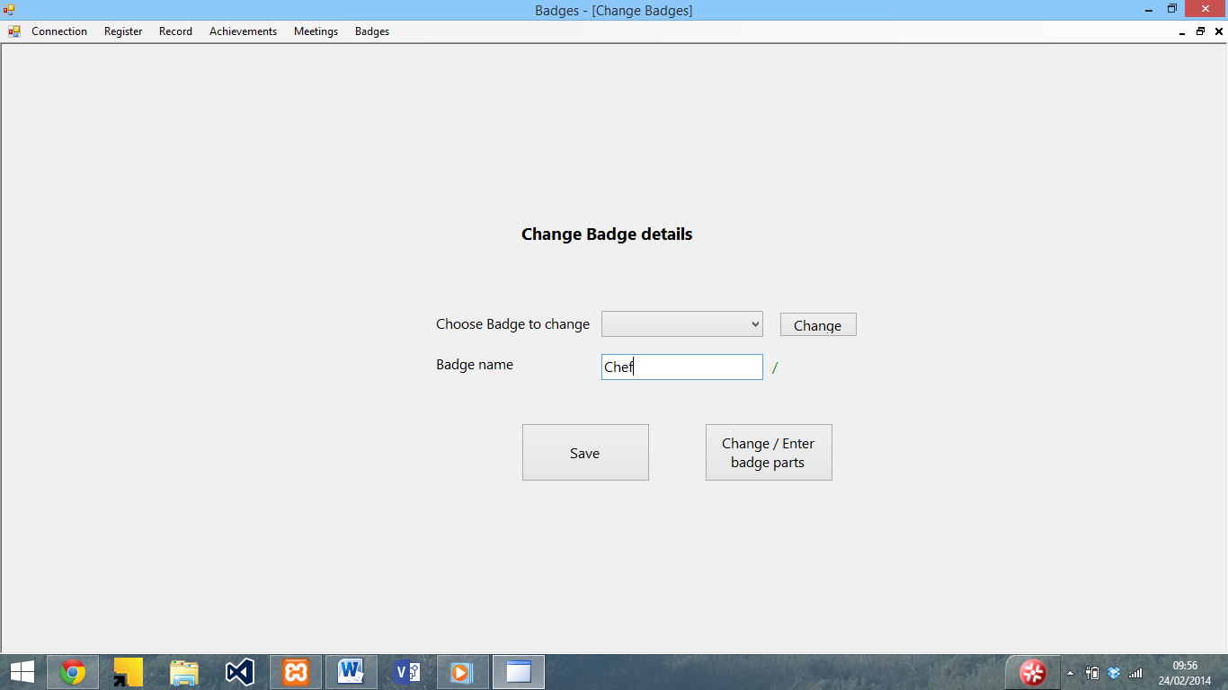

To add a new badge, simply enter the name of the badge into the box and press save. The / or x to the right of the box will let you know if the input is valid (Characters which are not a-z or 0-9 are not allowed). If the input is valid, the badge will save and a confirmation will be displayed when the save button.

Adding Badge parts

To add the criteria for each badge, once the badge has been saved press the Change / Enter Badge parts. The following screen will then be displayed.

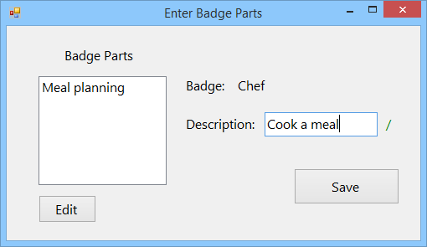

To add a new part, enter a description into the description box, and then press save. The part will then be displayed in the list to the left. The / or x to the right of the box will let you know if the input is valid (Characters which are not a-z or 0-9 are not allowed).

Editing badges

To edit the details of a badge, from the badges menu choose either Edit / Add new Staged Badge or Edit / Add new Activity or challenge badge depending on the badge type.

Staged badges

You will be presented with this screen. From the dropdown list, select the badge you wish to edit and then press edit.

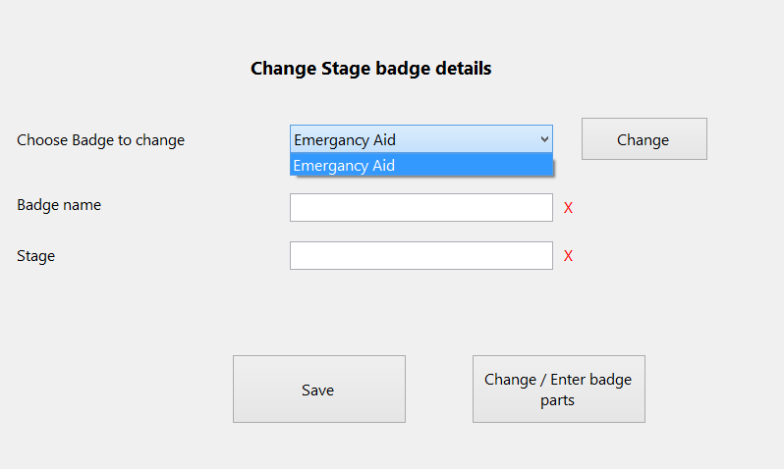

The textboxes will then be filled with the badge details for editing. The badge is saved in the same way as adding a badge.

Non – staged badges

Other badges are edited by using the Edit / Add new Activity or challenge badge button from the badges menu. The editing process is the same as for a staged badge.

Editing parts

To edit the parts for a badge, follow the instructions to edit the badge to select it. Once the boxes contain the details of the badge, save it and select the parts button. The following screen will then be displayed.

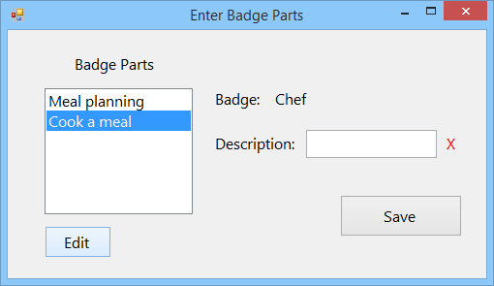

To edit a part, select the part you wish to edit and then press edit. The description box will then be filled with the name of the badge for you to edit. To save the part, press the save button.

Adding a meeting

To add a meeting, select Edit Meeting from the meeting menu. The following form will then be displayed.

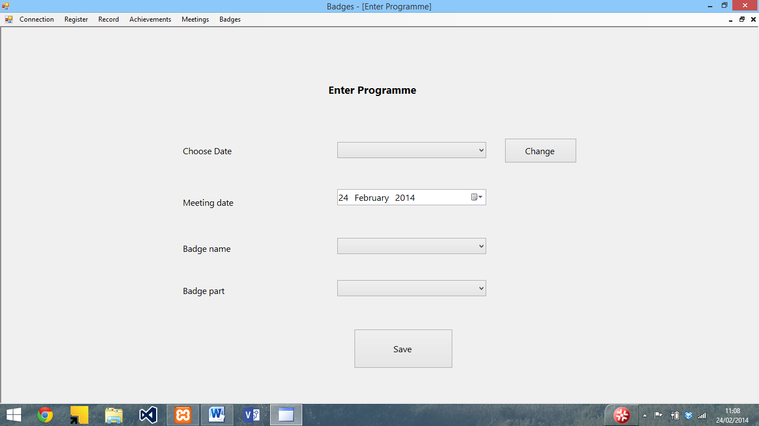

Enter the meeting date (see below) and select the badge name and part from the dropdown list (you will not be able to select a part without selecting a badge)

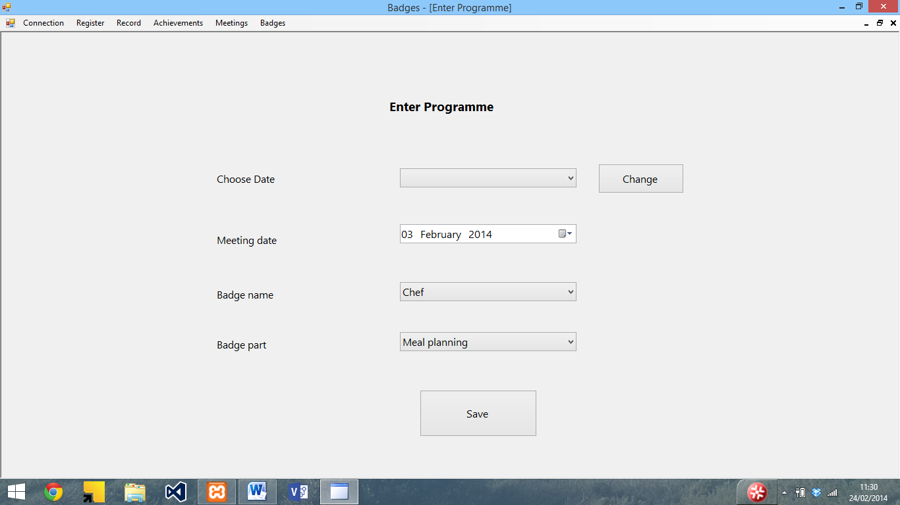

Once you have entered the badge name and part press save. A confirmation will then be displayed.

Editing a meeting

To edit a meeting, choose edit meeting from the meeting menu. In the screen that appears, choose a meeting date to edit.

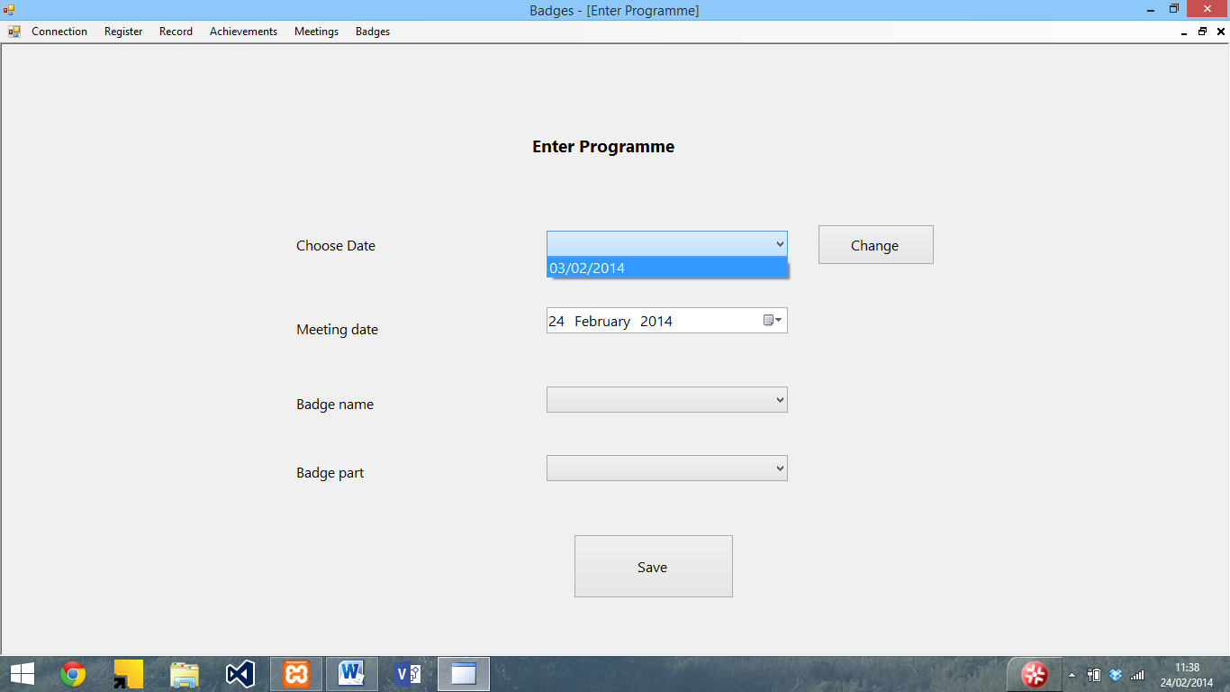

To change the date, press the change button. The boxes will then be filled with the details of the meeting, which can be edited in the same way as adding a meeting.

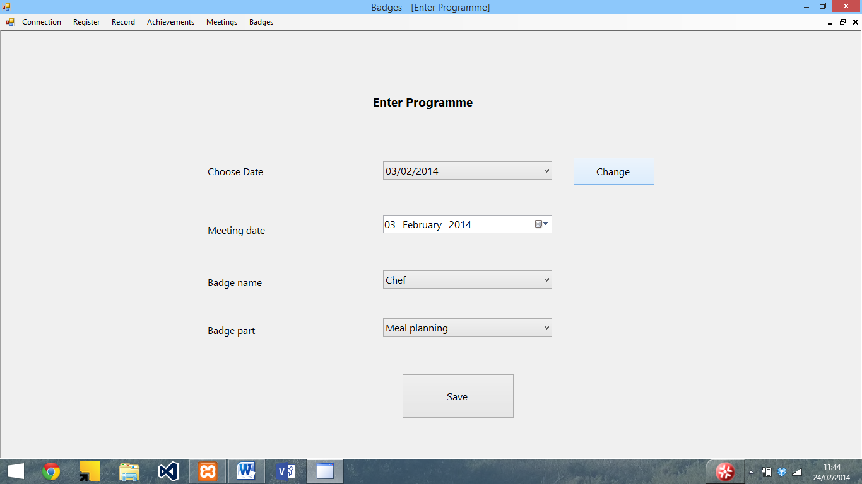

Entering dates

To enter a date, click on the calendar item next to the date box and use the arrows to navigate the month. To select the date, click on it.

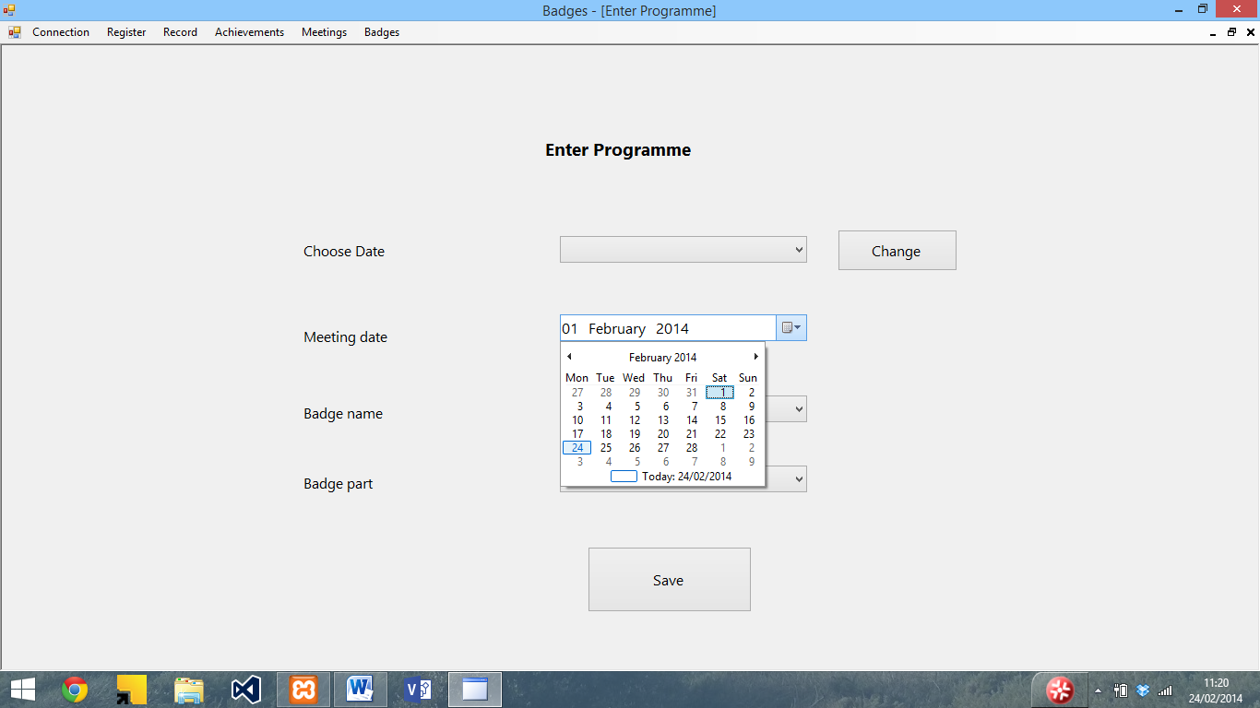

Deleting meetings

To delete a meeting, select delete meeting from the meeting menu. The following screen will then be displayed.

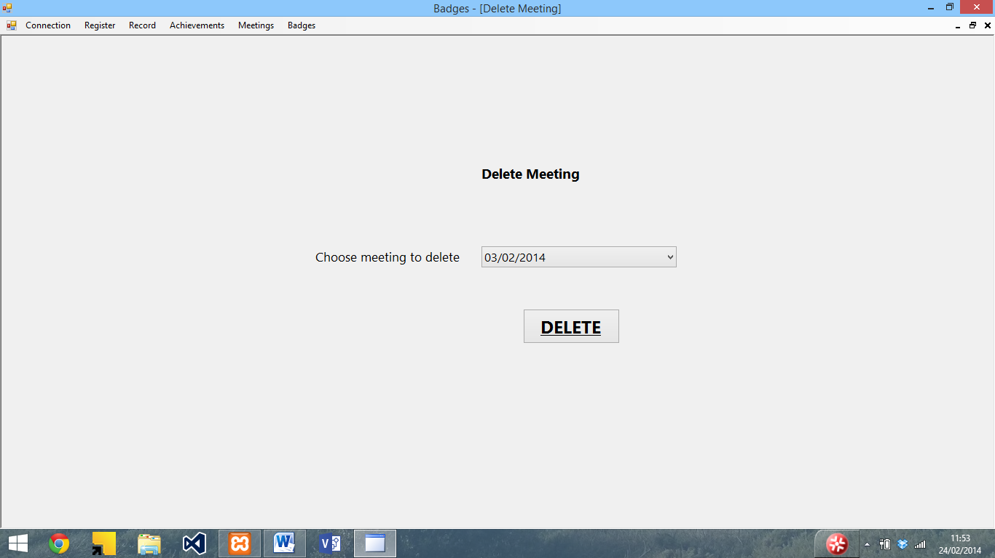

To delete a meeting, select the date from the list and press delete. The following confirmation will then be displayed

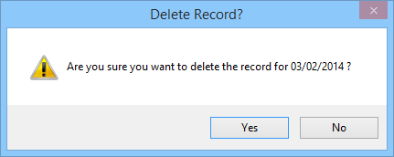

If you wish to delete the meeting, press yes. The following prompt will then be displayed.

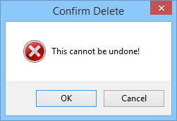

To delete the meeting, press OK. Once this is pressed the delete cannot be undone. To cancel the delete, press cancel. Upon pressing OK, the record will be deleted and a confirmation of the delete will then be displayed.

Enter record

To create a new record, select Create New Record from the record menu. The following form will be displayed.

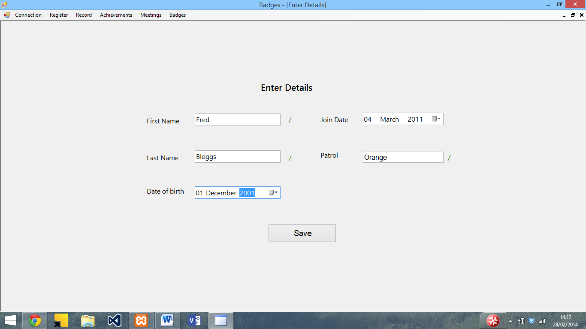

Enter the details into the system (see the entering dates section for entering dates). The / or X show whether the input is valid or not for the name and patrol boxes (only a-z and capitals are allowed). Once the details have been input, press the save button to save the details, and a confirmation will be displayed.

Editing a record

To edit a record, select the edit record button from the menu. The following screen will then be shown

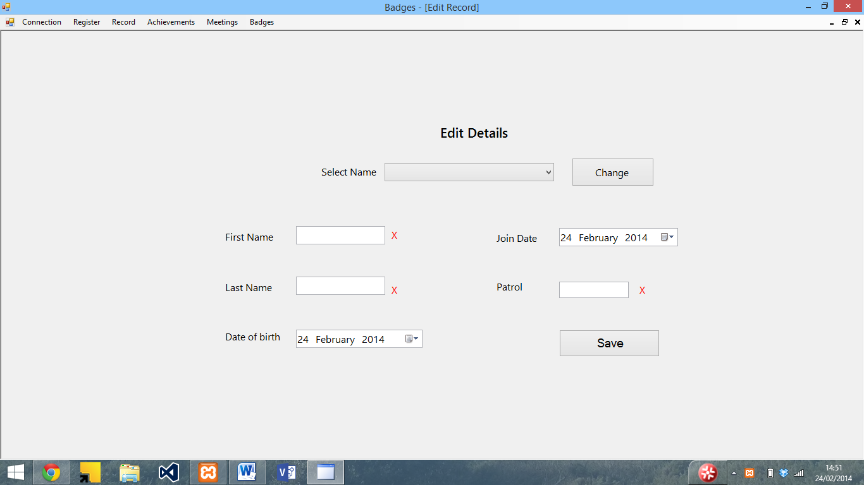

To edit a record, select the name from the drop down list, and press change. The boxes will then be filled with the details of that person

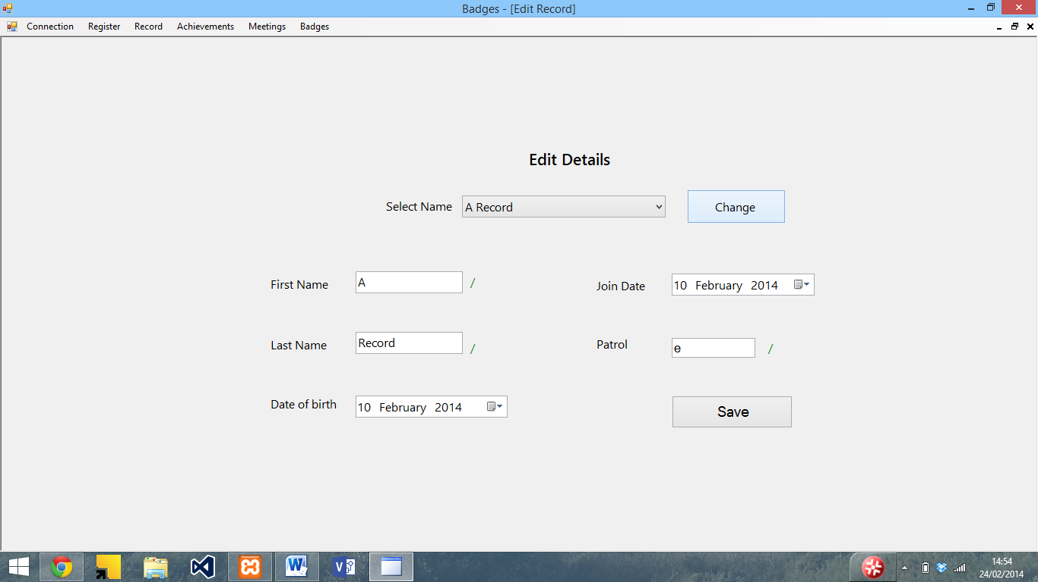

The record can then be edited in the same way as adding a new record.

Delete record

To delete a record, select the delete record button from the record menu. The following screen will then be displayed

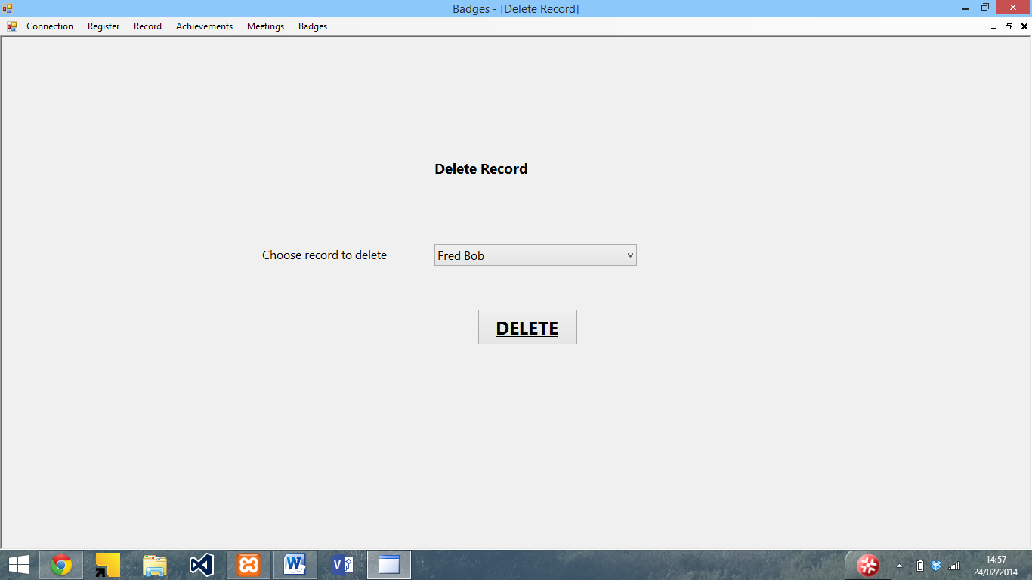

To delete a record, select the person from the dropdown list and press the delete button. The following message will then be displayed.

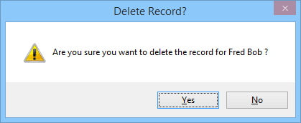

To delete the record, press the yes button. A message to warn you that it cannot be undone will then be displayed.

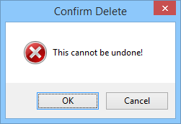

If the Ok button is pressed, then the record will be deleted and a confirmation will be displayed.

View individual record

To view an individual record, select the view individual record button from the record menu. The following screen will then be displayed.

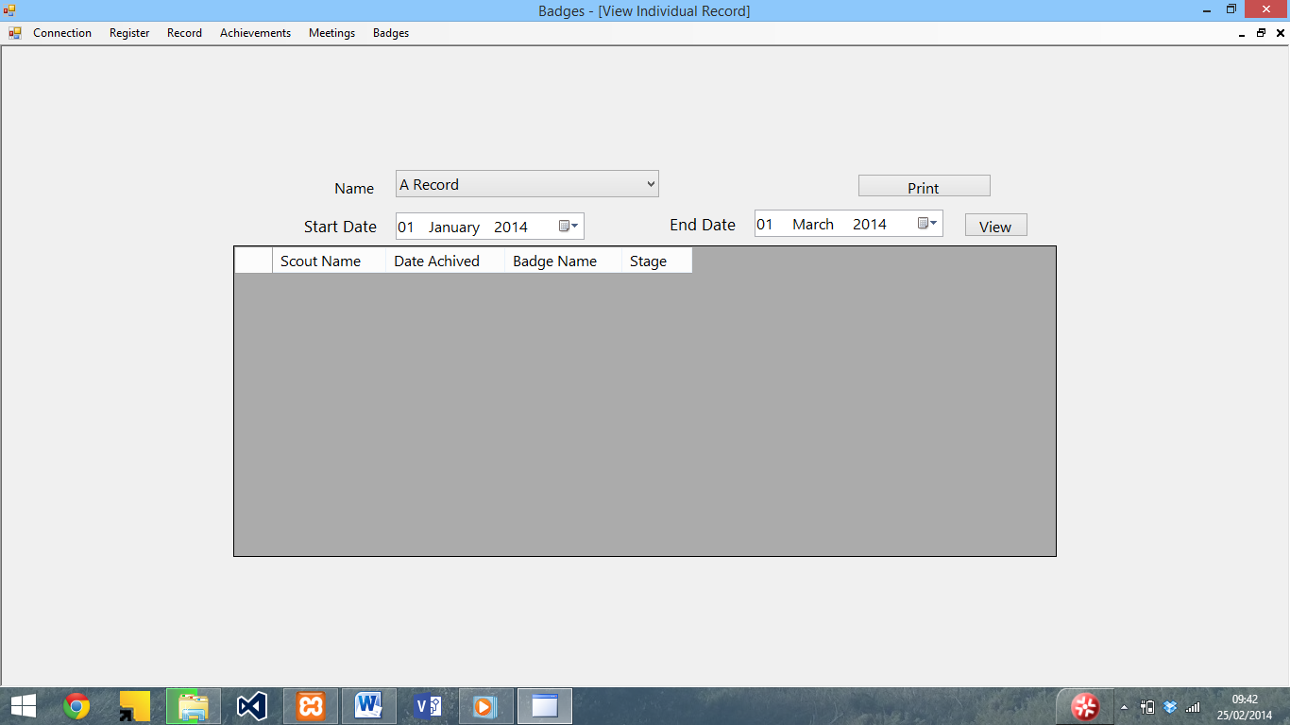

To view a record, select a name from the drop down list and a date range, and press the view button.

The badges achieved by that person will then be displayed

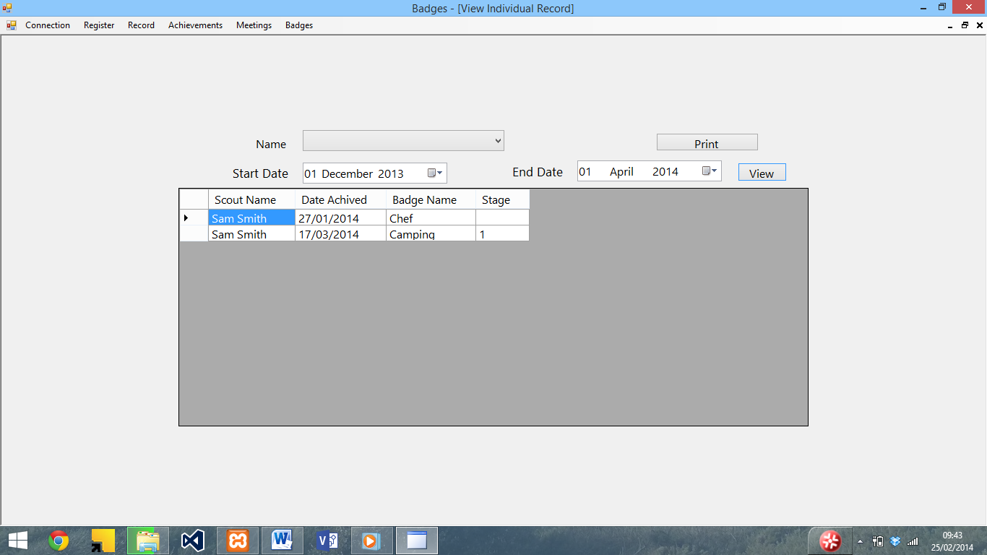

To print the view, press the print button (see printing forms for more on this)

Enter register

To enter the register, select the Enter Register button from the register menu. The following screen will be displayed

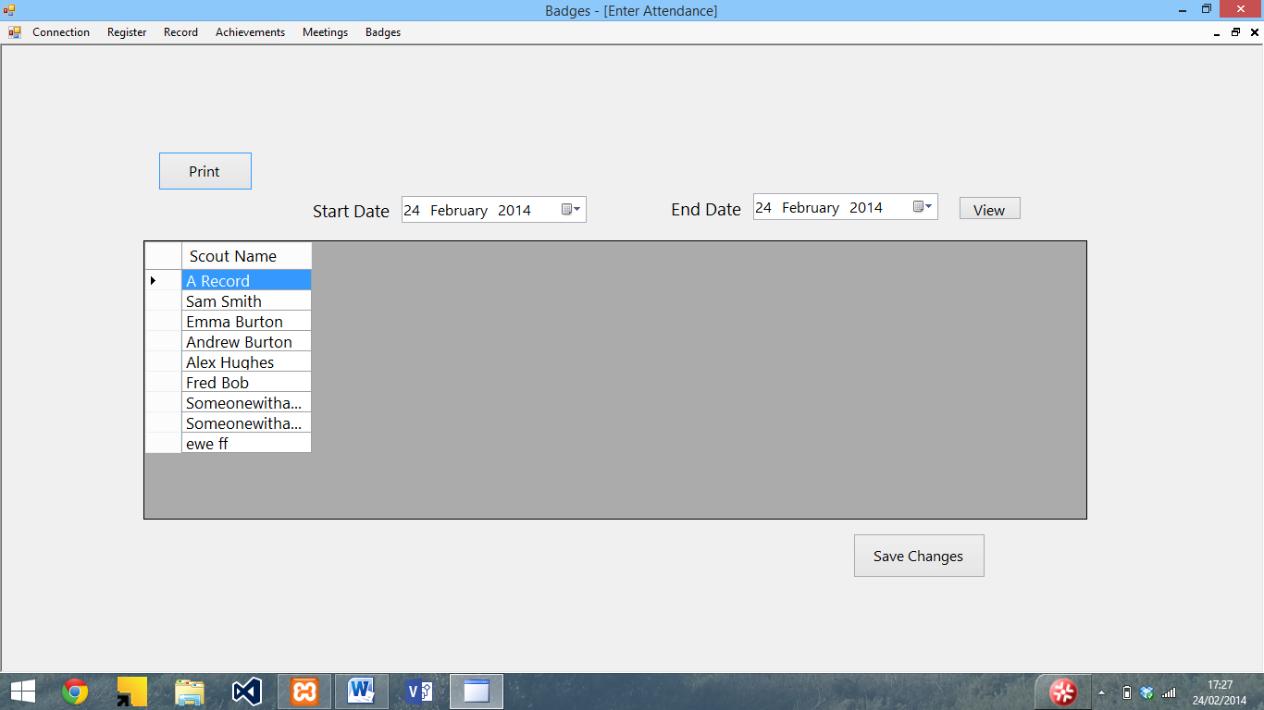To enter the register, select the date range using the start date and end date boxes and press view. The meetings between that date range and the attendance will be displayed

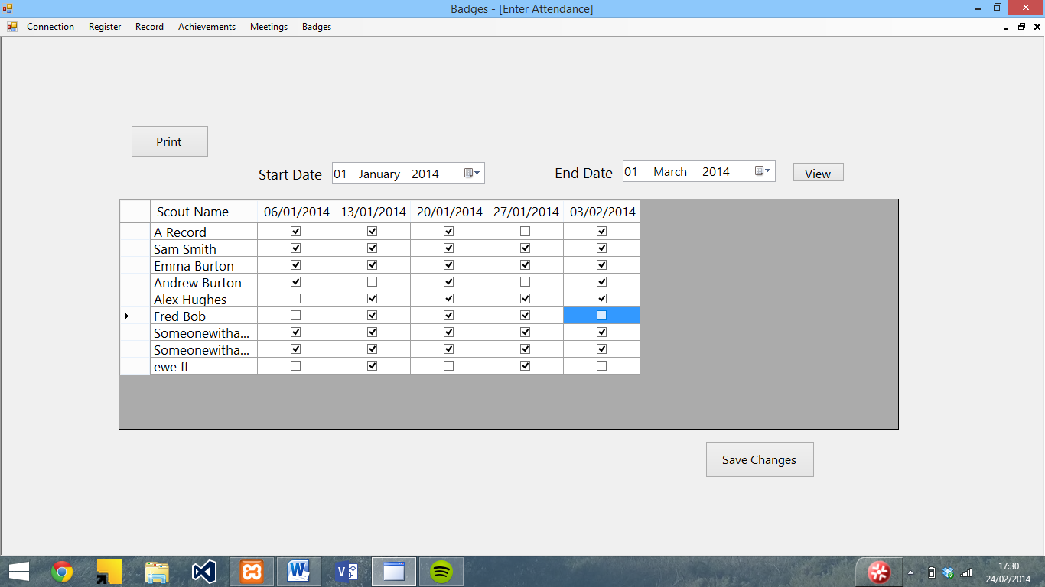

To edit the attendance, tick or untick the boxes (ticked means there) and press save to update the database. A confirmation message will then be displayed.

Printing forms

The enter attendance, View individual record, View missed meetings, View achieved badges and View least achieved badges all allow you to print what is being displayed. To do this, press the print button on the form. A dialogue box will then appear allowing you to set the printer and number of copies.

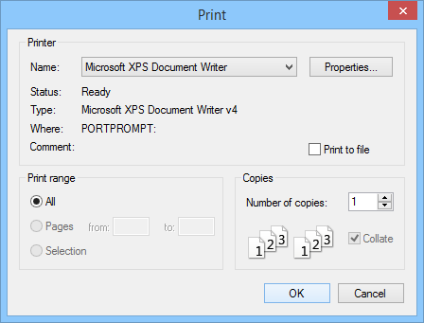

Once the OK button is pressed, a preview of the printout will appear. To print it, press the print button in the top left hand corner.

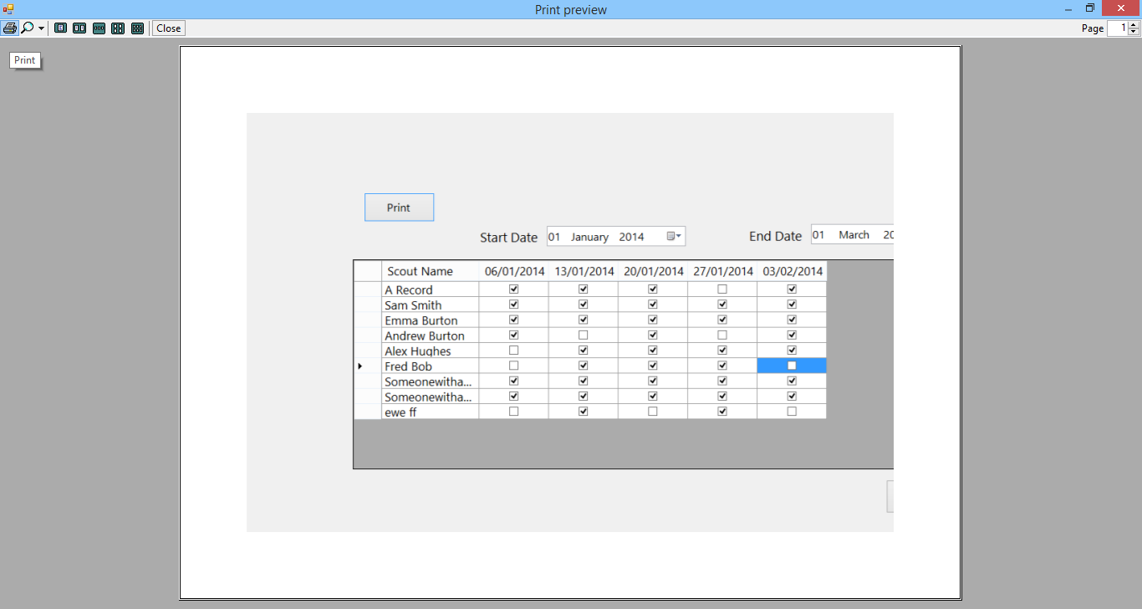

The selected printer will then print the view

Enter achieved badges

To enter achieved badges manually, select enter achieved badges from the register menu. The following screen will then be displayed.

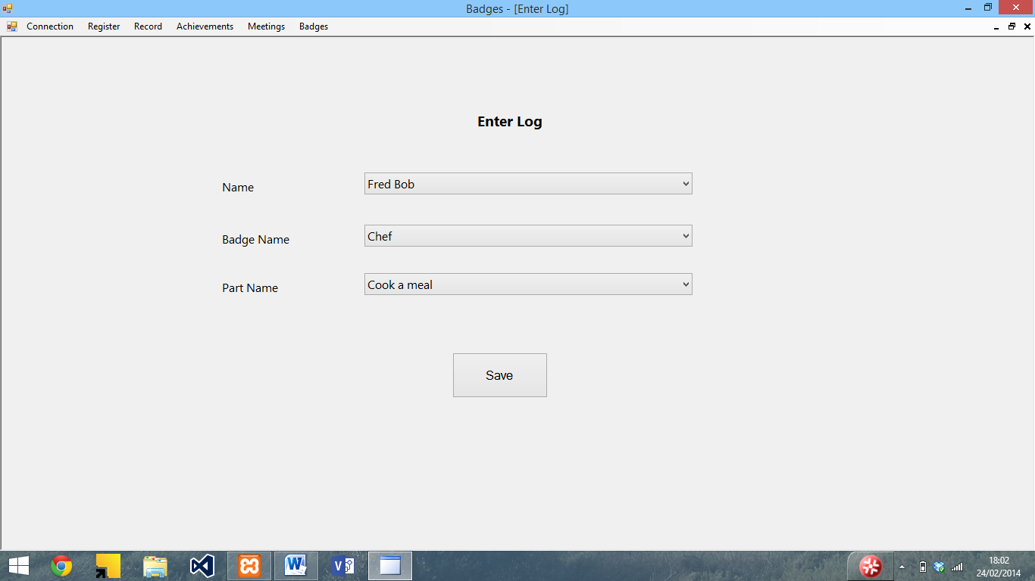

To enter the details, select the Scout name, badge name and part name from the lists (the badge needs to be selected before selecting the part). Once the details have been selected, press save. A confirmation will then be displayed.

View achieved badges

To view the achieved badges, select view achieved badges from the Achievements menu. The following screen will then be displayed

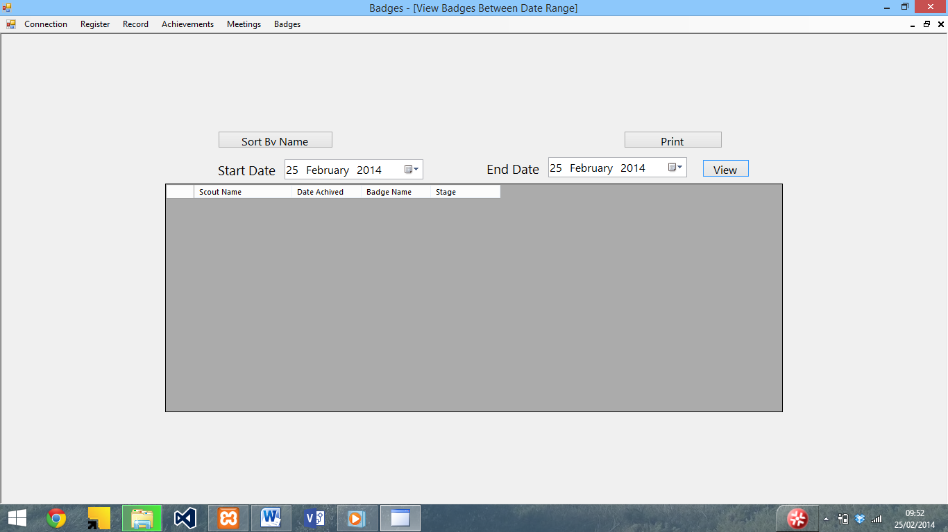

To view the achieved badges, select the date range and press view. The achieved badges will then be displayed

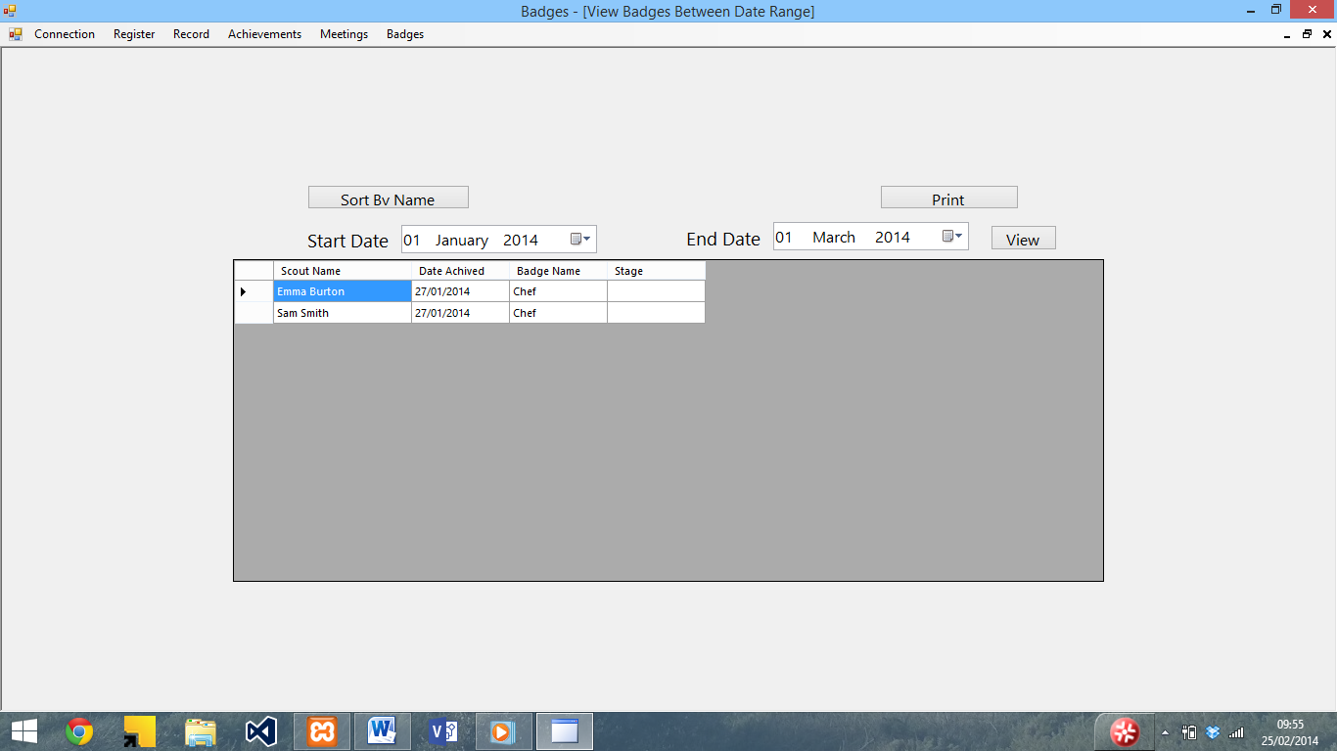

To sort the view, use the sort by name button at the top. It is also possible to print the view using the print button (see printing forms for instructions).

View least achieved badges

To view the least achieved badges, select View Least achieved badges from the Achievements menu. The following screen will be displayed.

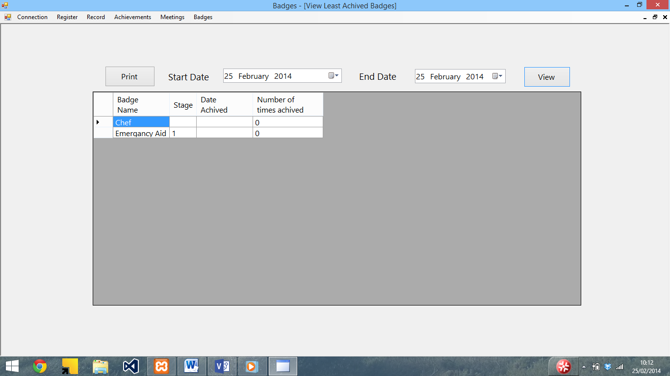

To view the number of times achieved and date last achieved, enter a date range using the boxes at the top, and press the view button. The date achieved and number of times columns will then be filled

It is also possible to print the view using the print button. See printing forms for more on this.

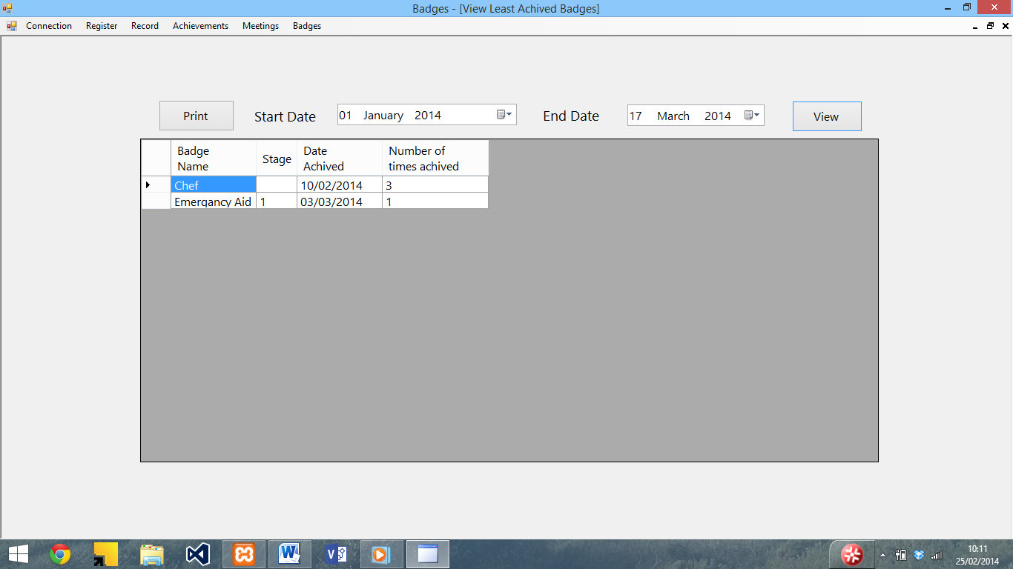

View missed sessions

To view missed sessions, select view missed sessions from the achievements menu. The following screen will then be displayed.

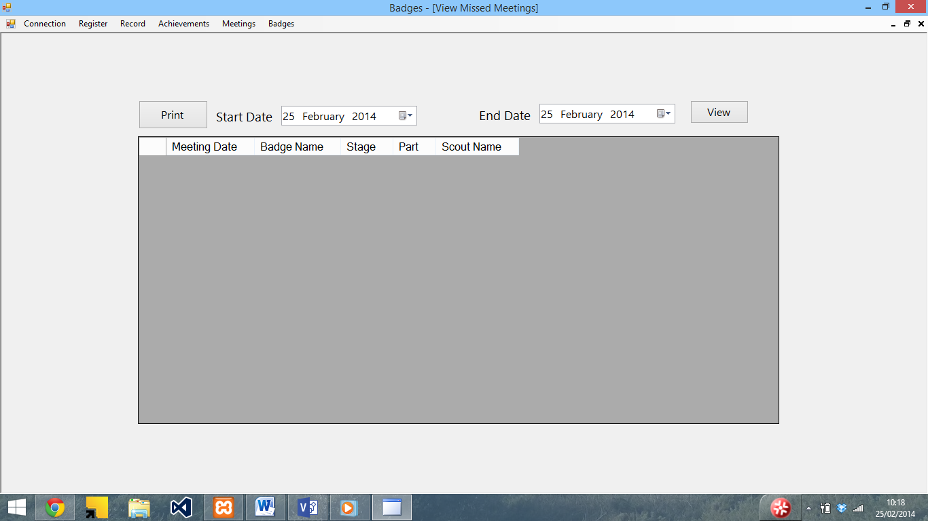

To view missed meetings, enter a date range using the date range boxes and press view. The meetings, along with absent Scouts’ names will be displayed.

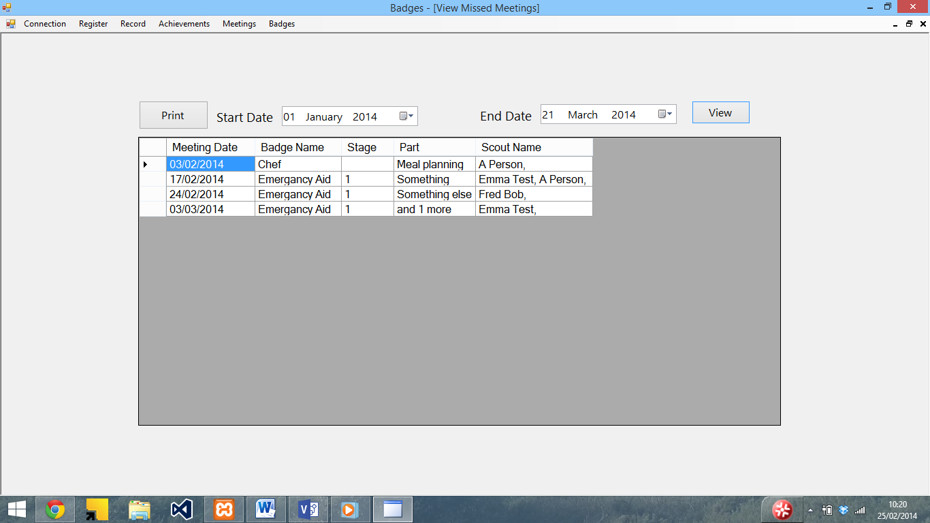

To print the view, press the print button (see printing forms for more on this).

Error messages and troubleshooting

This section contains the error messages within the program and details of how to resolve them.

|  |  |
| --- | --- |
| Error | Description |
|  | (Connect to SQL server) The SQL server details are incorrect. Check that the details (Address, Username, Password, and Database) are correct and try again. |
|  | (Connect to SQL server) You are already connected to the SQL server and don’t need to connect again. |
|  | (Enter achieved badges) You need to select a name, badge and part before saving. Ensure that you have selected a name, badge and part and try saving again |
|  | (Enter details / Edit details (similar error message for Enter and edit details)) You need to enter a valid first name / last name / patrol. Ensure that the details have been input and are valid (see section in user guide for valid inputs) |
|  | (View individual record) You need to select a name to view a record. Select a record and press view to solve this |
|  | (Delete record) You need to select a name before you delete it. Select a name from the list and press delete to solve this. |
|  | (Enter Programme) – You need to select a badge and part before saving a meeting. Ensure that a badge, part and date are selected and try saving again. |
|  | (Delete meeting) – You need to select a date before it can be deleted. Select a date and try deleting it again. |
|  | (Enter / Add new Staged badge and Enter / Add new Activity or Challenge badge) – The badge name needs to be valid before saving – Ensure that the name / stage have been entered and are valid (see section in user guide for valid inputs) |
|  | (Enter / Add new Staged badge and Enter / Add new Activity or Challenge badge) – The badge needs to be saved before the parts are edited. Save the badge and then press edit parts to edit the parts |
|  | (Enter badge parts) – The badge description needs to be valid before saving. Ensure that the description have been entered and are valid (see section in user guide for valid inputs) |
|  | (Entire program) – You need to connect to the SQL server before using this section. Use the connect to SQL button in the Connection menu to do this, and you will the be able to open the form. |

Quick Guides

This section contains quick ‘how to’ guides for common functions.

Enter attendance

Step 1: Open the program and choose connect to SQL server from the connection menu

Step 2: Enter the server details and press Ok

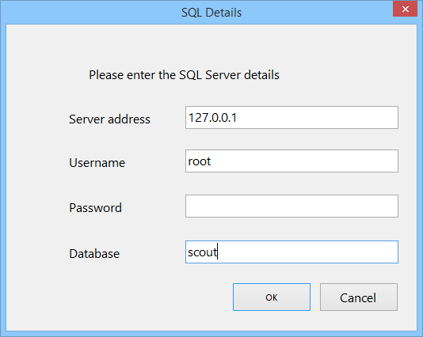

Step 4: Click on enter register in the register menu

Step 5: Enter the date range to view using the calendar buttons

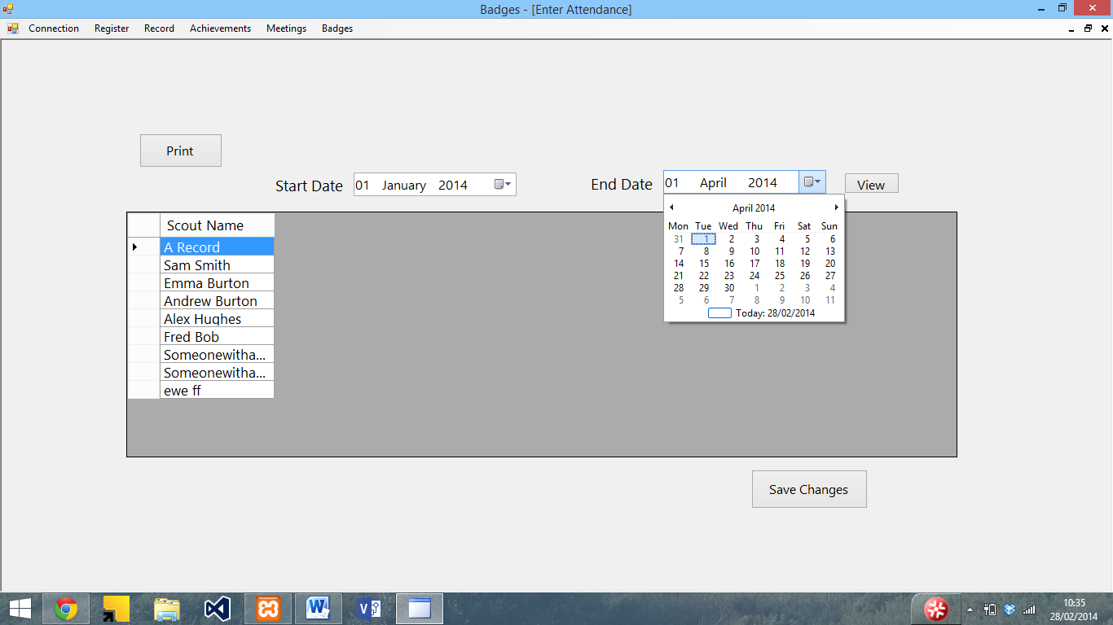

Step 5: Press view. The attendance will then be displayed

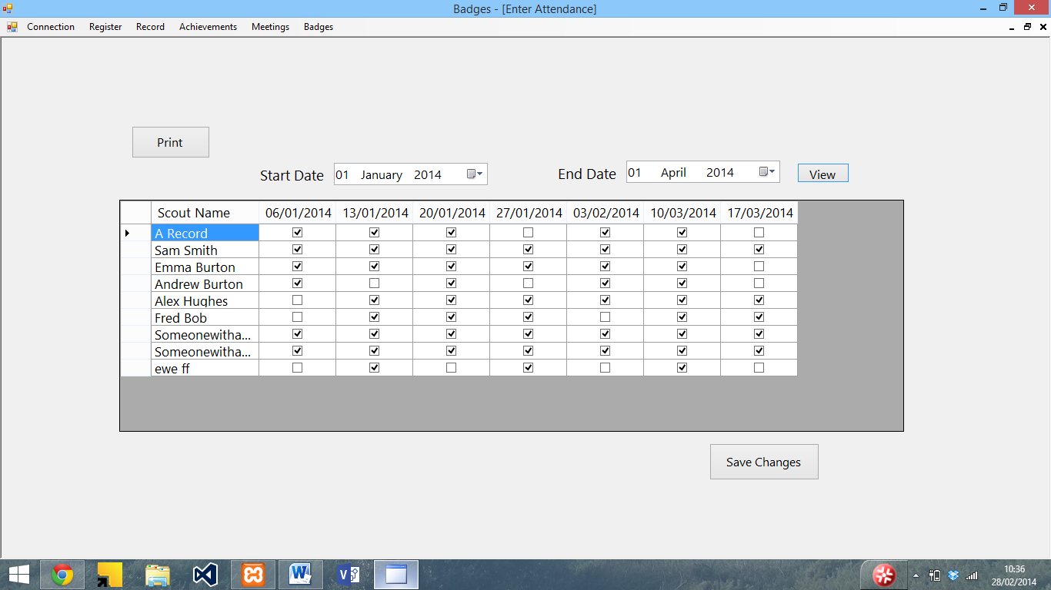

Step 6: Use the tick boxes to enter or edit the attendance for Scouts

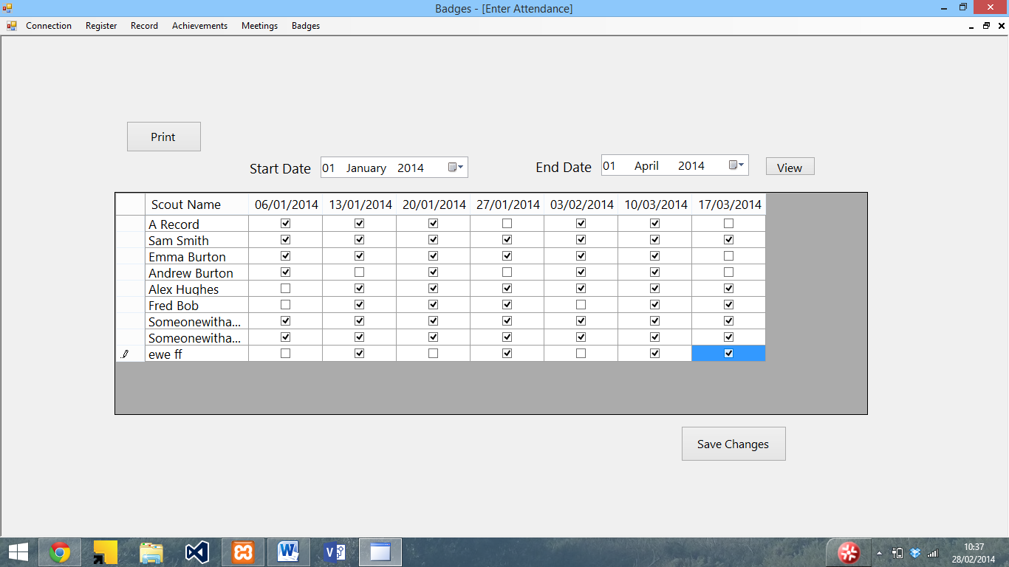

Step 7: press the save changes button to save the register. The register will then be saved and a confirmation will be displayed

Create new record

Step 1: Open the program and choose connect to SQL server from the connection menu

Step 2: Enter the server details and press Ok



Step 3: Select Create New record from the record menu

Step 4: Enter the Scout’s details into the boxes (use the dropdown calendar to enter dates)

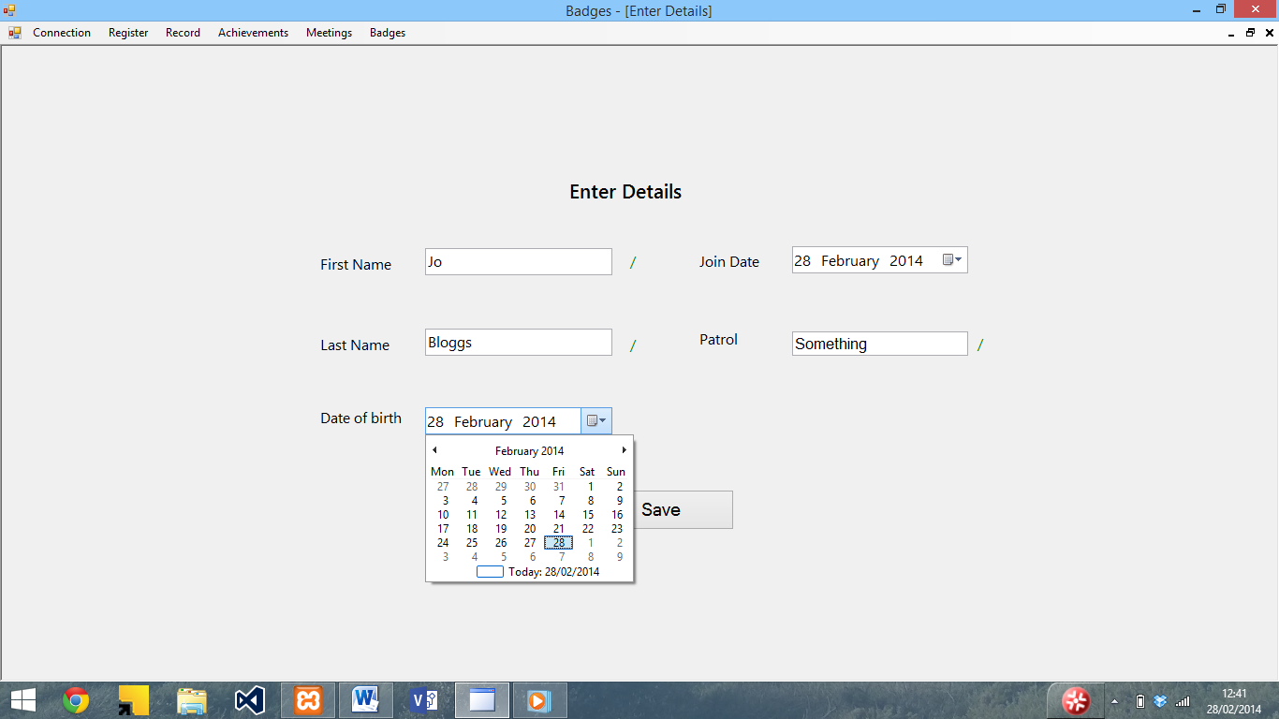

Step 6: Press the save button to save the record. A confirmation will then be displayed.

View Achieved badges

Step 1: Open the program and choose connect to SQL server from the connection menu

Step 2: Enter the server details and press Ok



Step 3: Select view achieved badges from the achievements menu.

Step 4: Enter the date range using the drop down calendar in the form that appears and press view

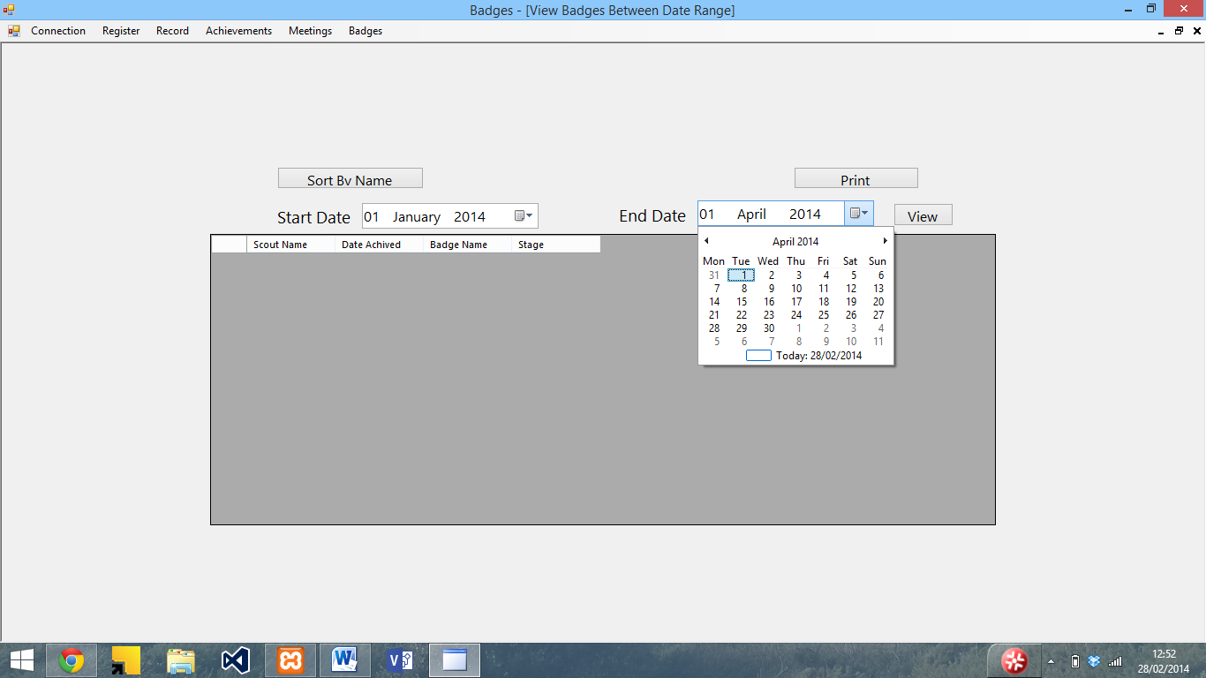

Step 5: The achieved badges between the date range will then be displayed

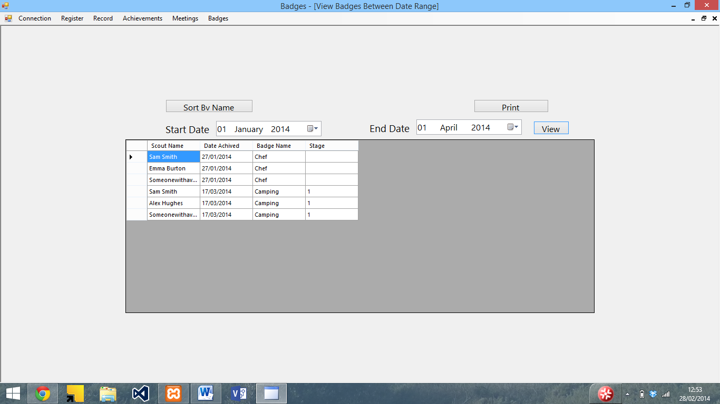

Add a meeting

Step 1: Open the program and choose connect to SQL server from the connection menu

Step 2: Enter the server details and press Ok



Step 3: Select Edit meetings from the meetings menu

Step 4: In the screen that appears, select the meeting date, along with badge name and part

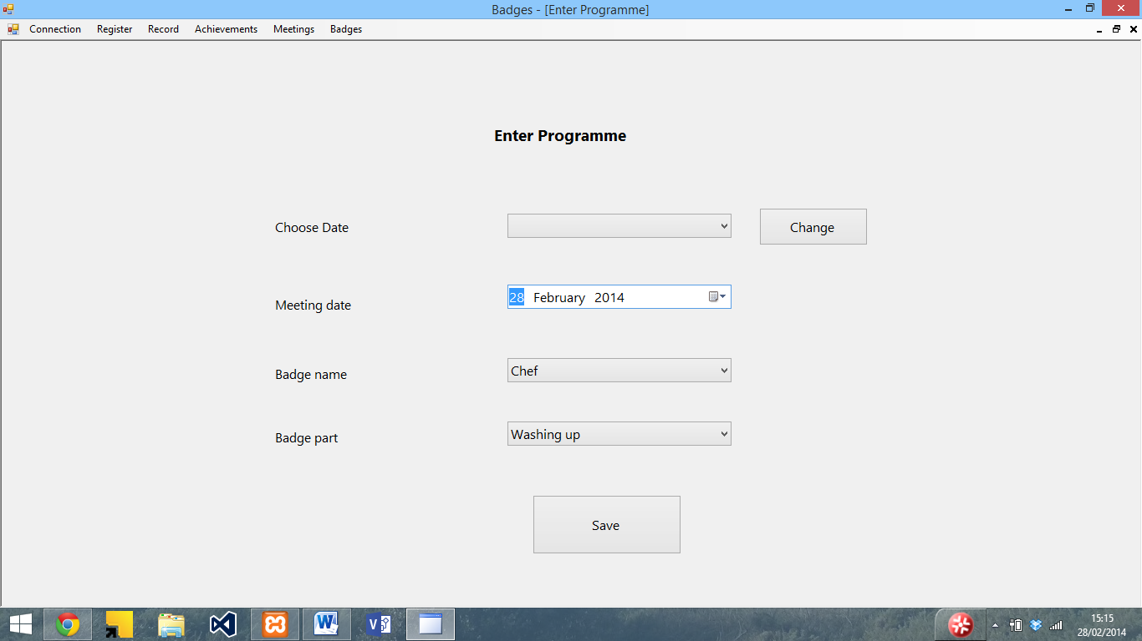

Step 5: Once you have entered the details, press save to save the details

Appraisal

In this section, I will analyse how well the system meets the original objectives, as well as gather some end user feedback on the system and suggest some ways in which the system could be improved

# Comparison with original objectives

Below I have compared the final system with the original objectives that I set out in the analysis.

1. To be easily useable

Met – All of the system is clearly labelled and a complete user guide is available as well.

* 1. The end user must be able to navigate to all of the functions within 4 mouse clicks.

With the exception of enter parts (which require more clicks to select the badge) this has been met.

* 1. Inputs need to provide instruction and validation to ensure the system doesn’t crash

This has been met – all of the inputs have labels descriptions and the system has a complete user manual. There is also validation for all of the inputs to ensure that they will not crash the system.

* 1. There must be adequate documentation in order to ensure that this happens. This must be ready at the same time as the program.

This has been met – The system has a full user manual which is ready at the same time as the system

1. To be able to store the attendance data

This has been met – the user is able to enter the attendance data into the system which then stores it for later viewing

* 1. The end user must be able to enter the attendance data into the system with no more than 2 clicks per record

This has been met – the attendance requires one click of a tick box to enter for each record

* 1. This data must then be stored for future use as soon as the user presses save

This has been met – the attendance data is stored in the database as soon as the user presses save

1. To be able to store details of the achieved badges

This has been met - The user can manually enter achieved badges as well as entering attendance for meetings which automatically updates the achieved badges record.

* 1. The end user must be able to enter in the achieved badges

This has been met – the user can manually enter achieved badges as well as the register

* 1. This will then need to be stored with the persons record as soon as the end user presses save

This has been met – the Log table is updated with the achieved badge part

1. To be able to see which badges have been achieved based on attendance

This has been met – the user can use the view achieved badges function to see the achieved badges based on attendance and manually entered achievements

* 1. The end user must be able to enter the attendance register each meeting

This has been met – the user can enter the attendance for each meeting

* 1. The system must be able to determine the attendance for each session, along with the parts of badges within 15 seconds of the end user loading the section

This has been partially met – the attendance for each session is displayed within 1 second of the section loading (tested on a dual core laptop) although the badge part for each meeting is not displayed next to the meeting date in the enter attendance screen.

* 1. The system must then be able to produce an achieved badges list which the user can then print

This has been met – the system is able to produce a list of achieved badges which can be then printed

1. To be able to print achieved badges lists

This has been met – the system is able to produce lists of achieved badges which can then be printed

* 1. The system must be able to produce an achieved badge list for the end user

This has been met – the system can produce a list of achieved badges from the achieved badge parts

* 1. The end user must then be able to print this list for reference if they want to

This has been met – the user and print the list of achieved badges

1. To be able to view and print record cards

This has been partially met – the user can view achieved badges for an individual person

* 1. The end user must be able to view a list of all the badges each person has achieved similar to the record card used in the existing system

This has been partially met – the user can view the all the badges each person has achieved, although it does not list all of their details and the badges they have not achieved.

* 1. The end user must then be able to print it

This has been met – the user is able to print the list of achieved badges for each person

1. To see which sessions have been missed in order to work out which stages to run

This has been met – the user is able to view which sessions have been missed and by whom.

7.1 The system must be able to work out which scouts missed meetings between a date ranges. The system must be able to calculate this within 15 seconds

This has been met – the user can enter a date range to view and the missed sessions will be displayed. The system can typically do this in less than one second (dual core laptop)

7.2 The system must then be able to determine which badges were being done on those dates and produce a list of people who missed the sessions sorted by date

This has been met – the system displays details of the badges which were being done at the meetings as well as the people who were not there.

1. To see which parts of a badge have not been achieved in order to assist in programme planning

This has not been met – the program is not able to produce a list of parts.

* 1. The system must be able to produce a list of the badges sorted by number of achieved times based on the badges database

Partially met – the system is unable to produce a list of parts, although it is able to produce a list of achieved badges

1. To be able to modify the badges to enable new badges to be entered / requirements to be updated

This has been met – the badges can be added to or edited at any time

9.1 The end user must be able to modify the badge details as well as being able to add and remove badges. This must be able to be done within the main programme

Partially met – the user is able to add and edit badges within the main program, although it is not possible to delete them within the program.

1. To be able to be easily adapted for use with Scouts and Beavers

This has been met – the user simply needs to create another database by entering Beavers or Scouts in the database box when connecting to the SQL server

10.1 The end user must be able to modify the badges and the records in order to use it with the other sections of Scouts. This must be able to be done within the program

This has been met – the user simply needs to create a new database (which can be done within the program) and enter the details for another section.

1. To be able to access the main functions of the program quickly

This has been met – the main functions are easily accessible from the menu bar.

* 1. The end user must be able to use the program without needing any external help

This has been met – there is a complete user guide which provides instructions on how to use the system

Overall, the system does meet the original objectives, with the exception of viewing the parts of the badge which have been achieved, which I ran out of time to implement, Badge parts next to the meeting dates in the enter attendance screen (which I could not find a way of having the part as well as meeting date without having big column headings), deleting meetings (although it is possible to edit them), which I ran out of time to implement, and Viewing the record cards, which I was unable to do due to the fact that I could not find a way do display it in the format of the record card, although I was able to create a view individual record form.

# User Feedback

I gave my program, along with the user guide to Terry Newman, the Assistant Group Scout Leader and a Cub Scout Leader, who gave me the following feedback on my program:

|  |  |
| --- | --- |
| Gmail | **Andrew Burton <andrew.p.burton@gmail.com>** |

|  |
| --- |
| **Your Database is setup** |

|  |  |
| --- | --- |
| **Terry Newman**<tmn.m6aqw@sky.com> | 16 March 2014 12:06 |
| To: Andrew Burton <andrew.p.burton@gmail.com> | |
| |  | | --- | | Hi Andrew  I've had a look at the database. Very good effort,  a couple of points to start with worth noting it could be a bit more intuitive for example it's not obvious in which order you put the data in, it's worth bearing in mind that not every user is going to be computer savvy.  The screen layout is very good, nice and clear the only thing I did notice is after putting data in and saving, the fields are not cleared a bit disconcerting, I did like the year fields, I didn't realise till after some time of scrolling day by day that clicking the year you could scroll back a year at a time and then pick the date from there nice touch.  The manual is very good, very clear my only comment would be the order that the instructions are in.  All in all a useful database I'll give you more feedback later when I've loaded more into it and used it more.  Regards Terry |  Analysis of user feedback The user said that the system could be a bit more intuitive. To do this I could have added more help prompts within the system, and made the system clearer to use.  They liked the layout of the program although found that the fields are not cleared after saving data. This could have been easily done, and if I was to make any changes to the program I would do this.  They also commented on the year fields. Again, I could have added the prompts to these to make it clearer how to use them.  The user liked the user manual, but felt that the instructions are in a slightly bad order, which I could have improved (such as by putting the quick guides first, or sorting the forms by order of use).  Overall they said it was a useful system. | |

# Future Improvements

There are a few ways in which the system could be improved. To start with, I would modify the view individual record to show a full record, add a function to see the badge parts achieved, add the badge parts to the attendance screen, and add a function to delete the meeting dates.

The system could also be made to work offline, using SQLite, Microsoft Access or a similar database system so an internet connection would not be required to use the program, however I did not have the time or skills to implement this whilst I was creating the program.

The system could also be modified to allow the user to edit the details of the SQL server, such as adding user accounts and changing permissions within the program, rather than having to use a SQL management program, however I did not have the time or skills to implement this whilst I was creating the program.

I could have also included some more help prompts and made parts of the system clearer to use, in order to make it easier to use. I could have also made sure that all the fields are cleared after saving data, rather than just some.

I could have also added a section to allow the user to edit the database, including setting levels of access and repairing the database within the program rather than having to use a specific database management package.

Appendix A – Testing Screenshots

This section contains screenshots of tests used in the testing section. The numbers above the screenshots relate to the numbers in the testing table in brackets.

1)

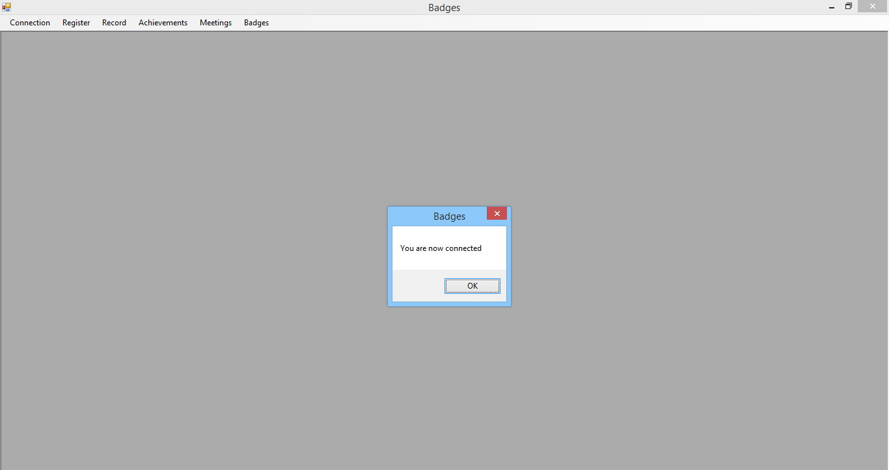

2)

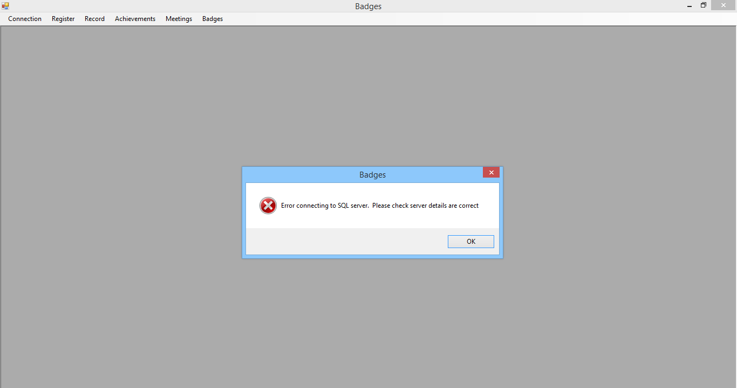

3) 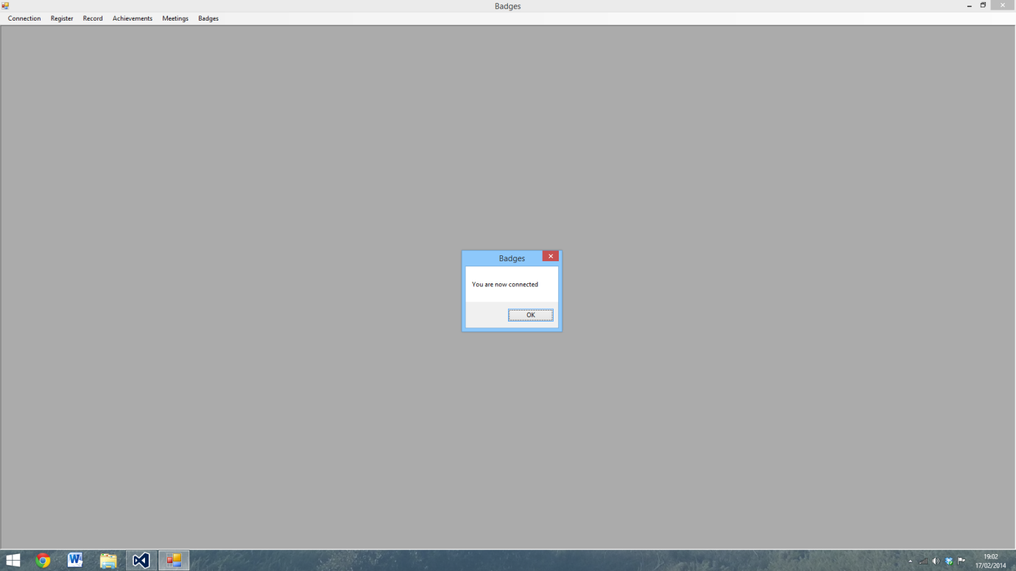

4)

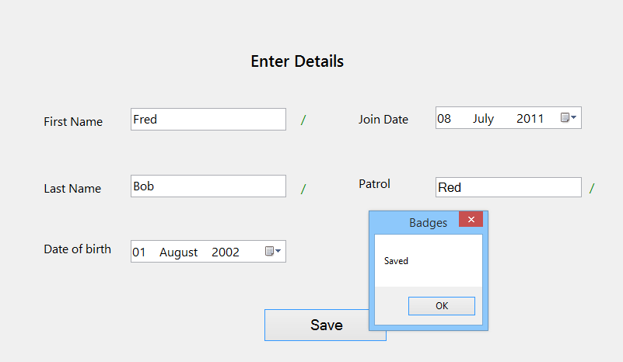

5)

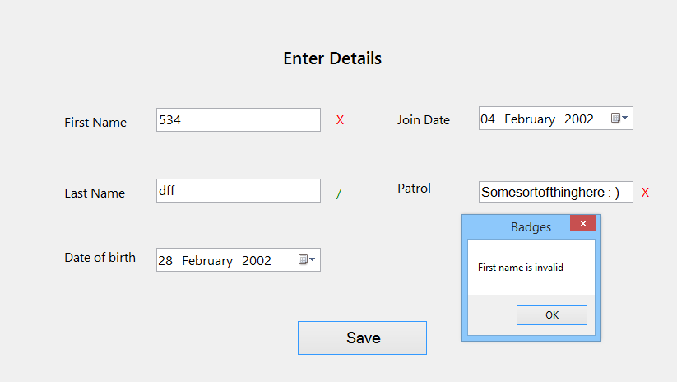

6)

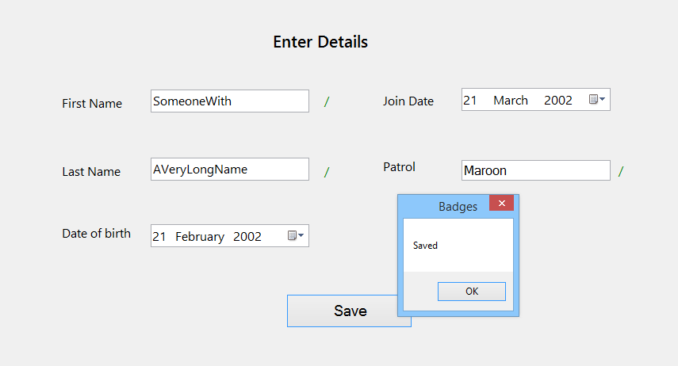

7)

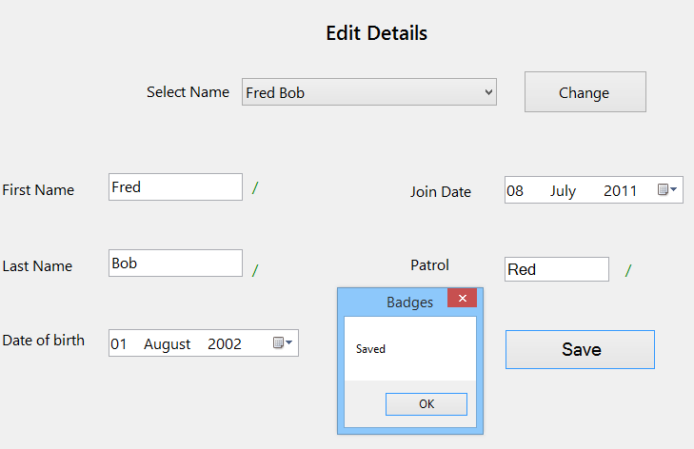

8)

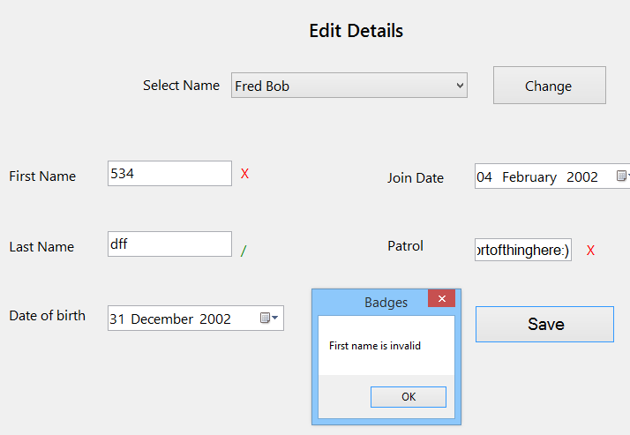

9)

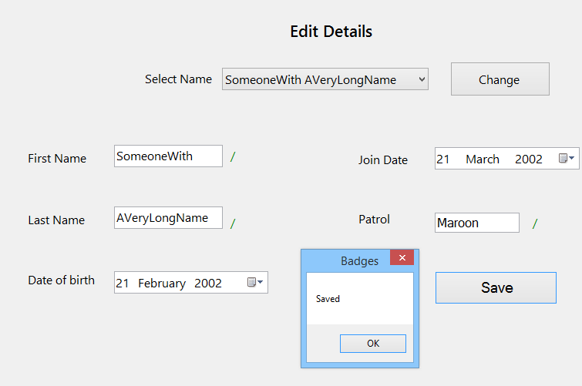

10)

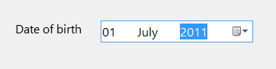

11)

Defaults to

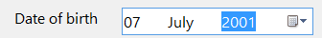

12)

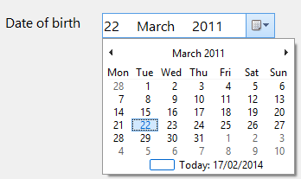

13)

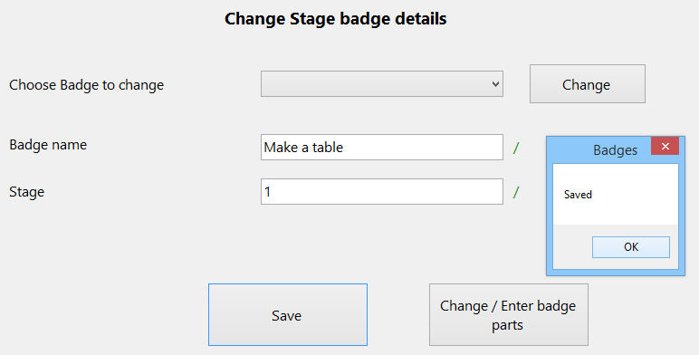

14)

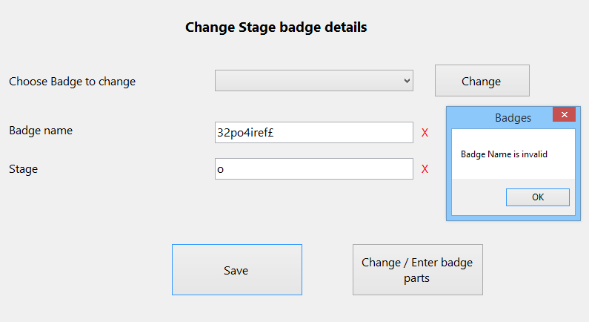

15)

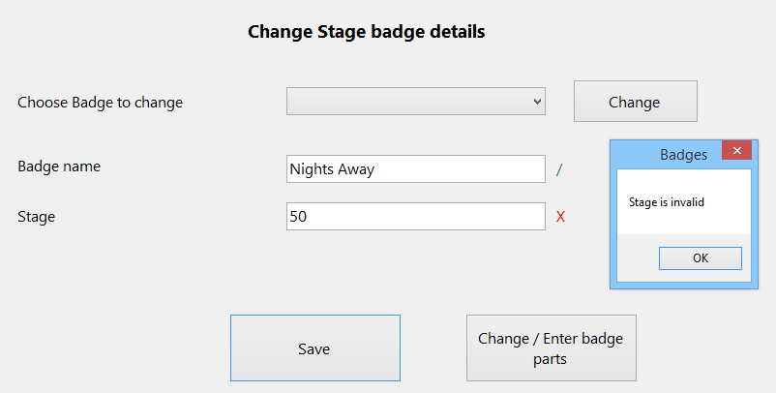

16)

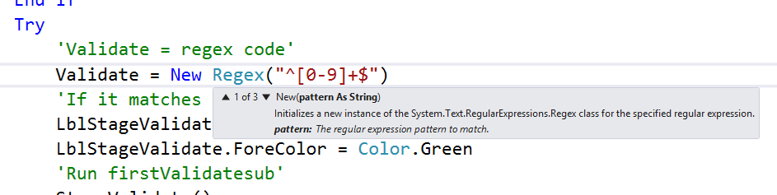

17)

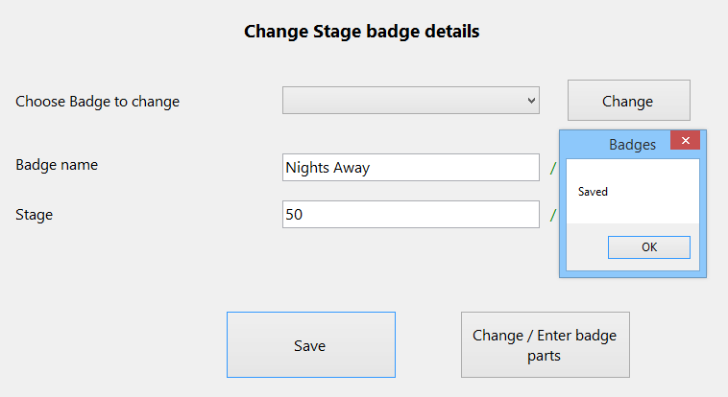

18)

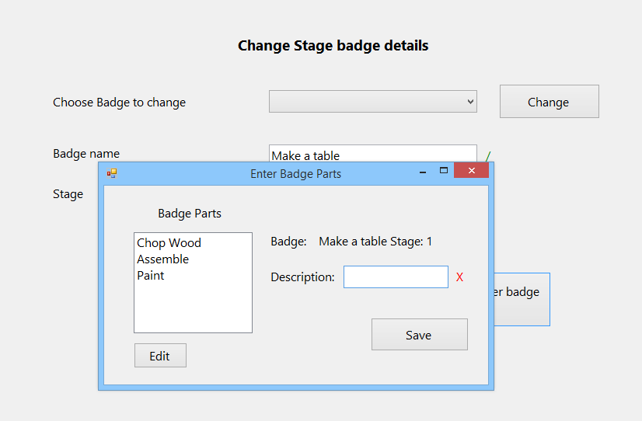

19)

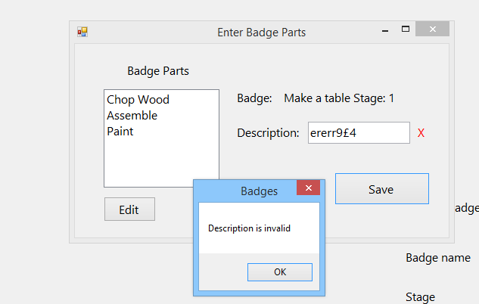

20)

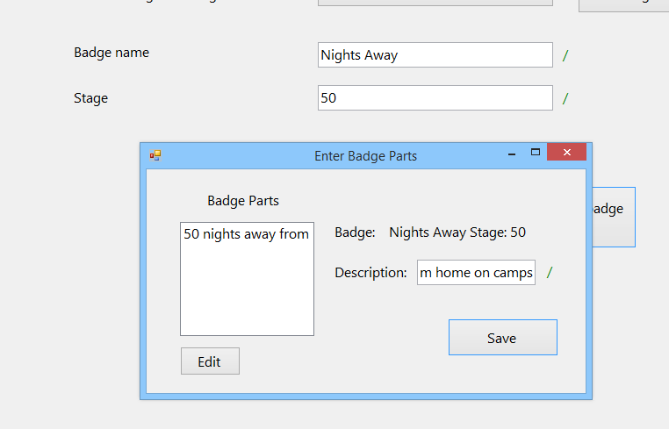

21)

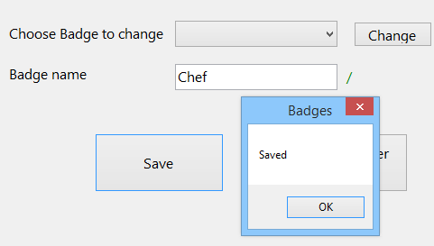

22)

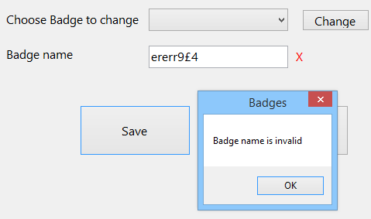

23)

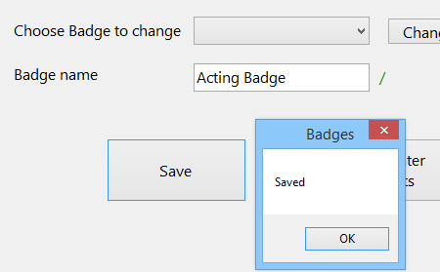

24)

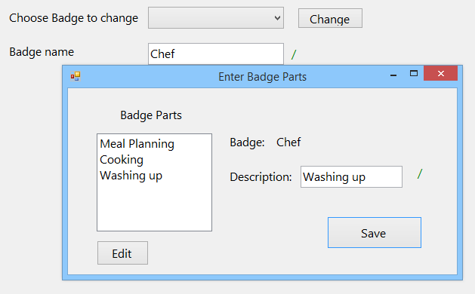

25)

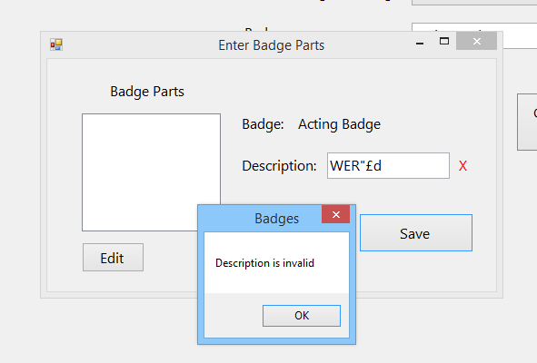

26)

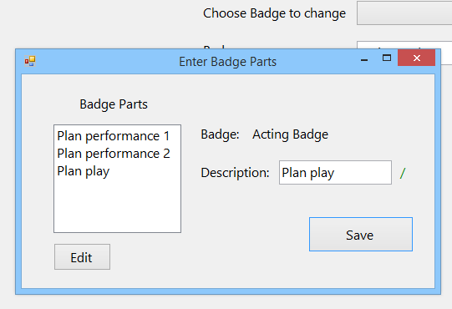

27)

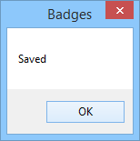

28)

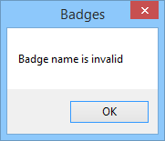

29)

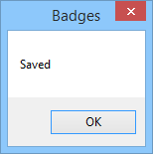

30)

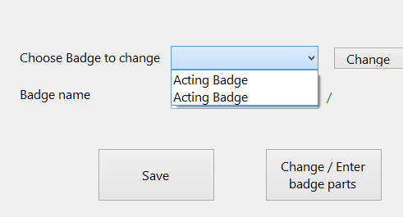

31)

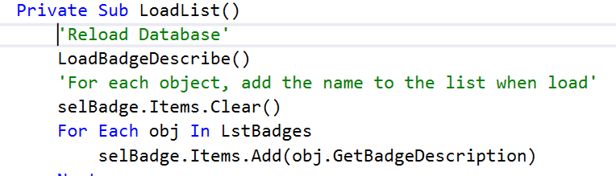

32)

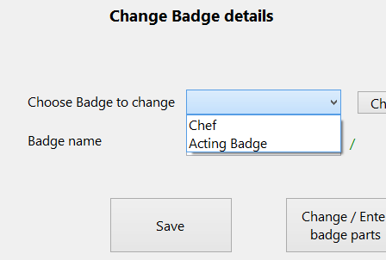

33)

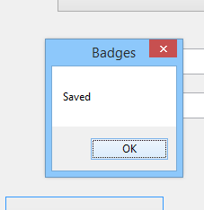

34)

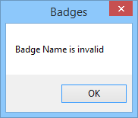

35)



36)

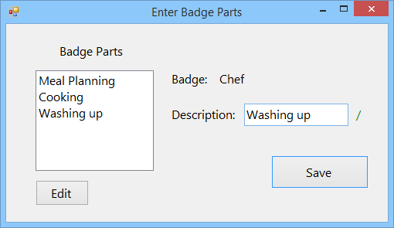

37)

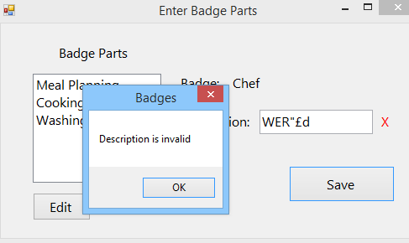

38)

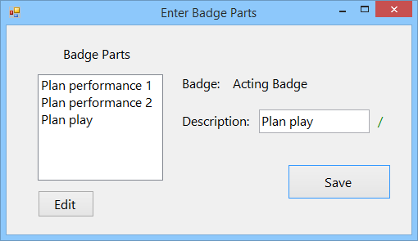

39)

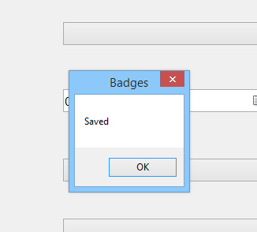

40)



41)



43)

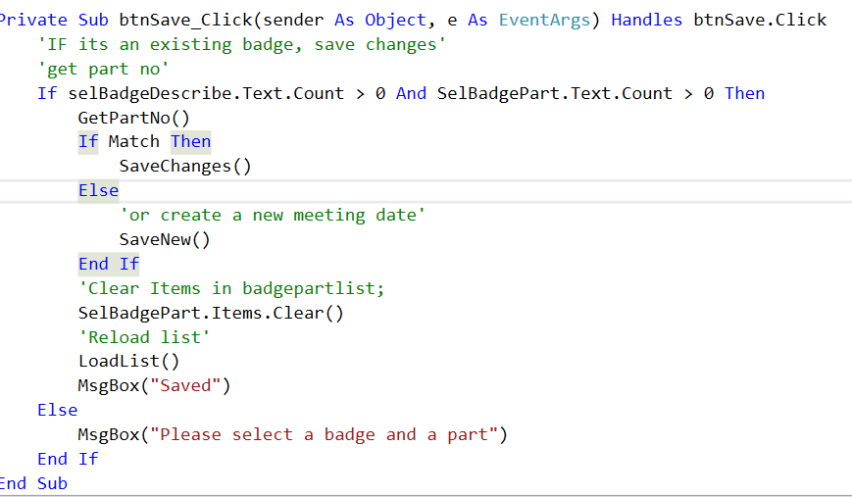

44)

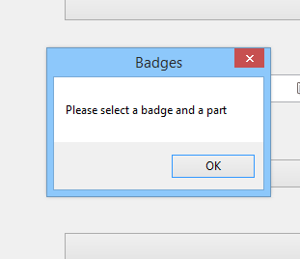

45)



46)

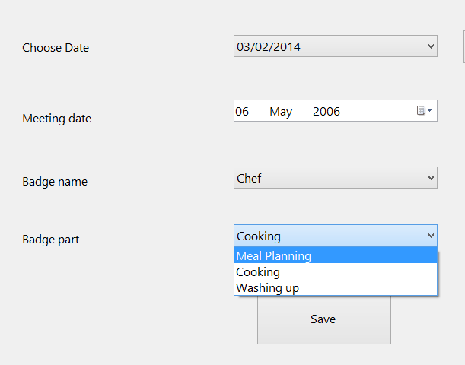

47)



48)

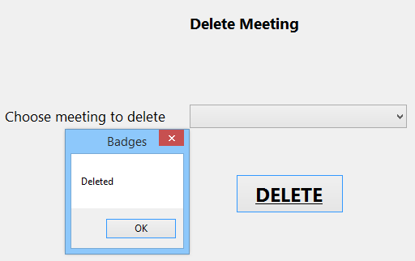

49)

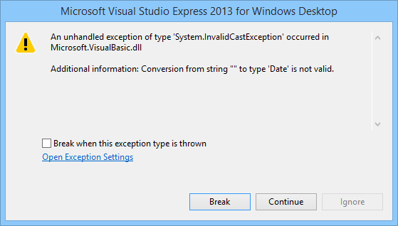

50)

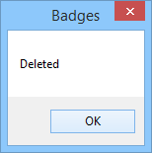

51)

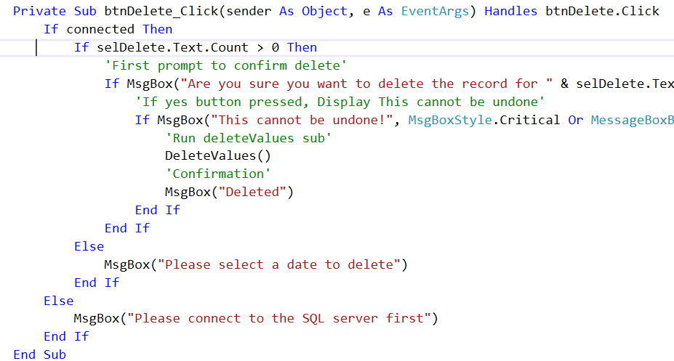

52)

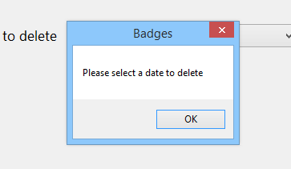

53)

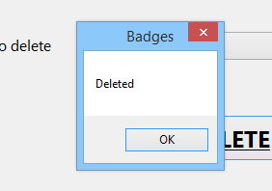

54)

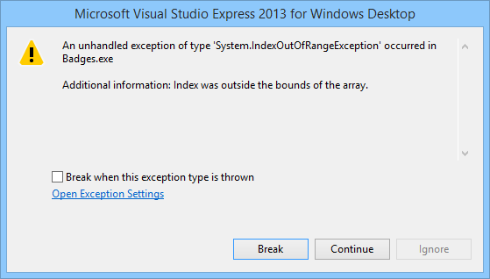

55)

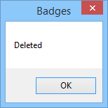

56)

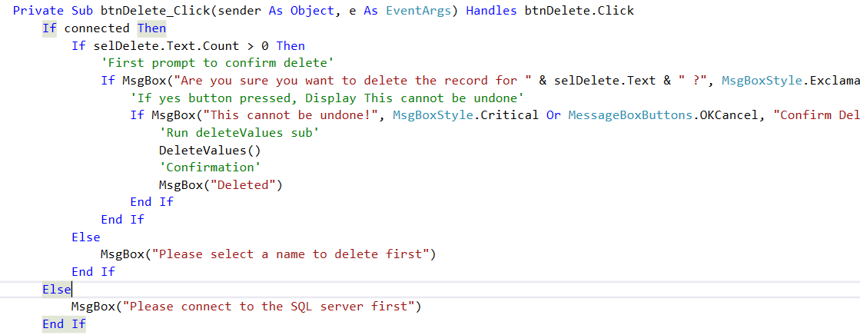

57)

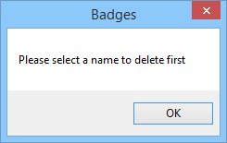

58)

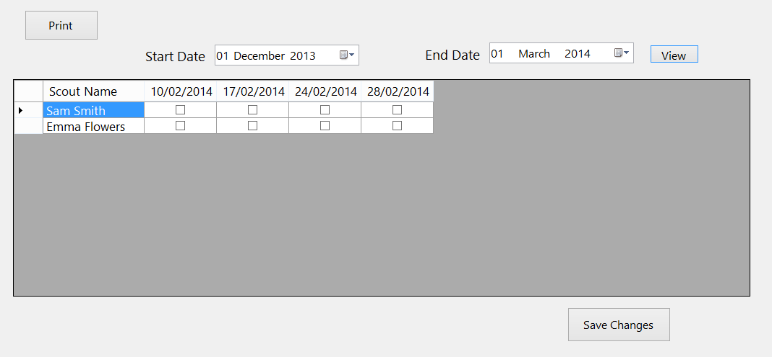

59)



60)

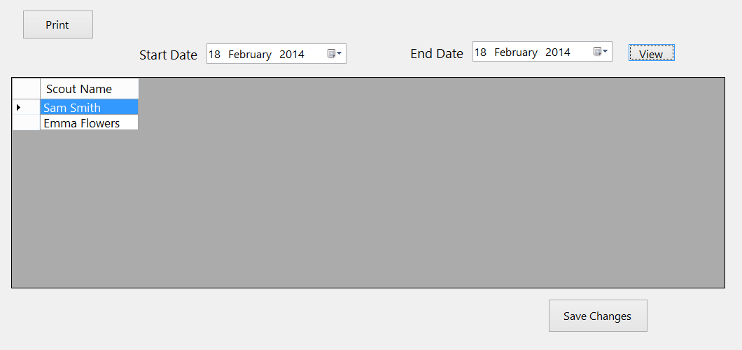

61)

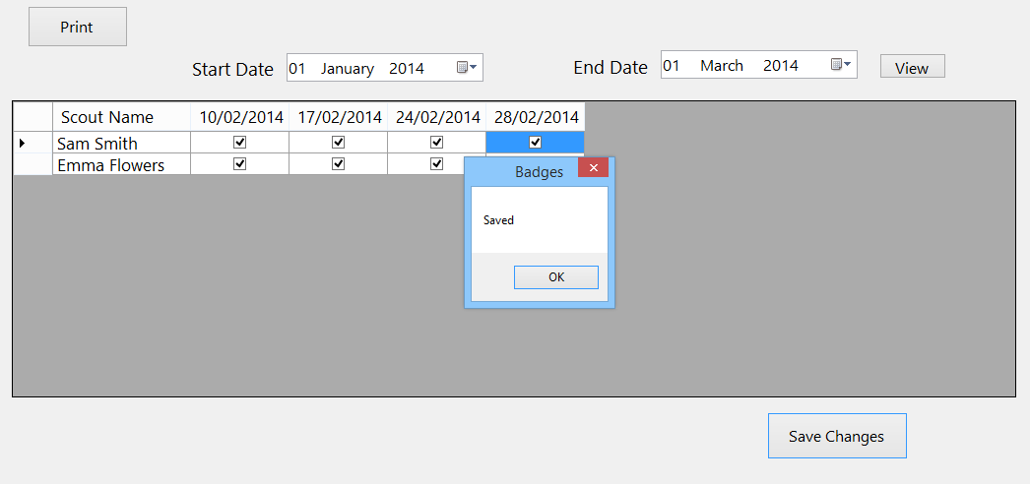

62)

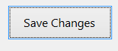

63)

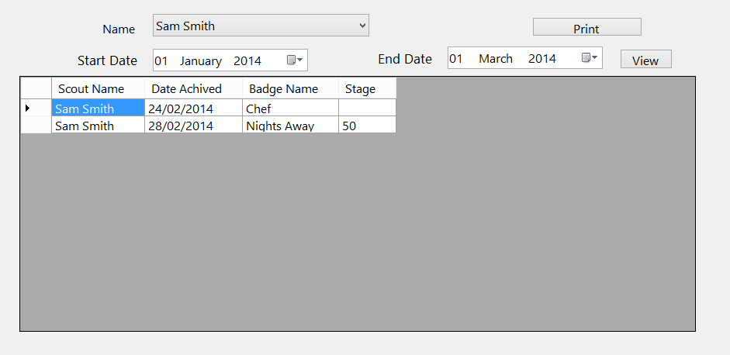

64)



65)

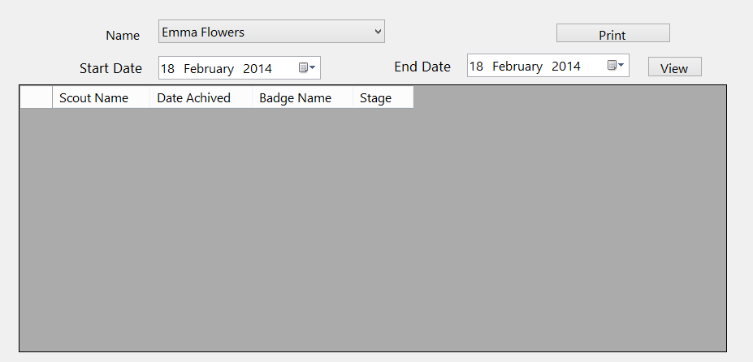

66)

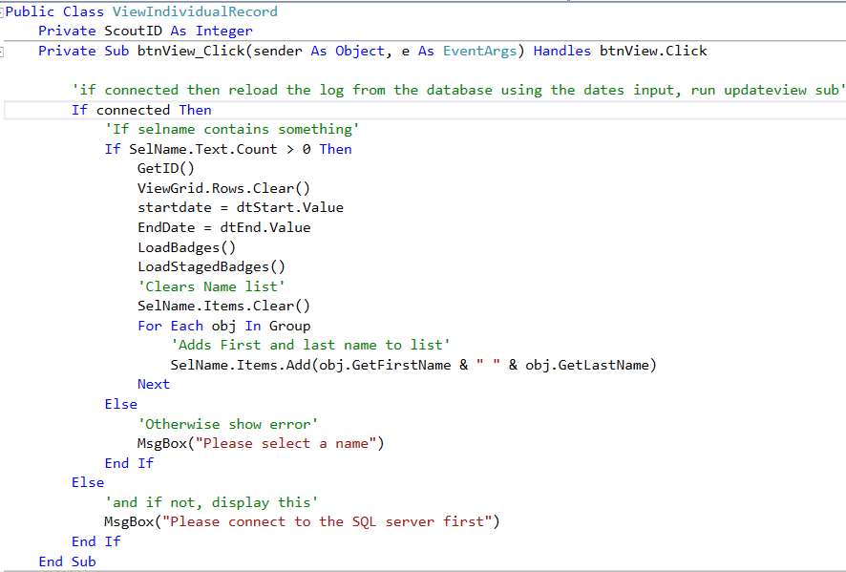

67)

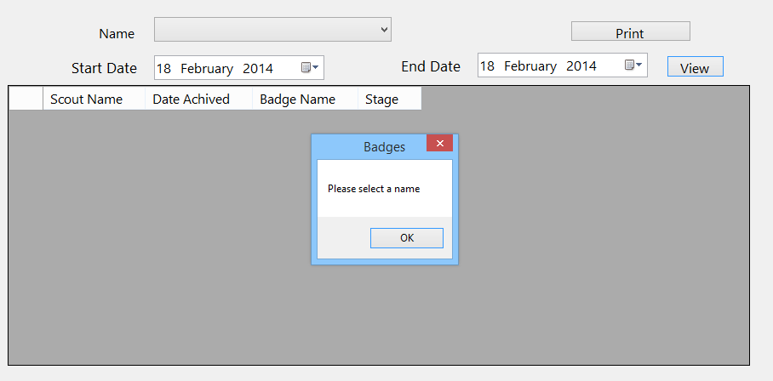

68)

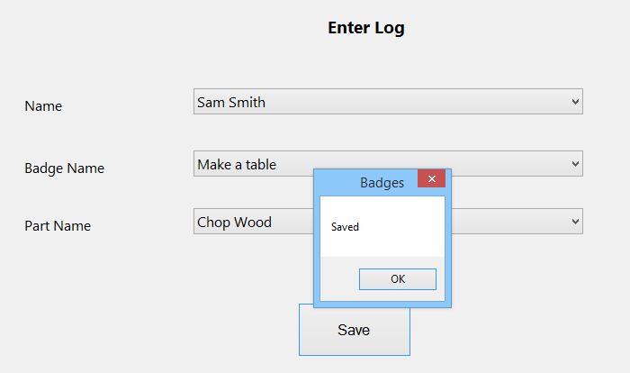

69)



70)

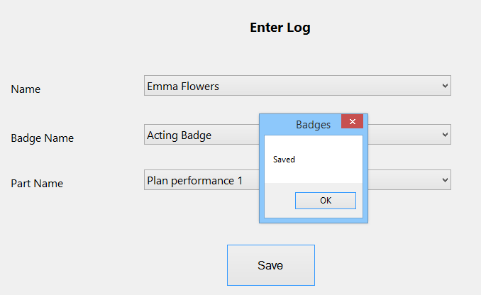

71)

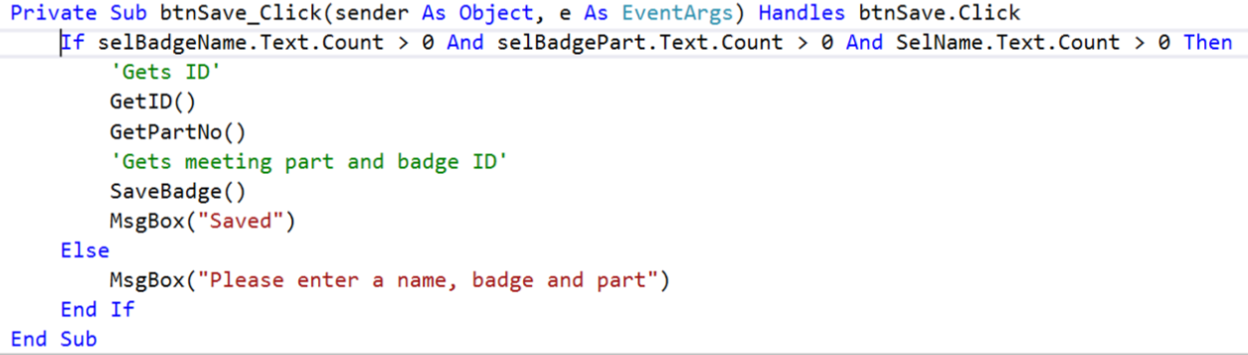

72)

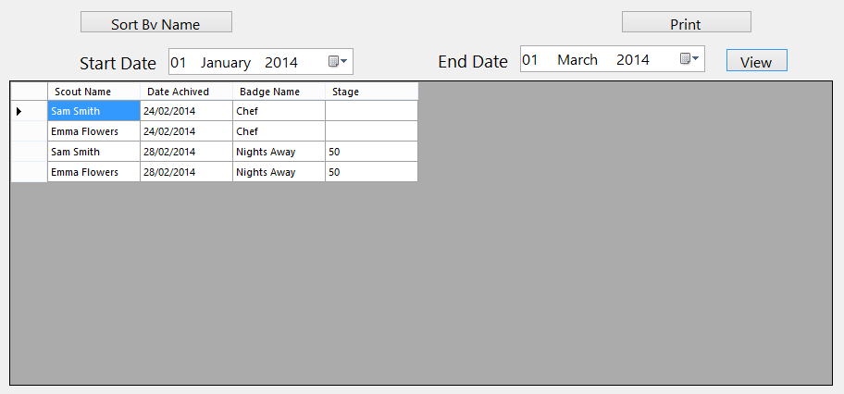

73)



74)

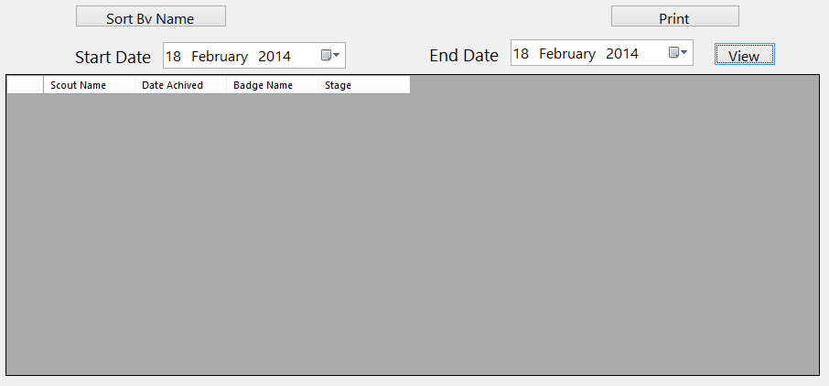

75)

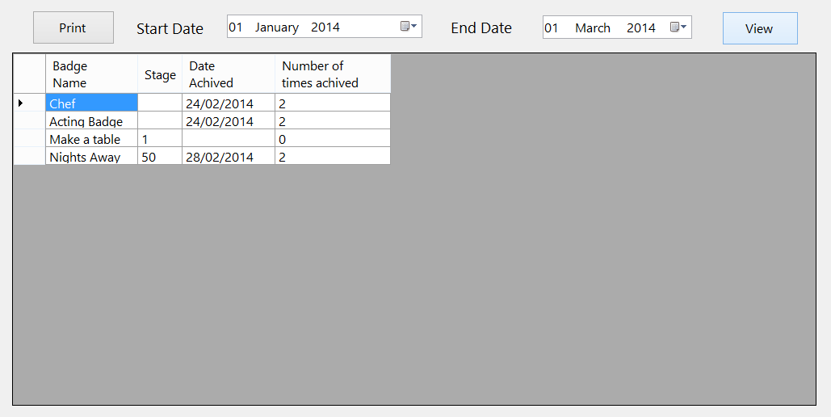

76)



77)

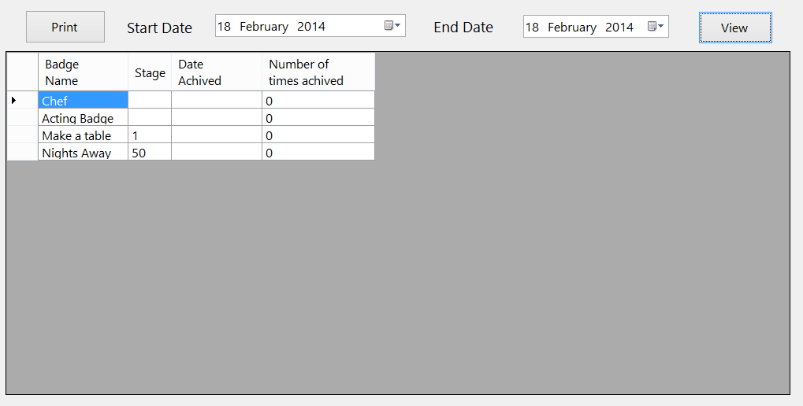

78)

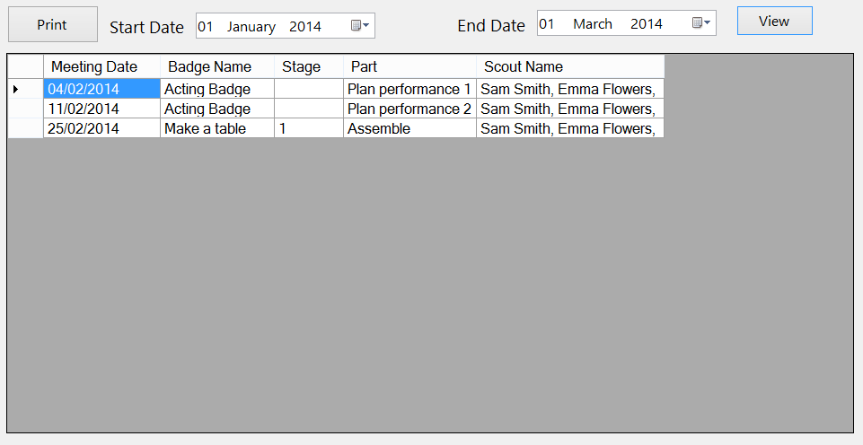

79)

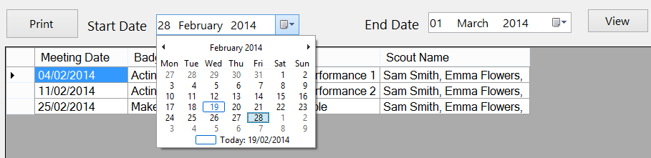

80)

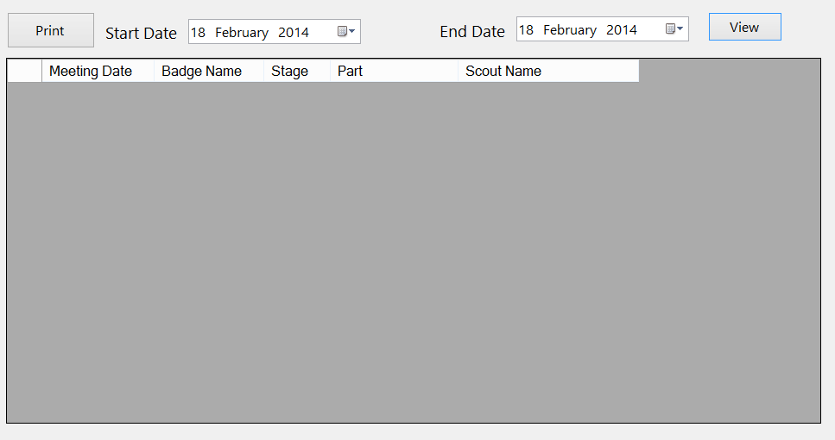

81)

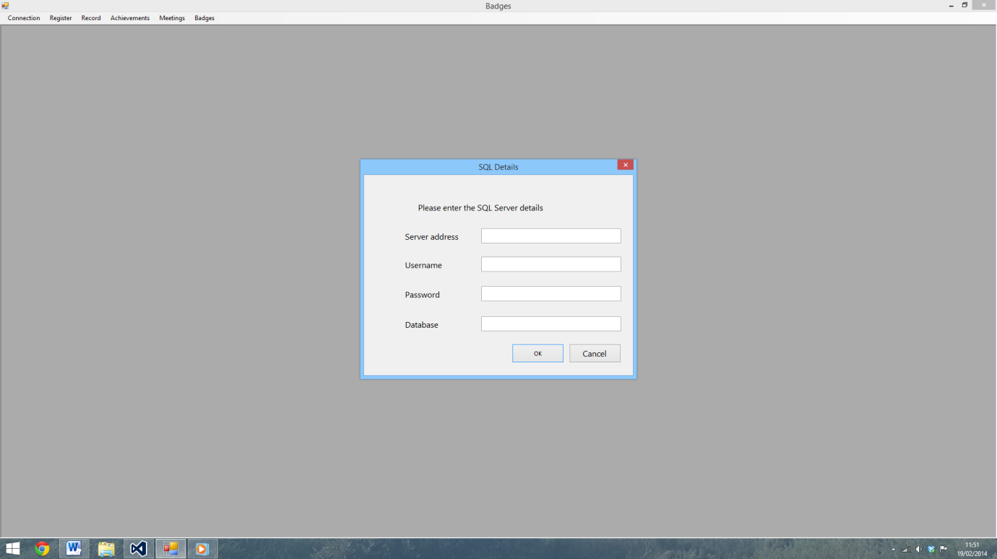

82)

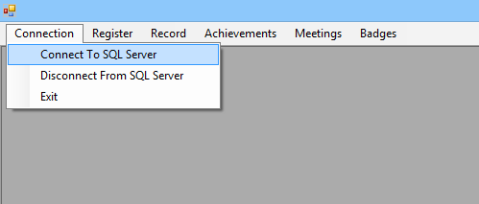

83)



84)



85)

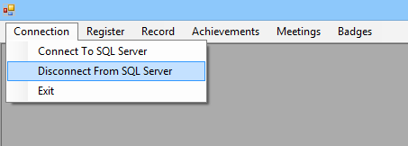

86)



87)



88)



89)



90)

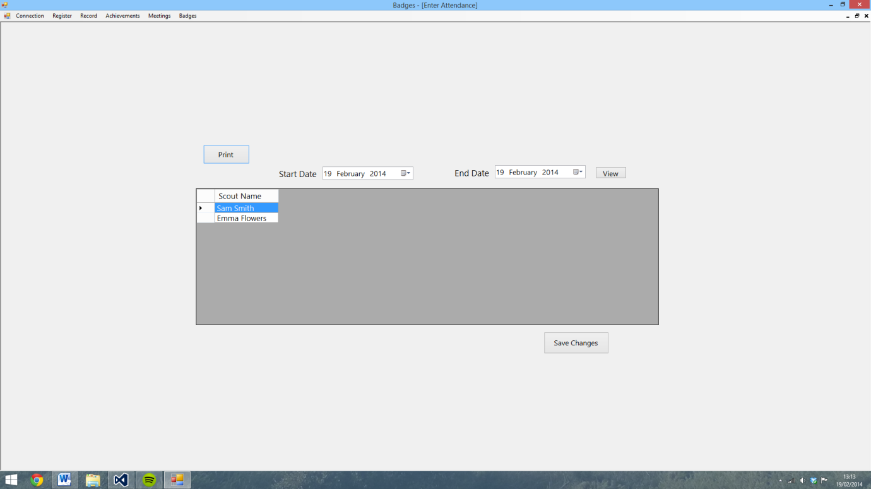

91)

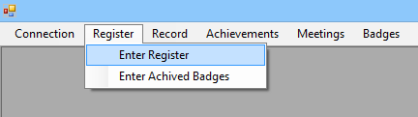

92)

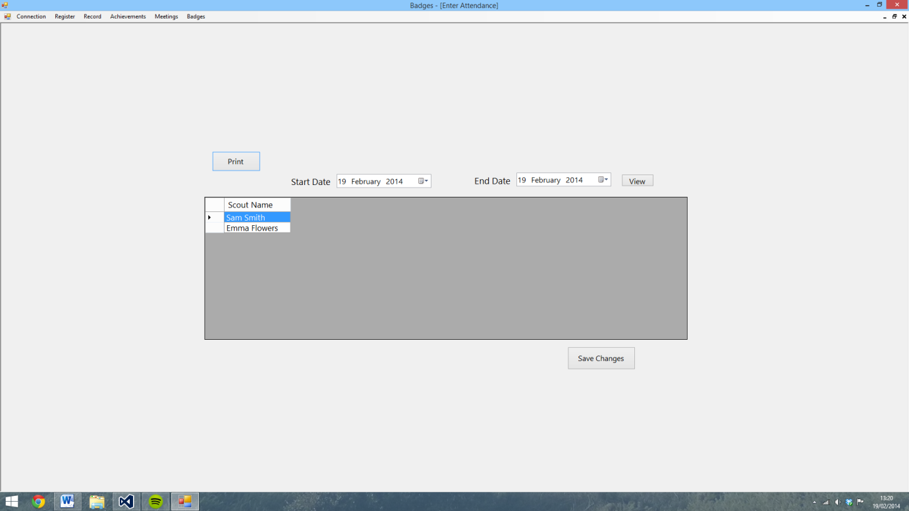

93)

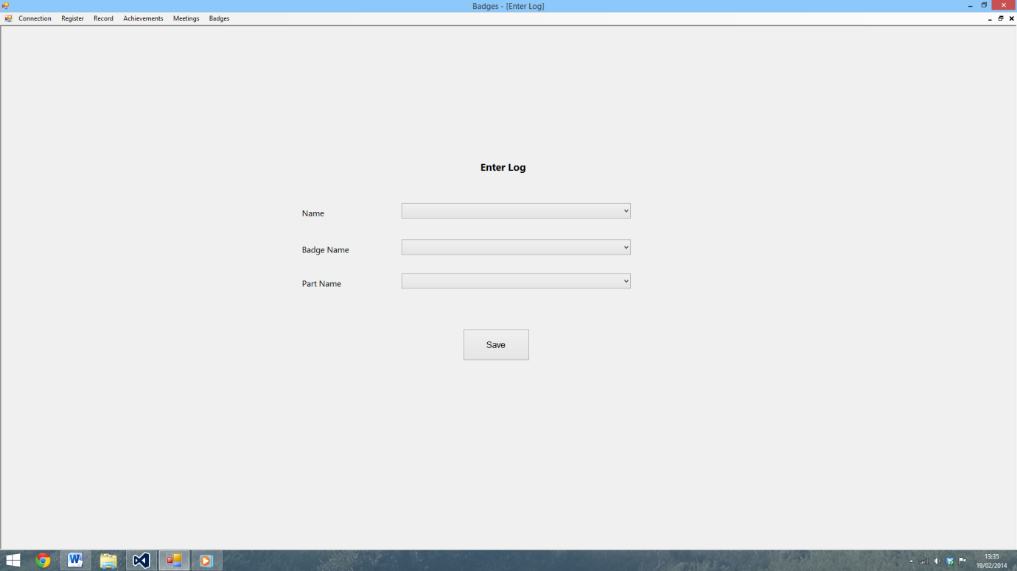

94)

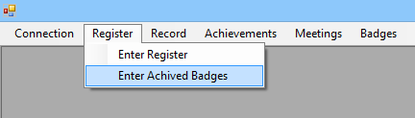

95)

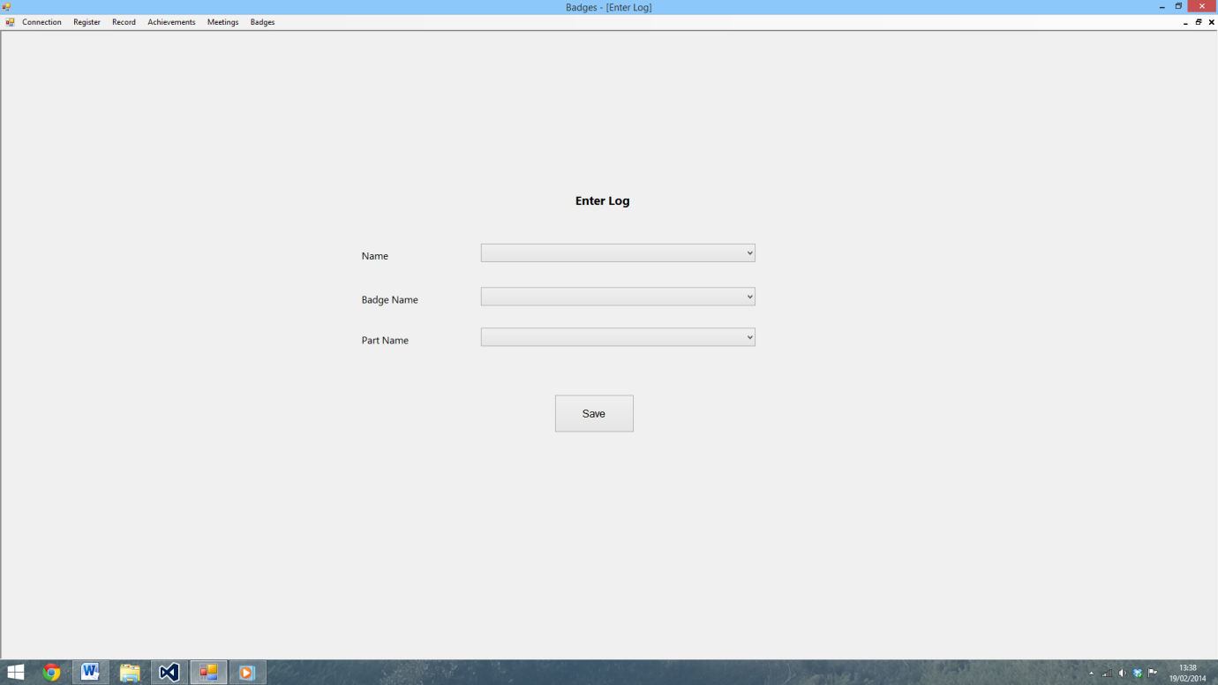

96)

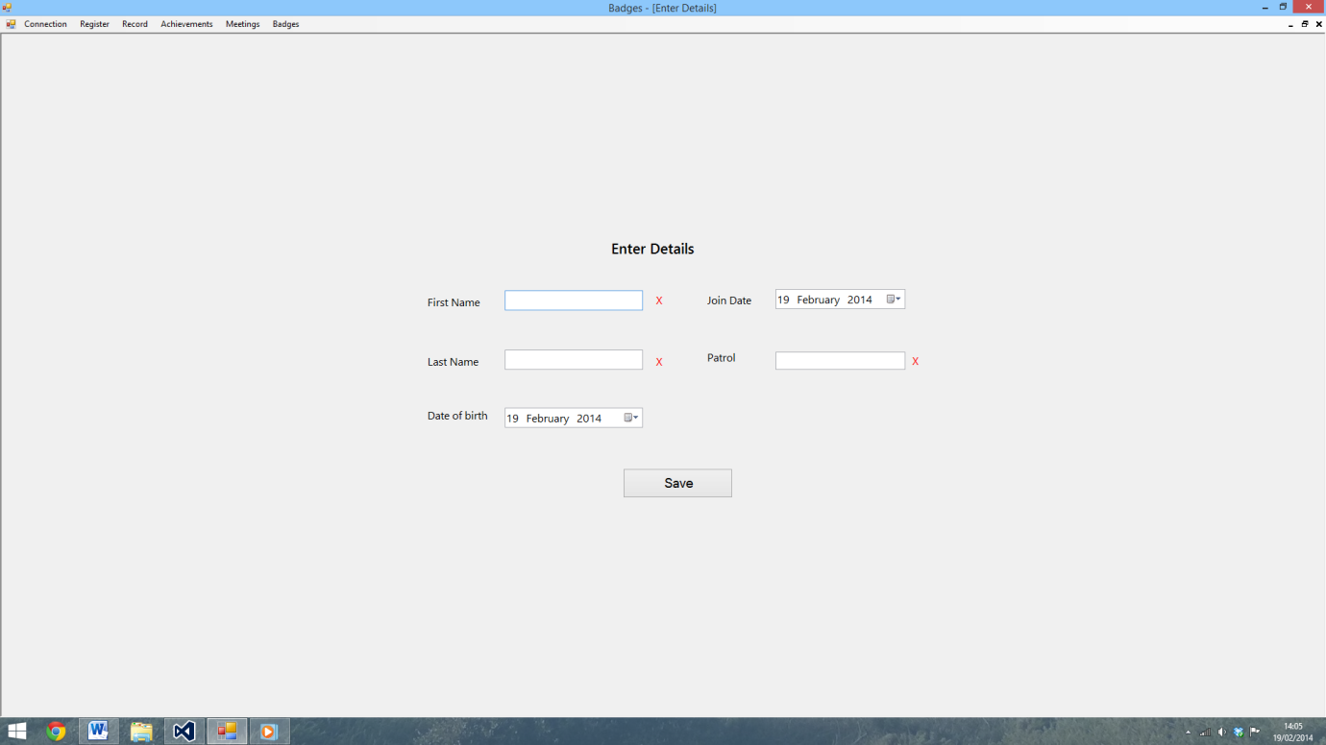

97)

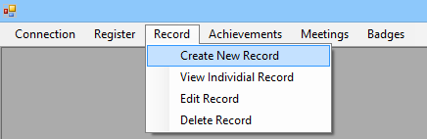

98)

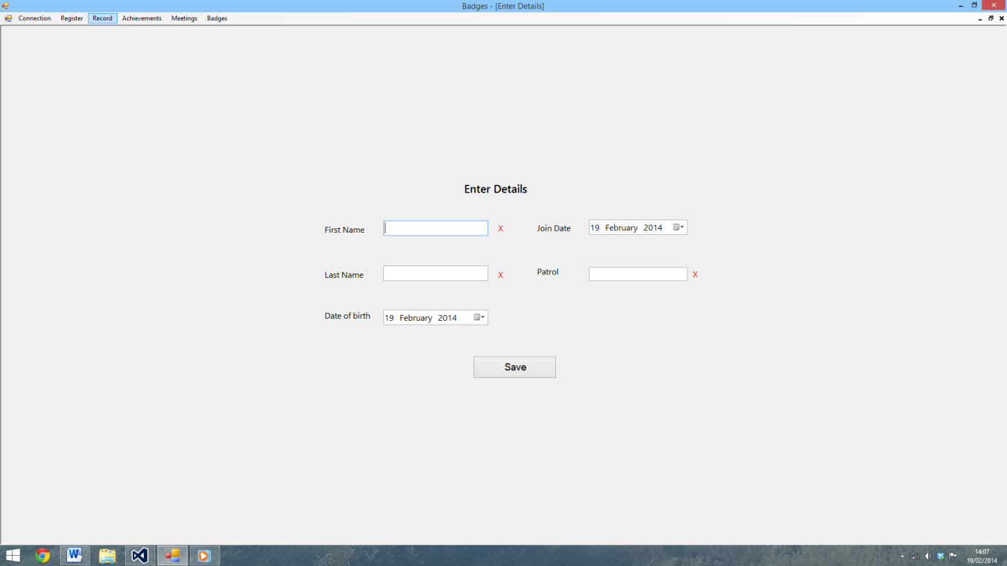

99)

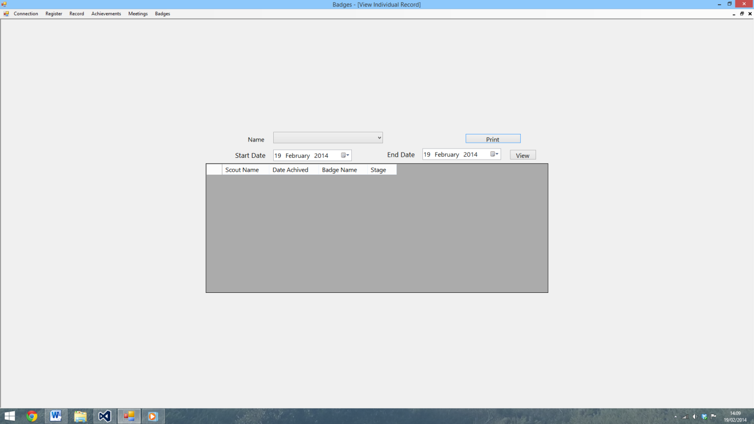

100)



101)

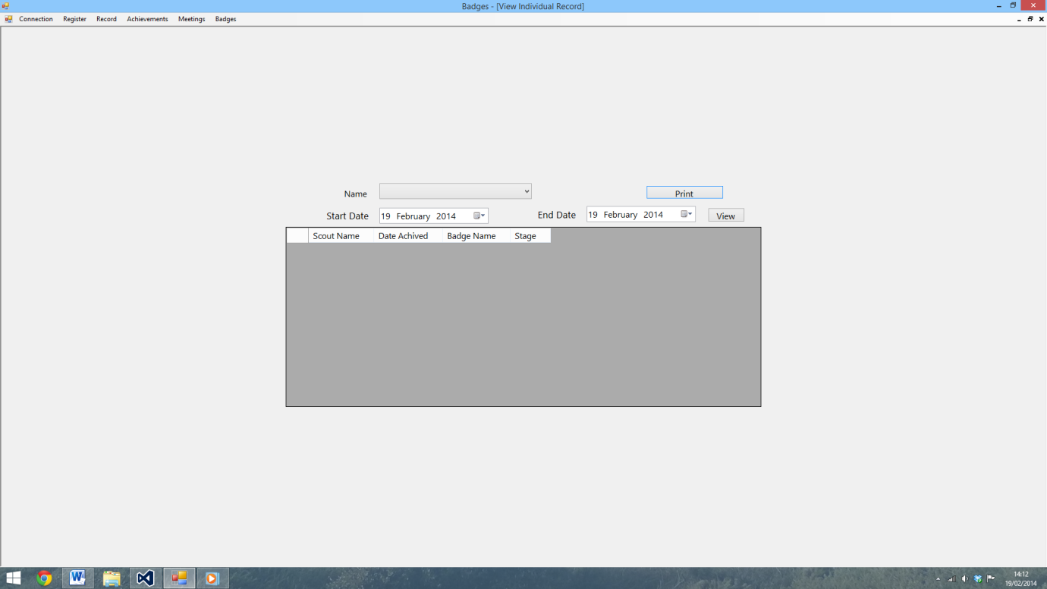

102)

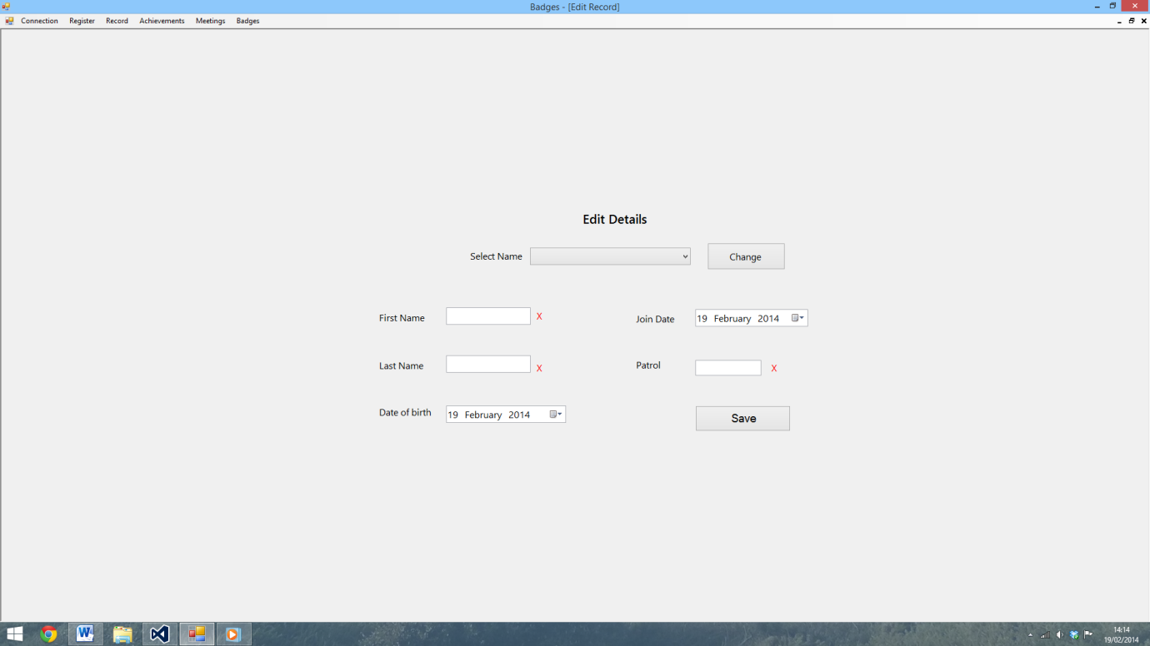

103)



104)

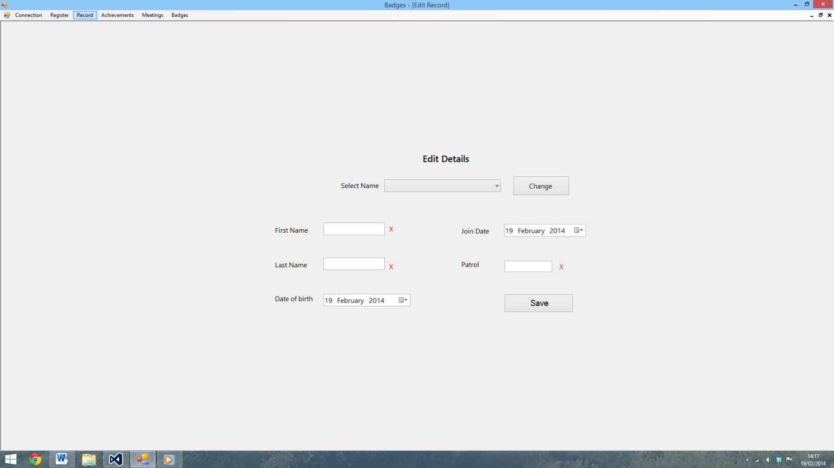

105)

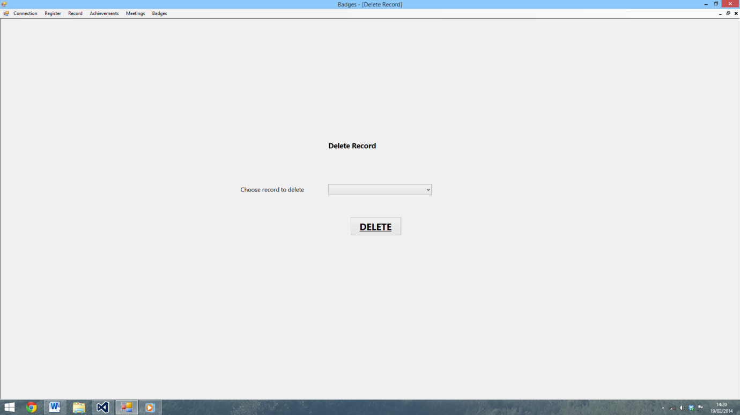

106)

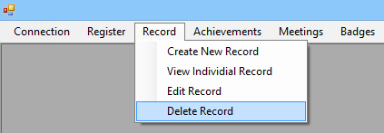

107)

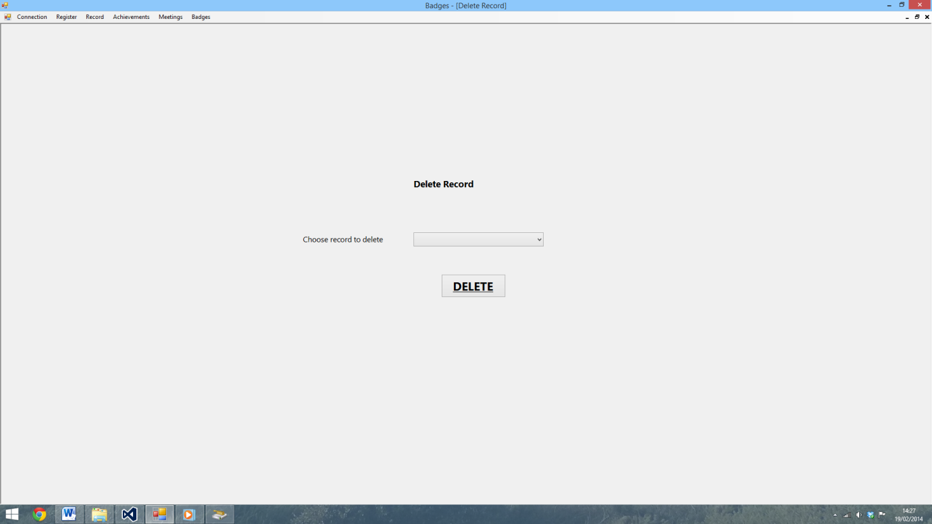

108)

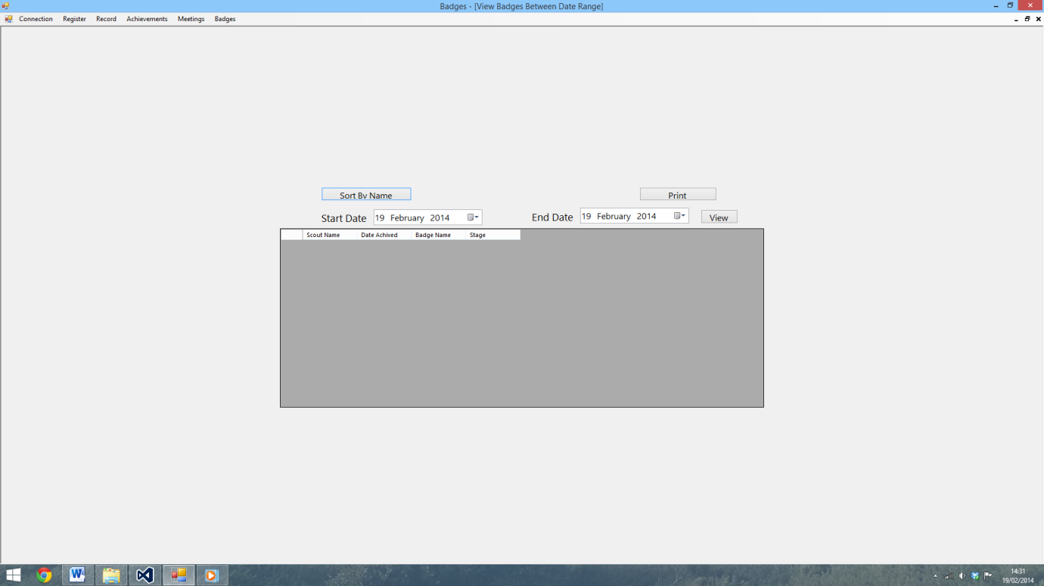

109)



110)

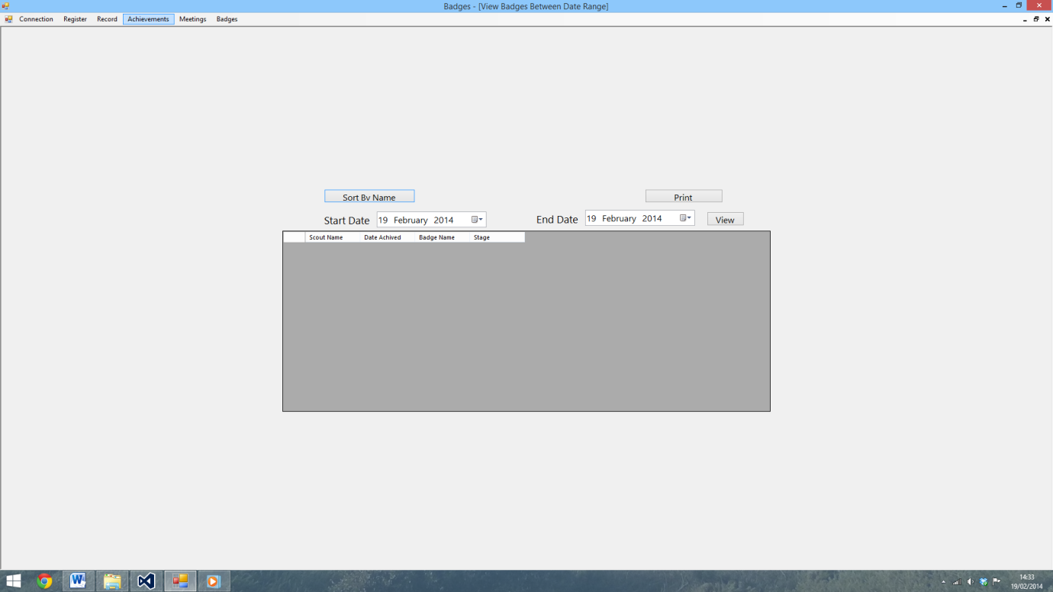

111)

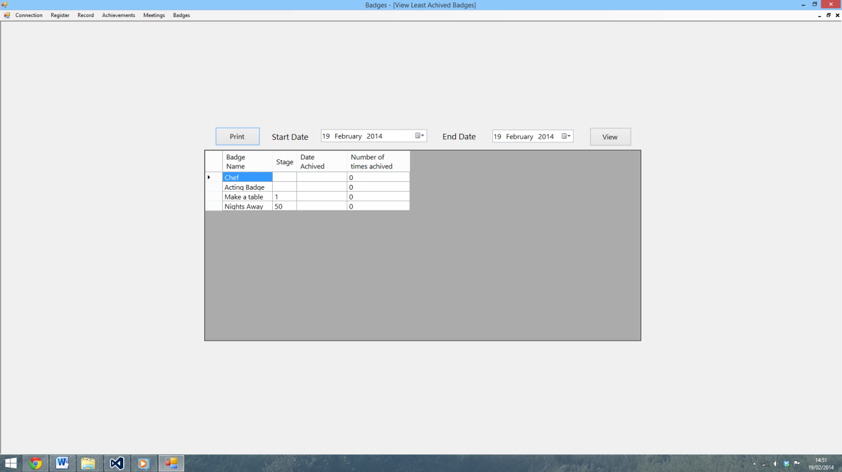

112)

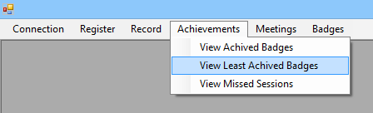

113)

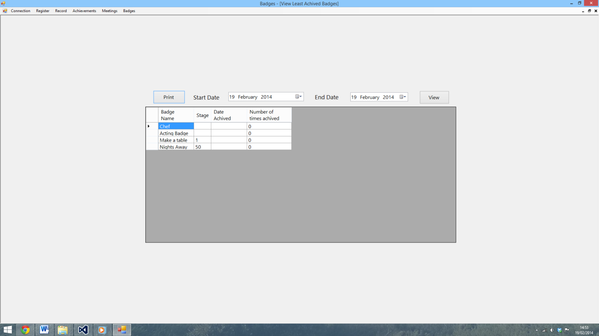

114)

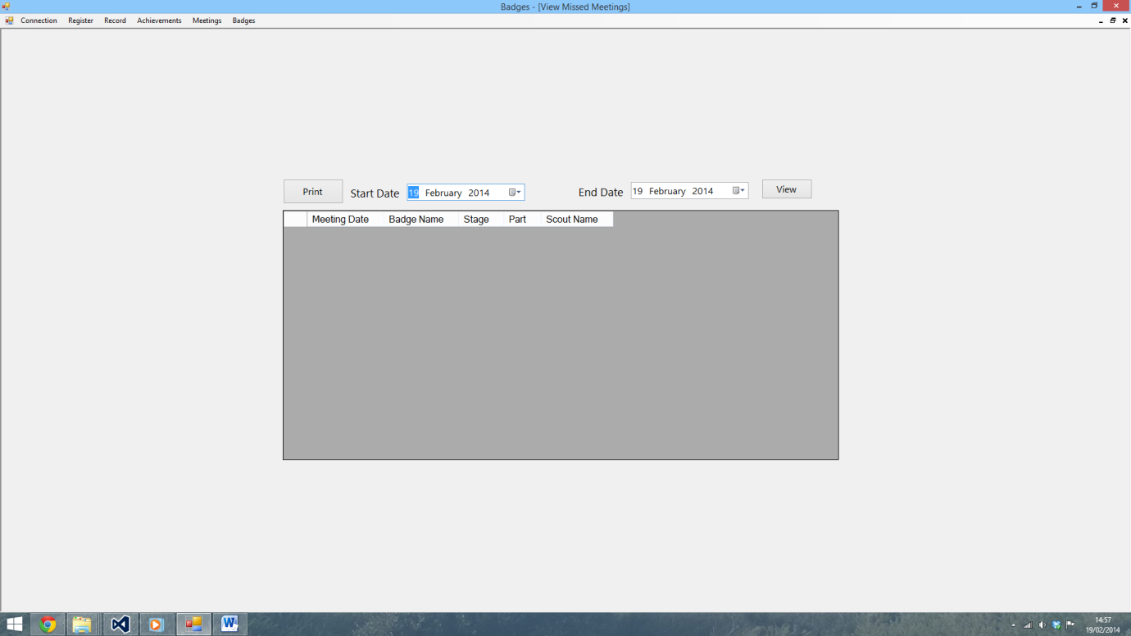

115)

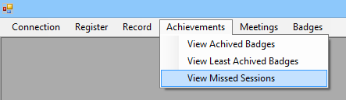

116)

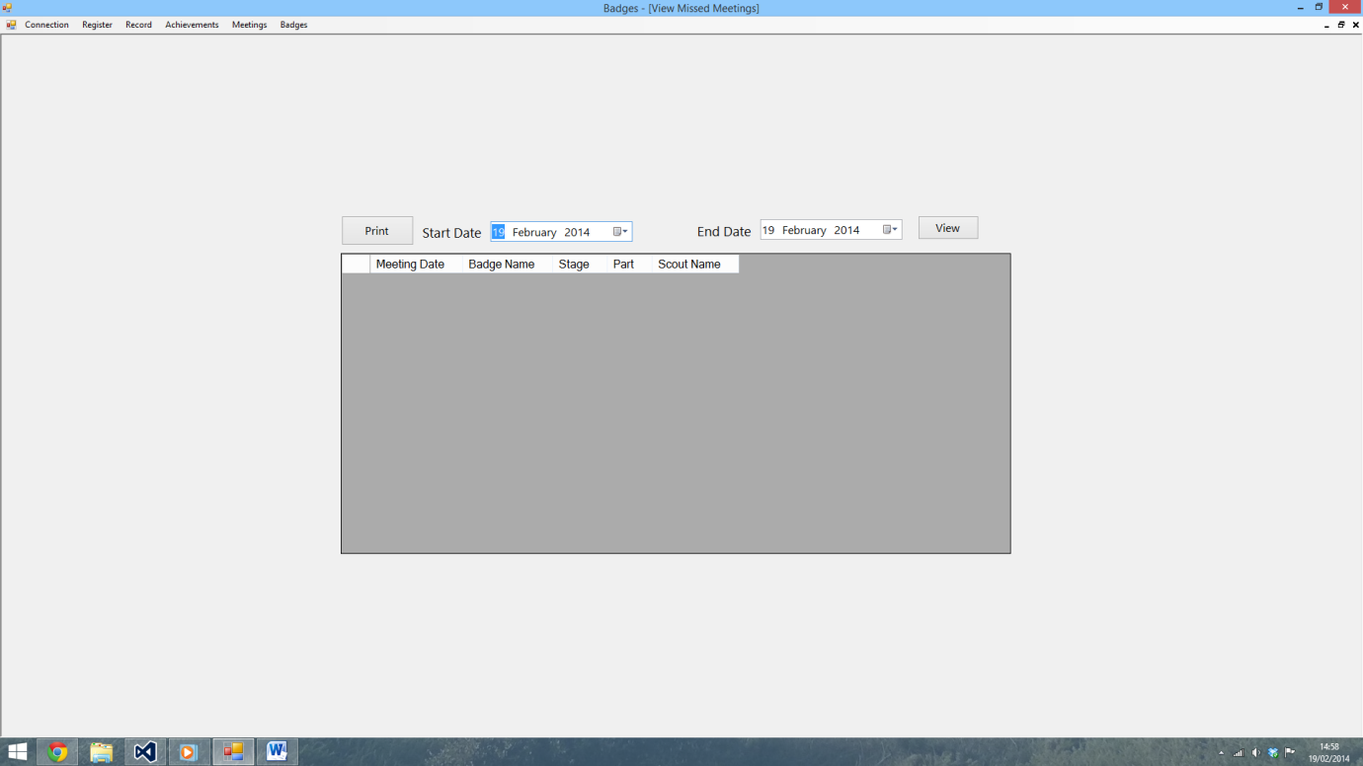

117)

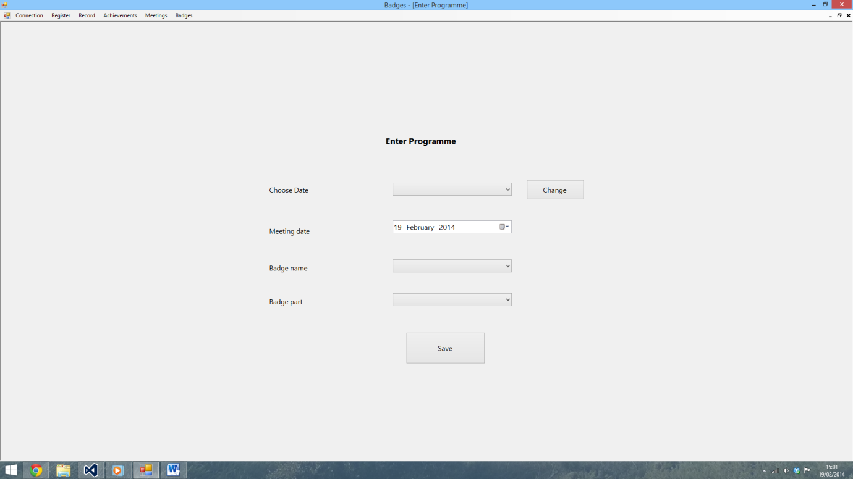

118)

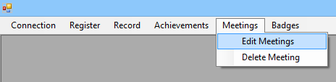

119)

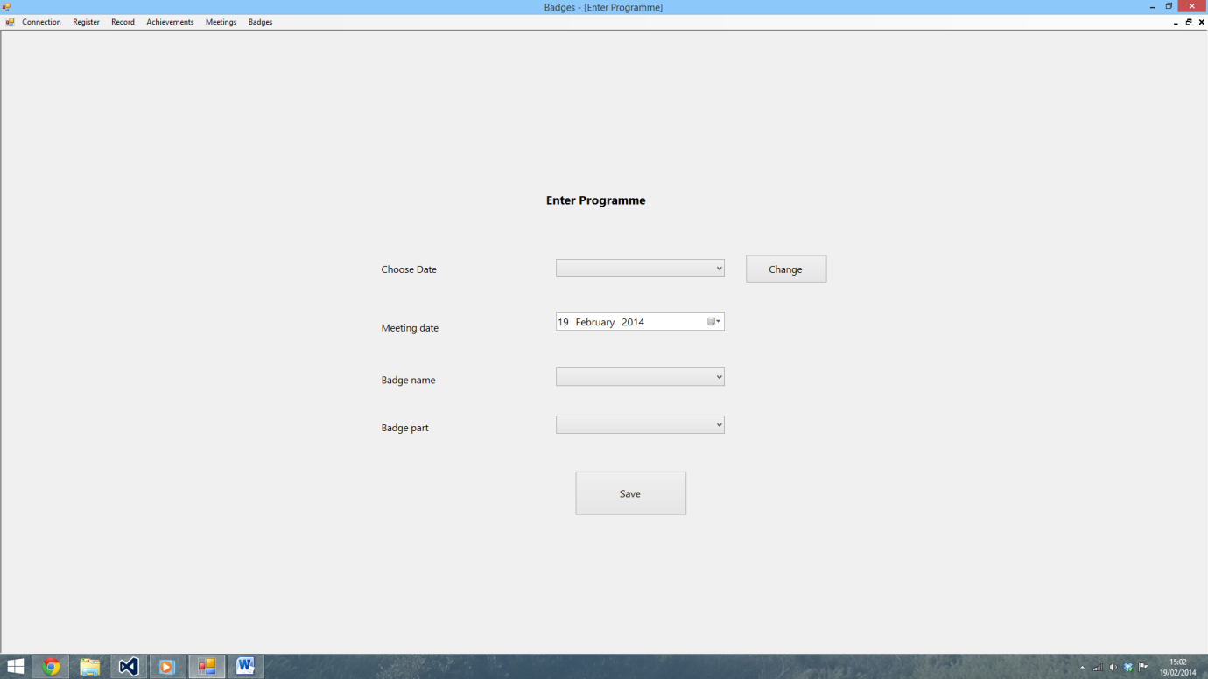

120)

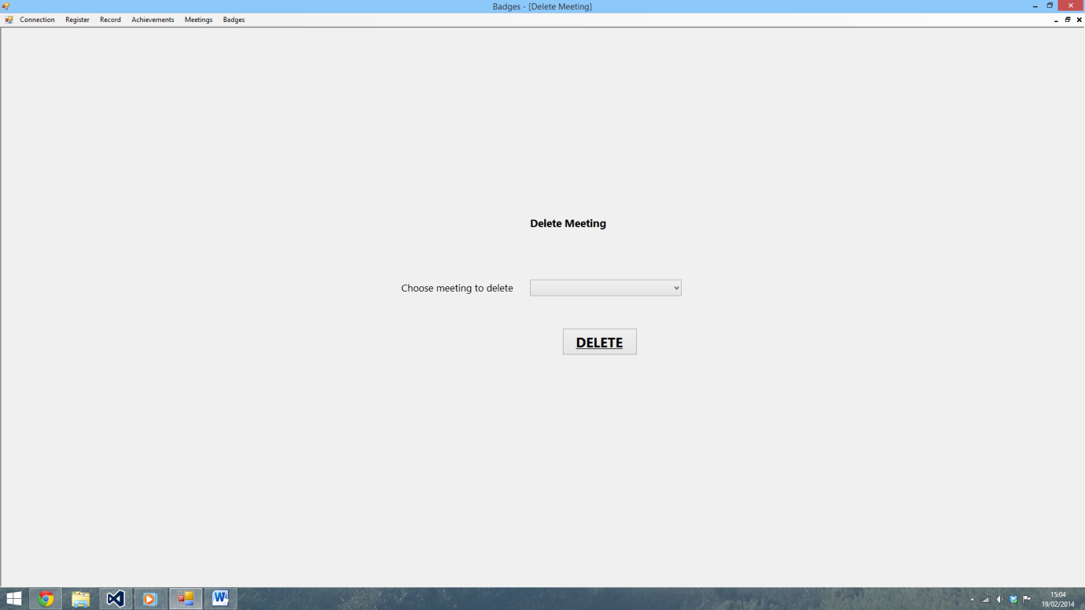

121)

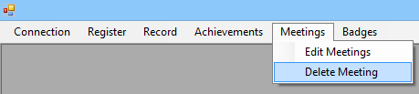

122)

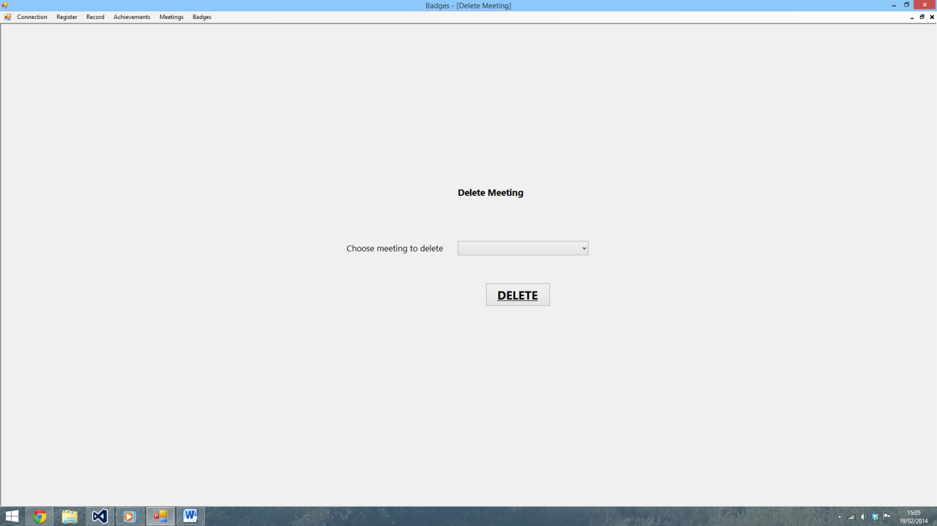

123)

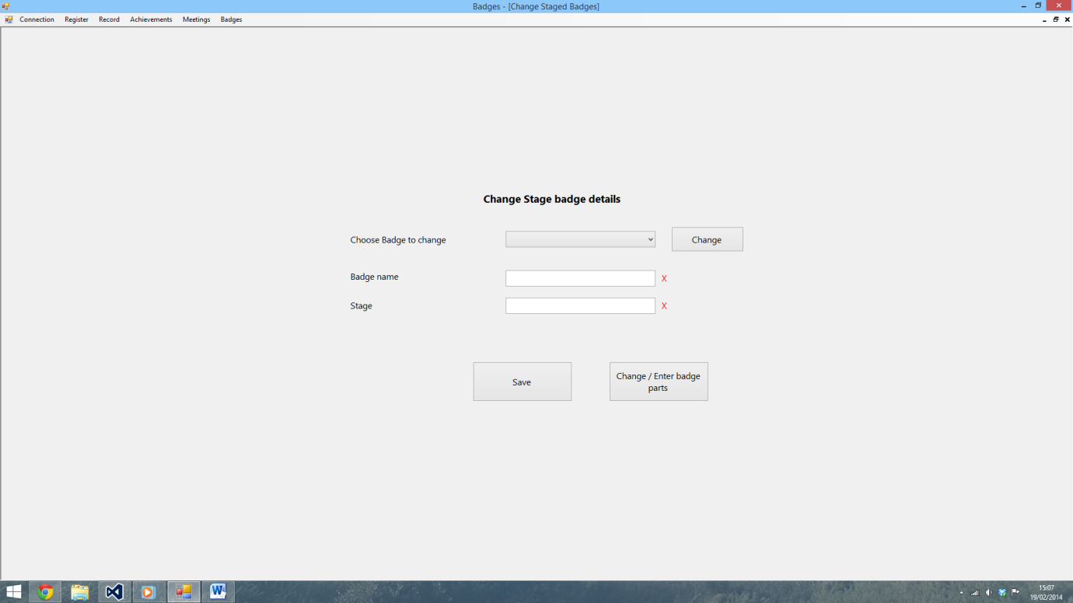

124)

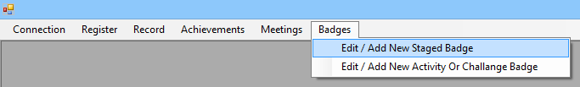

125)

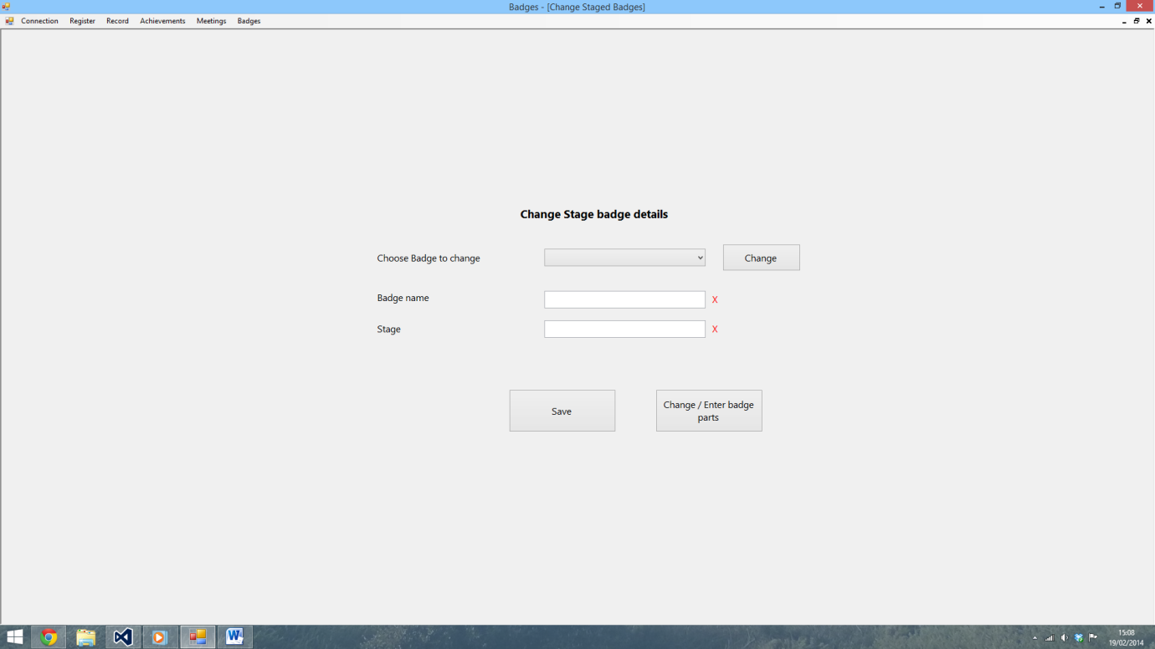

126)

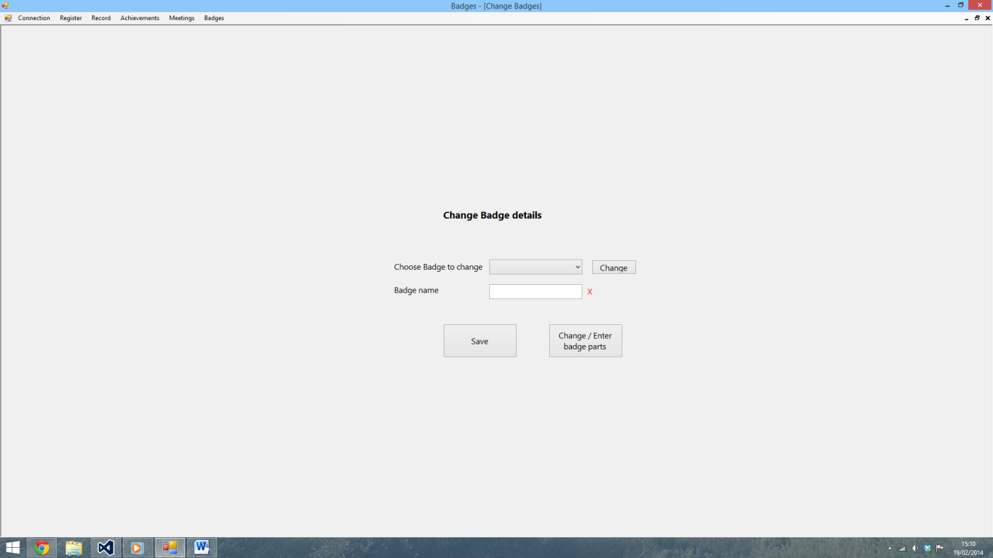

127)

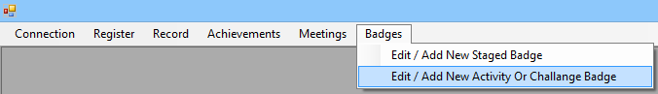

128)

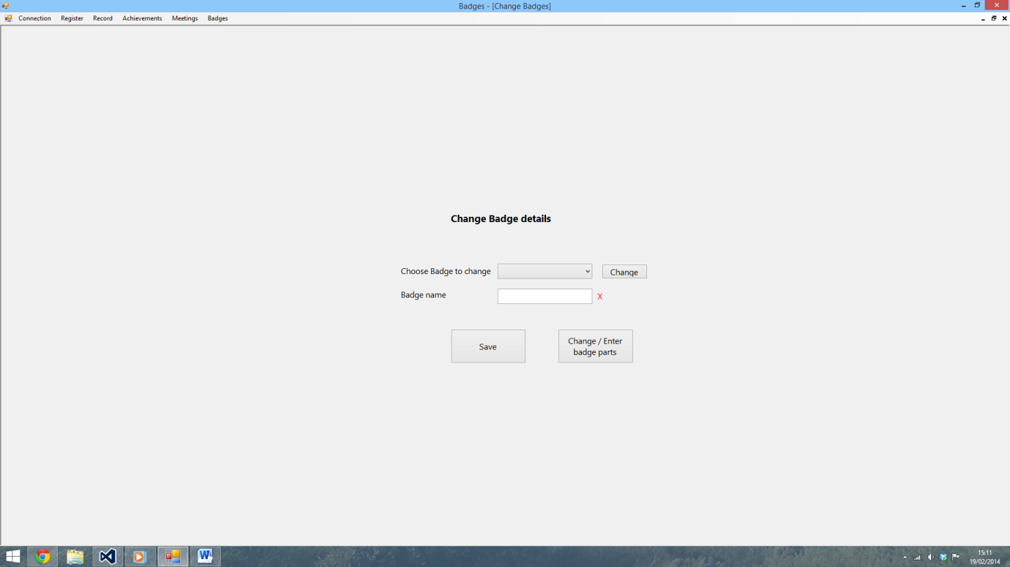

129)

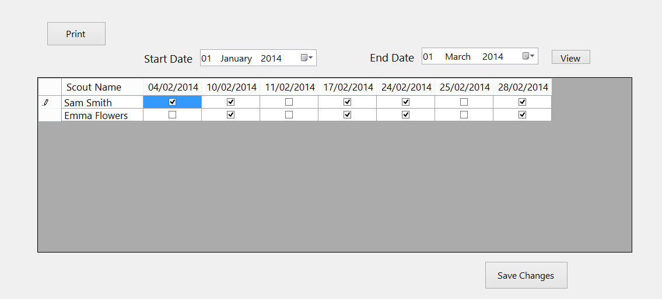

130)

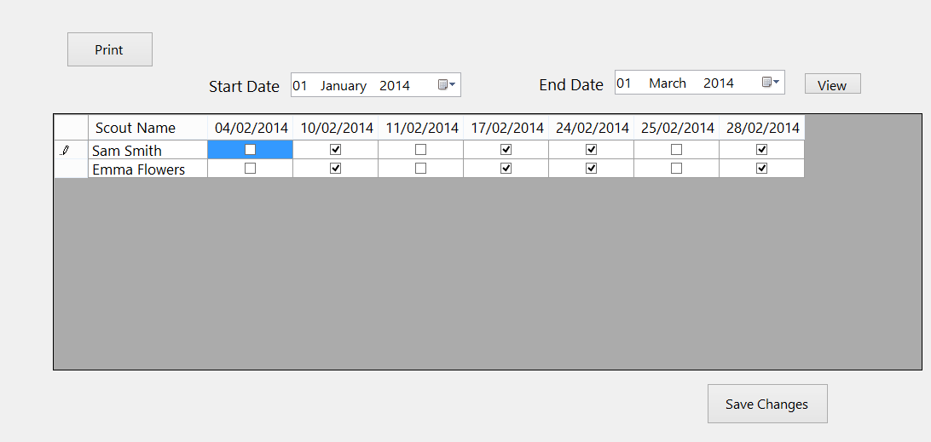

131)

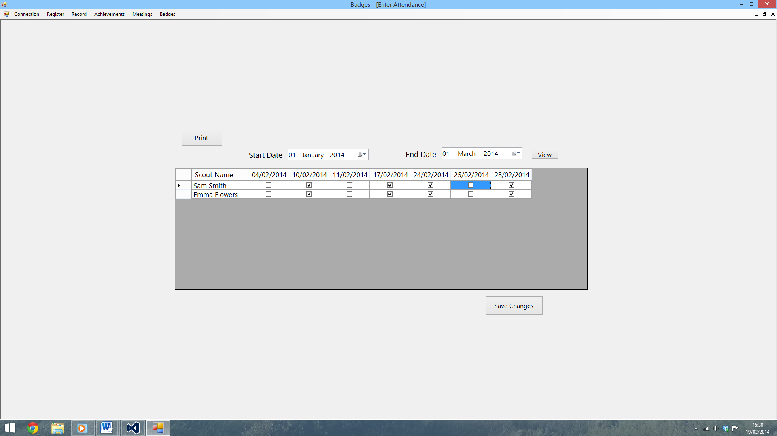

Appendix B – Developmental Testing

This section contains a sample of the testing I did whilst I was creating a program.

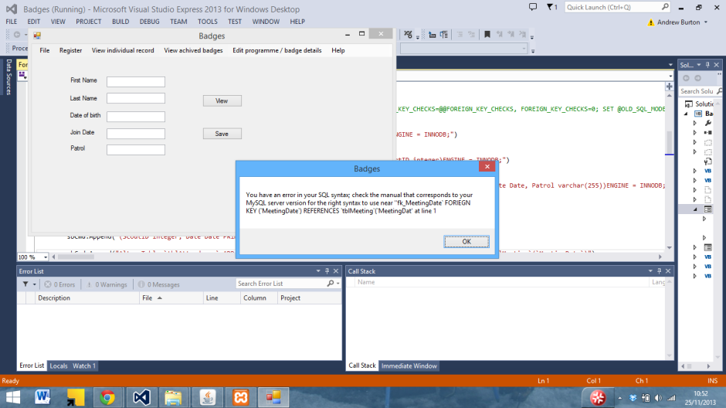

In this screenshot, a SQL syntax error can be seen due to me trying to assign some values a foreign key from another table. After trialling with different methods, I eventually decided to use joins instead to enforce integrity between the databases.

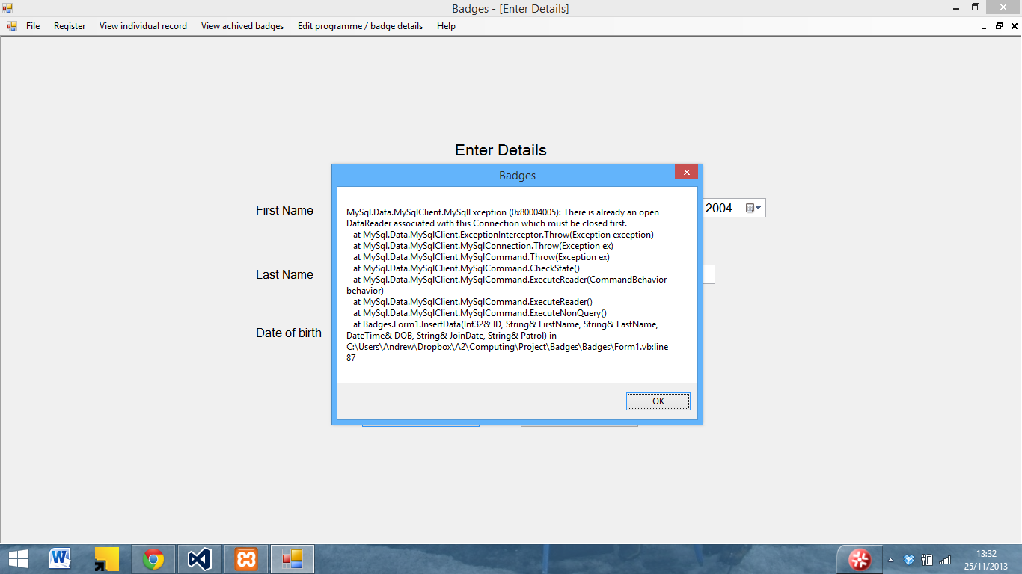

Here another SQL error can be seen whilst inserting data. It has been caused by the fact that I have not closed the data reader when writing or reading the last set of data to the database. As a result I added Reader.Close() to the end SQL statements as can be seen below

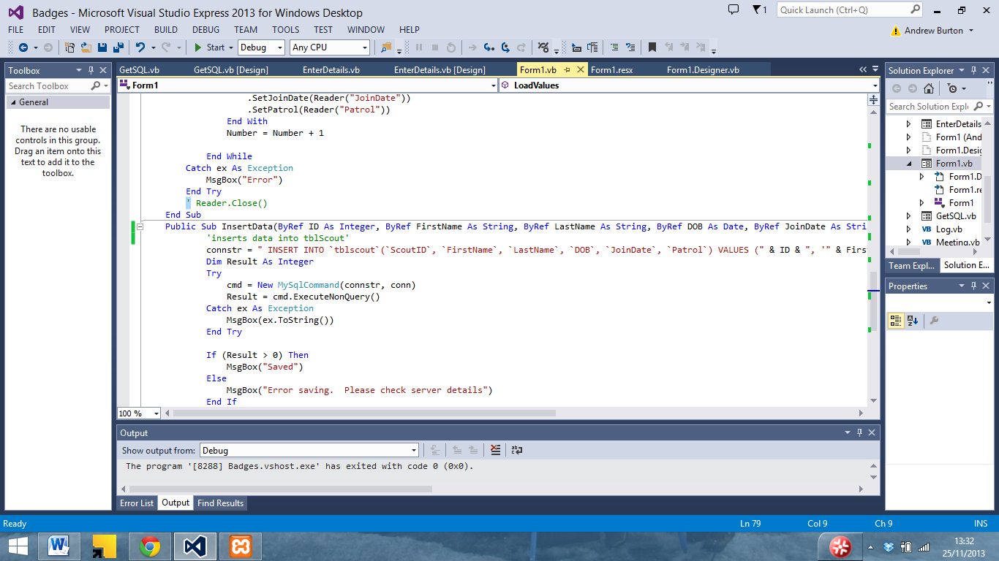

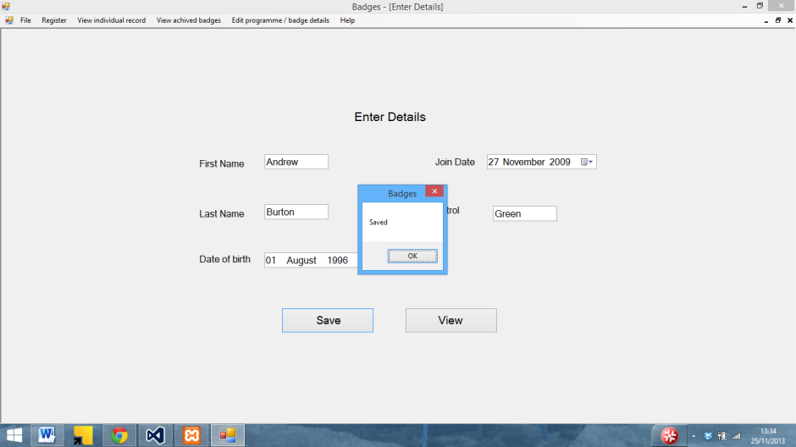

The data could then be saved in the databases

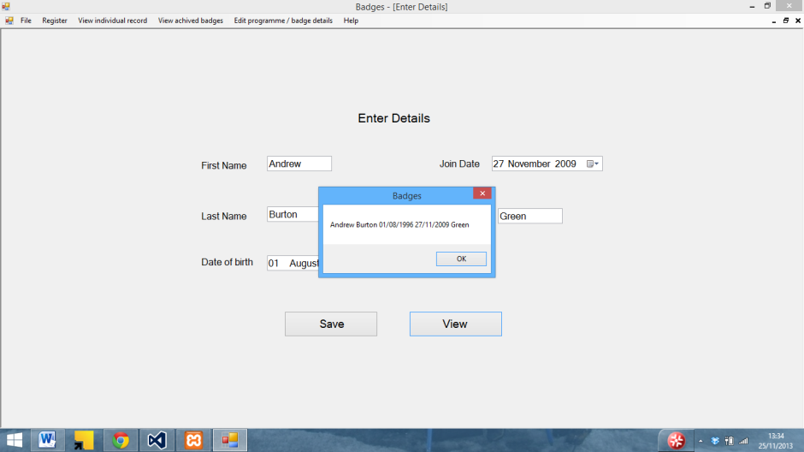

And then displayed in the view function I created to test that the data inserted correctly (removed in final version)

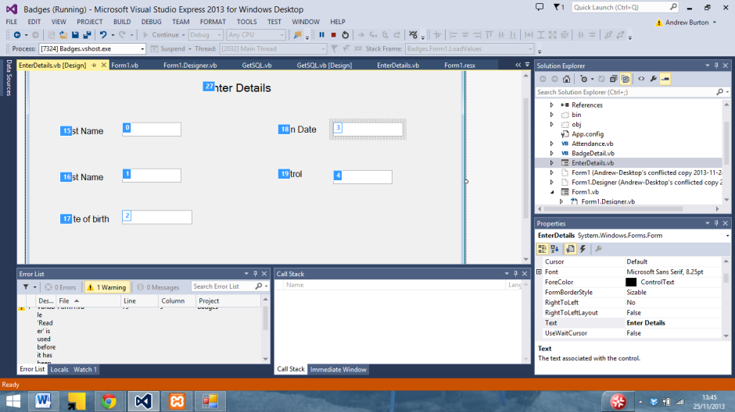

In the above screenshot I am editing the tab order for the enter details form

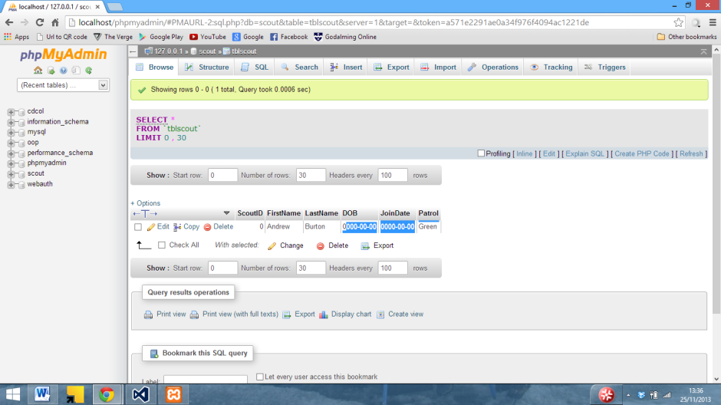

In the above screenshot it can be seen that despite the fact that the data has been entered into the database, the dates have not been stored correctly

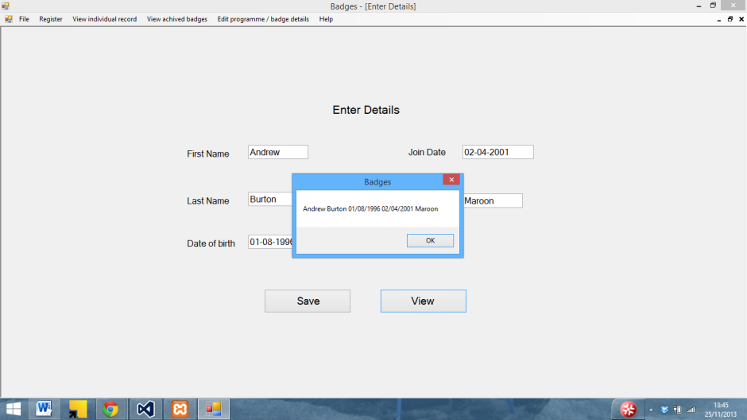

I tried to enter it into the database using – instead of / and replaced the date boxes with text boxed

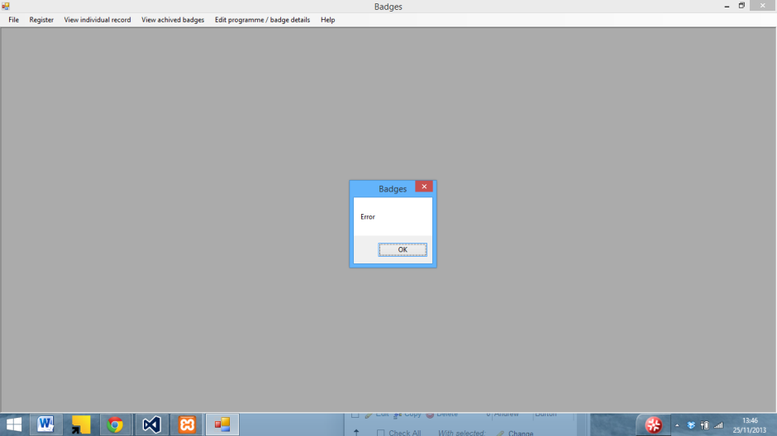

However this crashed the program

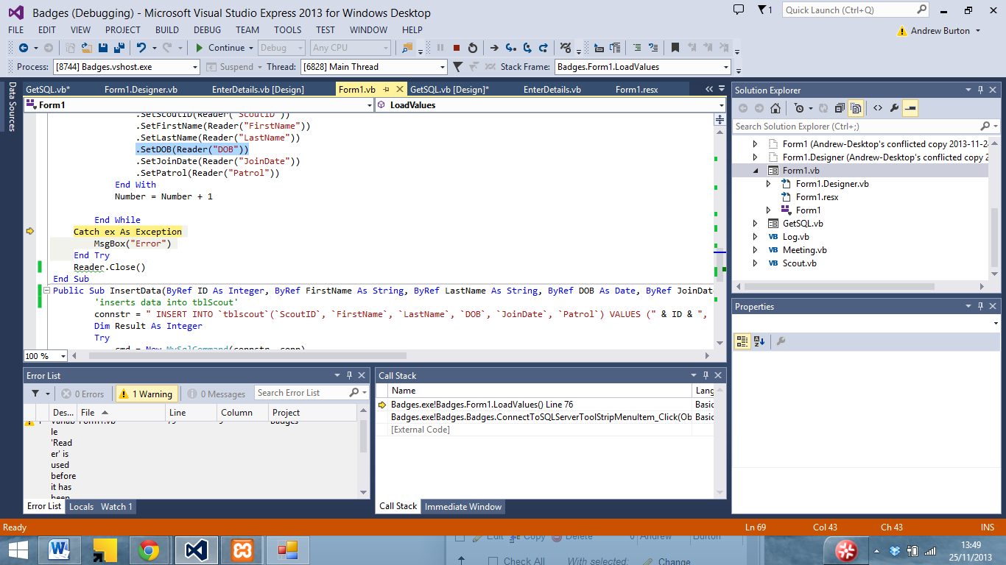

As can be seen above it was due to the program loading the DOB from the SQL server

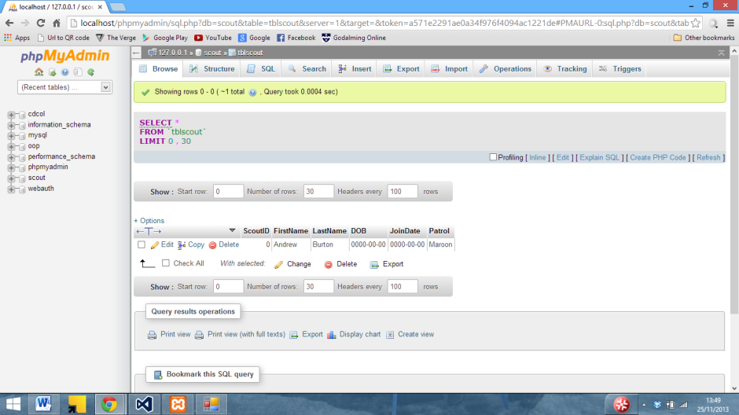

And as can be seen here the database is still not storing the dates.

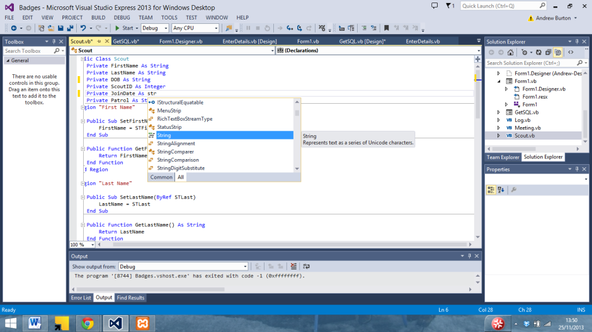

I tried changing the date values in the class to a string

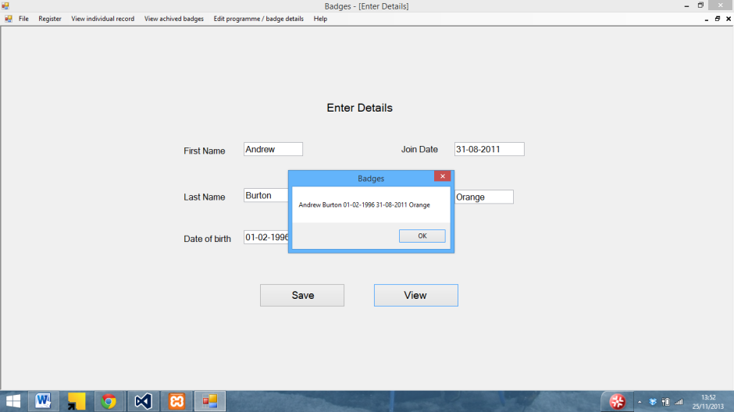

Which whilst saving in the class still wasn’t saving in the database. I eventually realised that SQL uses a 2013-12-29 date format rather than a 29/12/2013 format that is commonly used in the UK.

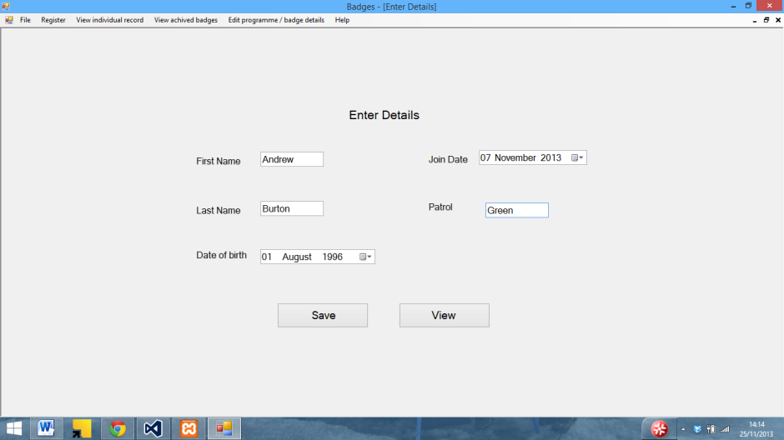

So I changed the date boxes back

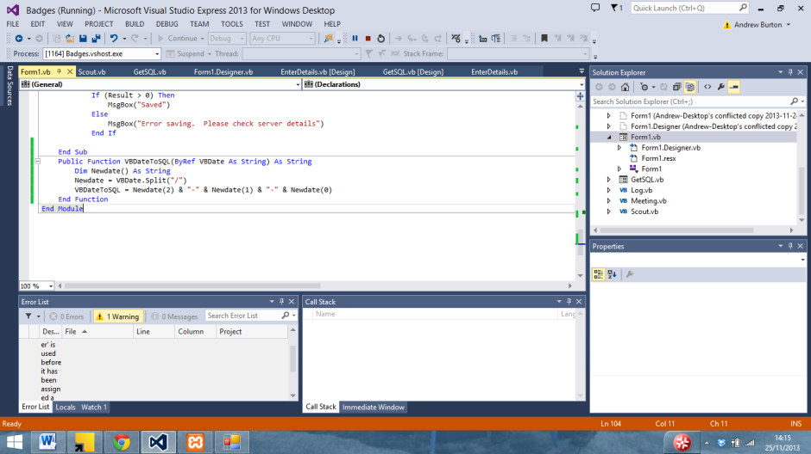

And wrote a function to convert VB dates to the SQL format using the split function

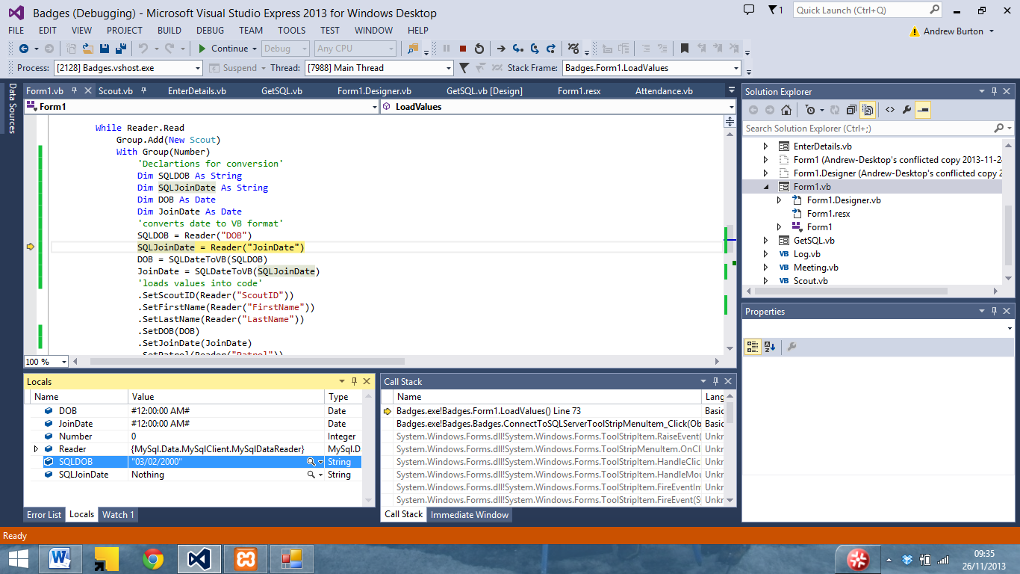On the other hand, whilst loading dates in from the database VB was converting it from a SQ L format

To a US format

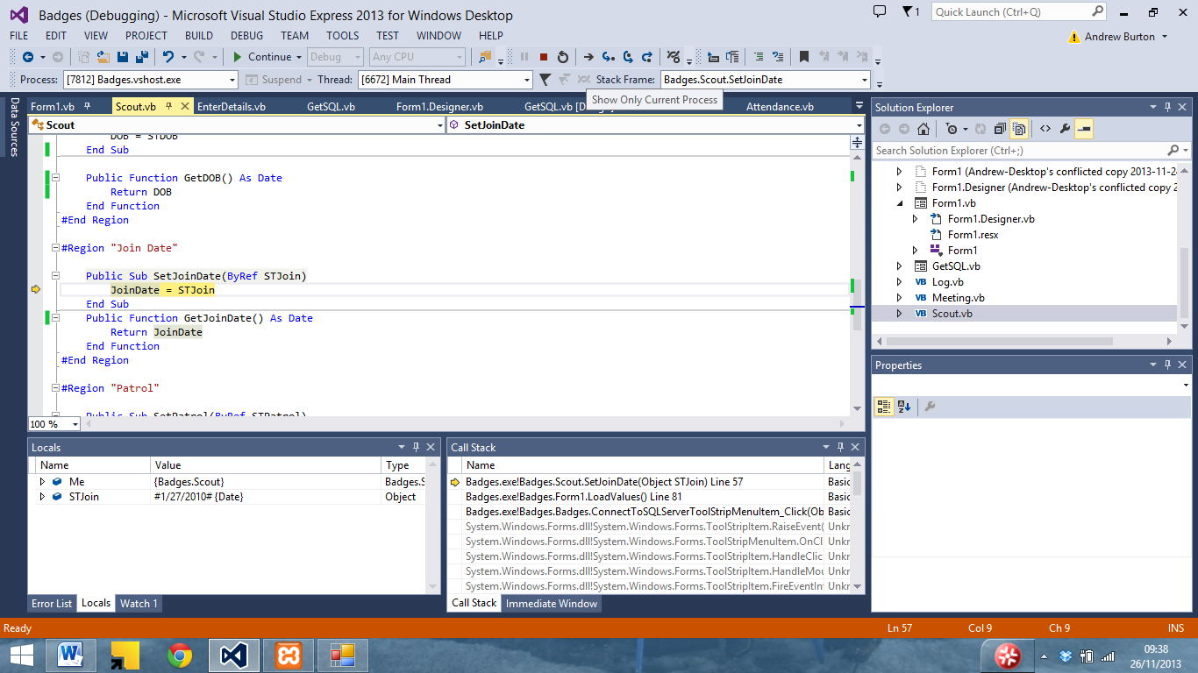

So I wrote a function to convert it to a UK date

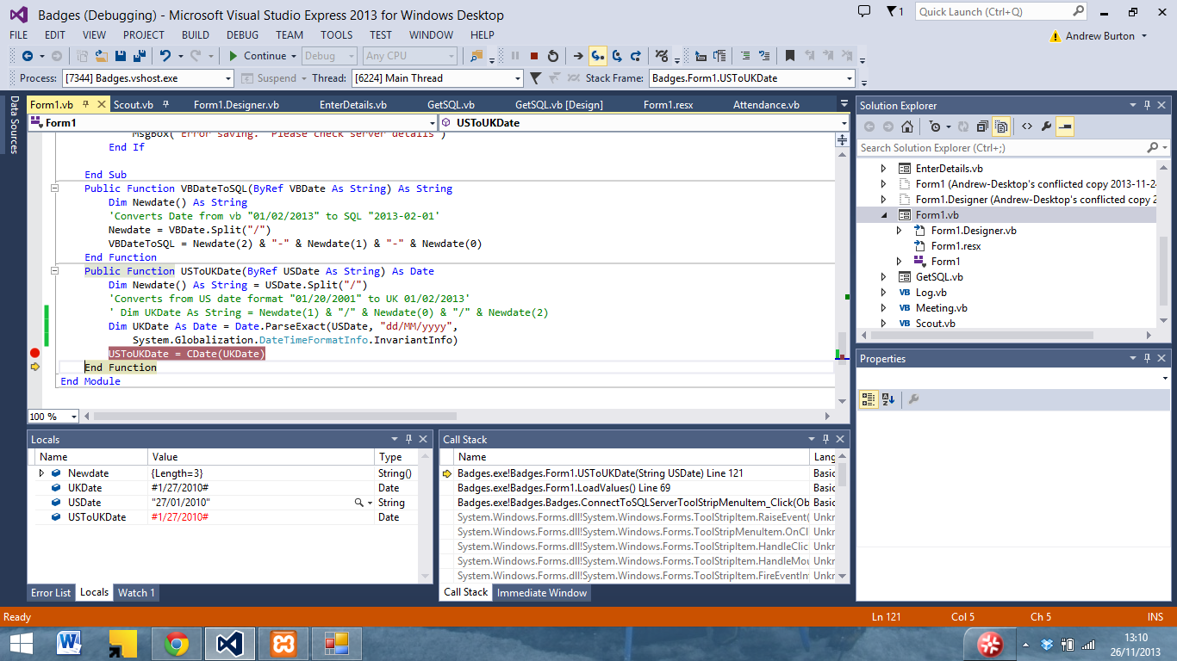

Which now means that data can be written into the database correctly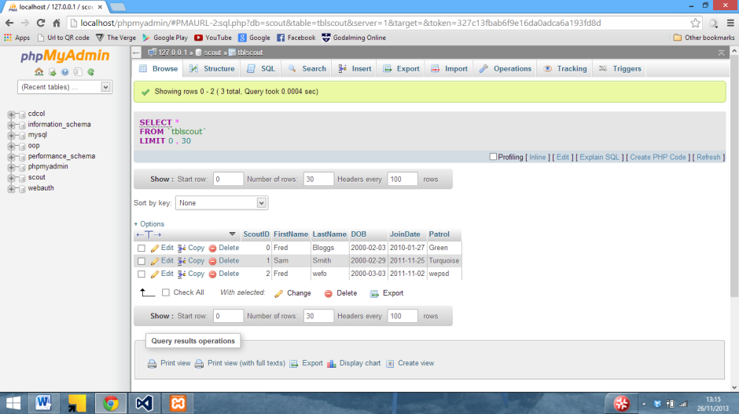

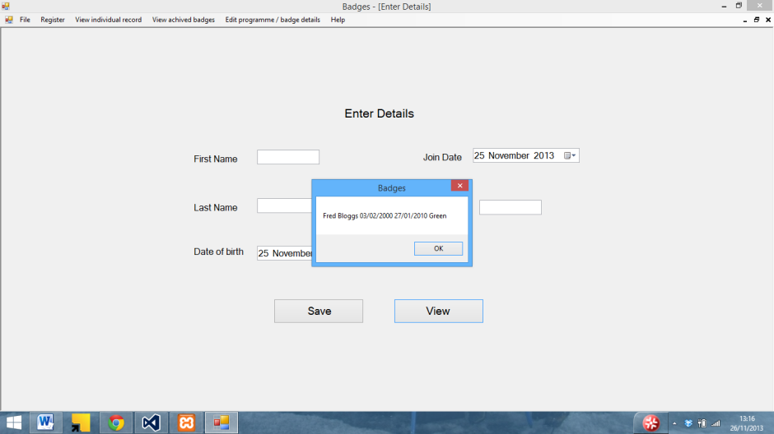

And then load back into VB correctly.

Here an experiment with of putting logs into a datagridview can be seen using an array

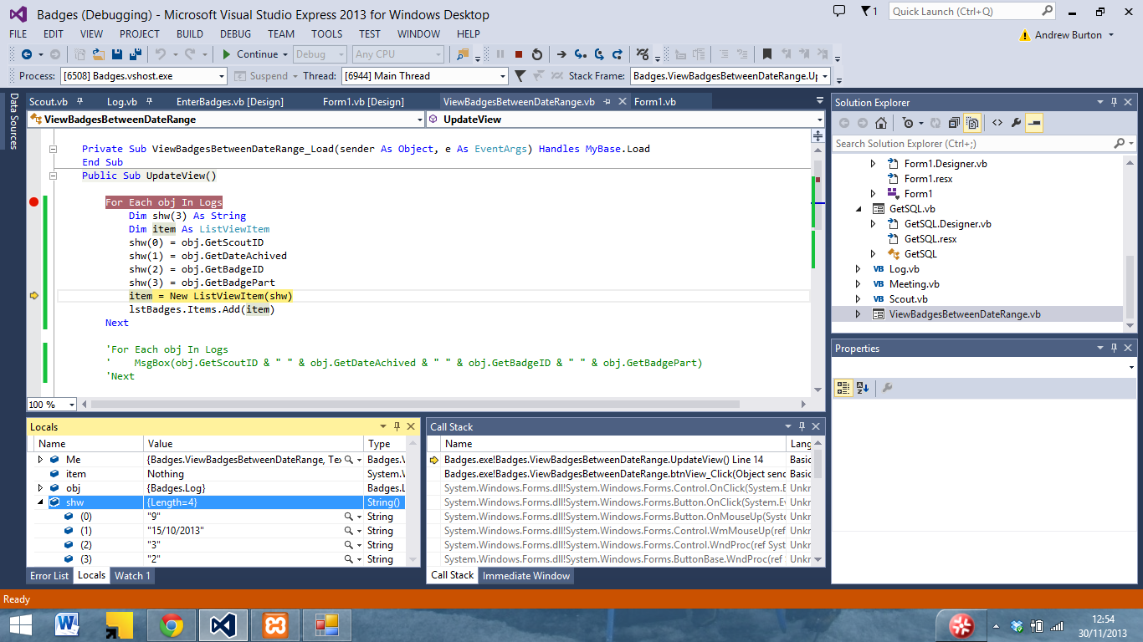

It puts the values into the array

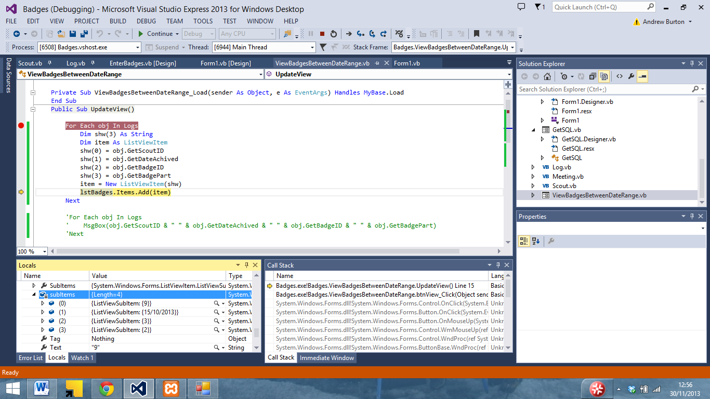

But then won’t display it correctly

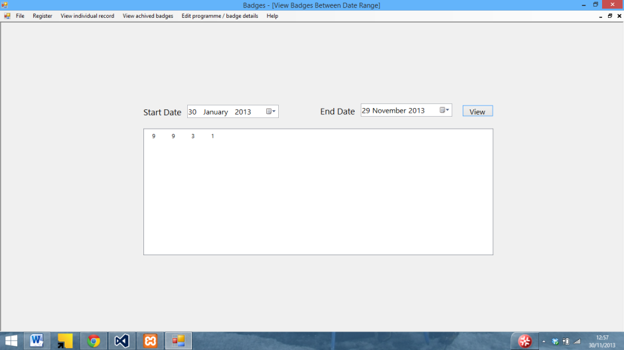

I then tried using some static text to see if that would work

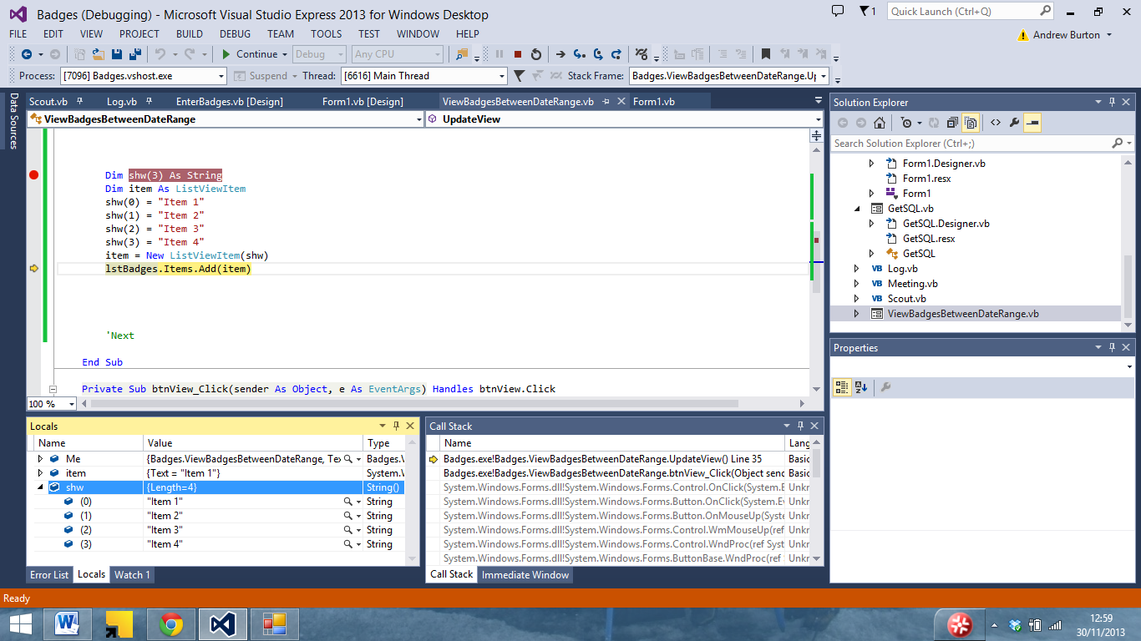

Whilst going into the array with no issue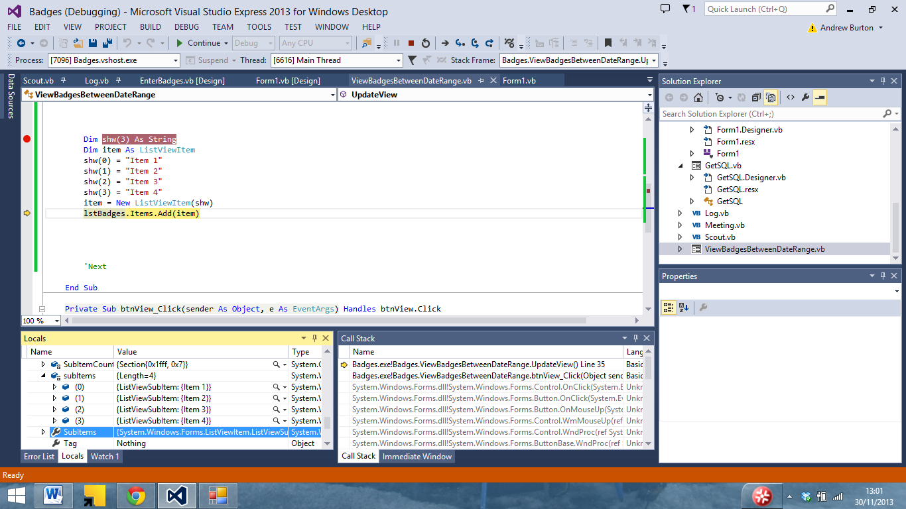

It still would not display correctly.

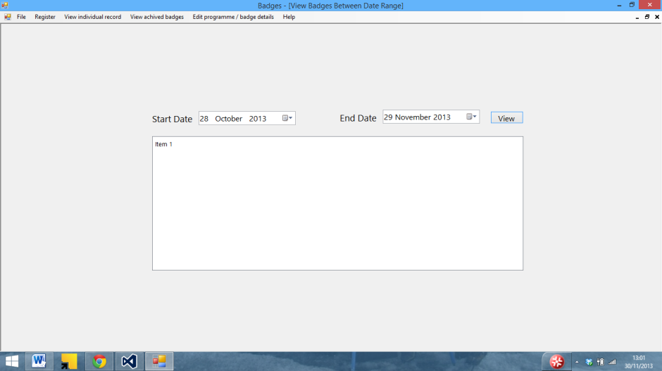

I then tried to get the data from log to display in a message box to ensure that it was in a suitable format to be displayed

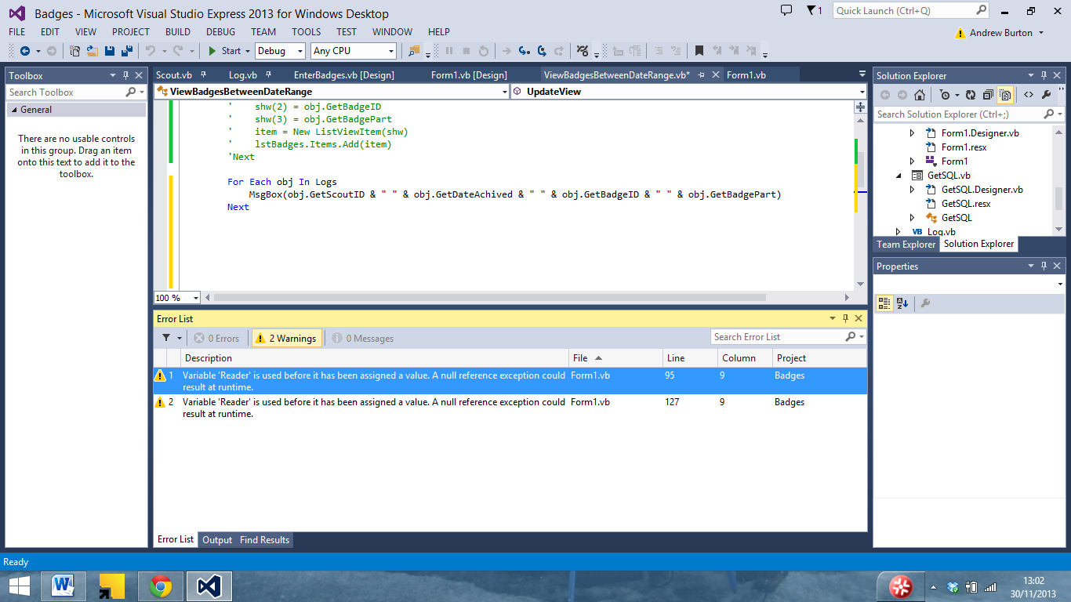

Which was able to display data with no issue.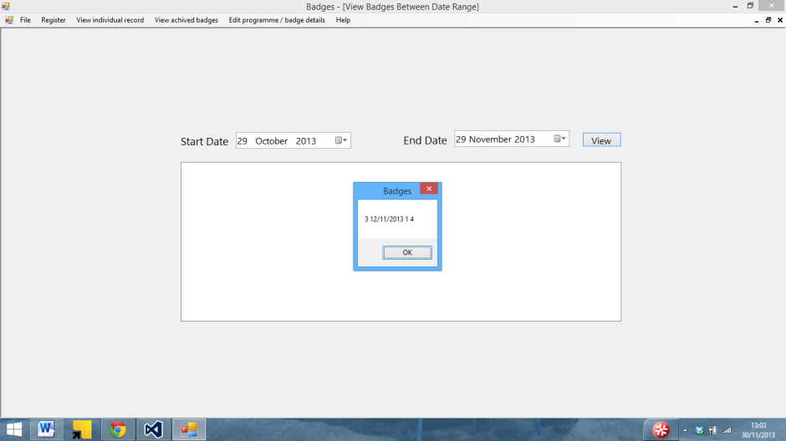

I then tried to use a datagridview to see if that would display the data

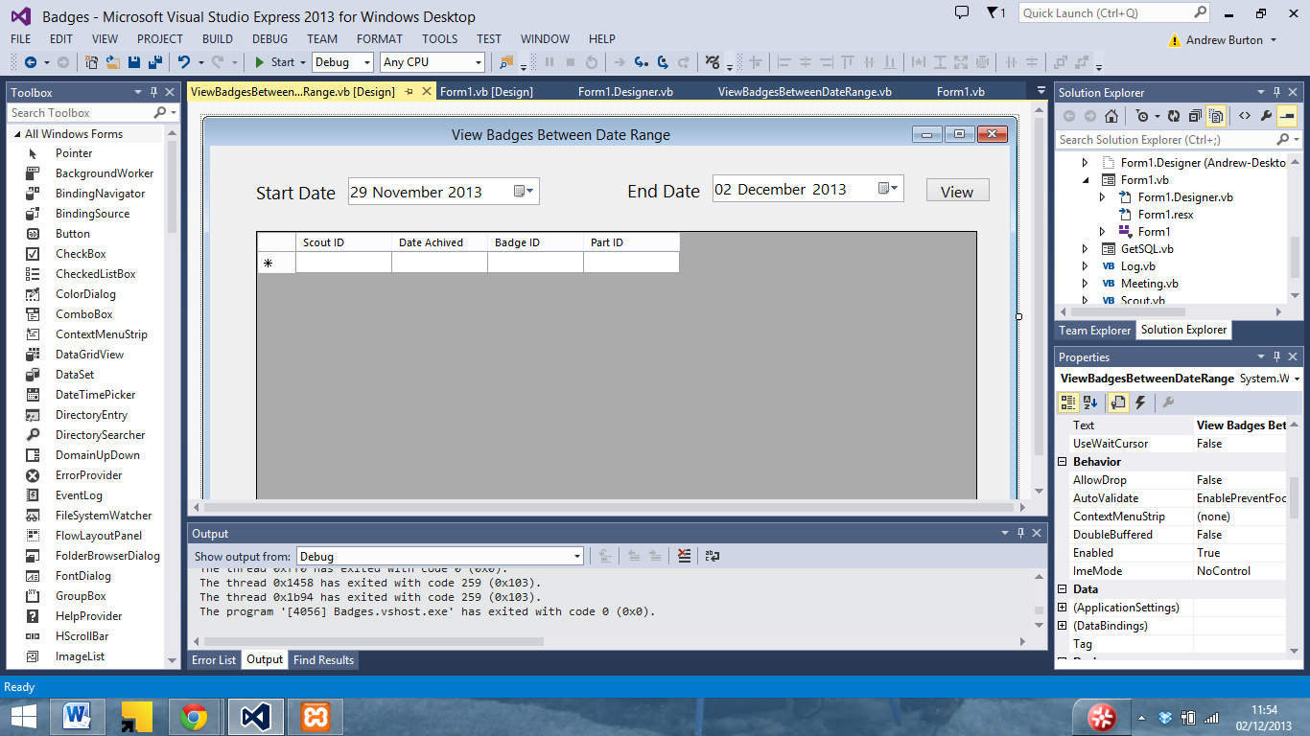

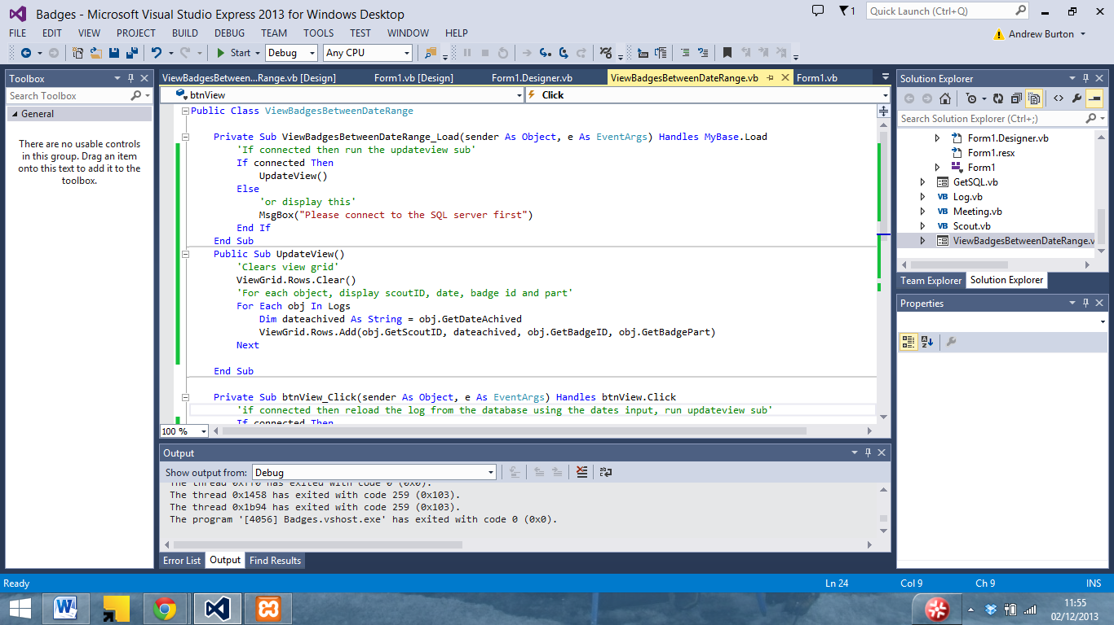

With different code

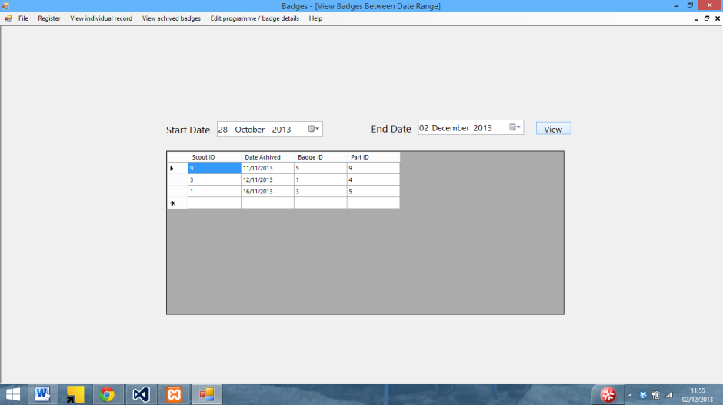

Which was able to display the data from log

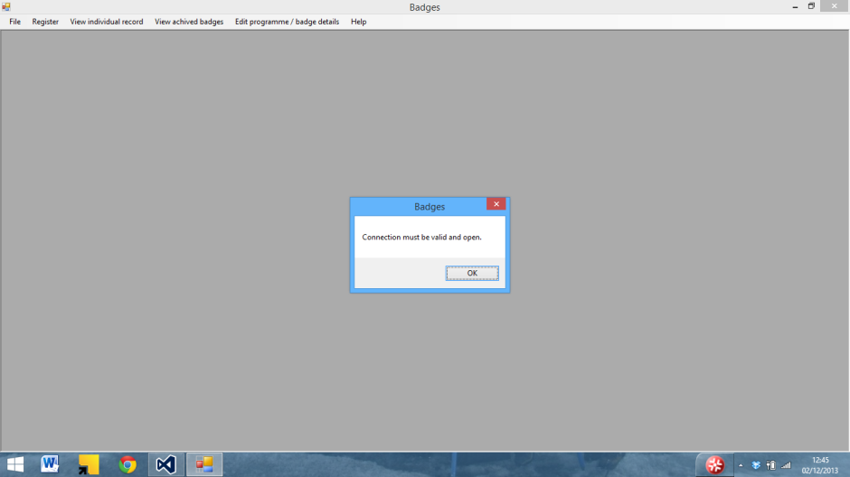

Here an error caused by the fact that the program was unable to connect to the server can be seen

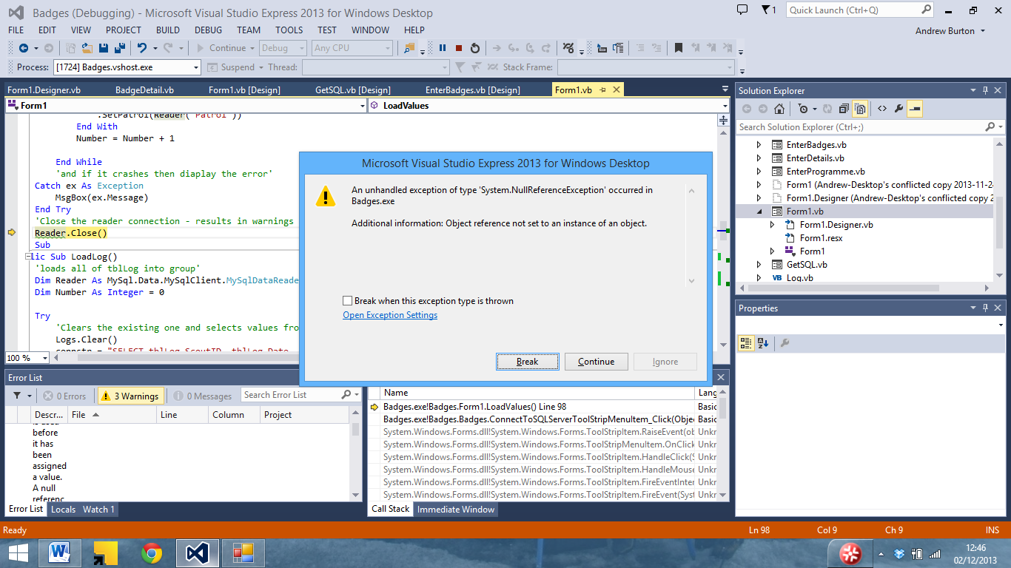

Which then causes the program to crash.

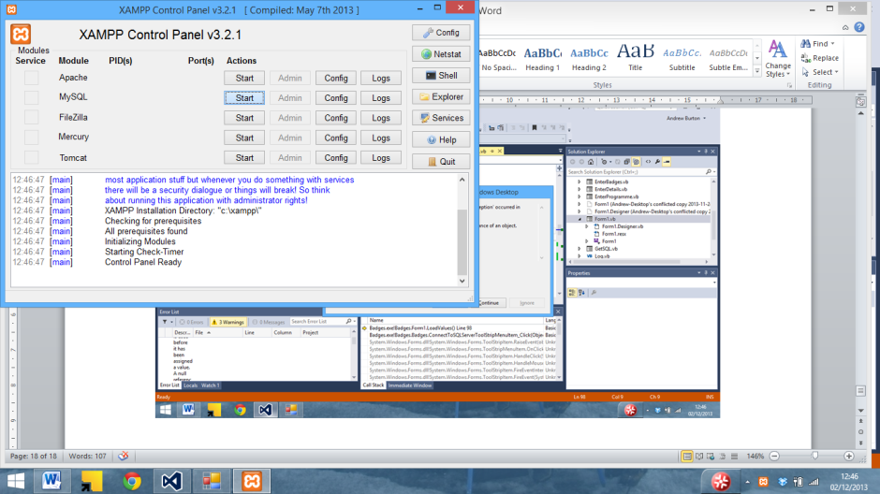

After a bit of troubleshooting it turned out that there was no server running.

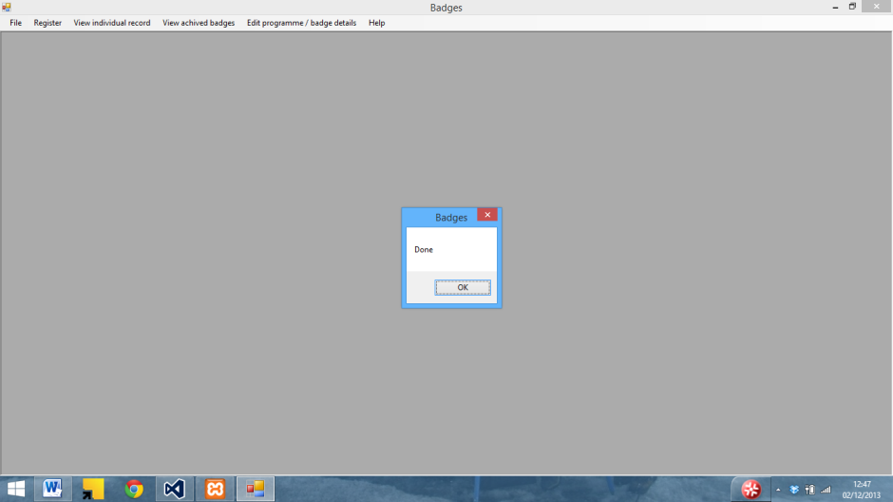

The program was then able to connect to the SQL server

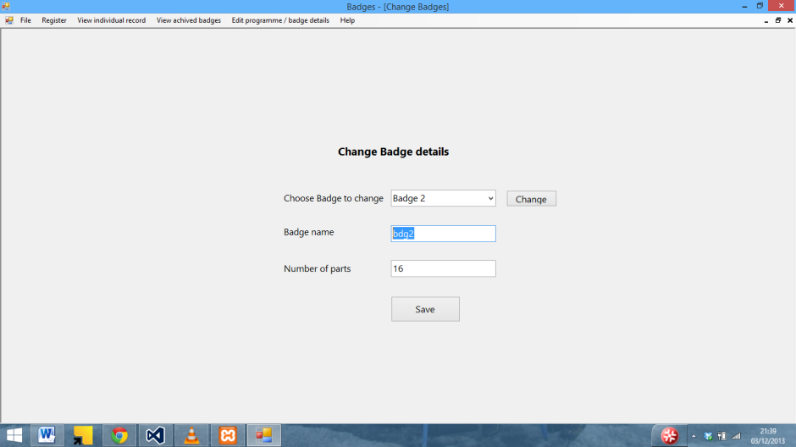

I also had issues with the change badge details form. Here the enter badge name screen can be seen.

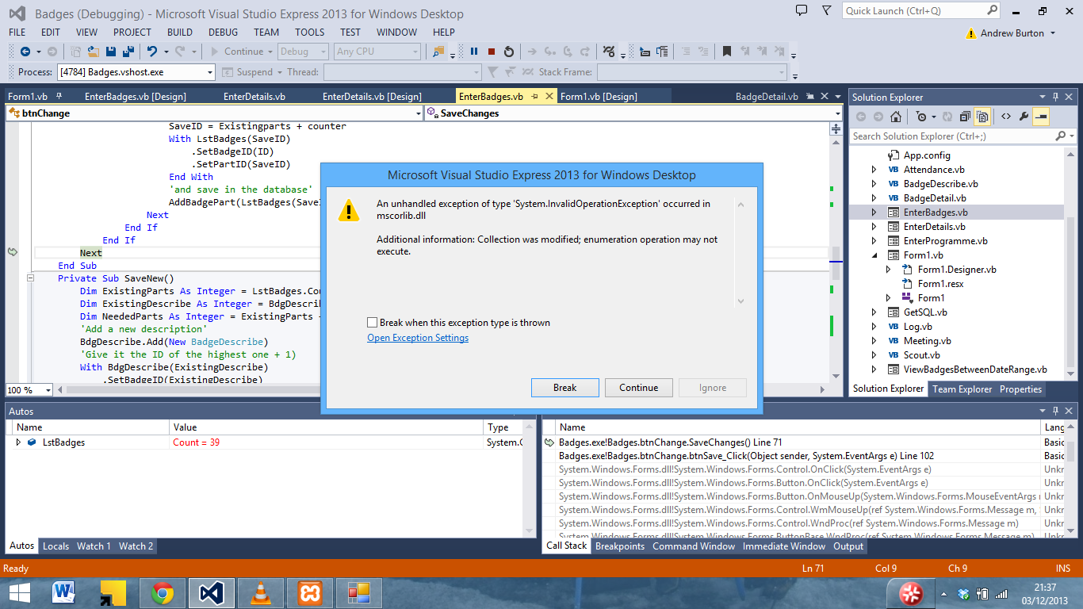

Which crashes when saving

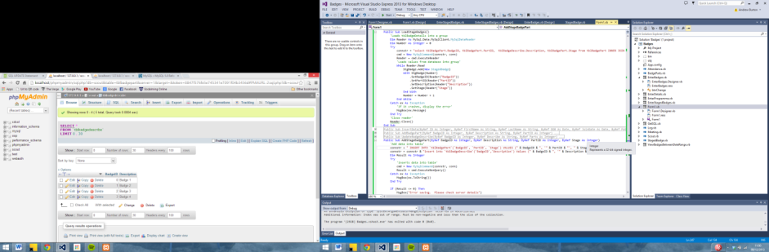

Although not very clear I modified loadbadges to store the position of the item in the list as well

While Reader.Read

StgBadge.Add(New StagedBadge)

With StgBadge(Number)

.SetBadgeID(Reader("BadgeID"))

.SetBadgeDescription(Reader("BadgeDescription"))

.SetStage(Reader("Stage"))

.SetPosition(Number)

End With

Which then saves the badge into the database.

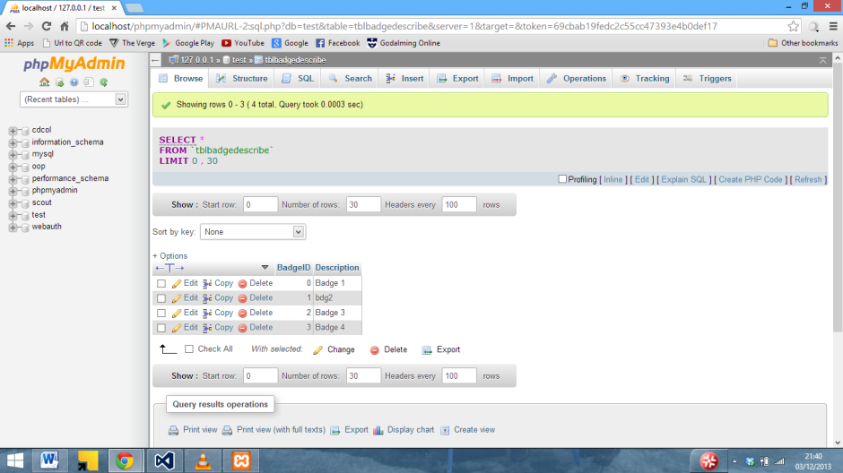

Here an SQL error in the change stage badges screen can be seen.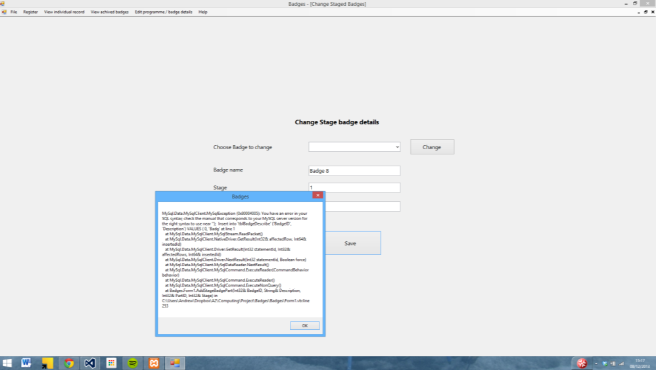

After trying different things with the SQL statement, it turns out there was a ‘ in the SQL statement missing after the date value

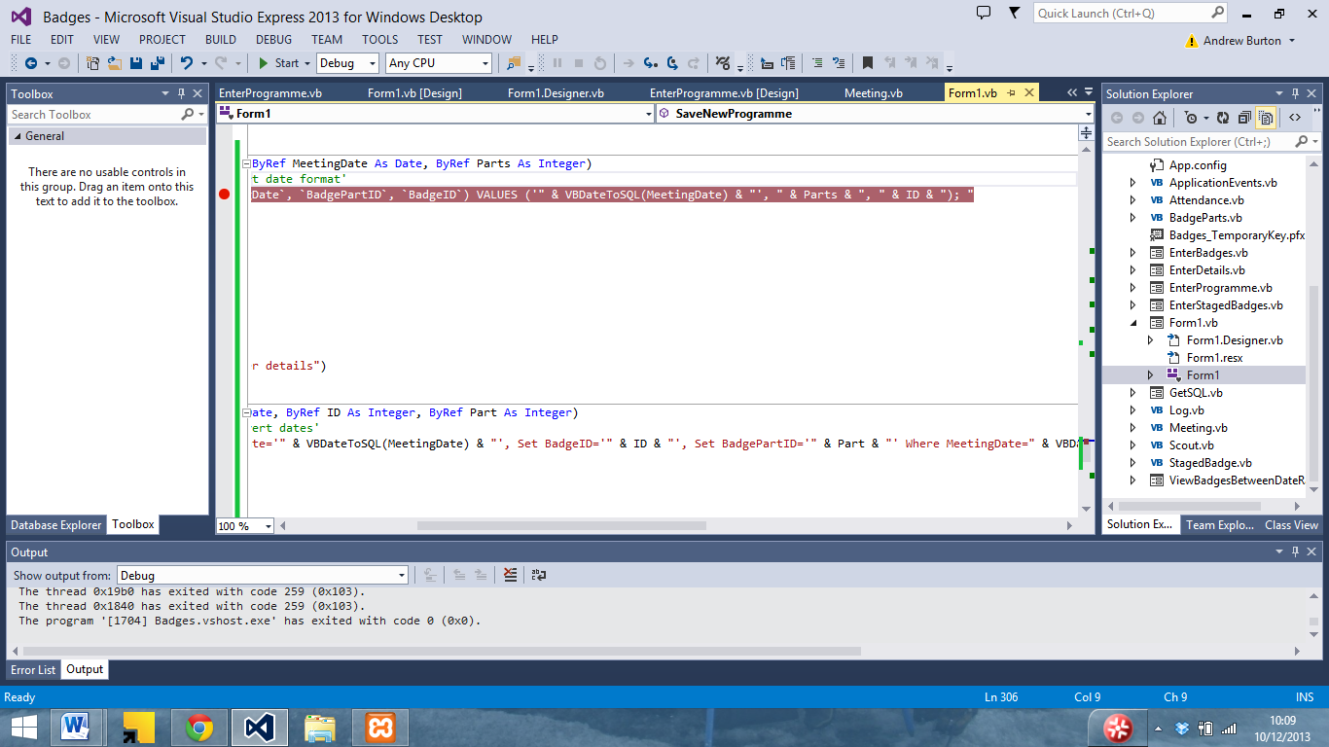

The staged badges now save into the database.

Here another SQL error can be seen in the log table, which has occoured due to the fact that the date already exists as it is the primary key for the table.

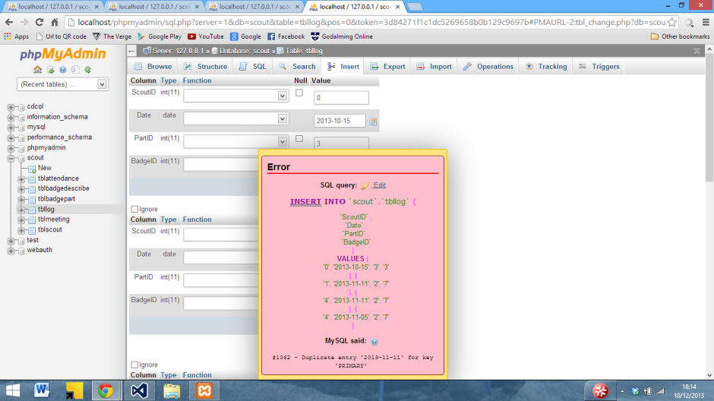

I sorted it by editing the database creation command to remove the primary key from the table

Although this ended up throwing another error due to the fact that I had set dateachived in ViewBadgesBetweenDateRange as a string rather than as a date

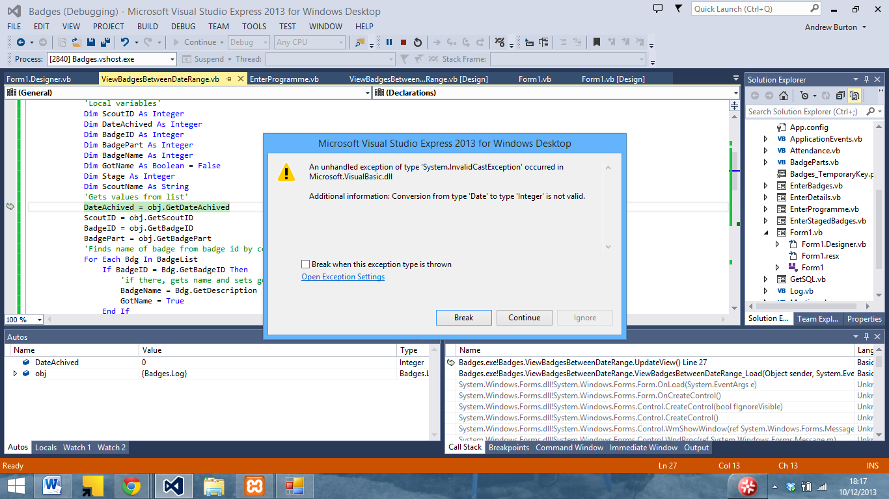

I changed the declaration

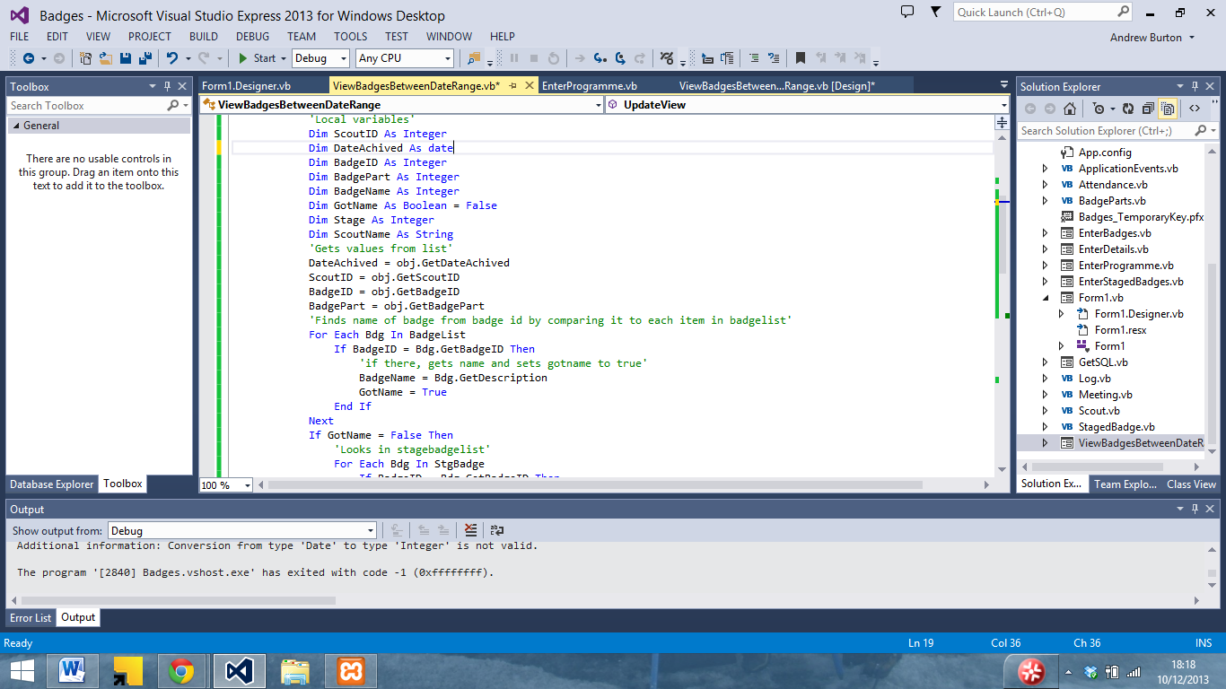

Although when I reran it, I encountered the following error due to the fact that BadgeName had been declared as an integer instead of a string

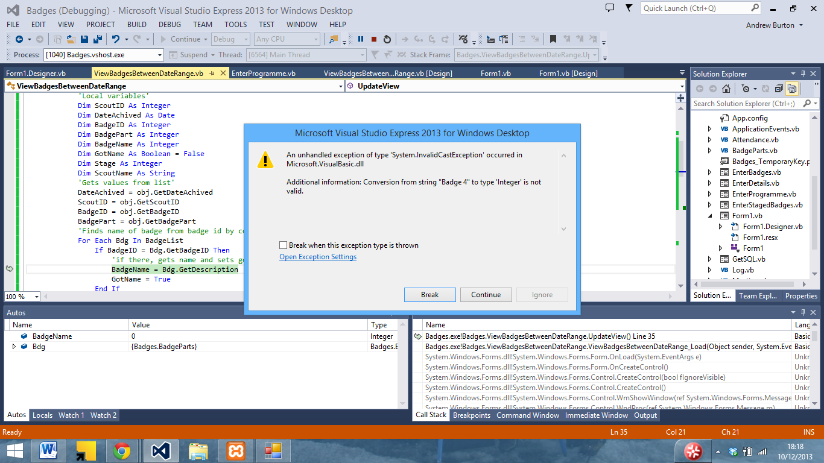

Once I had changed it to a string, I reran the program and it displayed the data correctly

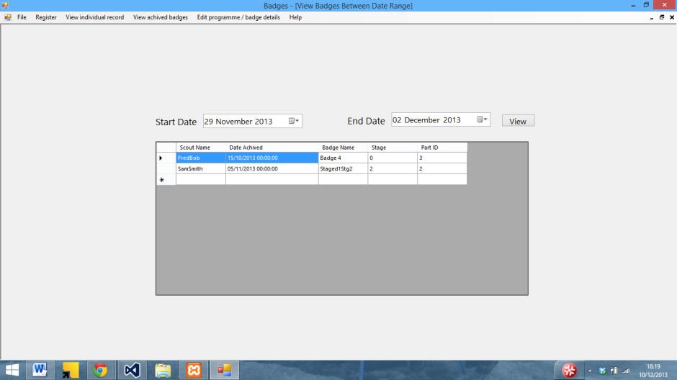

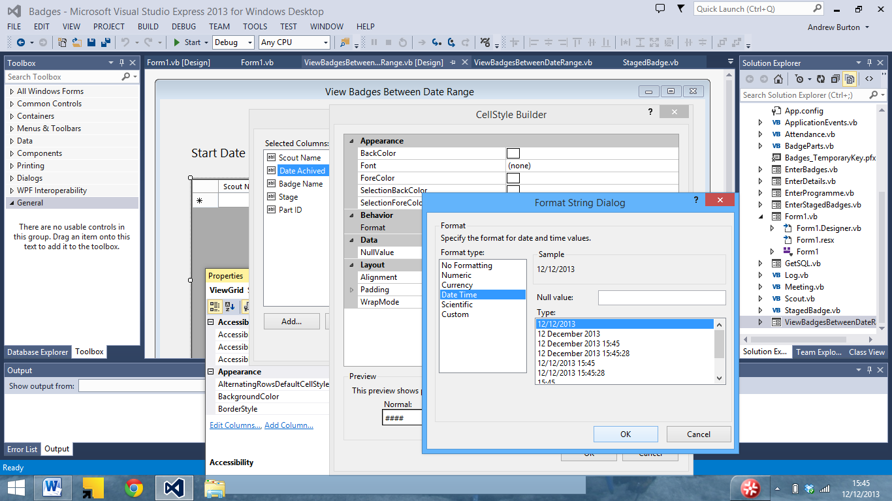I then changed the date format to hide the time.

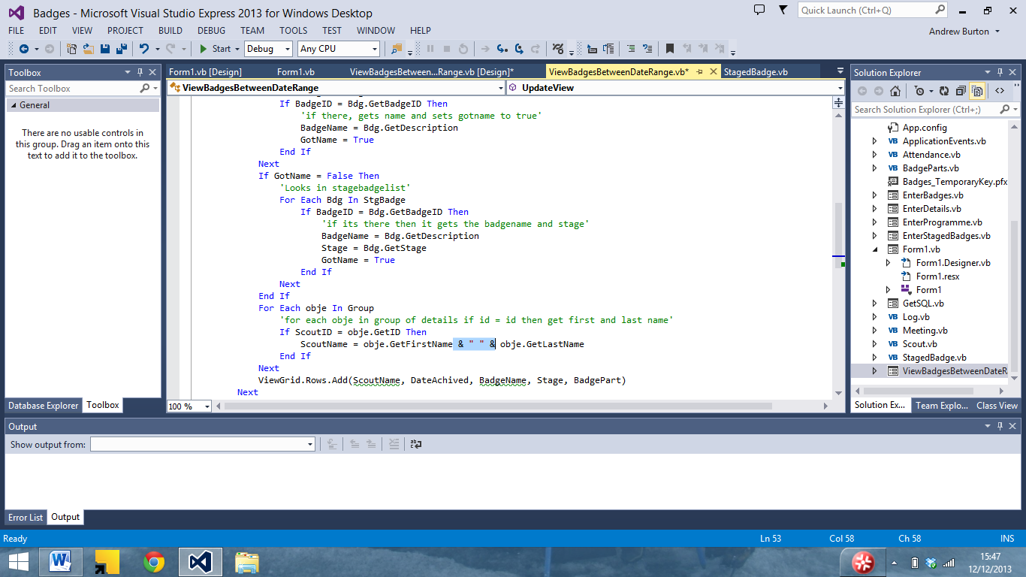

And I added a space between the first name and last name

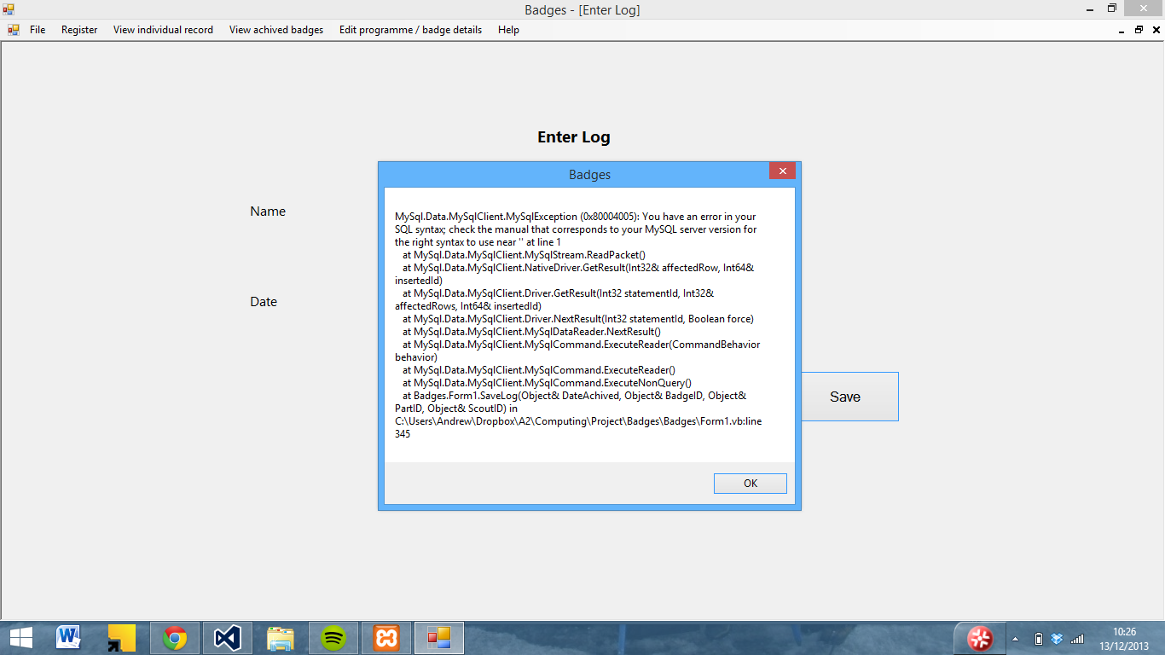

Above a SQL error in enter log can be seen. After some troubleshooting, it turns out SQL statement was missing a )

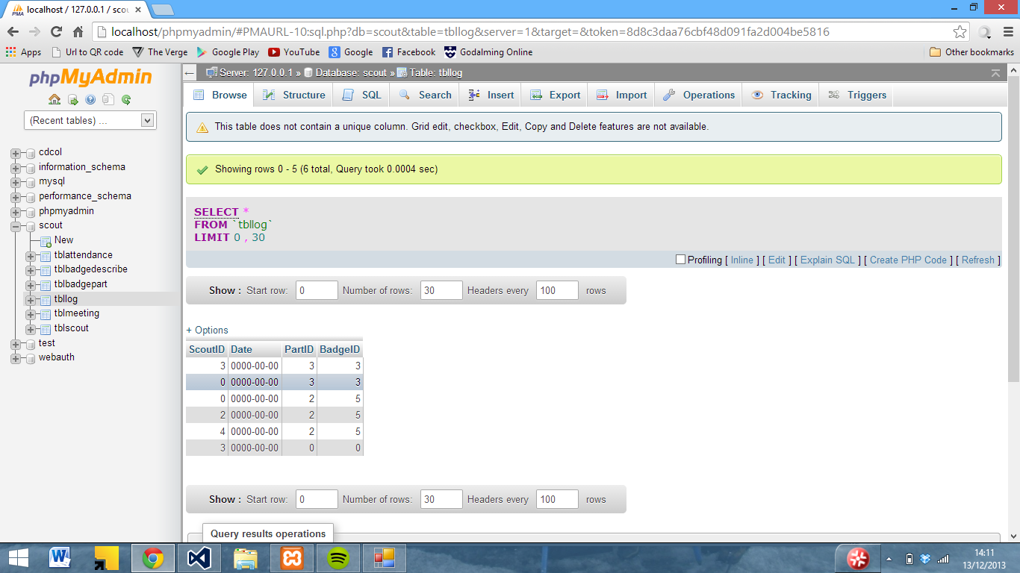

The program was also not storing the date in the correct format as seen above

Stepping through the code I can see that it is inserting it in the correct format.

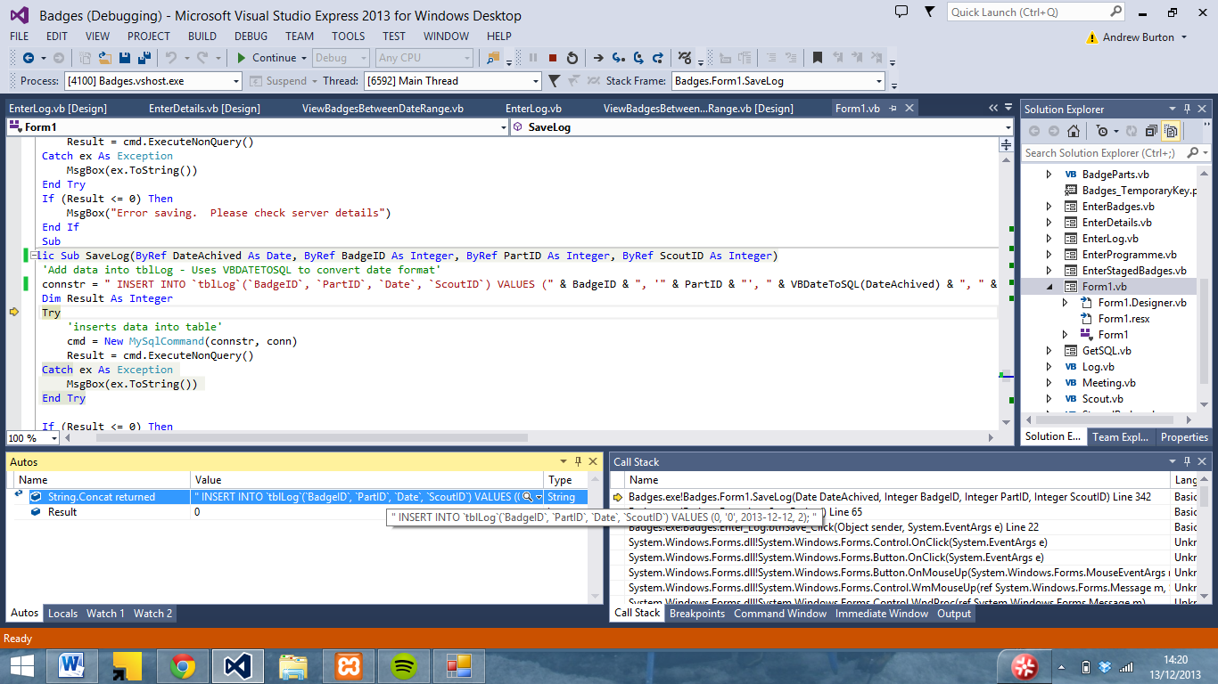

I looked at the other SQL subs to see if there was something missing or wrong with the statement, and found that the date in other subs had been declared as a a string rather than as a date

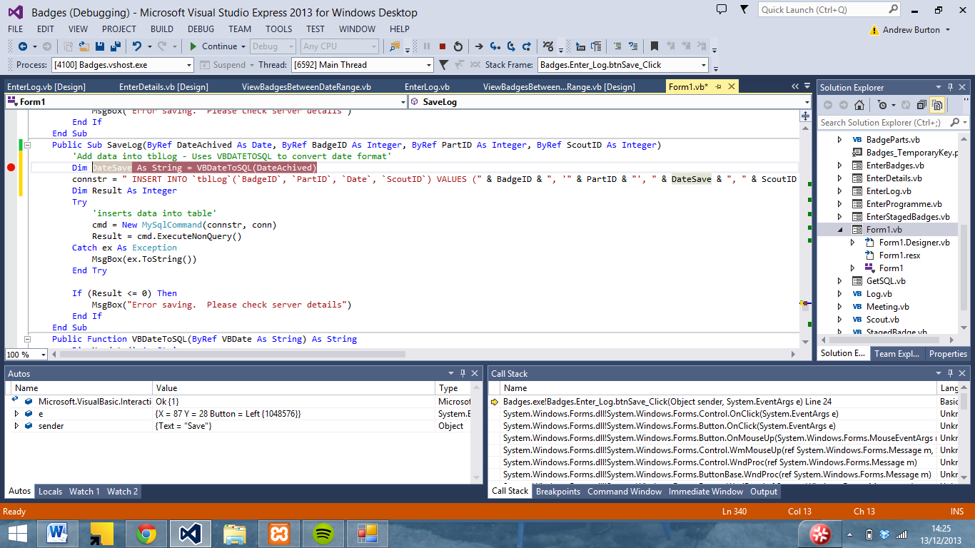

Although this still did not work

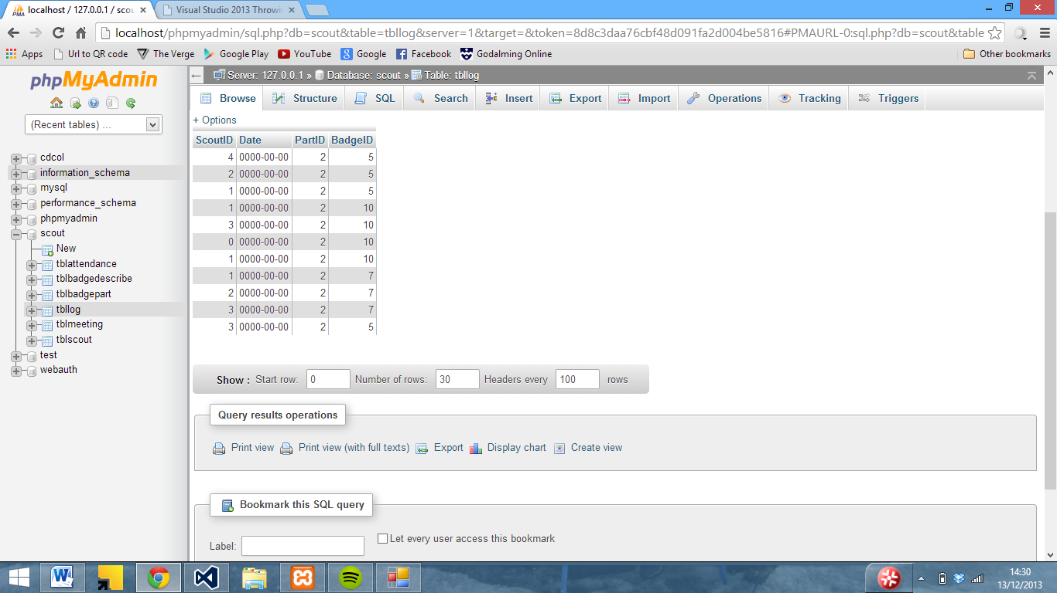

After various other attempts to fix it, it turned out to be an issue with the SQL command.

Here are a few more SQL errors

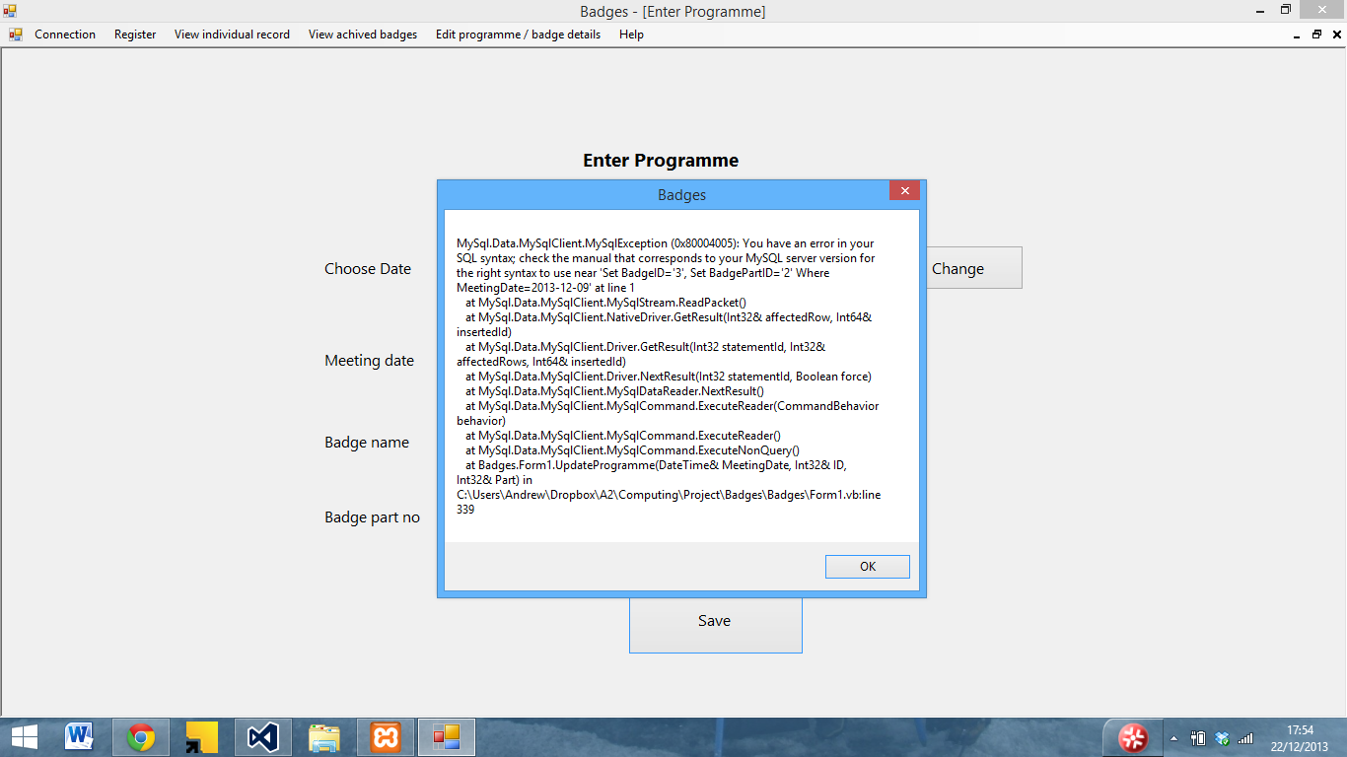

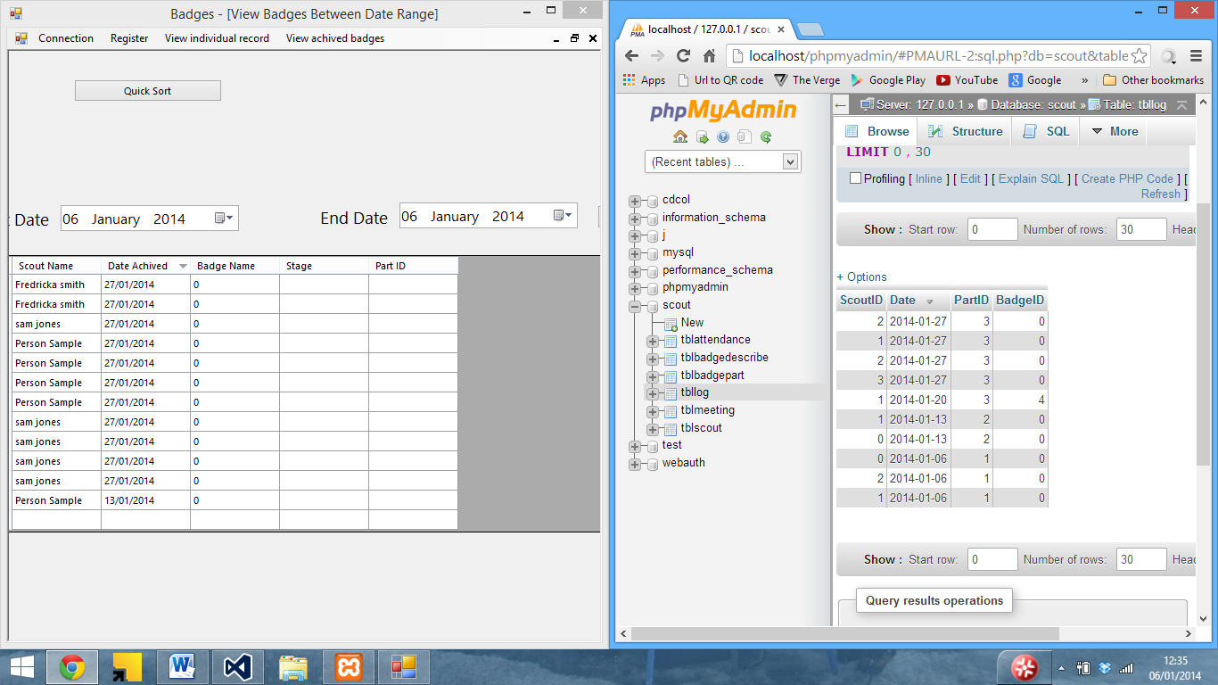

Here an SQL error can be seen whilst adding a badge

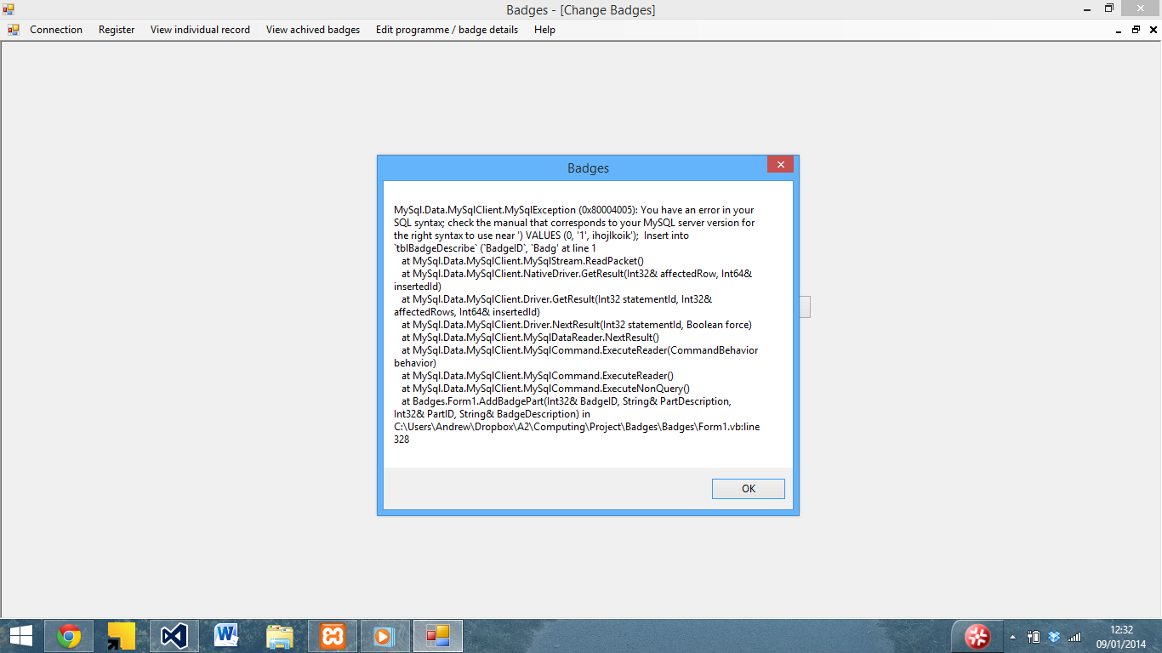

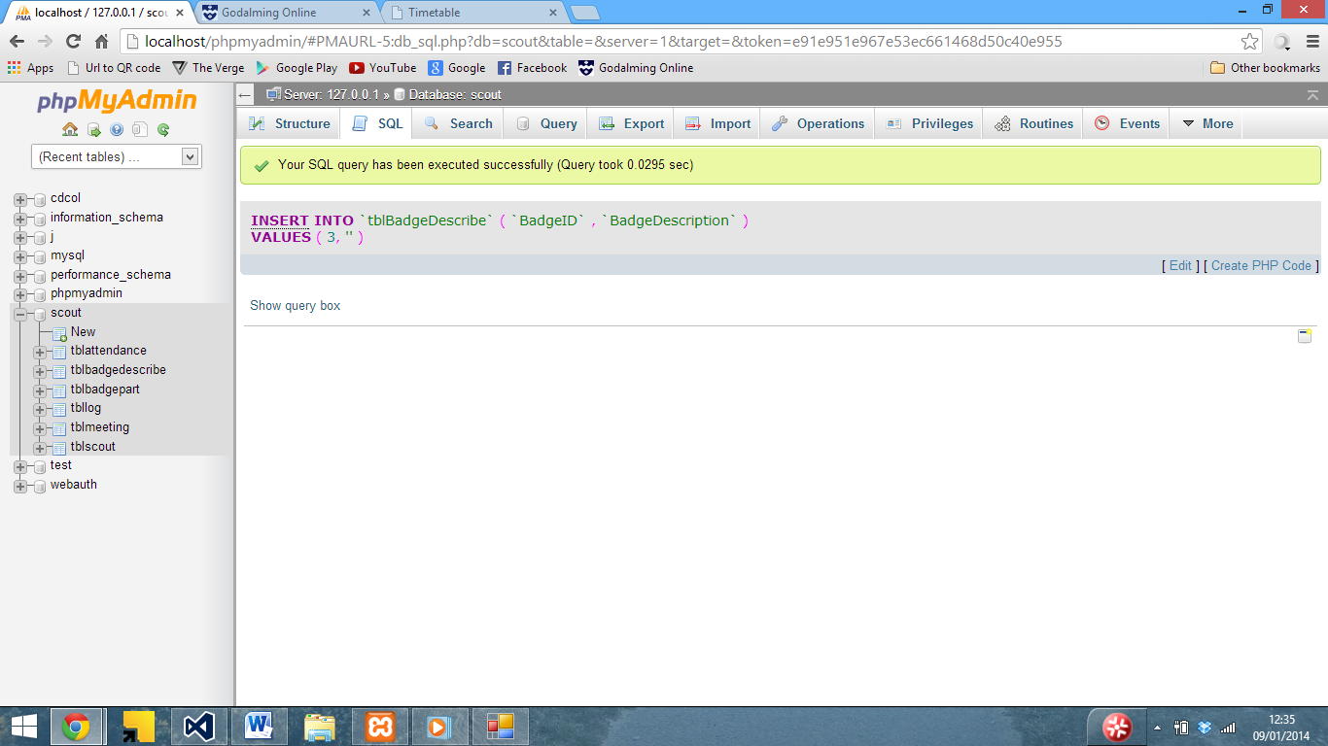Although inserting manually works…

I also had a similar issue with inserting badge parts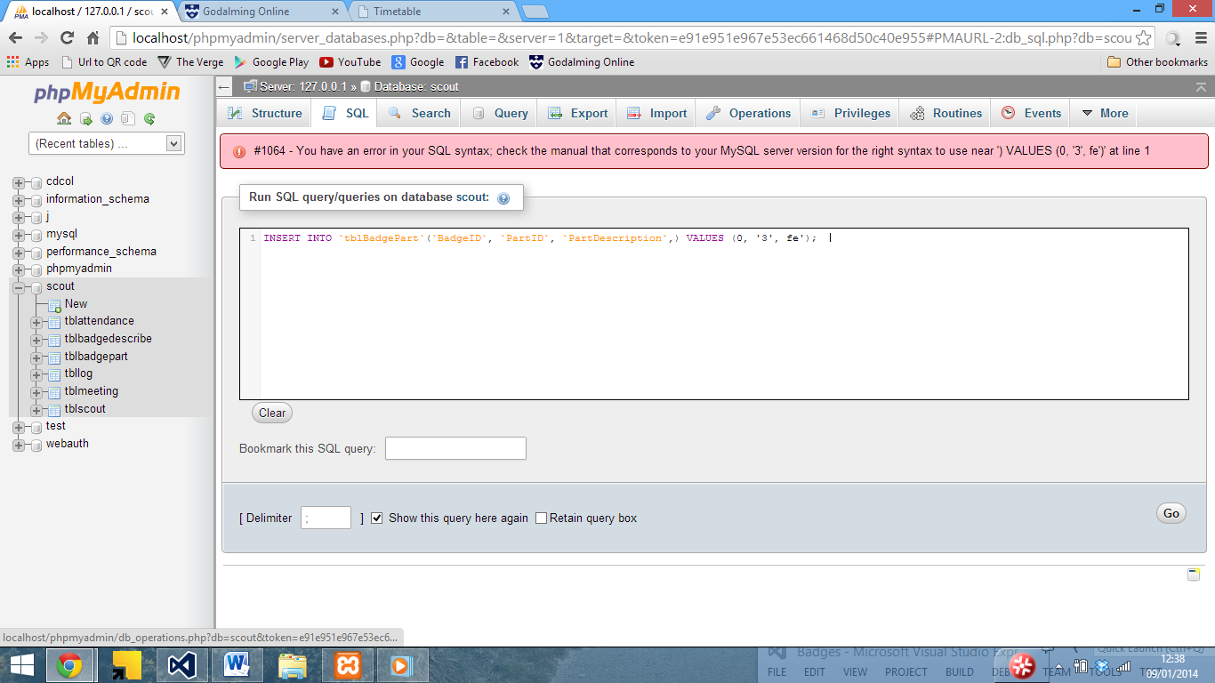

In both cases the issue was caused by a missing ‘ in the SQL statement.

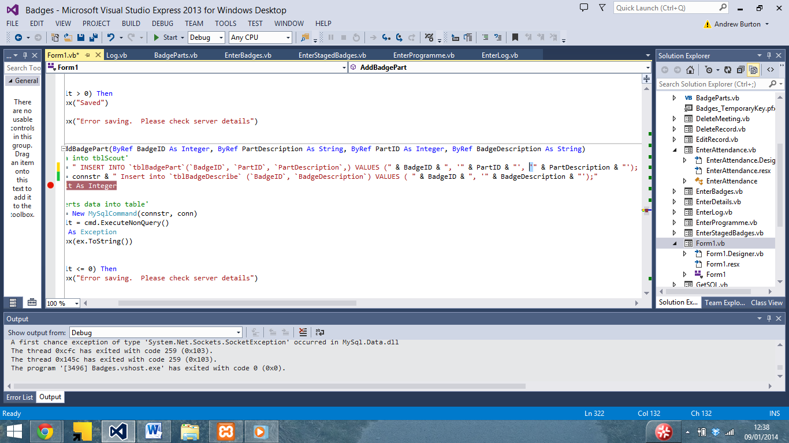

Which I then added to the SQL statement.

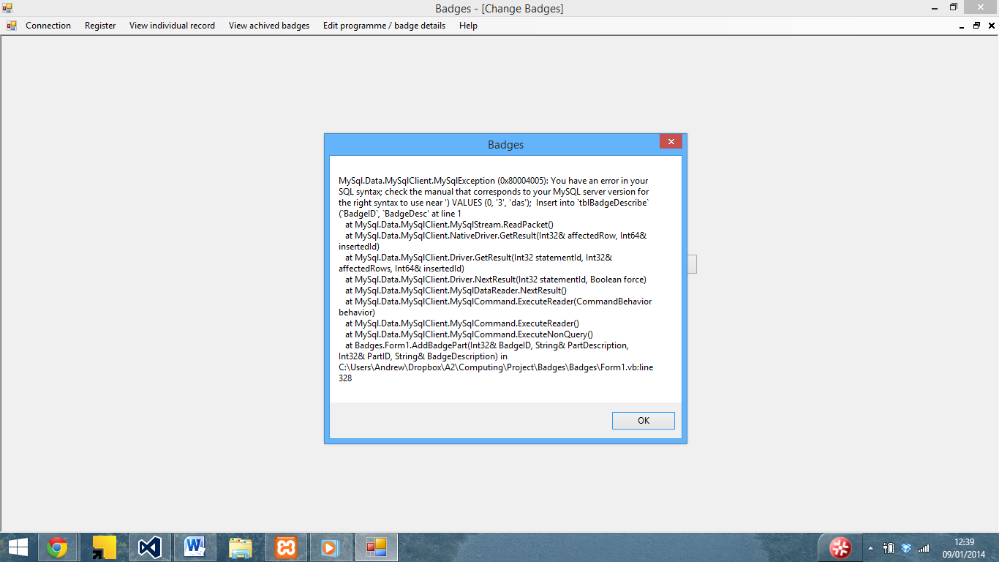

Although another error occoured whilst entering badge details

After looking at the SQL statement in VB, I noticed that there was a comma in the wrong place as well as seen below 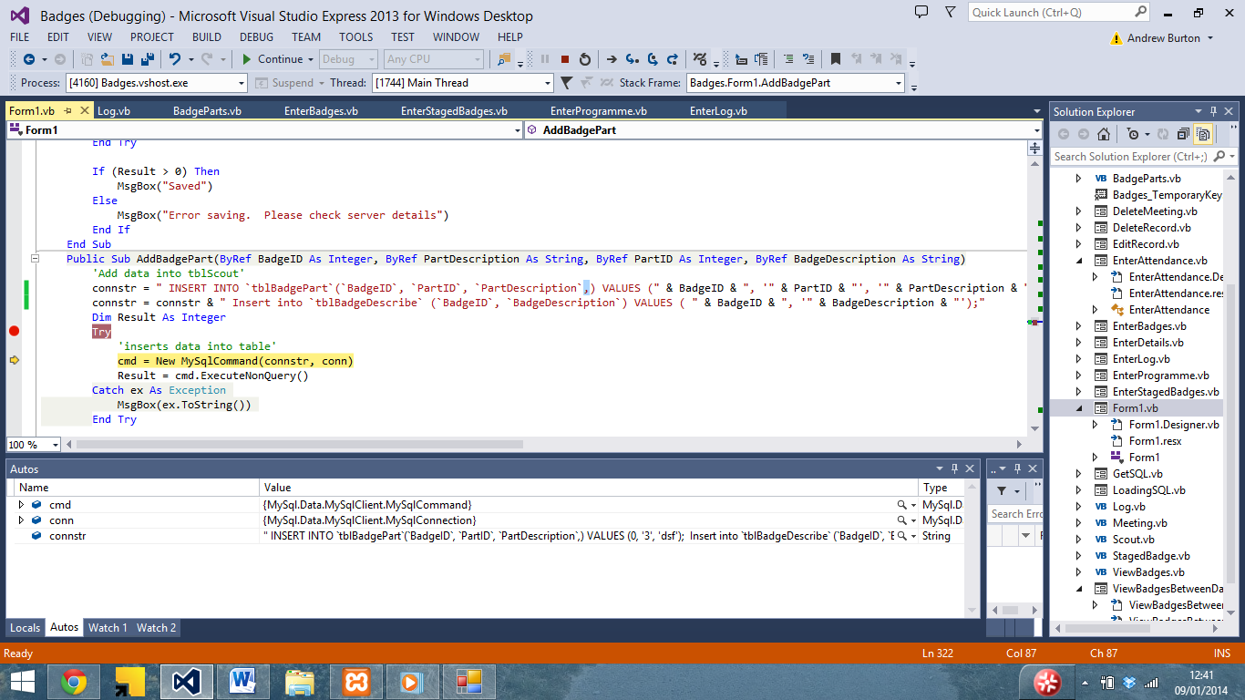

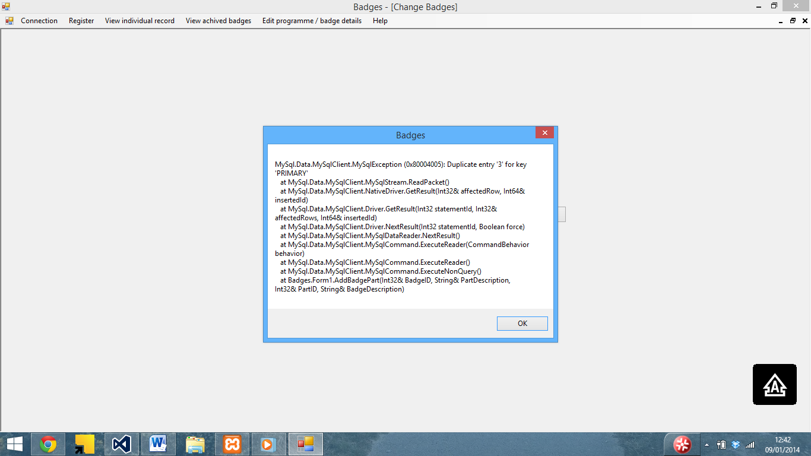

I then reran the program and encountered the error seen above due to a duplicate primary key, which I resolved by editing the database creation code to remove the primary key, which then saved.

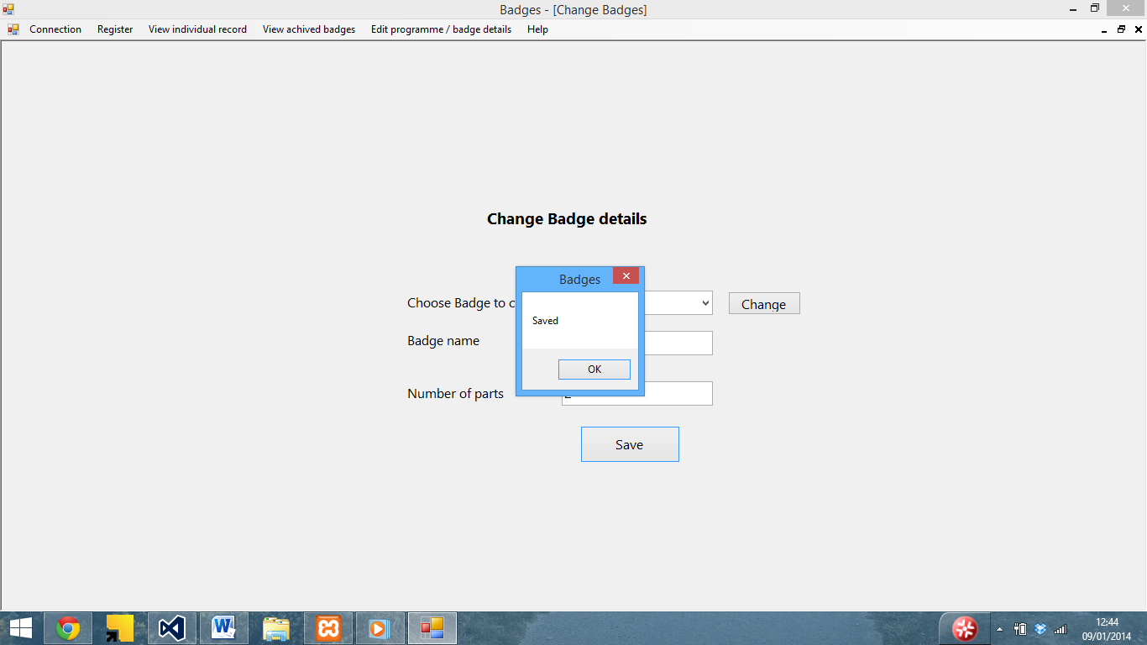

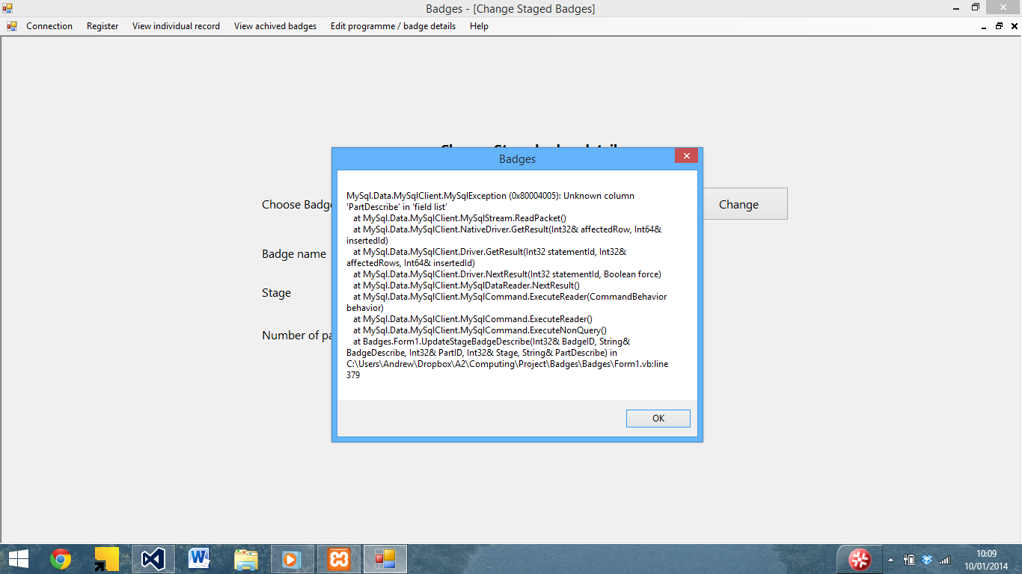

I also encountered a similar issue with enter stage badges

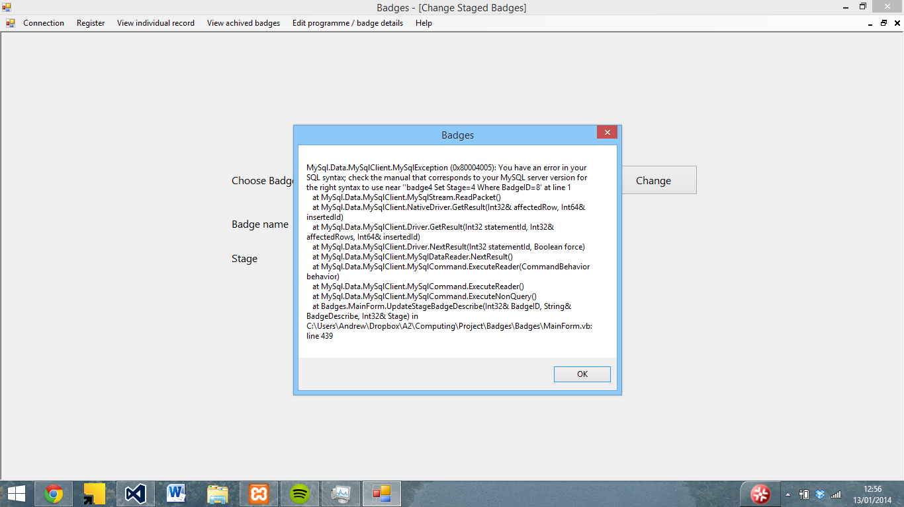

Which was due to an SQL error 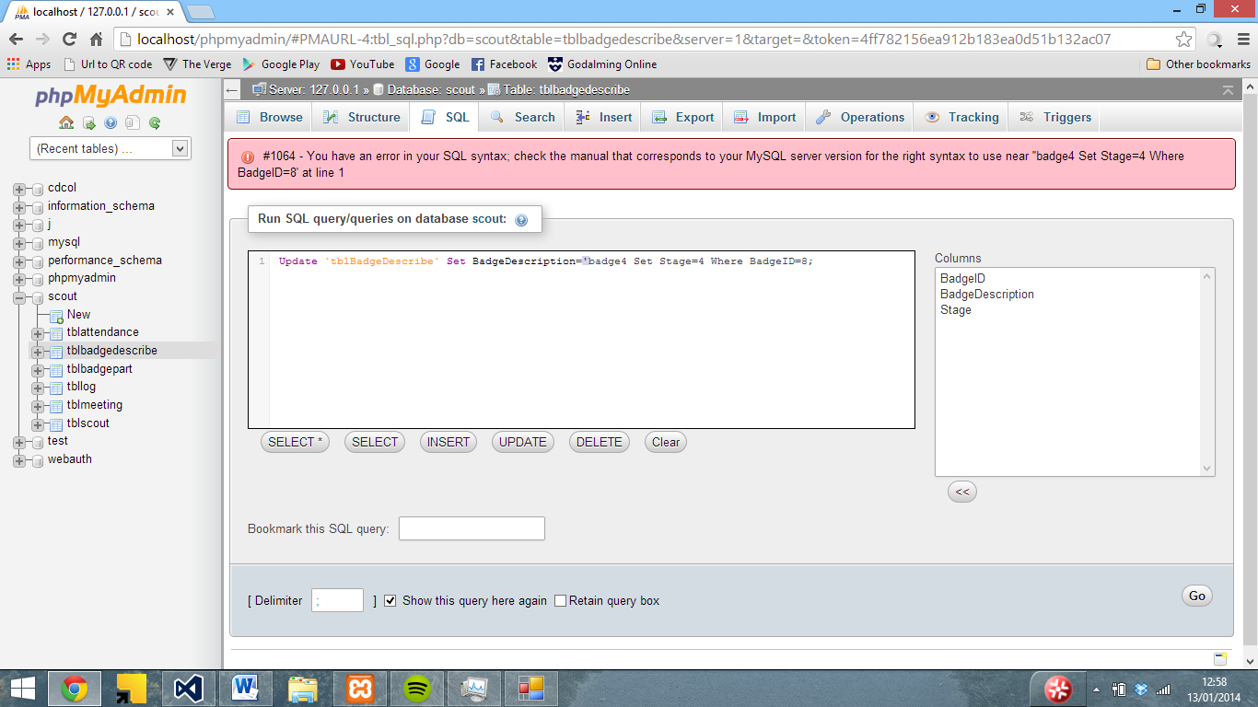

Which I eventually isolated to a missing ‘ after the badge description

I encountered another issue with the enter programme screen – the badge part should be the part name instead of the ID

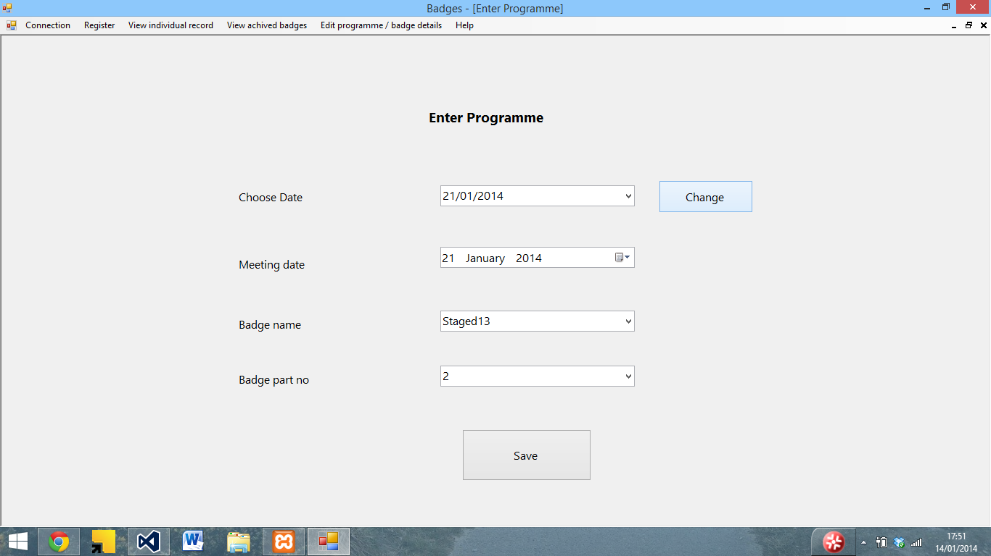

After looking at the code, it turned out that I had set badgepart to Id instead of description

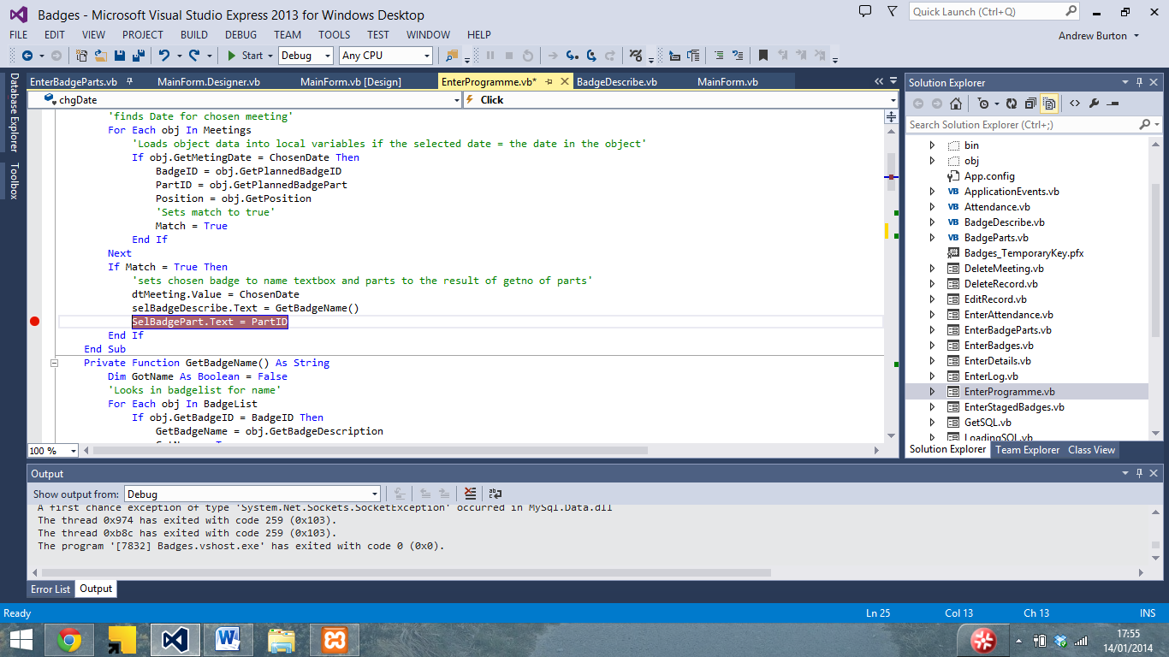

So I created a getpartname function to get the part name from the ID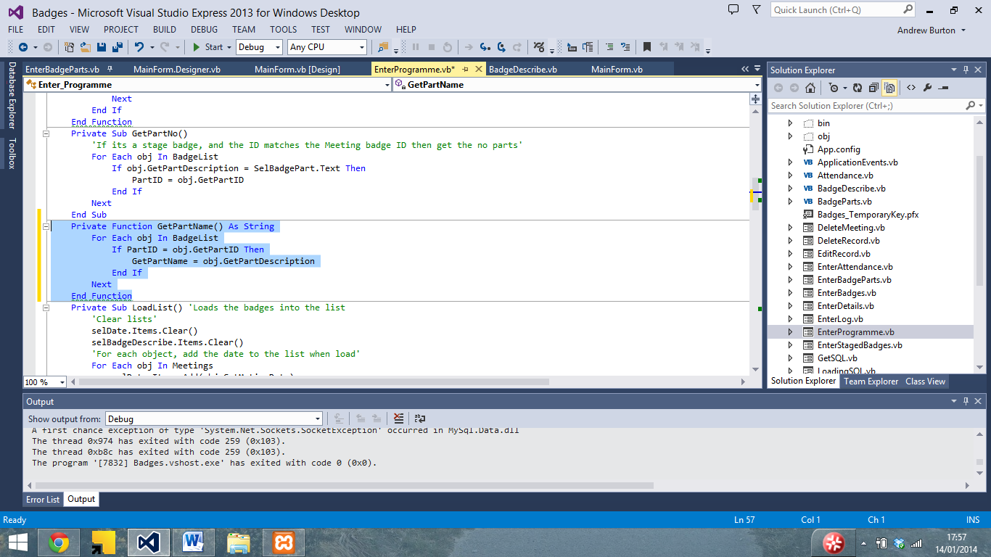

And set selbadgepart to be equal to that function

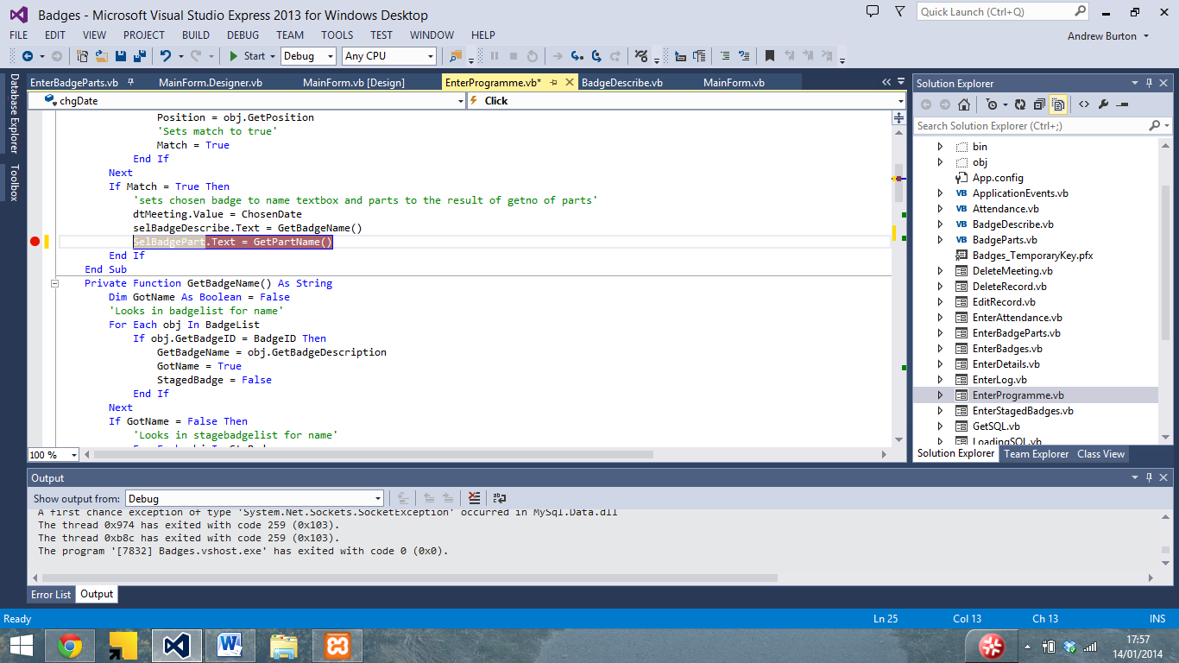

This fixed the issue

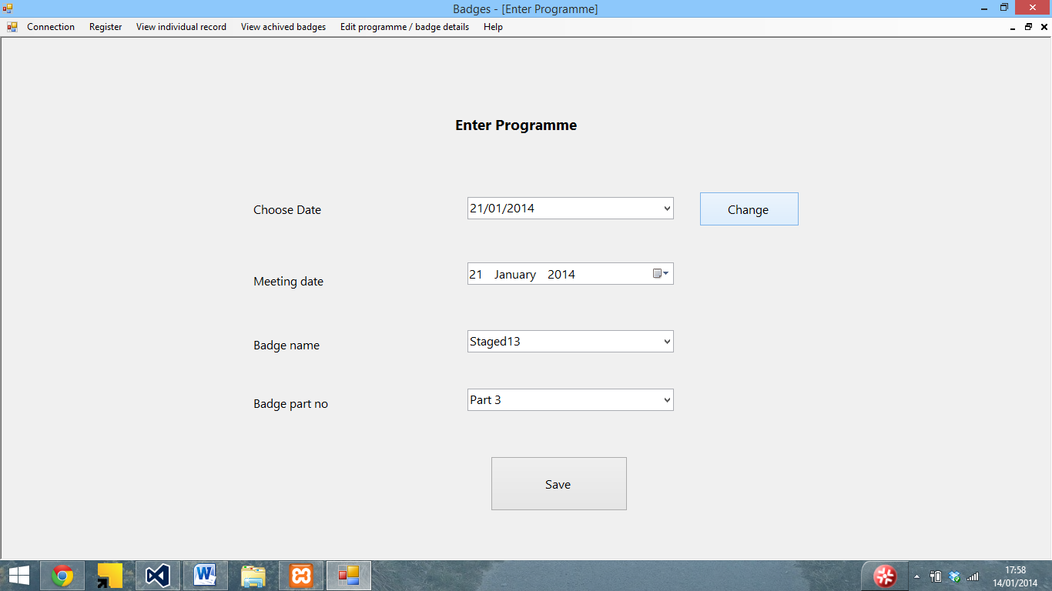

Although I had a similar issue with save changes

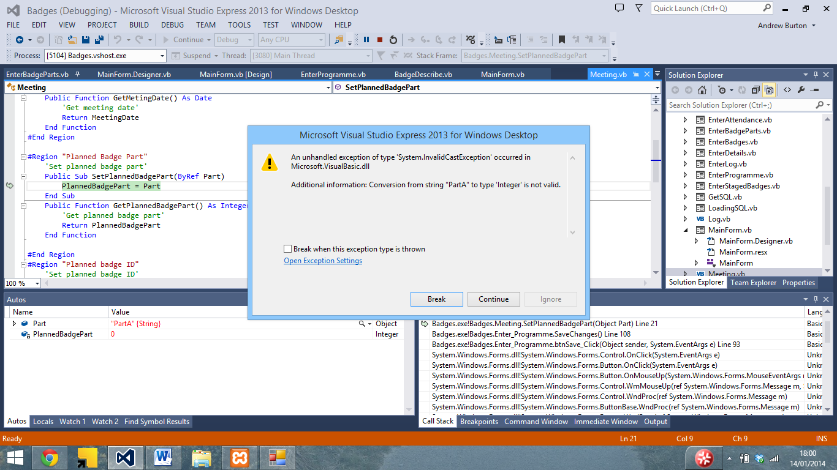

Which I was trying to save as a string rather than an integer

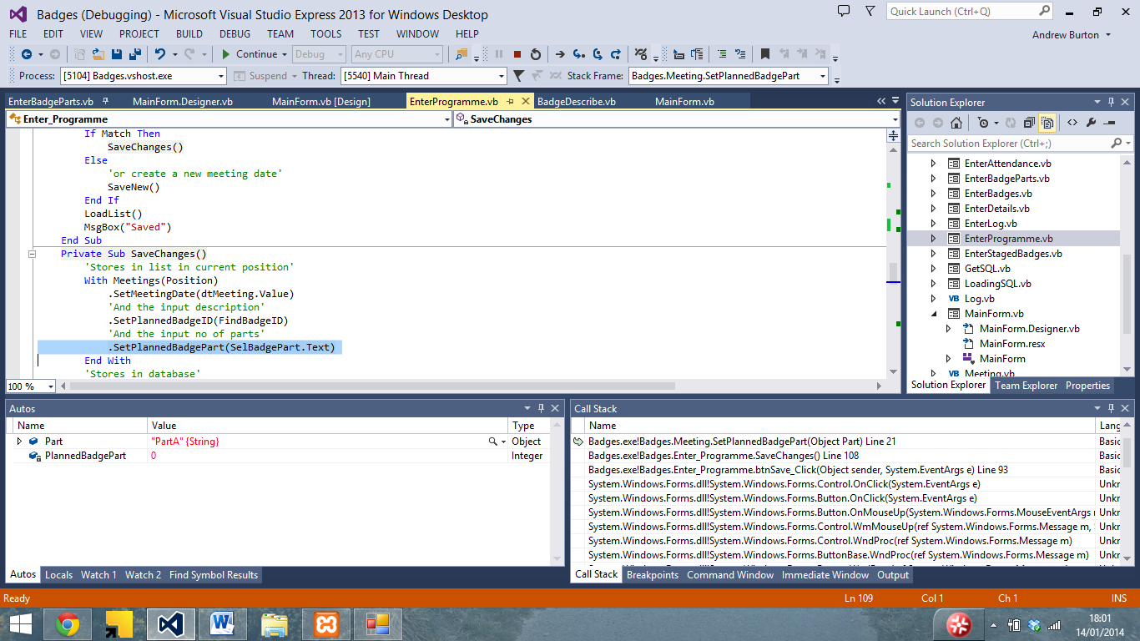

Changed badgepart to partID

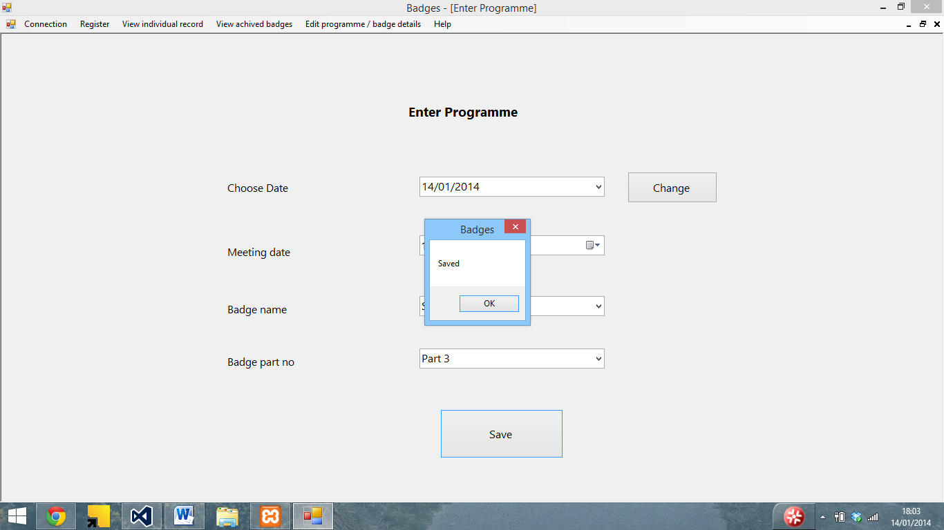

Another issue I encountered was that Attendance being wrongly assigned when new person added

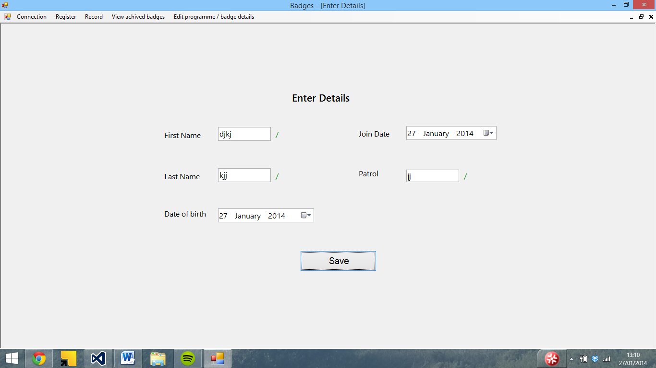

Fine in the SQL server and when you reconnect…

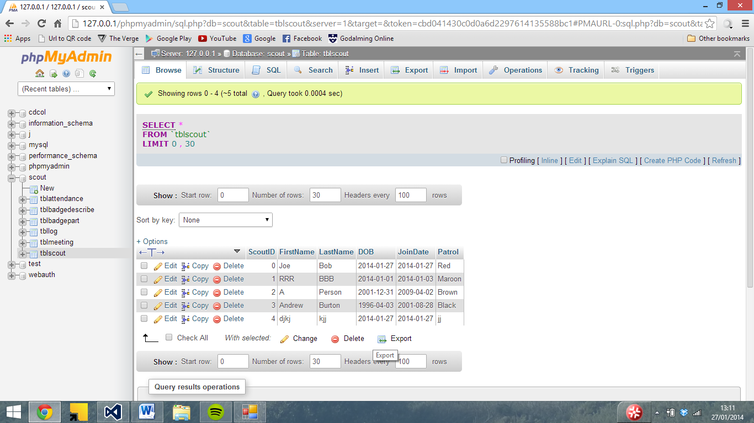

No ID is assigned

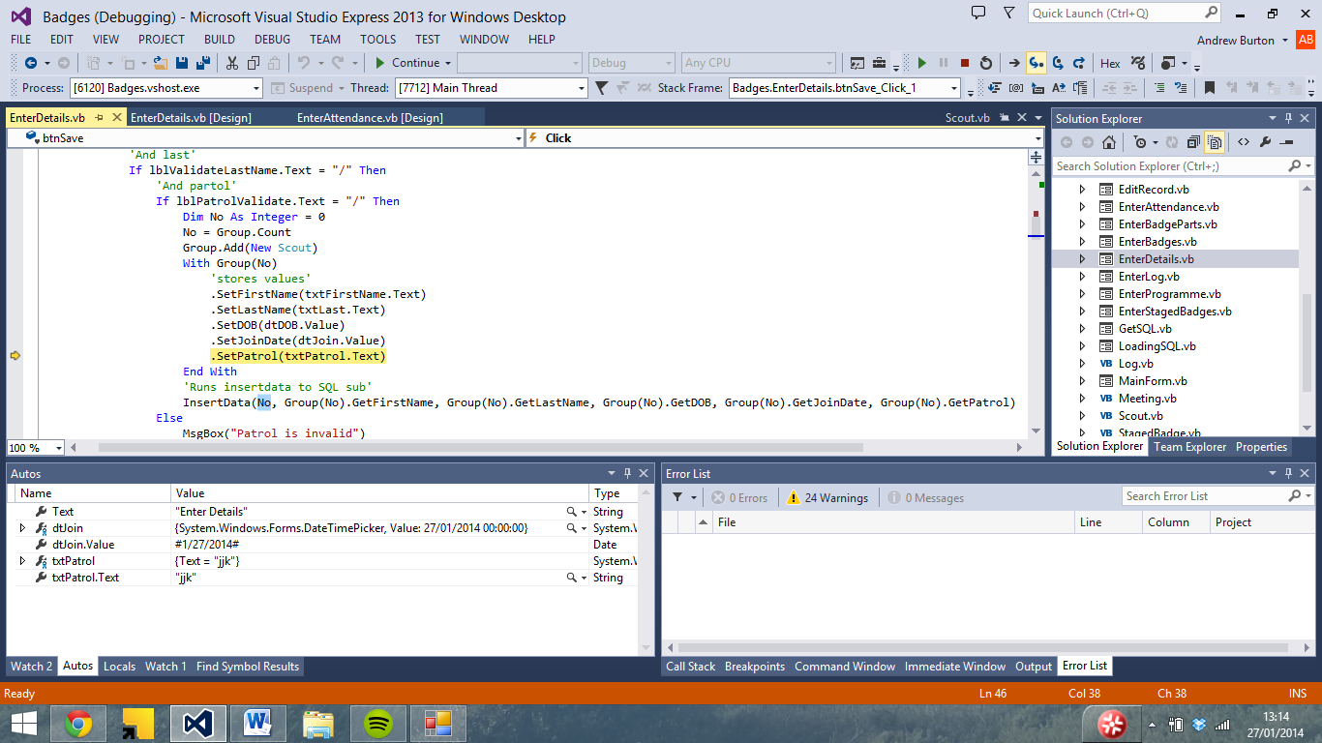

But is at the SQL stage

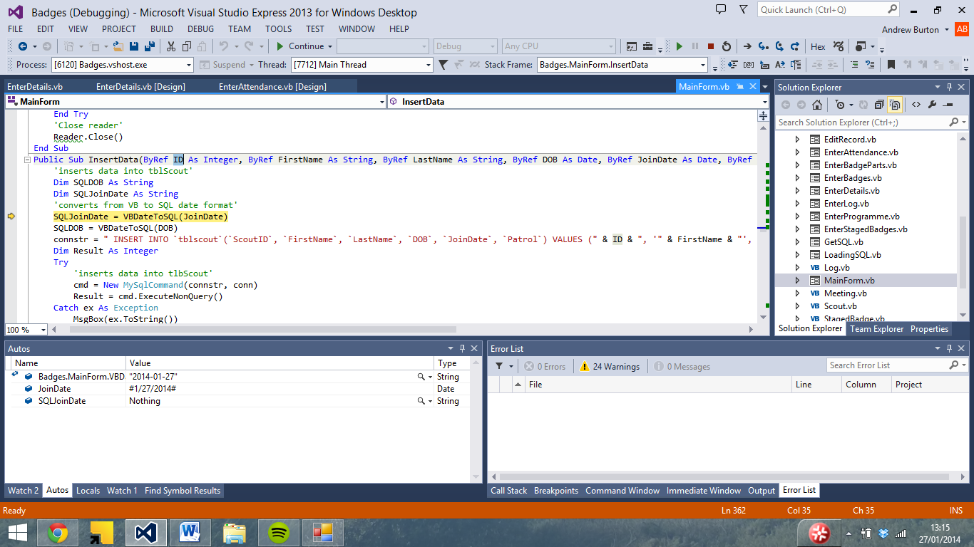

So I added a line of code to assign it the next highest ID

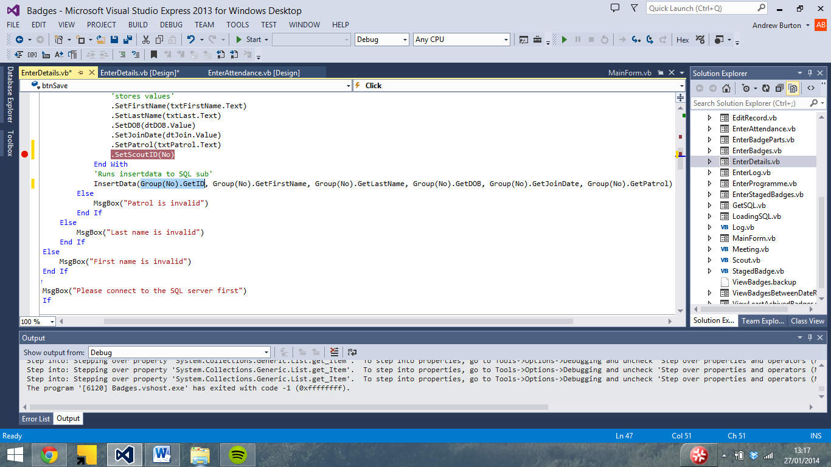

Which meant that the record saved

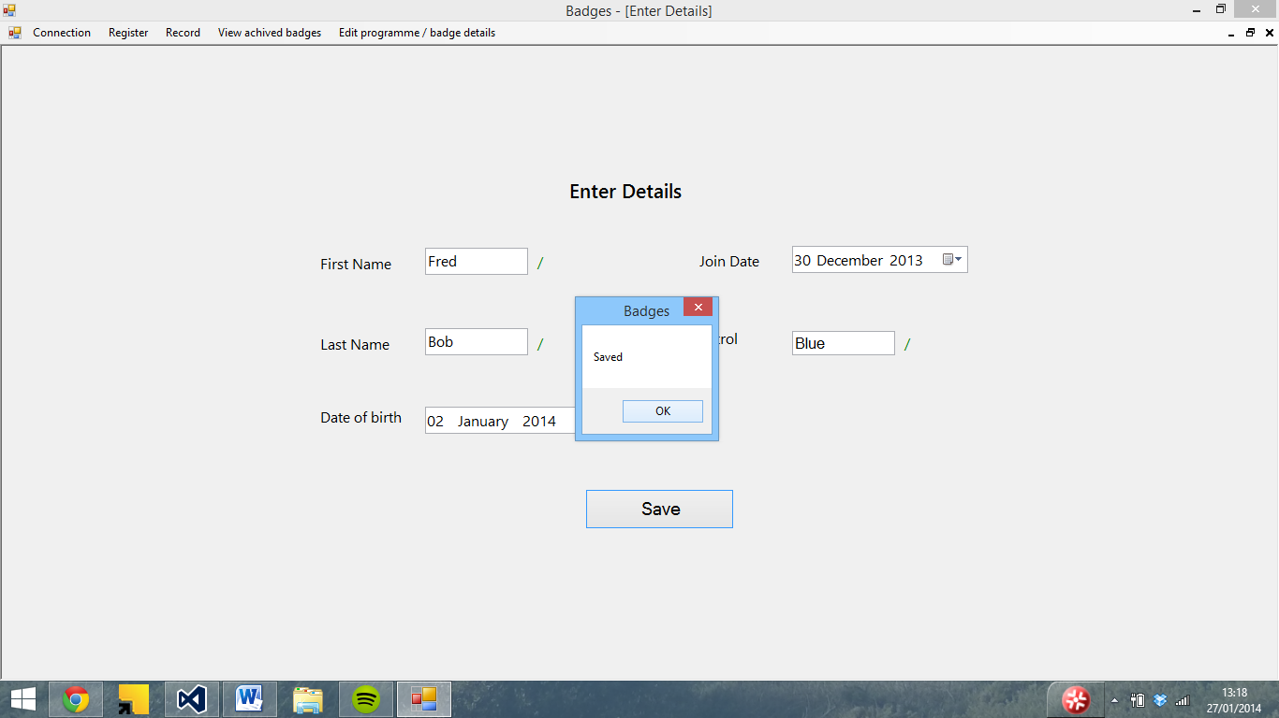

And the attendance displays correctly

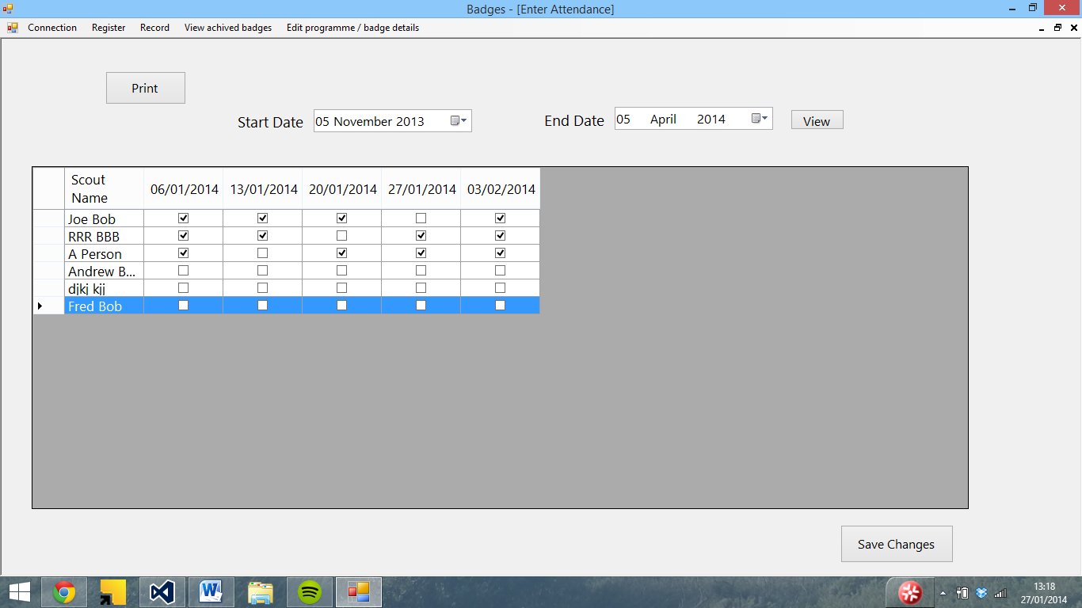

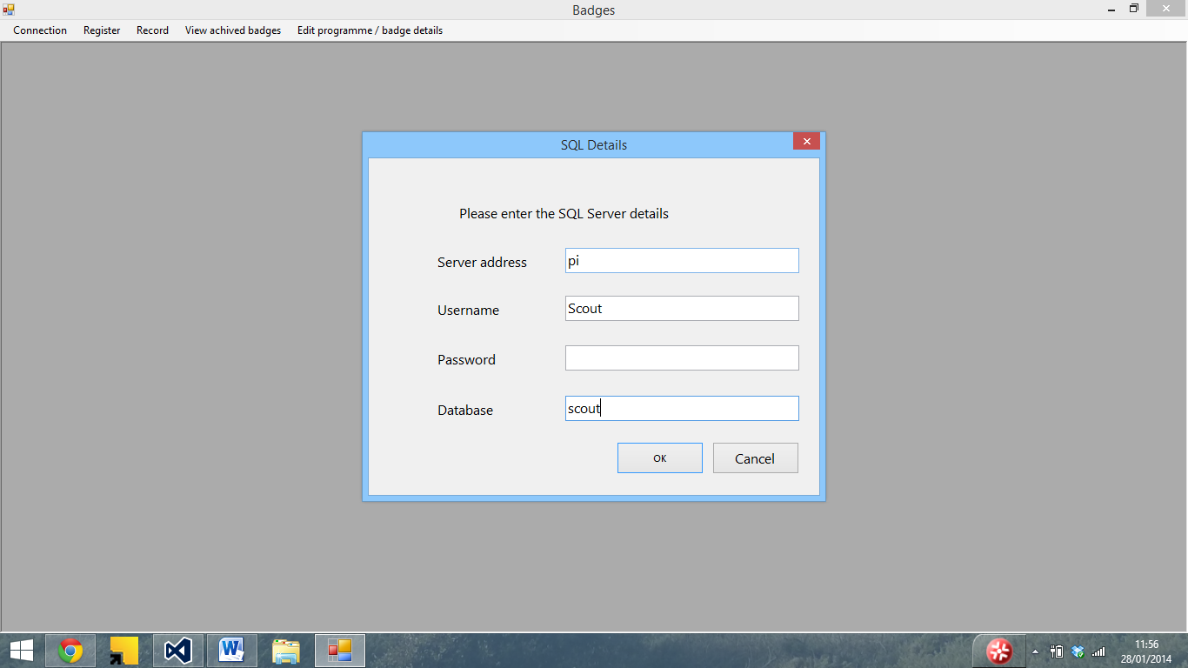

Wrong table name (should be Scout) – password removed

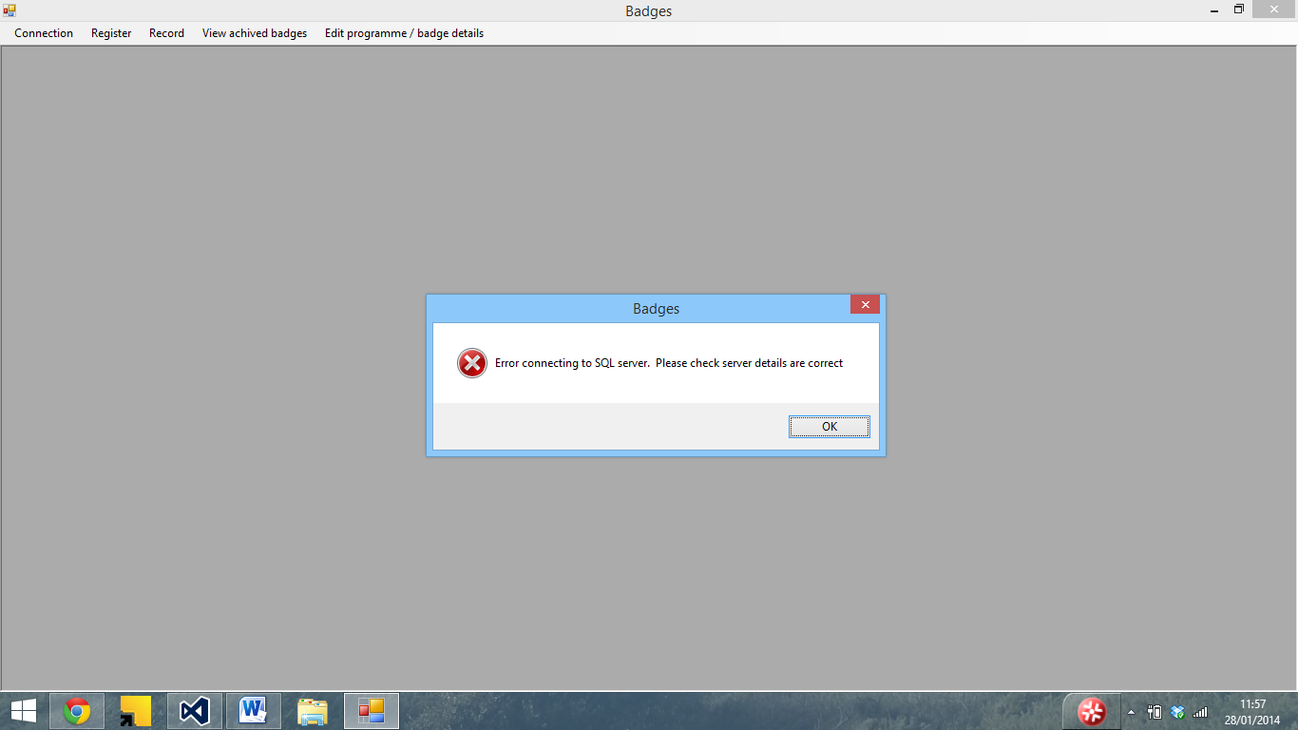

And if I enter the correct details

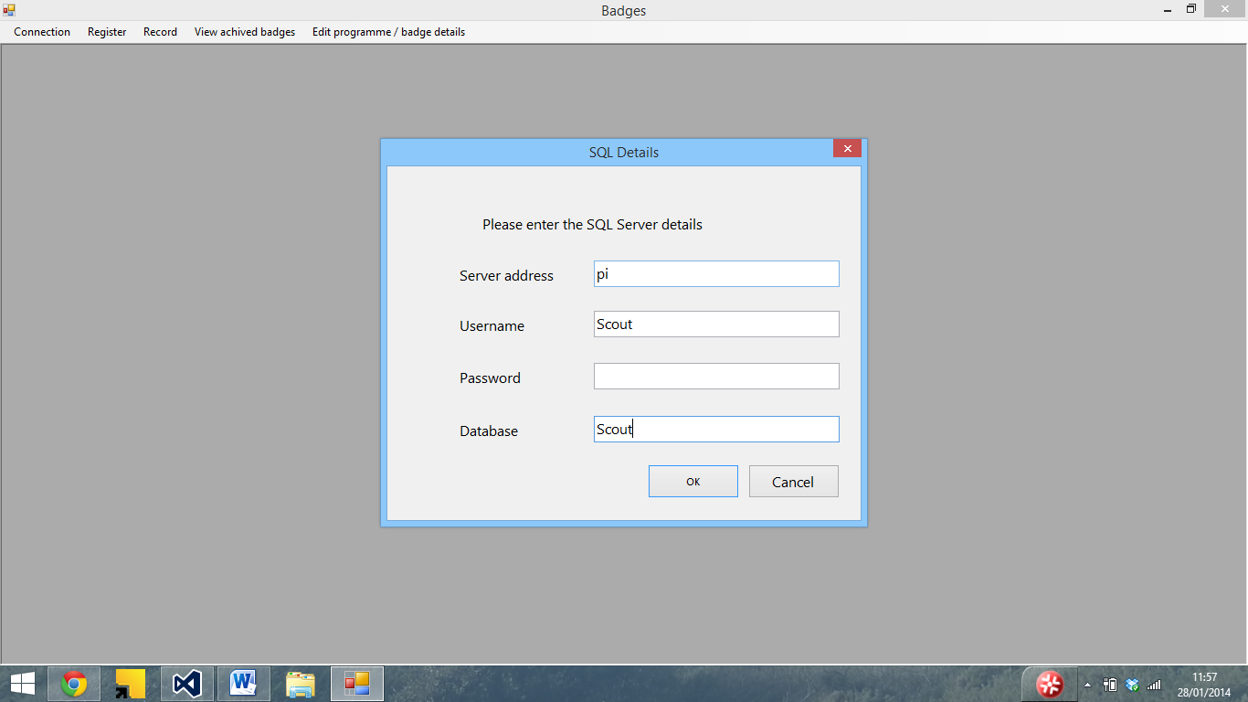

It crashes as the connection is open

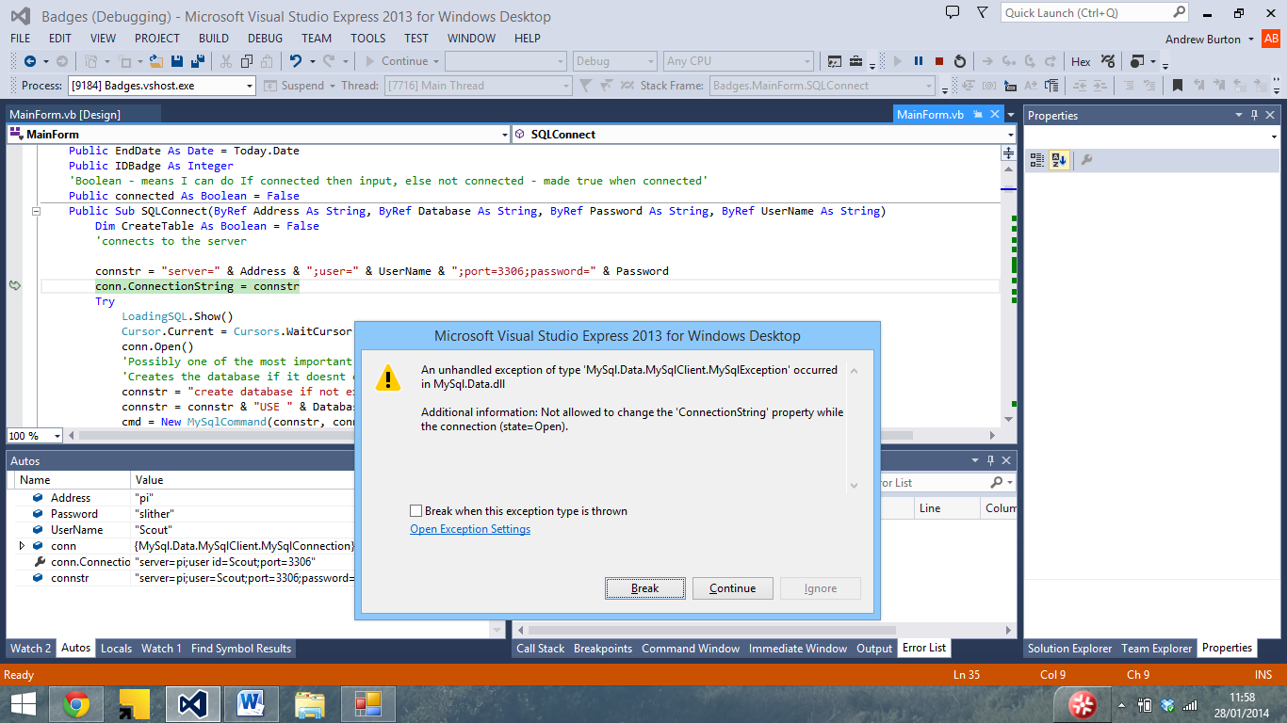

I tried adding in a connection close line

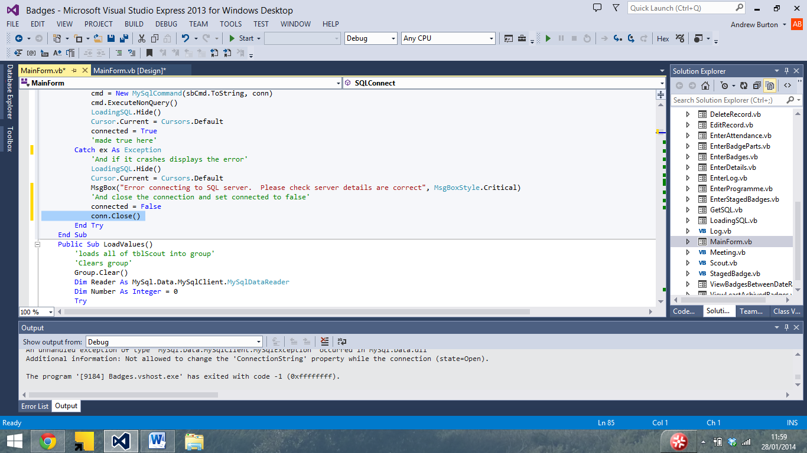

I then tried again With Wrong details

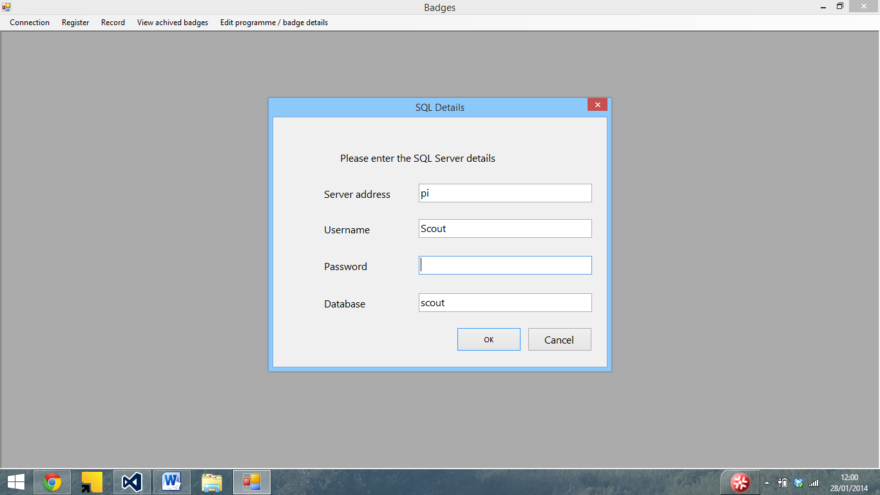

The program throws an error

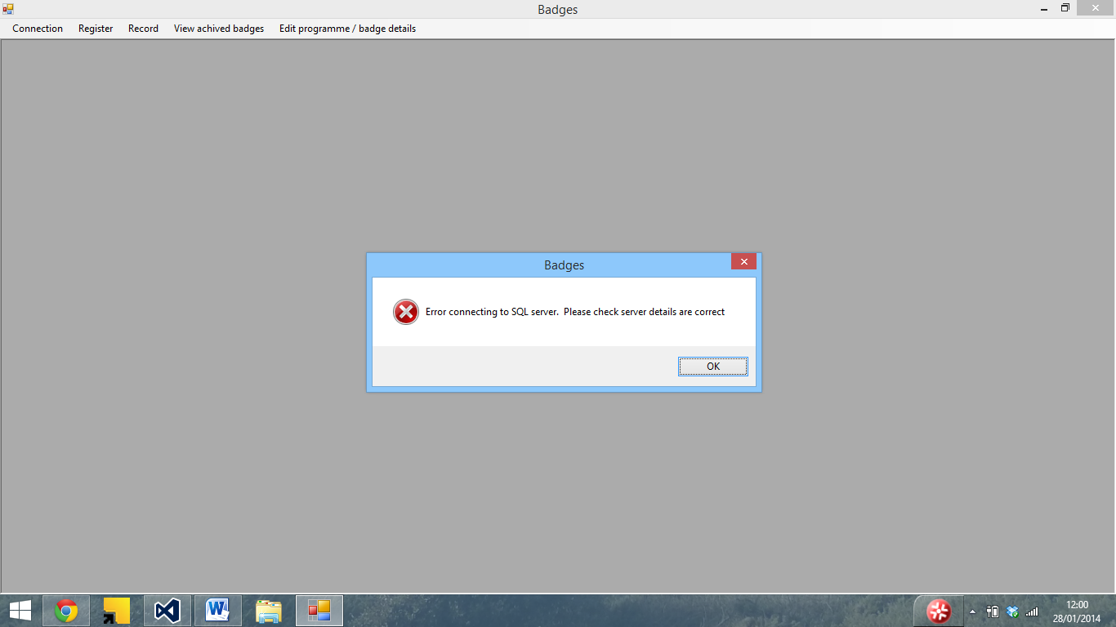

And with correct details

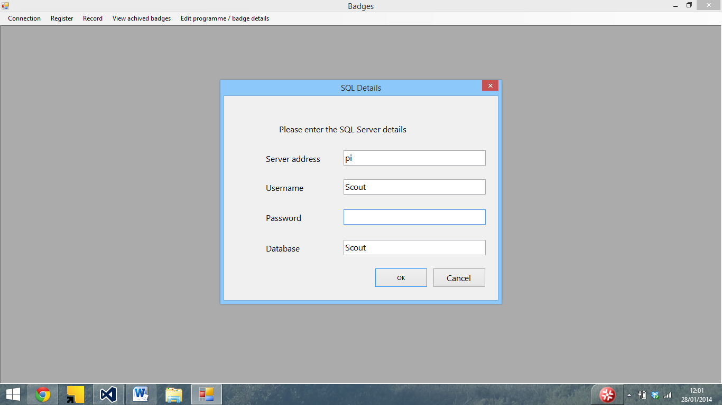

It connects

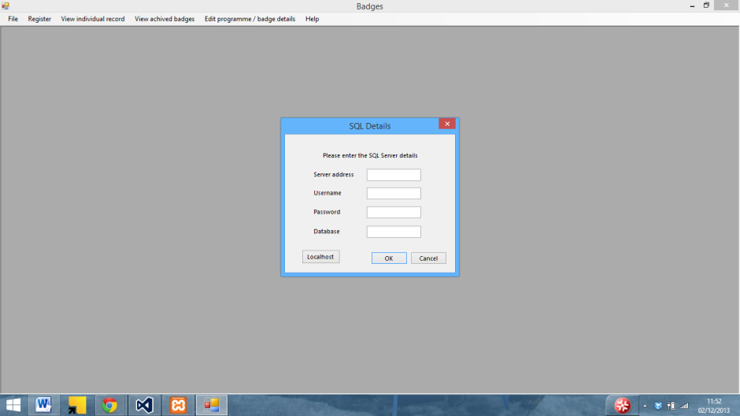

During development I added a localhost button to the SQL details form to allow me to quickly connect to the SQL server

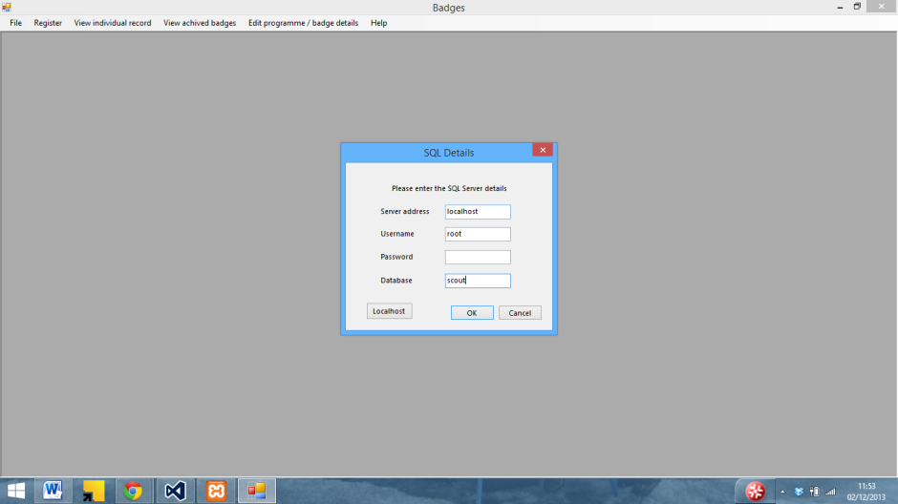

The textboxes also worked

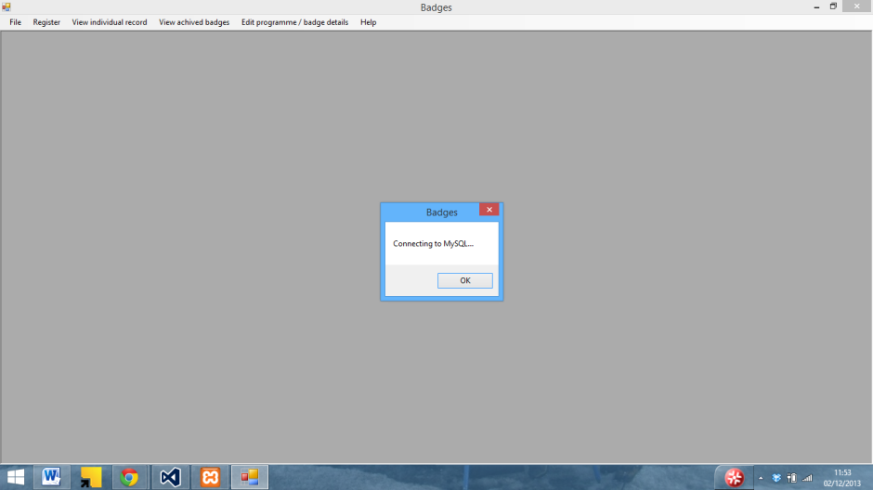

I also originally used a message box instead a form to display that the connection was working, although I changed this since the program would not connect to the server until the OK button was pressed

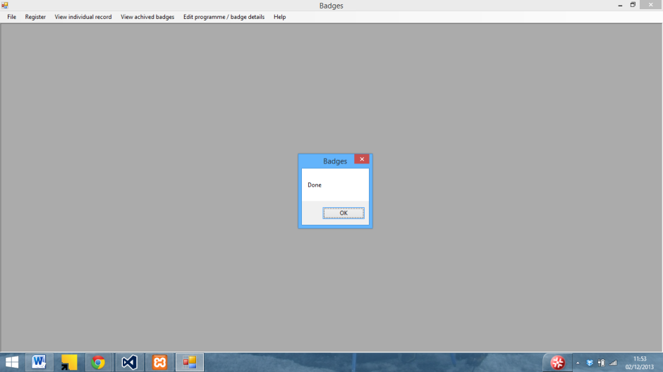

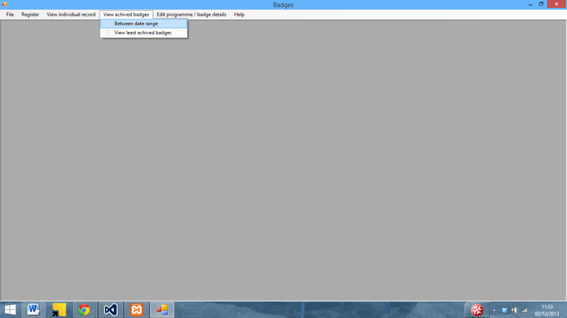

The view badges between date range originally used IDs rather than names whilst I sorted out the issued with the grid view and other parts of the program



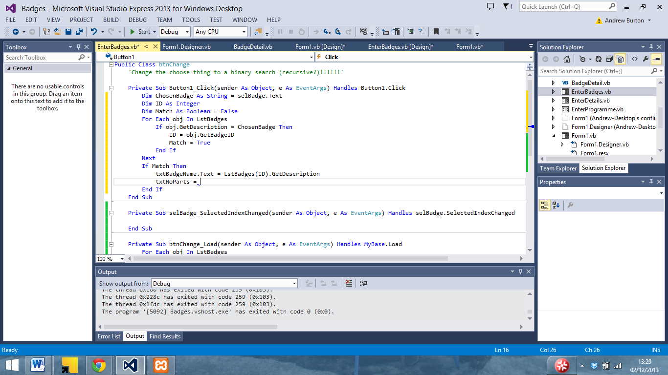

Hmm… if I do this each badge …

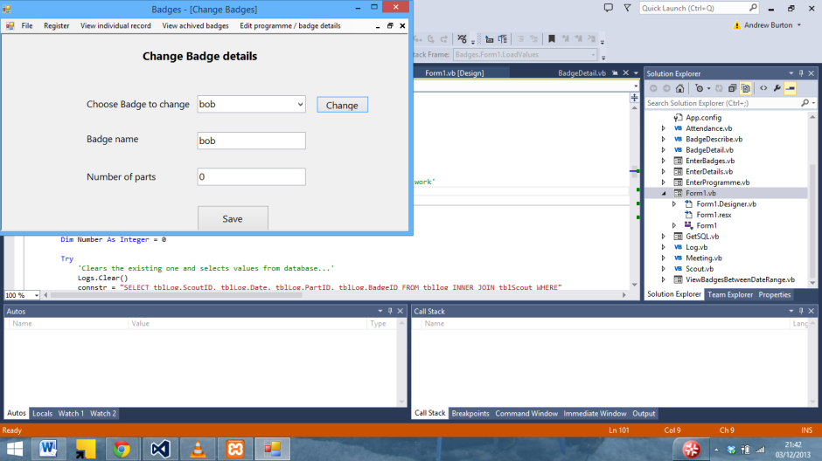

…Except its leaving a load of null values

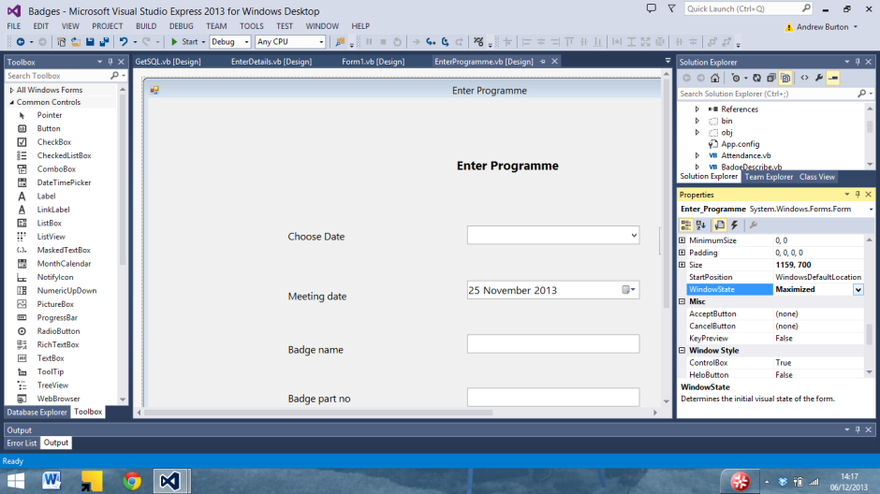

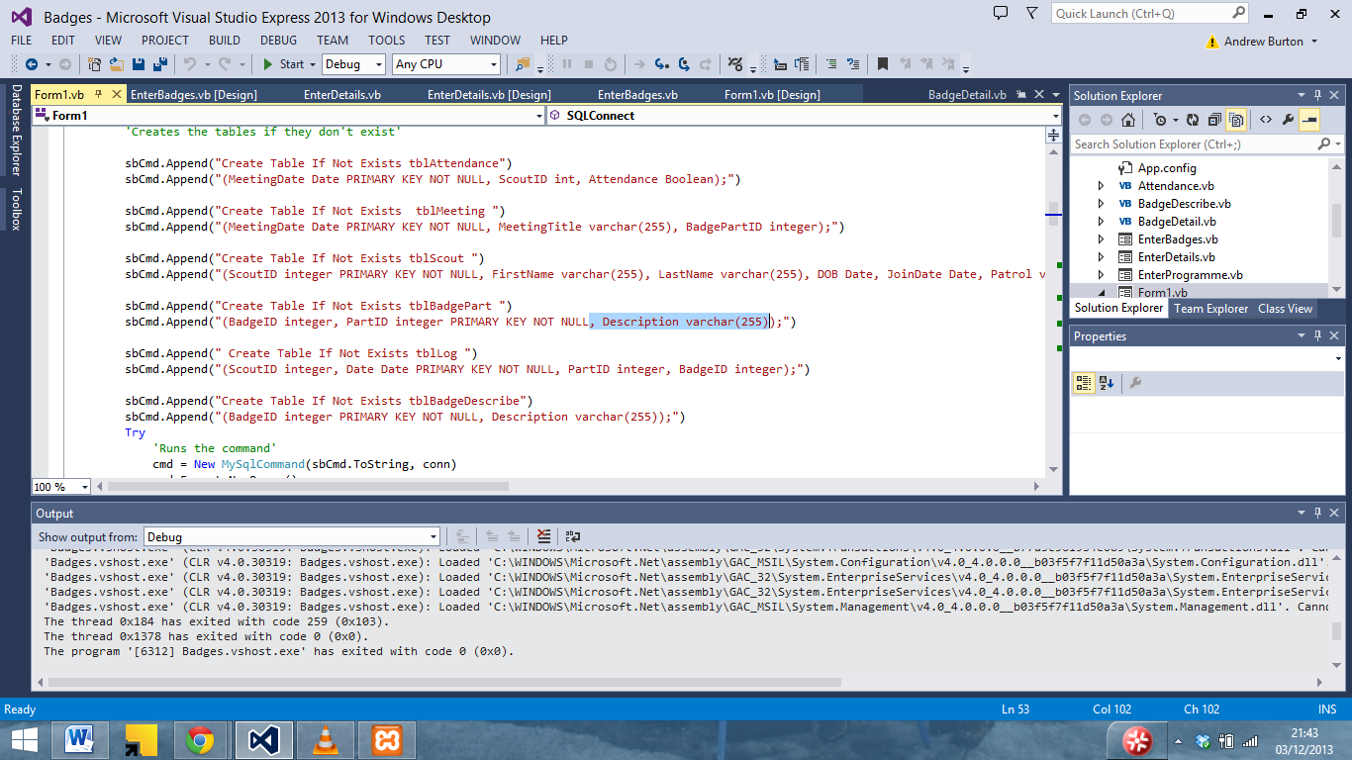

.. and it works

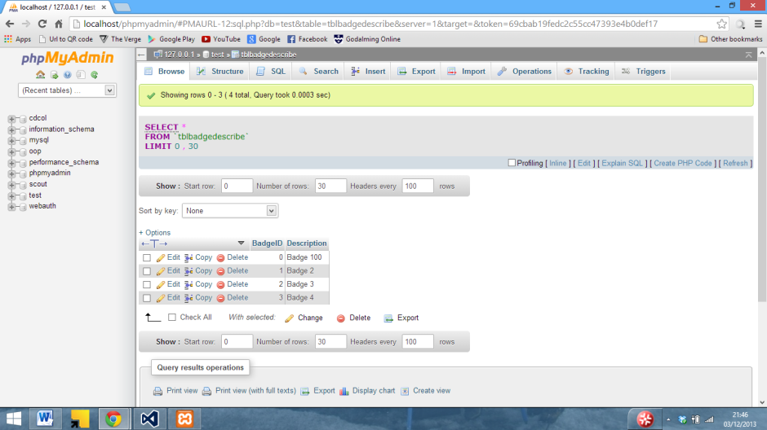

Even if changing a number of parts results in the number of parts being duplicated (And 1 more than entered being added when the badge is created)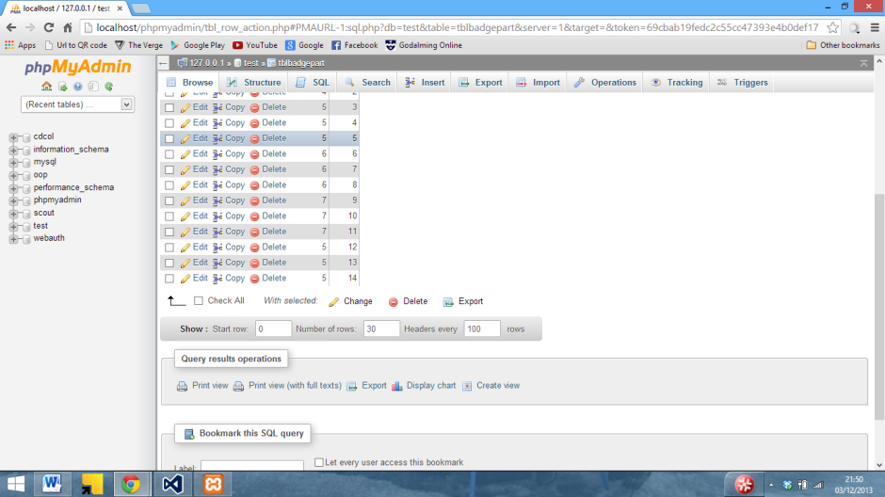

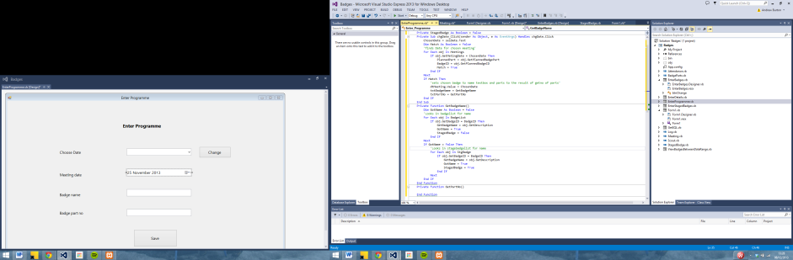

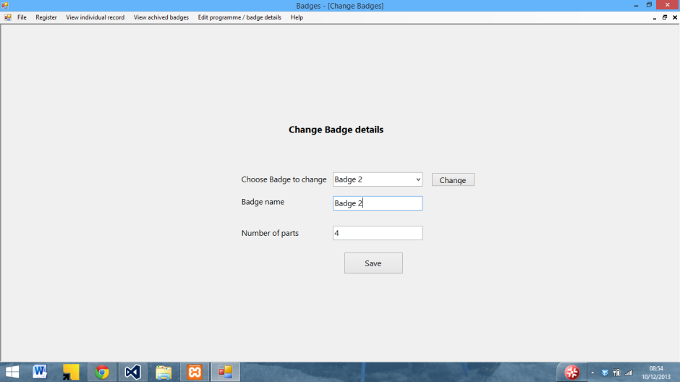

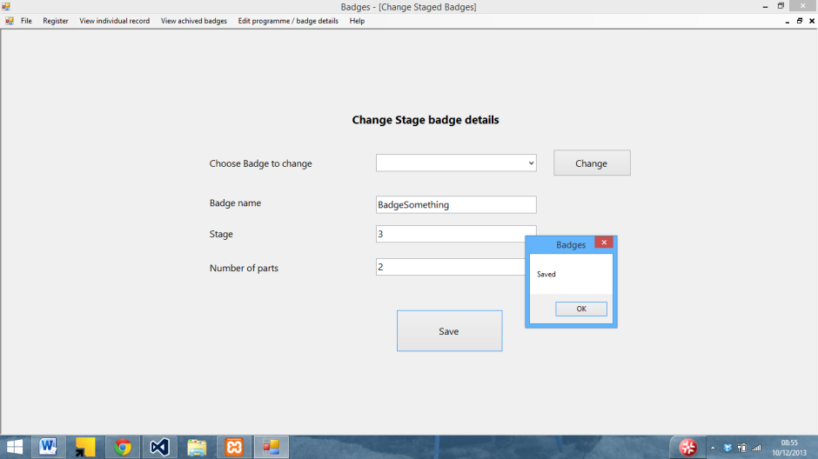

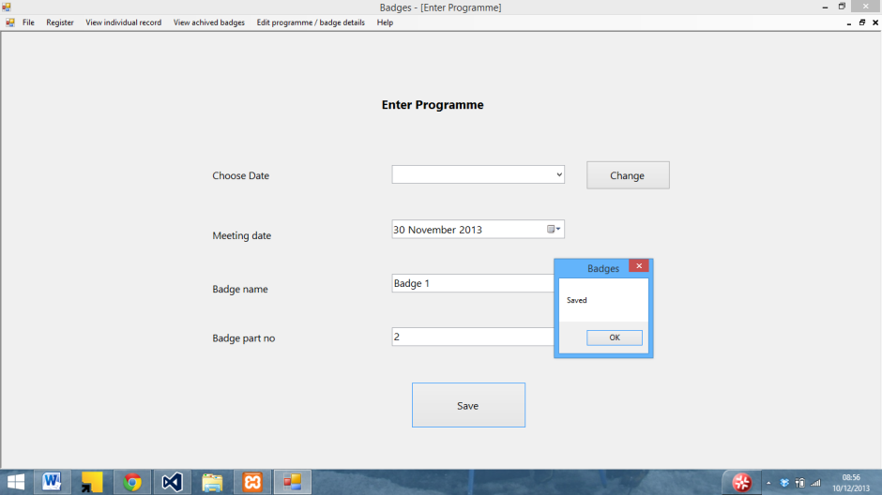

… It saves (but not to the database yet)

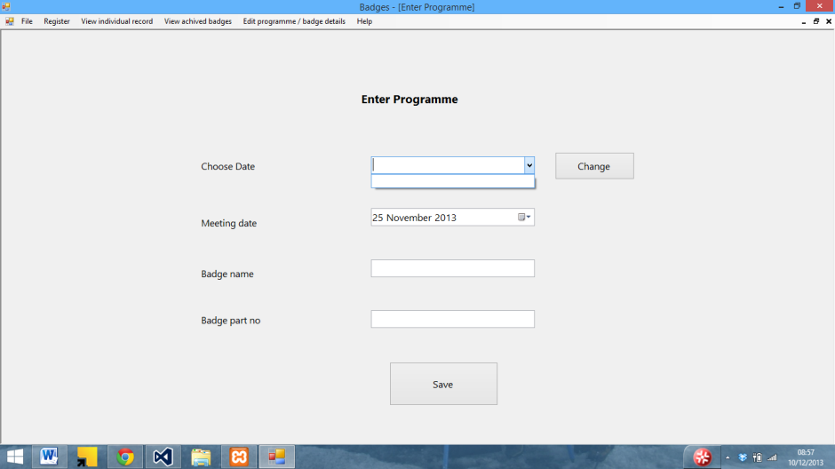

Managed to get a list of the badges in (and working)

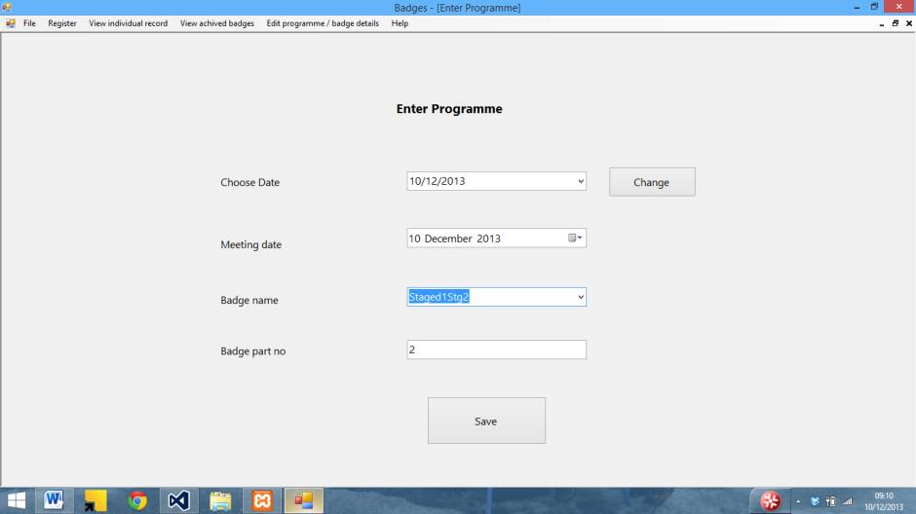

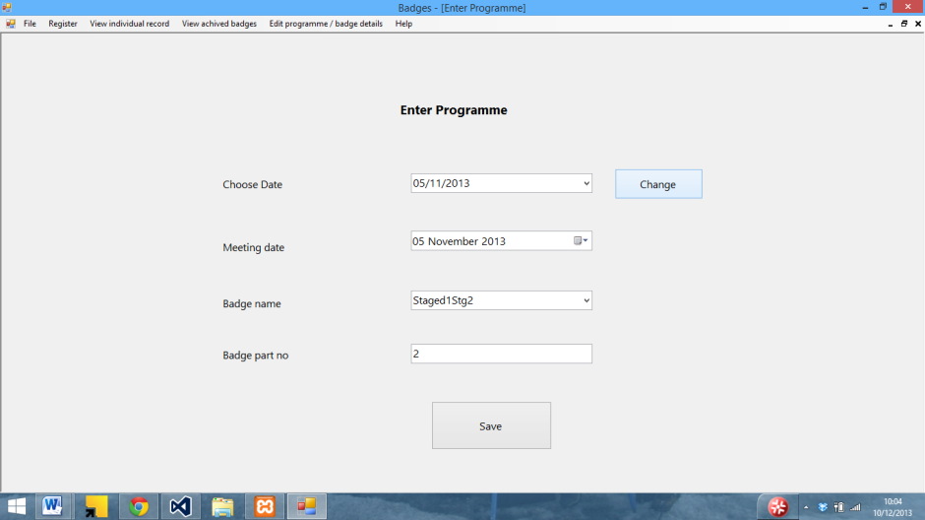

And it now connects to the SQL server

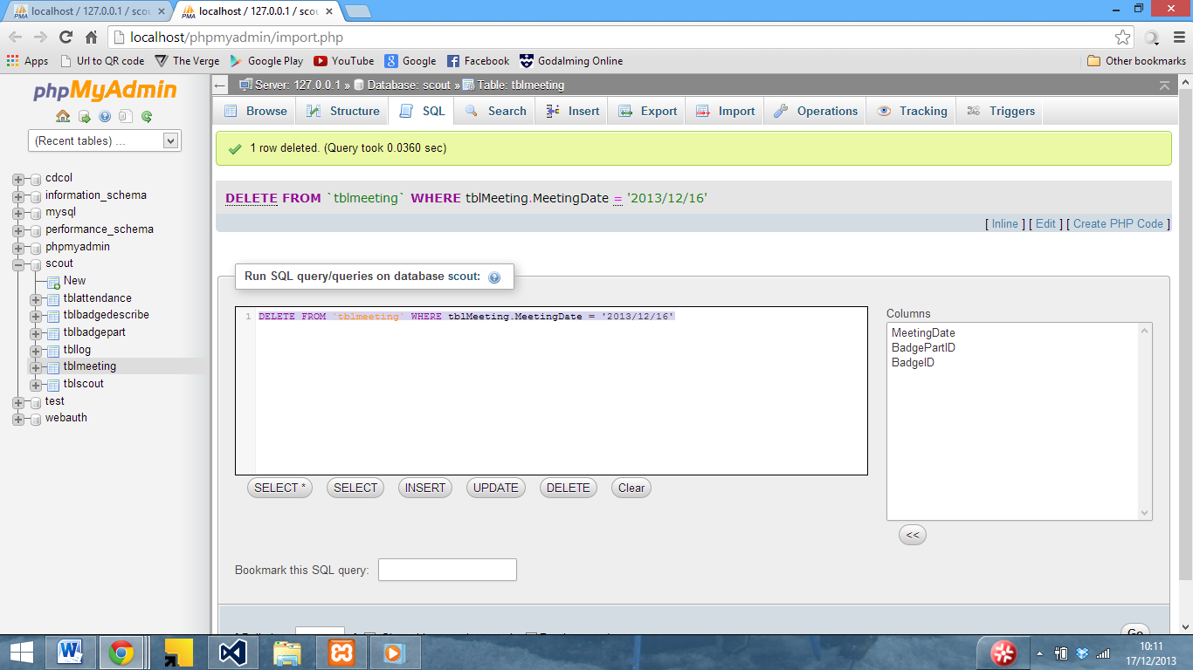

Testing SQL statements before implementing

Appendix C – Program Code

This section lists the code used in the program. Details of the forms and subs which this code relates to can be seen in systems maintenance

# Classes

## Attendance

Public Class Attendance

'Declarations'

Private Attendance As Boolean

Private MeetingDate As Date

Private ScoutID As Integer

#Region "Attendance"

'Set attendance'

Public Sub SetAttendance(ByRef STAttendance)

Attendance = STAttendance

End Sub

'Get attendance'

Public Function GetAttendance() As Boolean

Return Attendance

End Function

#End Region

#Region "MeetingDate"

'Set meeting date'

Public Sub SetMeetingDate(ByRef STMeetingDate)

MeetingDate = STMeetingDate

End Sub

Public Function GetMeetingDate() As Date

'Get meeting date'

Return MeetingDate

End Function

#End Region

#Region "ScoutID"

'Set Scout ID'

Public Sub SetScoutID(ByRef STID)

ScoutID = STID

End Sub

'Get Scout ID'

Public Function GetScoutID()

Return ScoutID

End Function

#End Region

End Class

## BadgeDescribe

Public Class BadgeDescribe

Private BadgeID As Integer

Private BadgeDescription As String

Private Position As Integer

#Region "BadgeDescription"

'Set Description'

Public Sub SetBadgeDescription(ByRef Description)

BadgeDescription = Description

End Sub

'Get Description'

Public Function GetBadgeDescription()

Return BadgeDescription

End Function

#End Region

#Region "Badge ID"

'Set Badge ID'

Public Sub SetBadgeID(ByRef STBadge)

BadgeID = STBadge

End Sub

'Get Badge ID'

Public Function GetBadgeID() As Integer

Return BadgeID

End Function

#End Region

#Region "Position"

'Set Position'

Public Sub SetPosition(ByRef Pos)

Position = Pos

End Sub

'Get Position'

Public Function GetPosition() As Integer

Return Position

End Function

#End Region

End Class

## BadgeParts

Public Class BadgeParts

'Declarations'

Private PartID As Integer

Private BadgeID As Integer

Private PartDescription As String

Private Position As Integer

Private BadgeDescription As String

#Region "Badge ID"

'Set Badge ID'

Public Sub SetBadgeID(ByRef STBadge)

BadgeID = STBadge

End Sub

'Get Badge ID'

Public Function GetBadgeID() As Integer

Return BadgeID

End Function

#End Region

#Region "PartDescription"

'Set Description'

Public Sub SetPartDescription(ByRef Describe)

PartDescription = Describe

End Sub

'Get Description'

Public Function GetPartDescription()

Return PartDescription

End Function

#End Region

#Region "Part ID"

'Set Part ID'

Public Sub SetPartID(ByRef PTID)

PartID = PTID

End Sub

'Get Part ID'

Public Function GetPartID() As Integer

Return PartID

End Function

#End Region

#Region "Position"

'Set planned badge ID'

Public Sub SetPosition(ByRef Pos)

Position = Pos

End Sub

Public Function GetPosition() As Integer

'Get planned badge id'

Return Position

End Function

#End Region

#Region "BadgeDescription"

'Set Description'

Public Sub SetBadgeDescription(ByRef Description)

BadgeDescription = Description

End Sub

'Get Description'

Public Function GetBadgeDescription()

Return BadgeDescription

End Function

#End Region

End Class

## Log

Public Class Log

'Declarations for properties'

Private ScoutID As Integer

Private PartID As Integer

Private DateAchived As Date

Private BadgeID As Integer

#Region "Date Achived"

'set Date achived

Public Sub SetDateAchived(ByRef DTAchived)

DateAchived = DTAchived

End Sub

'Get date achived'

Public Function GetDateAchived()

Return DateAchived

End Function

#End Region

#Region "ScoutID"

'set Scout ID;

Public Sub SetScoutID(ByRef ID As Integer)

ScoutID = ID

End Sub

'Gets scout ID'

Public Function GetScoutID() As Integer

Return ScoutID

End Function

#End Region

#Region "Badge PartID"

'set badge part'

Public Sub SetPartID(ByRef Part As Integer)

PartID = Part

End Sub

'Gets Badge part'

Public Function GetPartID() As Integer

Return PartID

End Function

#End Region

#Region "BadgeID"

'set Badge ID'

Public Sub SetBadgeID(ByRef ID As Integer)

BadgeID = ID

End Sub

'Get badge ID'

Public Function GetBadgeID() As Integer

Return BadgeID

End Function

#End Region

End Class

## Meeting

Public Class Meeting

'Declarations'

Private MeetingDate As Date

Private PlannedBadgePart As Integer

Private BadgeID As Integer

Private Position As Integer

#Region "Meeting Date"

'Set meeting date'

Public Sub SetMeetingDate(ByRef MeetDate)

MeetingDate = MeetDate

End Sub

Public Function GetMetingDate() As Date

'Get meeting date'

Return MeetingDate

End Function

#End Region

#Region "Planned Badge Part"

'Set planned badge part'

Public Sub SetPlannedBadgePart(ByRef Part)

PlannedBadgePart = Part

End Sub

Public Function GetPlannedBadgePart() As Integer

'Get planned badge part'

Return PlannedBadgePart

End Function

#End Region

#Region "Planned badge ID"

'Set planned badge ID'

Public Sub SetPlannedBadgeID(ByRef ID)

BadgeID = ID

End Sub

Public Function GetPlannedBadgeID() As Integer

'Get planned badge id'

Return BadgeID

End Function

#End Region

#Region "Position"

'Set planned badge ID'

Public Sub SetPosition(ByRef Pos)

Position = Pos

End Sub

Public Function GetPosition() As Integer

'Get planned badge id'

Return Position

End Function

#End Region

End Class

## Scout

Public Class Scout

'Declarations'

Private FirstName As String

Private LastName As String

Private DOB As Date

Private ScoutID As Integer

Private JoinDate As Date

Private Patrol As String

#Region "First Name"

'Set first name'

Public Sub SetFirstName(ByVal STFirst As String)

FirstName = STFirst

End Sub

'Get first name'

Public Function GetFirstName() As String

Return FirstName

End Function

#End Region

#Region "Last Name"

'Set Last name'

Public Sub SetLastName(ByRef STLast)

LastName = STLast

End Sub

'Get last name'

Public Function GetLastName() As String

Return LastName

End Function

#End Region

#Region "ID"

'Set scout ID'

Public Sub SetScoutID(ByRef STID As Integer)

ScoutID = STID

End Sub

Public Function GetID() As Integer

'Get scout id'

Return ScoutID

End Function

#End Region

#Region "DOB"

'Set DOB

Public Sub SetDOB(ByRef STDOB)

DOB = STDOB

End Sub

'Get DOB'

Public Function GetDOB() As Date

Return DOB

End Function

#End Region

#Region "Join Date"

'Set join date'

Public Sub SetJoinDate(ByRef STJoin)

JoinDate = STJoin

End Sub

'Get join date

Public Function GetJoinDate() As Date

Return JoinDate

End Function

#End Region

#Region "Patrol"

'Set Patrol

Public Sub SetPatrol(ByRef STPatrol)

Patrol = STPatrol

End Sub

'Get Patrol'

Public Function GetPatrol() As String

Return Patrol

End Function

#End Region

End Class

## StagedBadge

Public Class StagedBadge

Inherits BadgeDescribe

Private Stage As Integer

#Region "Stage"

'sets stage ID'

Public Sub SetStage(ByRef StageNo)

Stage = StageNo

End Sub

'gets stage'

Public Function GetStage()

Return Stage

End Function

#End Region

End Class

# Forms

## Delete meeting

Public Class DeleteMeeting

Private Sub DeleteMeeting_Load(sender As Object, e As EventArgs) Handles MyBase.Load

'Runs LoadList sub'

LoadList()

End Sub

Private Sub btnDelete_Click(sender As Object, e As EventArgs) Handles btnDelete.Click

If connected Then

If selDelete.Text.Count > 0 Then

'First prompt to confirm delete'

If MsgBox("Are you sure you want to delete the record for " & selDelete.Text & " ?", MsgBoxStyle.Exclamation Or MessageBoxButtons.YesNo, "Delete Record?") = MsgBoxResult.Yes Then

'If yes button pressed, Display This cannot be undone'

If MsgBox("This cannot be undone!", MsgBoxStyle.Critical Or MessageBoxButtons.OKCancel, "Confirm Delete") = MsgBoxResult.Ok Then

'Run deleteValues sub'

DeleteValues()

'Confirmation'

MsgBox("Deleted")

End If

End If

Else

MsgBox("Please select a date to delete")

End If

Else

MsgBox("Please connect to the SQL server first")

End If

End Sub

Private Sub LoadList()

'For each object in group'

For Each obj In Meetings

'Add meeting date items'

selDelete.Items.Add(obj.GetMetingDate)

Next

End Sub

Private Sub DeleteValues()

'Declarations'

Dim MeetingDate As Date

MeetingDate = selDelete.Text

'Then remove it from the database'

DelMeeting(MeetingDate)

'Then reload the values from the database'

LoadValues()

LoadLog()

LoadBadges()

LoadStageBadges()

LoadMeeting()

'Then clear and reload the list'

selDelete.Items.Clear()

LoadList()

End Sub

End Class

## Delete record

Public Class DeleteRecord

Private Sub DeleteRecord_Load(sender As Object, e As EventArgs) Handles MyBase.Load

'Runs LoadList sub'

LoadList()

End Sub

Private Sub btnDelete_Click(sender As Object, e As EventArgs) Handles btnDelete.Click

If connected Then

If selDelete.Text.Count > 0 Then

'First prompt to confirm delete'

If MsgBox("Are you sure you want to delete the record for " & selDelete.Text & " ?", MsgBoxStyle.Exclamation Or MessageBoxButtons.YesNo, "Delete Record?") = MsgBoxResult.Yes Then

'If yes button pressed, Display This cannot be undone'

If MsgBox("This cannot be undone!", MsgBoxStyle.Critical Or MessageBoxButtons.OKCancel, "Confirm Delete") = MsgBoxResult.Ok Then

'Run deleteValues sub'

DeleteValues()

'Confirmation'

MsgBox("Deleted")

End If

End If

Else

MsgBox("Please select a name to delete first")

End If

Else

MsgBox("Please connect to the SQL server first")

End If

End Sub

Private Sub LoadList()

selDelete.Items.Clear()

'For each object in group'

For Each obj In Group

'Add First name and last name to items'

selDelete.Items.Add(obj.GetFirstName & " " & obj.GetLastName)

Next

End Sub

Private Sub DeleteValues()

'Declarations'

Dim NameInput(2) As String

Dim FirstName As String

Dim LastName As String

Dim ScoutID As Integer

'Splits chosen name into array using space'

NameInput = selDelete.Text.Split(" ")

'Sets firstname to the first item in nameinput array'

FirstName = NameInput(0)

'Sets lastname to the 2nd item in the name input array

LastName = NameInput(1)

'For each obj in group, if the firstname and lastname match the one in the list, set scoutID = obj.getID'

For Each obj In Group

If obj.GetFirstName = FirstName And obj.GetLastName = LastName Then

ScoutID = obj.GetID

End If

Next

'Then remove it from the database'

DelRecord(ScoutID)

'Then reload the values from the database'

LoadValues()

LoadLog()

LoadBadges()

LoadStageBadges()

LoadMeeting()

'Then reload the list'

LoadList()

End Sub

End Class

## Edit record

Imports System.Text.RegularExpressions

Public Class EditRecord

Private ScoutID As Integer

Private Validate As Regex

Private Sub EditRecord_Load(sender As Object, e As EventArgs) Handles MyBase.Load

'Sets date boxes to today'

dtDOB.Value = Today.Date

dtJoin.Value = Today.Date

LoadList()

End Sub

Private Sub LoadList()

For Each obj In Group

'Adds first name and last name to list'

selName.Items.Add(obj.GetFirstName & " " & obj.GetLastName)

Next

End Sub

Private Sub btnChange_Click(sender As Object, e As EventArgs) Handles btnChange.Click

GetValues()

End Sub

Private Sub GetValues()

'Gets Values from input name and places them in text boxes'

For Each obj In Group

If selName.Text = obj.GetFirstName & " " & obj.GetLastName Then

ScoutID = obj.GetID

txtFirstName.Text = obj.GetFirstName

txtLast.Text = obj.GetLastName

txtPatrol.Text = obj.GetPatrol

dtJoin.Text = obj.GetJoinDate

dtDOB.Text = obj.GetDOB

End If

Next

End Sub

Private Sub btnSave_Click(sender As Object, e As EventArgs) Handles btnSave.Click

'Saves changed values into list'

If connected Then

'if First valid = /

If lblValid.Text = "/" Then

'And last'

If lblValidateLastName.Text = "/" Then

'And partol'

If lblPatrolValidate.Text = "/" Then

With Group(ScoutID)

.SetFirstName(txtFirstName.Text)

.SetLastName(txtLast.Text)

.SetPatrol(txtPatrol.Text)

.SetJoinDate(dtJoin.Value)

.SetDOB(dtDOB.Value)

End With

'Then saves into the database'

UpdateRecord(Group(ScoutID).GetFirstName, Group(ScoutID).GetLastName, Group(ScoutID).GetPatrol, Group(ScoutID).GetJoinDate, Group(ScoutID).GetDOB, ScoutID)

MsgBox("Saved")

'Reloads list'

selName.Items.Clear()

LoadList()

'Clears textboxes'

txtFirstName.Text = ""

txtLast.Text = ""

txtPatrol.Text = ""

dtDOB.Value = Today.Date

dtJoin.Value = Today.Date

Else

MsgBox("Patrol is invalid")

End If

Else

MsgBox("Last name is invalid")

End If

Else

MsgBox("First name is invalid")

End If

Else

MsgBox("Please connect to the SQL server first")

End If

End Sub

Private Sub txtFirstName_TextChanged(sender As Object, e As EventArgs) Handles txtFirstName.TextChanged

'if FirstNameTest empty'

If txtFirstName.Text = String.Empty Then

'Label text X and colour red'

lblValid.Text = "X"

lblValid.ForeColor = Color.Red

End If

Try

'Validate = regex code'

Validate = New Regex("^[a-z|A-Z]+$")

'If it matches then label = / and colour = green

lblValid.Text = "/"

lblValid.ForeColor = Color.Green

'Run firstValidatesub'

FirstValidate()

Catch ex As Exception

'if invalid set valid label to X and red'

lblValid.Text = "X"

lblValid.ForeColor = Color.Red

End Try

End Sub

Private Sub FirstValidate()

Dim Valid As Boolean = Validate.IsMatch(txtFirstName.Text)

'if FirstNameTest empty'

If txtFirstName.Text = String.Empty Then

'Label text X and colour red'

lblValid.Text = "X"

lblValid.ForeColor = Color.Red

End If

If Valid Then

'If valid then set the label to / and green'

lblValid.Text = "/"

lblValid.ForeColor = Color.Green

Else

'otherwise set it to X and red'

lblValid.Text = "X"

lblValid.ForeColor = Color.Red

End If

End Sub

Private Sub txtLast_TextChanged(sender As Object, e As EventArgs) Handles txtLast.TextChanged

'if LastNameTest empty'

If txtLast.Text = String.Empty Then

'Label text X and colour red'

lblValidateLastName.Text = "X"

lblValidateLastName.ForeColor = Color.Red

End If

Try

'Validate = regex code'

Validate = New Regex("^[a-z|A-Z]+$")

'If it matches then label = / and colour = green

lblValidateLastName.Text = "/"

lblValidateLastName.ForeColor = Color.Green

'Run firstValidatesub'

LastValidate()

Catch ex As Exception

'if invalid set valid label to X and red'

lblValidateLastName.Text = "X"

lblValidateLastName.ForeColor = Color.Red

End Try

End Sub

Private Sub LastValidate()

Dim Valid As Boolean = Validate.IsMatch(txtLast.Text)

'if Lastname text empty'

If txtLast.Text = String.Empty Then

'Label text X and colour red'

lblValidateLastName.Text = "X"

lblValidateLastName.ForeColor = Color.Red

End If

If Valid Then

'If valid then set the label to / and green'

lblValidateLastName.Text = "/"

lblValidateLastName.ForeColor = Color.Green

Else

'otherwise set it to X and red'

lblValidateLastName.Text = "X"

lblValidateLastName.ForeColor = Color.Red

End If

End Sub

Private Sub txtPatrol_TextChanged(sender As Object, e As EventArgs) Handles txtPatrol.TextChanged

'if Patroltext empty'

If txtPatrol.Text = String.Empty Then

'Label text X and colour red'

lblPatrolValidate.Text = "X"

lblPatrolValidate.ForeColor = Color.Red

End If

Try

'Validate = regex code'

Validate = New Regex("^[a-z|A-Z]+$")

'If it matches then label = / and colour = green

lblPatrolValidate.Text = "/"

lblPatrolValidate.ForeColor = Color.Green

'Run firstValidatesub'

PatrolValidate()

Catch ex As Exception

'if invalid set valid label to X and red'

lblPatrolValidate.Text = "X"

lblPatrolValidate.ForeColor = Color.Red

End Try

End Sub

Private Sub PatrolValidate()

Dim Valid As Boolean = Validate.IsMatch(txtPatrol.Text)

'if Patrol Empty then set validate to X and red'

If txtPatrol.Text = String.Empty Then

'Label text X and colour red'

lblPatrolValidate.Text = "X"

lblPatrolValidate.ForeColor = Color.Red

End If

If Valid Then

'If valid then set the label to / and green'

lblPatrolValidate.Text = "/"

lblPatrolValidate.ForeColor = Color.Green

Else

'otherwise set it to X and red'

lblPatrolValidate.Text = "X"

lblPatrolValidate.ForeColor = Color.Red

End If

End Sub

End Class

## Enter Attendance

Public Class EnterAttendance

Private BadgeID As Integer

Private BadgePart As Integer

Private Sub EnterAttendance_Load(sender As Object, e As EventArgs) Handles MyBase.Load

'Sets date boxes to today'

dtStart.Value = Today.Date

dtEnd.Value = Today.Date

'Loads database'

LoadAttendance()

LoadViewMeeting()

'Displays Attendance'

DisplayAttend()

End Sub

Private Sub DisplayAttend()

Dim Name As String

'ClearsGrid'

grdAttendance.Columns.Clear()

'Adds Name column'

grdAttendance.Columns.Add(New DataGridViewTextBoxColumn)

'Sets header to scout name'

grdAttendance.Columns(0).HeaderText = "Scout Name"

'Makes it readonly'

grdAttendance.Columns(0).ReadOnly = True

'And set the with to 60

grdAttendance.Columns(0).Width = 140

'Adds rows for each scout'

For Each obj In Group

grdAttendance.Rows.Add(obj.GetFirstName & " " & obj.GetLastName)

Next

Dim Position As Integer

'Adds coloum for each meeting'

For Each obj In ViewMeeting

Position = grdAttendance.Columns.Count

grdAttendance.Columns.Add(New DataGridViewCheckBoxColumn)

'And sets the heading to the meetingdate'

grdAttendance.Columns(Position).HeaderText = obj.GetMetingDate

grdAttendance.Columns(Position).SortMode = DataGridViewColumnSortMode.Automatic

Next

For Each obj In Attend

For count = 1 To grdAttendance.Columns.Count - 1

Dim ObjDate As Date = obj.GetMeetingDate

Dim ClmDate As Date = CDate(grdAttendance.Columns(count).HeaderText)

If ClmDate = ObjDate Then

'And obj.GetAttendance = True

Name = GetName(obj.GetScoutID)

For counter = 0 To grdAttendance.Rows.Count - 1

If grdAttendance(0, counter).Value = Name Then

For ColCount = 1 To grdAttendance.Columns.Count - 1

If CDate(grdAttendance.Columns(ColCount).HeaderText).Date = ObjDate Then

grdAttendance(ColCount, counter).Value = obj.GetAttendance

End If

Next

End If

Next

End If

Next

Next

End Sub

Private Function GetName(ByRef ID) As String

'For each name if ID passed in = scout id then

For Each obj In Group

If ID = obj.GetID Then

'Return first and lastname'

GetName = obj.GetFirstName & " " & obj.GetLastName

End If

Next

End Function

Private Function GetID(ByRef Name) As Integer

Dim SplitName() As String

'Splits the name by space

SplitName = Split(Name, " ")

'For each scout if firstname = firstname and lastname = lastname

For Each obj In Group

If SplitName(0) = obj.GetFirstName And SplitName(1) = obj.GetLastName Then

'Then GetID = scout ID'

GetID = obj.GetID

End If

Next

End Function

Private Sub btnView_Click(sender As Object, e As EventArgs) Handles btnView.Click

'Sets date variables'

FirstDate = dtStart.Value

LastDate = dtEnd.Value

'Loads database'

LoadAttendance()

LoadViewMeeting()

'Displays Attendance'

DisplayAttend

End Sub

Private Sub btnQuickSort_Click(sender As Object, e As EventArgs)

End Sub

Private Sub btnSave_Click(sender As Object, e As EventArgs) Handles btnSave.Click

'For each coloum (except the name one)'

For ColCount = 1 To grdAttendance.Columns.Count - 1

'And for each row'

For RowCount = 0 To grdAttendance.Rows.Count - 1

Dim ExistingAttend As Boolean = False

'And each attendance'

For Each obj In Attend

'If scoutid = getID and meetingDate = meetingDate from coloum heading'

If obj.GetScoutID = GetID(grdAttendance(0, RowCount).Value) And obj.GetMeetingDate = CDate(grdAttendance.Columns(ColCount).HeaderText) Then

ExistingAttend = True

If grdAttendance(ColCount, RowCount).Value = False Then

'If attendance false then get meeting details'

GetMeetingDetails(grdAttendance.Columns(ColCount).HeaderText)

'And delete log'

DeleteAttendance(obj.GetScoutID, obj.GetMeetingDate, BadgeID, BadgePart)

End If

End If

Next

'If existing attend = false then add new attendance'

If ExistingAttend = False Then

'If Attendance is true

If grdAttendance(ColCount, RowCount).Value = True Then

'Assigns the number of values in attend to attendcount

Dim AttendCount As Integer = Attend.Count

'Adds new attendance'

Attend.Add(New Attendance)

'Sets values

With Attend(AttendCount)

'Sets scout ID (gets ID based on name'

.SetScoutID(GetID(grdAttendance(0, RowCount).Value))

'Sets Meeting Date (gets date from coloum heading)

.SetMeetingDate(CDate(grdAttendance.Columns(ColCount).HeaderText))

'Sets Attendance

.SetAttendance(grdAttendance(ColCount, RowCount).Value)

'Update database'

AddAttendance(.GetScoutID, .GetMeetingDate, .GetAttendance)

'Get meeting details'

GetMeetingDetails(grdAttendance.Columns(ColCount).HeaderText)

'Save Badge'

SaveBadge(.GetScoutID, grdAttendance.Columns(ColCount).HeaderText)

End With

End If

End If

Next

Next

'Then Display confirmation'

MsgBox("Saved")

End Sub

Private Sub GetMeetingDetails(ByRef MeetingDate As String)

'Sets Date chosen to the input date'

'For each object if the datechosen matches the object meeting date then get the planned ID and part'

For Each obj In Meetings

If obj.GetMetingDate = MeetingDate Then

BadgeID = obj.GetPlannedBadgeID

BadgePart = obj.GetPlannedBadgePart

End If

Next

End Sub

Private Sub SaveBadge(ByRef ID As Integer, ByRef DateAchived As String)

'Stores badge ID in list'

'Determines number of items in group and assigns it to position'

Dim Position As Integer = Logs.Count

'Adds new log'

Logs.Add(New Log)

'Adds items into list'

With Logs(Position)

.SetScoutID(ID)

.SetBadgeID(BadgeID)

.SetPartID(BadgePart)

.SetDateAchived(DateAchived)

End With

'Saves into database'

SaveLog(Logs(Position).GetDateAchived, Logs(Position).GetBadgeID, Logs(Position).GetPartID, Logs(Position).GetScoutID)

End Sub

Private Sub btnPrint_Click(sender As Object, e As EventArgs) Handles btnPrint.Click

Dim Print As New PrintDialog

'Sets page layout to landscape'

Print.PrinterSettings.DefaultPageSettings.Landscape = True

'Shows Print Dialogue'

If Print.ShowDialog(Me) = Windows.Forms.DialogResult.OK Then

'Sets printsettings to dialogue'

PrintForm.PrinterSettings = Print.PrinterSettings

'sets it to form only'

PrintForm.Print(Me, PowerPacks.Printing.PrintForm.PrintOption.ClientAreaOnly)

End If

End Sub

Private Sub grdAttendance_CellContentClick(sender As Object, e As DataGridViewCellEventArgs) Handles grdAttendance.CellContentClick

End Sub

End Class

## Enter Badge Parts

'Imports regex'

Imports System.Text.RegularExpressions

Public Class EnterBadgeParts

Private BadgeID As Integer

Private BadgeName As String

Private PartID As Integer

Private ExistingPart As Boolean = False

Private Position As Integer

Private Stage As Integer = 0

Private Validate As Regex = Nothing

Private Sub lblBadge_Load(sender As Object, e As EventArgs) Handles MyBase.Load

'Sets BadgeName label to badgename'

If Stage > 0 Then

lblBadgeName.Text = BadgeName & " Stage: " & Stage

Else

lblBadgeName.Text = BadgeName

End If

LoadList()

End Sub

Public Sub SetValues(ByRef ID As Integer, ByRef Name As String, ByRef Stg As Integer)

'Sets local variables'

BadgeID = ID

BadgeName = Name

Stage = Stg

End Sub

Private Sub LoadList()

'Clears list'

lstbxBadgeParts.Items.Clear()

'For each obj in badge list of ID = badge ID

If BadgeList.Count > 0 Then

For Each obj In BadgeList

If obj.GetBadgeID = BadgeID Then

'then add part description to list'

lstbxBadgeParts.Items.Add(obj.GetPartDescription)

End If

Next

End If

End Sub

Private Sub btnEdit_Click(sender As Object, e As EventArgs) Handles btnEdit.Click

'Sets partdescribe = selected item'

Dim PartDescribe As String = lstbxBadgeParts.SelectedItem.ToString

'Goes through badgelist'

For Each obj In BadgeList

'If part description is partdescribe'

If obj.GetPartDescription = PartDescribe Then

'Set description to partdescribe'

txtDescription.Text = PartDescribe

'Part id to obj partID'

PartID = obj.GetPartID

'And position to obj position'

Position = obj.GetPosition

ExistingPart = True

End If

Next

End Sub

Private Sub btnSave_Click(sender As Object, e As EventArgs) Handles btnSave.Click

Dim BadgePosition As Integer

'if regex valid'

If lblPartValidate.Text = "/" Then

'IF its an existing part then update the part'

If ExistingPart = True Then

With BadgeList(Position)

'with the new description'

.SetPartDescription(txtDescription.Text)

.SetBadgeID(BadgeID)

.SetPartID(PartID)

UpdateBadgePart(.GetBadgeID, .GetPartID, .GetPartDescription)

End With

Else

'otherwise Add a new badgepart'

BadgePosition = BadgeList.Count

BadgeList.Add(New BadgeParts)

With BadgeList(BadgePosition)

'and set the part description, badge id, position and part ID'

.SetPartDescription(txtDescription.Text)

.SetBadgeID(BadgeID)

.SetPosition(BadgePosition)

.SetPartID(BadgePosition)

AddBadgePart(.GetBadgeID, .GetPartID, .GetPartDescription)

End With

End If

'then reload the list

LoadList()

'And set existing part to false'

ExistingPart = False

Else

'Otherwise error'

MsgBox("Description is invalid")

End If

End Sub

Private Sub txtDescription_TextChanged(sender As Object, e As EventArgs) Handles txtDescription.TextChanged

'if FirstNameTest empty'

If txtDescription.Text = String.Empty Then

'Label text X and colour red'

lblPartValidate.Text = "X"

lblPartValidate.ForeColor = Color.Red

End If

Try

'Validate = regex code'

Validate = New Regex("^[a-z|A-Z|0-9| ]+$")

'If it matches then label = / and colour = green

lblPartValidate.Text = "/"

lblPartValidate.ForeColor = Color.Green

'Run firstValidatesub'

PartValidate()

Catch ex As Exception

'if invalid set valid label to X and red'

lblPartValidate.Text = "X"

lblPartValidate.ForeColor = Color.Red

End Try

End Sub

Private Sub PartValidate()

Dim Valid As Boolean = Validate.IsMatch(txtDescription.Text)

'if FirstNameTest empty'

If txtDescription.Text = String.Empty Then

'Label text X and colour red'

lblPartValidate.Text = "X"

lblPartValidate.ForeColor = Color.Red

End If

If Valid Then

'If valid then set the label to / and green'

lblPartValidate.Text = "/"

lblPartValidate.ForeColor = Color.Green

Else

'otherwise set it to X and red'

lblPartValidate.Text = "X"

lblPartValidate.ForeColor = Color.Red

End If

End Sub

End Class

## Enter Badges

Imports System.Text.RegularExpressions

Public Class btnChange

Private ID As Integer

Private ExistingBadge As Boolean = False

Private Position As Integer

Private Validate As Regex = Nothing

Private Saved As Boolean = False

Private Sub Button1_Click(sender As Object, e As EventArgs) Handles Button1.Click

'Sets saved to false'

Saved = False

Dim ChosenBadge As String = selBadge.Text

Dim Match As Boolean = False

'finds Id for chosen badge'

For Each obj In LstBadges

If obj.GetBadgeDescription = ChosenBadge Then

ID = obj.GetBadgeID

Match = True

End If

Next

If Match Then

'sets chosen badge to name textbox and parts to the result of getno of parts'

txtBadgeName.Text = ChosenBadge

ExistingBadge = True

End If

End Sub

Private Sub btnChange_Load(sender As Object, e As EventArgs) Handles MyBase.Load

LoadList()

End Sub

Private Sub SaveChanges()

'Sets badge details in badgelist'

With LstBadges(Position)

.SetBadgeDescription(txtBadgeName.Text)

.SetBadgeID(ID)

End With

'and save in the database'

UpdateBadgeDescribe(LstBadges(Position).GetBadgeID, LstBadges(Position).GetBadgeDescription)

End Sub

Private Sub SaveNew()

Dim ExistingDescribe As Integer

Dim PositionInList As Integer = LstBadges.Count

' If Badges exist then get max id

If StgBadge.Count Or LstBadges.Count > 0 Then

ExistingDescribe = GetMaxID() + 1

Else

'Else set existing describe to 0

ExistingDescribe = 0

End If

'Add a new badge'

LstBadges.Add(New BadgeDescribe)

'Give it the ID of the highest one)

With LstBadges(PositionInList)

.SetBadgeID(ExistingDescribe)

'And the input description'

.SetBadgeDescription(txtBadgeName.Text)

End With

'Sets badge ID'

ID = ExistingDescribe

'Add to the database'

AddBadge(LstBadges(PositionInList).GetBadgeID, LstBadges(PositionInList).GetBadgeDescription)

End Sub

Private Sub btnSave_Click(sender As Object, e As EventArgs) Handles btnSave.Click

If lblBadgeNameValidate.Text = "/" Then

If ExistingBadge Then

'IF its an existing badge, save changes'

SaveChanges()

Else

'or create a new badge'

'If badgename exists then display error'

If selBadge.Items.Contains(txtBadgeName.Text) Then

MsgBox("A badge with this name already exists")

Else

'Otherwise save'

SaveNew()

End If

End If

LoadList()

MsgBox("Saved")

Saved = True

Else

MsgBox("Badge name is invalid")

End If

End Sub

Private Sub LoadList()

'Reload Database'

LoadBadgeDescribe()

'For each object, add the name to the list when load'

selBadge.Items.Clear()

For Each obj In LstBadges

selBadge.Items.Add(obj.GetBadgeDescription)

Next

End Sub

Private Sub btnParts_Click(sender As Object, e As EventArgs) Handles btnParts.Click

If Saved Then

'If saved show enter parts'

EnterBadgeParts.SetValues(ID, txtBadgeName.Text, 0)

EnterBadgeParts.Show()

Else

'Otherwise show error'

MsgBox("Please save the badge first")

End If

End Sub

Private Sub txtBadgeName_TextChanged(sender As Object, e As EventArgs) Handles txtBadgeName.TextChanged

'Sets saved to false'

Saved = False

'if FirstNameTest empty'

If txtBadgeName.Text = String.Empty Then

'Label text X and colour red'

lblBadgeNameValidate.Text = "X"

lblBadgeNameValidate.ForeColor = Color.Red

End If

Try

'Validate = regex code'

Validate = New Regex("^[a-z|A-Z|0-9| ]+$")

'If it matches then label = / and colour = green

lblBadgeNameValidate.Text = "/"

lblBadgeNameValidate.ForeColor = Color.Green

'Run firstValidatesub'

BadgeValidate()

Catch ex As Exception

'if invalid set valid label to X and red'

lblBadgeNameValidate.Text = "X"

lblBadgeNameValidate.ForeColor = Color.Red

End Try

End Sub

Private Sub BadgeValidate()

Dim Valid As Boolean = Validate.IsMatch(txtBadgeName.Text)

'if FirstNameTest empty'

If txtBadgeName.Text = String.Empty Then

'Label text X and colour red'

lblBadgeNameValidate.Text = "X"

lblBadgeNameValidate.ForeColor = Color.Red

End If

If Valid Then

'If valid then set the label to / and green'

lblBadgeNameValidate.Text = "/"

lblBadgeNameValidate.ForeColor = Color.Green

Else

'otherwise set it to X and red'

lblBadgeNameValidate.Text = "X"

lblBadgeNameValidate.ForeColor = Color.Red

End If

End Sub

End Class

## Enter Details

Imports System.Text.RegularExpressions

Public Class EnterDetails

Private Validate As Regex = Nothing

Private Sub EnterDetails_Load(sender As Object, e As EventArgs) Handles MyBase.Load

'Sets date boxes to today's date'

dtDOB.Value = Today.Date

dtJoin.Value = Today.Date

End Sub

Private Sub btnSave_Click_1(sender As Object, e As EventArgs) Handles btnSave.Click

'If connected'

If connected Then

'if First valid = /

If lblValid.Text = "/" Then

'And last'

If lblValidateLastName.Text = "/" Then

'And partol'

If lblPatrolValidate.Text = "/" Then

Dim No As Integer = 0

No = Group.Count

Group.Add(New Scout)

With Group(No)

'stores values'

.SetFirstName(txtFirstName.Text)

.SetLastName(txtLast.Text)

.SetDOB(dtDOB.Value)

.SetJoinDate(dtJoin.Value)

.SetPatrol(txtPatrol.Text)

.SetScoutID(No)

End With

'Runs insertdata to SQL sub'

InsertData(Group(No).GetID, Group(No).GetFirstName, Group(No).GetLastName, Group(No).GetDOB, Group(No).GetJoinDate, Group(No).GetPatrol)

Else

MsgBox("Patrol is invalid")

End If

Else

MsgBox("Last name is invalid")

End If

Else

MsgBox("First name is invalid")

End If

Else

MsgBox("Please connect to the SQL server first")

End If

End Sub

Private Sub txtFirstName_TextChanged(sender As Object, e As EventArgs) Handles txtFirstName.TextChanged

'if FirstNameTest empty'

If txtFirstName.Text = String.Empty Then

'Label text X and colour red'

lblValid.Text = "X"

lblValid.ForeColor = Color.Red

End If

Try

'Validate = regex code'

Validate = New Regex("^[a-z|A-Z]+$")

'If it matches then label = / and colour = green

lblValid.Text = "/"

lblValid.ForeColor = Color.Green

'Run firstValidatesub'

FirstValidate()

Catch ex As Exception

'if invalid set valid label to X and red'

lblValid.Text = "X"

lblValid.ForeColor = Color.Red

End Try

End Sub

Private Sub FirstValidate()

Dim Valid As Boolean = Validate.IsMatch(txtFirstName.Text)

'if FirstNameTest empty'

If txtFirstName.Text = String.Empty Then

'Label text X and colour red'

lblValid.Text = "X"

lblValid.ForeColor = Color.Red

End If

If Valid Then

'If valid then set the label to / and green'

lblValid.Text = "/"

lblValid.ForeColor = Color.Green

Else

'otherwise set it to X and red'

lblValid.Text = "X"

lblValid.ForeColor = Color.Red

End If

End Sub

Private Sub txtLast_TextChanged(sender As Object, e As EventArgs) Handles txtLast.TextChanged

'if LastNameTest empty'

If txtLast.Text = String.Empty Then

'Label text X and colour red'

lblValidateLastName.Text = "X"

lblValidateLastName.ForeColor = Color.Red

End If

Try

'Validate = regex code'

Validate = New Regex("^[a-z|A-Z]+$")

'If it matches then label = / and colour = green

lblValidateLastName.Text = "/"

lblValidateLastName.ForeColor = Color.Green

'Run firstValidatesub'

LastValidate()

Catch ex As Exception

'if invalid set valid label to X and red'

lblValidateLastName.Text = "X"

lblValidateLastName.ForeColor = Color.Red

End Try

End Sub

Private Sub LastValidate()

Dim Valid As Boolean = Validate.IsMatch(txtLast.Text)

'if Lastname text empty'

If txtLast.Text = String.Empty Then

'Label text X and colour red'

lblValidateLastName.Text = "X"

lblValidateLastName.ForeColor = Color.Red

End If

If Valid Then

'If valid then set the label to / and green'

lblValidateLastName.Text = "/"

lblValidateLastName.ForeColor = Color.Green

Else

'otherwise set it to X and red'

lblValidateLastName.Text = "X"

lblValidateLastName.ForeColor = Color.Red

End If

End Sub

Private Sub txtPatrol_TextChanged(sender As Object, e As EventArgs) Handles txtPatrol.TextChanged

'if Patroltext empty'

If txtPatrol.Text = String.Empty Then

'Label text X and colour red'

lblPatrolValidate.Text = "X"

lblPatrolValidate.ForeColor = Color.Red

End If

Try

'Validate = regex code'

Validate = New Regex("^[a-z|A-Z]+$")

'If it matches then label = / and colour = green

lblPatrolValidate.Text = "/"

lblPatrolValidate.ForeColor = Color.Green

'Run firstValidatesub'

PatrolValidate()

Catch ex As Exception

'if invalid set valid label to X and red'

lblPatrolValidate.Text = "X"

lblPatrolValidate.ForeColor = Color.Red

End Try

End Sub

Private Sub PatrolValidate()

Dim Valid As Boolean = Validate.IsMatch(txtPatrol.Text)

'if Patrol Empty then set validate to X and red'

If txtPatrol.Text = String.Empty Then

'Label text X and colour red'

lblPatrolValidate.Text = "X"

lblPatrolValidate.ForeColor = Color.Red

End If

If Valid Then

'If valid then set the label to / and green'

lblPatrolValidate.Text = "/"

lblPatrolValidate.ForeColor = Color.Green

Else

'otherwise set it to X and red'

lblPatrolValidate.Text = "X"

lblPatrolValidate.ForeColor = Color.Red

End If

End Sub

End Class

## Enter Log

Public Class Enter_Log

Private ID As Integer

Private BadgeID As Integer

Private PartID As Integer

Private Sub Enter_Log_Load(sender As Object, e As EventArgs) Handles MyBase.Load

ListLoad()

End Sub

Private Sub ListLoad()

'Loads the scout names into the list'

For Each obj In Group

'Adds First and last name to list'

SelName.Items.Add(obj.GetFirstName & " " & obj.GetLastName)

Next

'For each object add the badge description to the list for the activity badges'

For Each obj In LstBadges

selBadgeName.Items.Add(obj.GetBadgeDescription)

Next

'And the staged badges'

For Each obj In StgBadge

selBadgeName.Items.Add(obj.GetBadgeDescription)

Next

End Sub

Private Sub btnSave_Click(sender As Object, e As EventArgs) Handles btnSave.Click

If selBadgeName.Text.Count > 0 And selBadgePart.Text.Count > 0 And SelName.Text.Count > 0 Then

'Gets ID'

GetID()

GetPartNo()

'Gets meeting part and badge ID'

SaveBadge()

MsgBox("Saved")

Else

MsgBox("Please enter a name, badge and part")

End If

End Sub

Private Sub GetID()

'Gets chosen scout ID'

'Assigns selected name to variable

Dim SelectedName As String = SelName.Text

Dim SplitName(2) As String

'Splits name into first and last by space'

SplitName = SelectedName.Split(" ")

'Gets ID from name

For Each obj In Group

'If firstname (splitname 0) and lastname (splitname 1) are the same as the ones in the object then get ID

If SplitName(0) = obj.GetFirstName And SplitName(1) = obj.GetLastName Then

ID = obj.GetID

End If

Next

End Sub

Private Sub SaveBadge()

'Stores badge ID in list'

'Determines number of items in group and assigns it to position'

Dim Position As Integer = Logs.Count

'Adds new log'

Logs.Add(New Log)

'Adds items into list'

With Logs(Position)

.SetScoutID(ID)

.SetBadgeID(BadgeID)

.SetPartID(PartID)

.SetDateAchived(Today.Date)

End With

'Saves into database'

SaveLog(Logs(Position).GetDateAchived, Logs(Position).GetBadgeID, Logs(Position).GetPartID, Logs(Position).GetScoutID)

End Sub

Private Sub selBadgeName_SelectedIndexChanged(sender As Object, e As EventArgs) Handles selBadgeName.SelectedIndexChanged

'When badge change reload partlist'

BadgeID = FindBadgeID()

selBadgePart.Items.Clear()

For Each obj In BadgeList

If obj.GetBadgeID = BadgeID Then

selBadgePart.Items.Add(obj.GetPartDescription)

End If

Next

End Sub

Private Sub selBadgePart_SelectedIndexChanged(sender As Object, e As EventArgs) Handles selBadgePart.SelectedIndexChanged

End Sub

Private Sub GetPartNo()

For Each obj In BadgeList

If obj.GetPartDescription = SelBadgePart.Text Then

PartID = obj.GetPartID

End If

Next

End Sub

Private Function GetPartName() As String

For Each obj In BadgeList

If PartID = obj.GetPartID Then

GetPartName = obj.GetPartDescription

End If

Next

End Function

Private Function FindBadgeID() As Integer

Dim Name As String = selBadgeName.Text

Dim Found As Boolean = False

'Looks in badgelist for ID'

For Each obj In LstBadges

If obj.GetBadgeDescription = Name Then

FindBadgeID = obj.GetBadgeID

Found = True

End If

Next

If Found = False Then

'Looks in stagebadgelist for name'

For Each obj In StgBadge

If obj.GetBadgeDescription = Name Then

FindBadgeID = obj.GetBadgeID

Found = True

End If

Next

End If

End Function

End Class

## Enter Programme

Public Class Enter_Programme

Private ChosenDate As Date

Private BadgeID As Integer

Private StagedBadge As Boolean = False

Private PartID As Integer

Private Position As Integer

Dim Match As Boolean = False

Private Sub chgDate_Click(sender As Object, e As EventArgs) Handles chgDate.Click

ChosenDate = selDate.Text

'finds Date for chosen meeting'

For Each obj In Meetings

'Loads object data into local variables if the selected date = the date in the object'

If obj.GetMetingDate = ChosenDate Then

BadgeID = obj.GetPlannedBadgeID

PartID = obj.GetPlannedBadgePart

Position = obj.GetPosition

'Sets match to true'

Match = True

End If

Next

If Match = True Then

'sets chosen badge to name textbox and parts to the result of getno of parts'

dtMeeting.Value = ChosenDate

selBadgeDescribe.Text = GetBadgeName()

SelBadgePart.Text = GetPartName()

End If

End Sub

Private Function GetBadgeName() As String

Dim GotName As Boolean = False

'Looks in badgelist for name'

For Each obj In BadgeList

If obj.GetBadgeID = BadgeID Then

GetBadgeName = obj.GetBadgeDescription

GotName = True

StagedBadge = False

End If

Next

If GotName = False Then

'Looks in stagebadgelist for name'

For Each obj In StgBadge

If obj.GetBadgeID = BadgeID Then

GetBadgeName = obj.GetBadgeDescription

GotName = True

StagedBadge = True

End If

Next

End If

End Function

Private Sub GetPartNo()

'If its a stage badge, and the ID matches the Meeting badge ID then get the no parts'

For Each obj In BadgeList

If obj.GetPartDescription = SelBadgePart.Text Then

PartID = obj.GetPartID

End If

Next

End Sub

Private Function GetPartName() As String

For Each obj In BadgeList

If PartID = obj.GetPartID Then

GetPartName = obj.GetPartDescription

End If

Next

End Function

Private Sub LoadList() 'Loads the badges into the list

'Clear lists'

selDate.Items.Clear()

selBadgeDescribe.Items.Clear()

'For each object, add the date to the list when load'

For Each obj In Meetings

selDate.Items.Add(obj.GetMetingDate)

Next

'For each object add the badge description to the list for the activity badges'

For Each obj In LstBadges

selBadgeDescribe.Items.Add(obj.GetBadgeDescription)

Next

'And the staged badges'

For Each obj In StgBadge

selBadgeDescribe.Items.Add(obj.GetBadgeDescription)

Next

End Sub

Private Sub Enter_Programme_Load(sender As Object, e As EventArgs) Handles MyBase.Load

'Sets meeting datebox = today'

dtMeeting.Value = Today.Date

'Runs loadlist sub on form load'

LoadList()

End Sub

Private Sub btnSave_Click(sender As Object, e As EventArgs) Handles btnSave.Click

'IF its an existing badge, save changes'

'get part no'

If selBadgeDescribe.Text.Count > 0 And SelBadgePart.Text.Count > 0 Then

GetPartNo()

If Match Then

SaveChanges()

Else

'or create a new meeting date'

SaveNew()

End If

'Clear Items in badgepartlist;

SelBadgePart.Items.Clear()

'Reload list'

LoadList()

MsgBox("Saved")

Else

MsgBox("Please select a badge and a part")

End If

End Sub

Private Sub SaveChanges()

'Stores in list in current position'

With Meetings(Position)

'Gets part no'

GetPartNo()

.SetMeetingDate(dtMeeting.Value)

'And the input description'

.SetPlannedBadgeID(FindBadgeID)

'And the input no of parts'

.SetPlannedBadgePart(PartID)

End With

'Stores in database'

UpdateProgramme(Meetings(Position).GetMetingDate, Meetings(Position).GetPlannedBadgeID, Meetings(Position).GetPlannedBadgePart, ChosenDate)

End Sub

Private Sub SaveNew()

Dim ExistingMeetingNo As Integer = Meetings.Count

Meetings.Add(New Meeting)

'Add a Meeting'

'Give it the ID of the highest one)

With Meetings(ExistingMeetingNo)

.SetPlannedBadgeID(FindBadgeID) ' Change this to set the ID'

.SetPlannedBadgePart(PartID)

'And the input Date'

.SetMeetingDate(dtMeeting.Value)

End With

SaveNewProgramme(Meetings(ExistingMeetingNo).GetPlannedBadgeID, Meetings(ExistingMeetingNo).GetMetingDate, Meetings(ExistingMeetingNo).GetPlannedBadgePart)

End Sub

Private Function FindBadgeID() As Integer

Dim Name As String = selBadgeDescribe.Text

Dim Found As Boolean = False

'Looks in badgelist for ID'

For Each obj In LstBadges

If obj.GetBadgeDescription = Name Then

FindBadgeID = obj.GetBadgeID

Found = True

End If

Next

If Found = False Then

'Looks in stagebadgelist for name'

For Each obj In StgBadge

If obj.GetBadgeDescription = Name Then

FindBadgeID = obj.GetBadgeID

Found = True

End If

Next

End If

End Function

Private Sub selDate_SelectedIndexChanged(sender As Object, e As EventArgs) Handles selDate.SelectedIndexChanged

End Sub

Private Sub selBadgeDescribe_SelectedIndexChanged(sender As Object, e As EventArgs) Handles selBadgeDescribe.SelectedIndexChanged

'When badge change reload partlist'

Dim BadgeID As Integer = FindBadgeID()

SelBadgePart.Items.Clear()

For Each obj In BadgeList

If obj.GetBadgeID = BadgeID Then

SelBadgePart.Items.Add(obj.GetPartDescription)

End If

Next

End Sub

End Class

## Change staged badges

Imports System.Text.RegularExpressions

Public Class EnterStagedBadges

Private ID As Integer

Private ExistingBadge As Boolean = False

Private NoParts As Integer

Private Stage As Integer

Private ObjectID As Integer

Private Position As Integer

Private Validate As Regex = Nothing

Private Saved As Boolean = False

Private Sub Button1_Click(sender As Object, e As EventArgs) Handles Button1.Click

Dim ChosenBadge As String = selBadge.Text

Dim Match As Boolean = False

'finds Id for chosen badge'

For Each obj In StgBadge

If obj.GetBadgeDescription = ChosenBadge Then

ID = obj.GetBadgeID

Stage = obj.GetStage

Position = obj.GetPosition

'ObjectID = StgBadge.Item

Match = True

End If

Next

If Match Then

'sets chosen badge to name textbox and parts to the result of getno of parts'

txtBadgeName.Text = ChosenBadge

txtChangeStageBadge.Text = Stage

ExistingBadge = True

'Sets saved to false'

Saved = False

End If

End Sub

Private Sub btnChange_Load(sender As Object, e As EventArgs) Handles MyBase.Load

LoadList()

End Sub

Private Sub SaveChanges()

'Sets badge details in stgbadge'

With StgBadge(Position)

.SetBadgeDescription(txtBadgeName.Text)

.SetBadgeID(ID)

.SetStage(txtChangeStageBadge.Text)

End With

'and save in the database'

UpdateStageBadgeDescribe(StgBadge(Position).GetBadgeID, StgBadge(Position).GetBadgeDescription, StgBadge(Position).GetStage)

End Sub

Private Sub SaveNew()

Dim ExistingDescribe As Integer

Dim NoStageBagde As Integer = StgBadge.Count

If StgBadge.Count Or LstBadges.Count > 0 Then

ExistingDescribe = GetMaxID() + 1

Else

ExistingDescribe = 0

End If

'Add a new badge'

StgBadge.Add(New StagedBadge)

'Give it the ID of the highest one)

With StgBadge(NoStageBagde)

.SetBadgeID(ExistingDescribe)

'And the input description'

.SetBadgeDescription(txtBadgeName.Text)

'And the input no of parts'

.SetStage(txtChangeStageBadge.Text)

End With

'SetID'

ID = ExistingDescribe

'Add to the database'

AddStageBadge(StgBadge(NoStageBagde).GetBadgeID, StgBadge(NoStageBagde).GetBadgeDescription, StgBadge(NoStageBagde).GetStage)

End Sub

Private Sub btnSave_Click(sender As Object, e As EventArgs) Handles btnSave.Click

'If regex for badgename valid'

If lblBadgeNameValidate.Text = "/" Then

'and regex for stage valid'

If LblStageValidate.Text = "/" Then

'IF its an existing badge, save changes'

If ExistingBadge Then

SaveChanges()

Else

'If badgename exists then display error'

If selBadge.Items.Contains(txtBadgeName.Text) Then

MsgBox("A badge with this name already exists")

Else

'Otherwise save'

SaveNew()

End If

End If

LoadList()

MsgBox("Saved")

'Sets saved to true'

Saved = True

'Otherwise error for stage'

Else

MsgBox("Stage is invalid")

End If

Else

'Otherwise error for badgename'

MsgBox("Badge Name is invalid")

End If

End Sub

Private Sub LoadList()

'For each object, add the name to the list when load'

selBadge.Items.Clear()

For Each obj In StgBadge

selBadge.Items.Add(obj.GetBadgeDescription)

Next

End Sub

Private Sub btnEnterParts_Click(sender As Object, e As EventArgs) Handles btnEnterParts.Click

'If saved show enterbadgeparts'

If Saved Then

EnterBadgeParts.SetValues(ID, txtBadgeName.Text, Stage)

EnterBadgeParts.Show()

Else

'Otherwise error message'

MsgBox("Please save the badge first")

End If

End Sub

Private Sub txtBadgeName_TextChanged(sender As Object, e As EventArgs) Handles txtBadgeName.TextChanged

'Sets saved to false'

Saved = False

'if FirstNameTest empty'

If txtBadgeName.Text = String.Empty Then

'Label text X and colour red'

lblBadgeNameValidate.Text = "X"

lblBadgeNameValidate.ForeColor = Color.Red

End If

Try

'Validate = regex code'

Validate = New Regex("^[a-z|A-Z|0-9| ]+$")

'If it matches then label = / and colour = green

lblBadgeNameValidate.Text = "/"

lblBadgeNameValidate.ForeColor = Color.Green

'Run firstValidatesub'

BadgeValidate()

Catch ex As Exception

'if invalid set valid label to X and red'

lblBadgeNameValidate.Text = "X"

lblBadgeNameValidate.ForeColor = Color.Red

End Try

End Sub

Private Sub BadgeValidate()

Dim Valid As Boolean = Validate.IsMatch(txtBadgeName.Text)

'if FirstNameTest empty'

If txtBadgeName.Text = String.Empty Then

'Label text X and colour red'

lblBadgeNameValidate.Text = "X"

lblBadgeNameValidate.ForeColor = Color.Red

End If

If Valid Then

'If valid then set the label to / and green'

lblBadgeNameValidate.Text = "/"

lblBadgeNameValidate.ForeColor = Color.Green

Else

'otherwise set it to X and red'

lblBadgeNameValidate.Text = "X"

lblBadgeNameValidate.ForeColor = Color.Red

End If

End Sub

Private Sub txtChangeStageBadge_TextChanged(sender As Object, e As EventArgs) Handles txtChangeStageBadge.TextChanged

'Sets saved to false'

Saved = False

'if stagebadge text empty'

If txtChangeStageBadge.Text = String.Empty Then

'Label text X and colour red'

LblStageValidate.Text = "X"

LblStageValidate.ForeColor = Color.Red

End If

Try

'Validate = regex code'

Validate = New Regex("^[0-9]+$")

'If it matches then label = / and colour = green

LblStageValidate.Text = "/"

LblStageValidate.ForeColor = Color.Green

'Run firstValidatesub'

StageValidate()

Catch ex As Exception

'if invalid set valid label to X and red'

LblStageValidate.Text = "X"

LblStageValidate.ForeColor = Color.Red

End Try

End Sub

Private Sub StageValidate()

Dim Valid As Boolean = Validate.IsMatch(txtChangeStageBadge.Text)

'if FirstNameTest empty'

If txtChangeStageBadge.Text = String.Empty Then

'Label text X and colour red'

LblStageValidate.Text = "X"

LblStageValidate.ForeColor = Color.Red

End If

If Valid Then

'If valid then set the label to / and green'

LblStageValidate.Text = "/"

LblStageValidate.ForeColor = Color.Green

Else

'otherwise set it to X and red'

LblStageValidate.Text = "X"

LblStageValidate.ForeColor = Color.Red

End If

End Sub

Private Sub lblBadgeNameValidate_Click(sender As Object, e As EventArgs) Handles lblBadgeNameValidate.Click

End Sub

End Class

## Get SQL

Imports System.Windows.Forms

Public Class GetSQL

'This is the form for entering the SQL details'

'IF ok pressed, then result is ok, and close.'

Private Sub OK_Button_Click(ByVal sender As System.Object, ByVal e As System.EventArgs) Handles OK_Button.Click

Me.DialogResult = System.Windows.Forms.DialogResult.OK

Me.Close()

End Sub

Private Sub Cancel_Button_Click(ByVal sender As System.Object, ByVal e As System.EventArgs) Handles Cancel_Button.Click

'if cancel pressed, result = cancel, close dialogue'

Me.DialogResult = System.Windows.Forms.DialogResult.Cancel

Me.Close()

End Sub

Private Sub GetSQL_Load(sender As Object, e As EventArgs) Handles MyBase.Load

End Sub

Private Sub lblUserName_Click(sender As Object, e As EventArgs) Handles lblUserName.Click

End Sub

End Class

## Loading SQL

Public Class LoadingSQL

End Class

## Main form

Note: located in Partial Class Badges which also contains a lot of automatically generated code.

Private Sub FileToolStripMenuItem_Click(sender As Object, e As EventArgs) Handles ConnectionToolStripMenuItem.Click

End Sub

Private Sub ExitToolStripMenuItem_Click(sender As Object, e As EventArgs) Handles ExitToolStripMenuItem.Click

conn.Close()

Me.Close()

End Sub

Friend WithEvents ConnectToSQLServerToolStripMenuItem As System.Windows.Forms.ToolStripMenuItem

Private Sub ConnectToSQLServerToolStripMenuItem_Click(sender As Object, e As EventArgs) Handles ConnectToSQLServerToolStripMenuItem.Click

Dim choice As New GetSQL

'Shows GetSQL dialogue. If ok button pressed then connect to SQL server using the values input and load the data into the objects.'

If connected = False Then

If choice.ShowDialog(Me) = Windows.Forms.DialogResult.OK Then

SQLConnect(choice.txtAddress.Text, choice.txtDatabase.Text, choice.txtPassword.Text, choice.txtUserName.Text)

If connected = True Then

'Load values from database'

LoadValues()

LoadLog()

LoadBadges()

LoadStageBadges()

LoadMeeting()

LoadAttendance()

LoadBadgeDescribe()

MsgBox("You are now connected")

End If

End If

Else

MsgBox("You are already connected to the SQL server")

End If

'or do nothing at all'

End Sub

Private Sub txtFirstName_TextChanged(sender As Object, e As EventArgs)

End Sub

Private Sub CreateNewRecordToolStripMenuItem_Click(sender As Object, e As EventArgs) Handles CreateNewRecordToolStripMenuItem.Click

If connected Then

'Show Enter Details form inside main form'

EnterDetails.MdiParent = Me

EnterDetails.Show()

Else

'Show error'

MsgBox("Please connect to the SQL server first")

End If

End Sub

Private Sub ViewAchivedBadgesToolStripMenuItem_Click(sender As Object, e As EventArgs) Handles AchivementsToolStripMenuItem.Click

End Sub

Private Sub BetweenDateRangeToolStripMenuItem_Click(sender As Object, e As EventArgs) Handles BetweenDateRangeToolStripMenuItem.Click

'Show Badges between date range form inside main form'

If connected Then

ViewBadgesBetweenDateRange.MdiParent = Me

ViewBadgesBetweenDateRange.Show()

Else

MsgBox("Please connect to the SQL server first")

End If

End Sub

Private Sub EnterNewProgrammeToolStripMenuItem_Click(sender As Object, e As EventArgs) Handles EnterNewProgrammeToolStripMenuItem.Click

'Show Enter new programme form inside main form'

If connected Then

Enter_Programme.MdiParent = Me

Enter_Programme.Show()

Else

MsgBox("Please connect to the SQL server first")

End If

End Sub

Friend WithEvents DisconnectFromSQLServerToolStripMenuItem As System.Windows.Forms.ToolStripMenuItem

Private Sub DisconnectFromSQLServerToolStripMenuItem_Click(sender As Object, e As EventArgs) Handles DisconnectFromSQLServerToolStripMenuItem.Click

'Closes connection'

conn.Close()

connected = False

MsgBox("Disconnected")

End Sub

Private Sub DeleteRecordToolStripMenuItem_Click(sender As Object, e As EventArgs) Handles DeleteRecordToolStripMenuItem.Click

'If connected, show delete record form inside main form'

If connected Then

DeleteRecord.MdiParent = Me

DeleteRecord.Show()

Else

MsgBox("Please connect to the SQL server first")

End If

End Sub

Private Sub ChangeActivityChallengeBadgesToolStripMenuItem_Click(sender As Object, e As EventArgs) Handles ChangeActivityChallengeBadgesToolStripMenuItem.Click

If connected Then

'Shows change badges form inside main form'

btnChange.MdiParent = Me

btnChange.Show()

Else

MsgBox("Please connect to the SQL server first")

End If

End Sub

Private Sub ChangeSagedBadgesToolStripMenuItem_Click(sender As Object, e As EventArgs) Handles ChangeSagedBadgesToolStripMenuItem.Click

'if connected'

If connected Then

'Show change staged badges form inside main form'

EnterStagedBadges.MdiParent = Me

EnterStagedBadges.Show()

Else

'Show error'

MsgBox("Please connect to the SQL server first")

End If

End Sub

Private Sub EditRecordToolStripMenuItem_Click(sender As Object, e As EventArgs) Handles EditRecordToolStripMenuItem.Click

If connected Then

'Shows Edit record in the main form'

EditRecord.MdiParent = Me

EditRecord.Show()

Else

MsgBox("Please connect to the SQL server first")

End If

End Sub

Private Sub Badges_Closing(ByVal sender As Object, ByVal e As System.Windows.Forms.FormClosingEventArgs) Handles Me.FormClosing

'Closes the SQL connection when program closed'

conn.Close()

End Sub

Friend WithEvents EnterLogToolStripMenuItem As System.Windows.Forms.ToolStripMenuItem

Private Sub EnterLogToolStripMenuItem_Click(sender As Object, e As EventArgs) Handles EnterLogToolStripMenuItem.Click

'If connected'

If connected Then

'show enter log form inside main form'

Enter_Log.MdiParent = Me

Enter_Log.Show()

Else

'Otherwise show error'

MsgBox("Please connect to the SQL server first")

End If

End Sub

Friend WithEvents DeleteMeetingToolStripMenuItem As System.Windows.Forms.ToolStripMenuItem

Private Sub DeleteMeetingToolStripMenuItem_Click(sender As Object, e As EventArgs) Handles DeleteMeetingToolStripMenuItem.Click

'IF connected'

If connected Then

'Show form inside main form

DeleteMeeting.MdiParent = Me

DeleteMeeting.Show()

Else

'otherwise show error'

MsgBox("Please connect to the SQL server first")

End If

End Sub

Private Sub EnterRegisterToolStripMenuItem_Click(sender As Object, e As EventArgs) Handles EnterRegisterToolStripMenuItem.Click

'if connected

If connected Then

'show form inside mainform'

EnterAttendance.MdiParent = Me

EnterAttendance.Show()

Else

'Otherwise show error'

MsgBox("Please connect to the SQL server first")

End If

End Sub

Private Sub ViewLeastAchivedBadgesToolStripMenuItem_Click(sender As Object, e As EventArgs) Handles ViewLeastAchivedBadgesToolStripMenuItem.Click

'If connected'

If connected Then

'Then show inside main form'

ViewLeastAchivedBadges.MdiParent = Me

ViewLeastAchivedBadges.Show()

Else

'Otherwise show error'

MsgBox("Please connect to the SQL server first")

End If

End Sub

Friend WithEvents ViewIndividialRecordToolStripMenuItem As System.Windows.Forms.ToolStripMenuItem

Private Sub ViewIndividialRecordToolStripMenuItem_Click(sender As Object, e As EventArgs) Handles ViewIndividialRecordToolStripMenuItem.Click

'if connected show inside main form'

If connected Then

ViewIndividualRecord.MdiParent = Me

ViewIndividualRecord.Show()

Else

'otherwise show error'

MsgBox("Please connect to the SQL server first")

End If

End Sub

Friend WithEvents BadgesToolStripMenuItem As System.Windows.Forms.ToolStripMenuItem

Friend WithEvents ChangeSagedBadgesToolStripMenuItem As System.Windows.Forms.ToolStripMenuItem

Friend WithEvents ChangeActivityChallengeBadgesToolStripMenuItem As System.Windows.Forms.ToolStripMenuItem

Friend WithEvents ViewMissedSessionsToolStripMenuItem As System.Windows.Forms.ToolStripMenuItem

Private Sub ViewMissedSessionsToolStripMenuItem_Click(sender As Object, e As EventArgs) Handles ViewMissedSessionsToolStripMenuItem.Click

'If connected Show inside main form

If connected Then

ViewMissedMeetings.MdiParent = Me

ViewMissedMeetings.Show()

Else

'Otherwise show error'

MsgBox("Please connect to the SQL server first")

End If

End Sub

Private Sub Badges_Load(sender As Object, e As EventArgs) Handles MyBase.Load

End Sub

End Class

## SQL commands

'Imports MySQL'

Imports System.Data

Imports MySql.Data

Imports MySql.Data.MySqlClient

Module MainForm

'Various public declarations'

'SQL connection'

Public conn As New MySqlConnection

Public connstr As String

Public cmd As MySqlCommand

'Lists of classes'

Public Group As New List(Of Scout)

Public Meetings As New List(Of Meeting)

Public Logs As New List(Of Log)

Public Attend As New List(Of Attendance)

Public BadgeList As New List(Of BadgeParts)

Public StgBadge As New List(Of StagedBadge)

Public ViewList As New List(Of Log)

Public LstBadges As New List(Of BadgeDescribe)

Public ViewMeeting As New List(Of Meeting)

'For date ranges'

Public FirstDate = Today.Date

Public LastDate = Today.Date

Public startdate As Date = Today.Date

Public EndDate As Date = Today.Date

Public IDBadge As Integer

'Boolean - means I can do If connected then input, else not connected - made true when connected'

Public connected As Boolean = False

Public Sub SQLConnect(ByRef Address As String, ByRef Database As String, ByRef Password As String, ByRef UserName As String)

Dim CreateTable As Boolean = False

'connects to the server

connstr = "server=" & Address & ";user=" & UserName & ";port=3306;password=" & Password

conn.ConnectionString = connstr

Try

LoadingSQL.Show()

Cursor.Current = Cursors.WaitCursor

conn.Open()

'Possibly one of the most important lines of code - connects to the SQL server!'

'Creates the database if it doesnt exist'

connstr = "create database if not exists " & Database & ";"

connstr = connstr & "USE " & Database & ";"

cmd = New MySqlCommand(connstr, conn)

cmd.ExecuteNonQuery()

Catch ex As Exception

End Try

Dim sbCmd As New System.Text.StringBuilder

'Creates the tables if they don't exist'

sbCmd.Append("Create Table If Not Exists tblAttendance")

sbCmd.Append("(MeetingDate Date , ScoutID int, Attendance Boolean);")

sbCmd.Append("Create Table If Not Exists tblMeeting ")

sbCmd.Append("(MeetingDate Date PRIMARY KEY NOT NULL, BadgePartID integer, BadgeID Integer);")

sbCmd.Append("Create Table If Not Exists tblScout ")

sbCmd.Append("(ScoutID integer PRIMARY KEY NOT NULL, FirstName varchar(255), LastName varchar(255), DOB Date, JoinDate Date, Patrol varchar(255));")

sbCmd.Append("Create Table If Not Exists tblBadgePart ")

sbCmd.Append("(PartID integer PRIMARY KEY NOT NULL, BadgeID integer, PartDescription varchar(100));")

sbCmd.Append(" Create Table If Not Exists tblLog ")

sbCmd.Append("(ScoutID integer, Date Date NOT NULL, PartID integer, BadgeID integer);")

sbCmd.Append("Create Table If Not Exists tblBadgeDescribe")

sbCmd.Append("(BadgeID integer PRIMARY KEY NOT NULL, BadgeDescription varchar(100), Stage integer);")

Try

'Runs the command'

cmd = New MySqlCommand(sbCmd.ToString, conn)

cmd.ExecuteNonQuery()

LoadingSQL.Hide()

Cursor.Current = Cursors.Default

connected = True

'made true here'

Catch ex As Exception

'And if it crashes displays the error'

LoadingSQL.Hide()

Cursor.Current = Cursors.Default

MsgBox("Error connecting to SQL server. Please check server details are correct", MsgBoxStyle.Critical)

'And close the connection and set connected to false'

connected = False

conn.Close()

End Try

End Sub

Public Sub LoadValues()

'loads all of tblScout into group'

'Clears group'

Group.Clear()

Dim Reader As MySql.Data.MySqlClient.MySqlDataReader

Dim Number As Integer = 0

Try

connstr = "select * from tblScout"

cmd = New MySqlCommand(connstr, conn)

Reader = cmd.ExecuteReader

'Loads each value from database into group'

While Reader.Read

Group.Add(New Scout)

With Group(Number)

Dim DOB As Date

Dim JoinDate As Date

DOB = USToUKDate(Reader("DOB"))

JoinDate = USToUKDate(Reader("JoinDate"))

.SetScoutID(Reader("ScoutID"))

.SetFirstName(Reader("FirstName"))

.SetLastName(Reader("LastName"))

.SetDOB(DOB)

.SetJoinDate(JoinDate)

.SetPatrol(Reader("Patrol"))

End With

Number = Number + 1

End While

'and if it crashes then diaplay the error'

Catch ex As Exception

MsgBox(ex.Message)

End Try

'Close the reader connection - results in warnings but otherwise insertdata doesn't work'

Reader.Close()

End Sub

Public Sub LoadLog()

'loads all of tblLog into group'

Dim Reader As MySql.Data.MySqlClient.MySqlDataReader

Dim Number As Integer = 0

Try

'Clears the existing one and selects values from database...'

Logs.Clear()

connstr = "SELECT tblLog.ScoutID, tblLog.Date, tblLog.PartID, tblLog.BadgeID FROM tblLog INNER JOIN tblScout WHERE"

'...With a inner join...'

connstr = connstr & " tblScout.ScoutID = tblLog.ScoutID"

cmd = New MySqlCommand(connstr, conn)

Reader = cmd.ExecuteReader

While Reader.Read

Logs.Add(New Log)

With Logs(Number)

Dim DateLog As Date

'sticks in group'

DateLog = USToUKDate(Reader("Date"))

.SetDateAchived(DateLog)

.SetScoutID(Reader("ScoutID"))

.SetPartID(Reader("PartID"))

.SetBadgeID(Reader("BadgeID"))

End With

Number = Number + 1

End While

Catch ex As Exception

'If it crashes - display the error )

MsgBox(ex.Message)

End Try

Reader.Close()

End Sub

Public Sub LoadBadges()

'Clears BadgeList'

BadgeList.Clear()

'Loads tblBadgeDetails into a group

Dim Reader As MySql.Data.MySqlClient.MySqlDataReader

Dim Number As Integer = 0

Try

'SQL selection code'

connstr = "select tblBadgePart.BadgeID, tblBadgePart.PartID, tblBadgePart.PartDescription, tblBadgeDescribe.BadgeDescription from tblBadgePart INNER JOIN tblBadgeDescribe where tblBadgePart.BadgeID = tblBadgeDescribe.BadgeID"

cmd = New MySqlCommand(connstr, conn)

Reader = cmd.ExecuteReader

'Loads values from database into group'

While Reader.Read

BadgeList.Add(New BadgeParts)

With BadgeList(Number)

.SetBadgeID(Reader("BadgeID"))

.SetPartID(Reader("PartID"))

.SetBadgeDescription(Reader("BadgeDescription"))

.SetPartDescription(Reader("PartDescription"))

.SetPosition(Number)

End With

Number = Number + 1

End While

Catch ex As Exception

'If it crashes, display the error'

MsgBox(ex.Message)

End Try

'Close reader'

Reader.Close()

End Sub

Public Sub LoadStageBadges()

'Clears Stgbadge'

StgBadge.Clear()

'Loads tblBadgeDetails into a group

Dim Reader As MySql.Data.MySqlClient.MySqlDataReader

Dim Number As Integer = 0

Try

connstr = "select tblBadgeDescribe.BadgeID, tblBadgeDescribe.BadgeDescription, tblBadgeDescribe.Stage from tblBadgeDescribe Where tblBadgeDescribe.Stage IS NOT NULL"

cmd = New MySqlCommand(connstr, conn)

Reader = cmd.ExecuteReader

'Loads values from database into group'

While Reader.Read

StgBadge.Add(New StagedBadge)

With StgBadge(Number)

.SetBadgeID(Reader("BadgeID"))

.SetBadgeDescription(Reader("BadgeDescription"))

.SetStage(Reader("Stage"))

.SetPosition(Number)

End With

Number = Number + 1

End While

Catch ex As Exception

'If it crashes, display the error'

MsgBox(ex.Message)

End Try

'Close reader'

Reader.Close()

End Sub

Public Sub LoadMeeting()

'Clears meetings'

Meetings.Clear()

'Loads meeting into a group

Dim Reader As MySql.Data.MySqlClient.MySqlDataReader

Dim Number As Integer = 0

Try

connstr = "SELECT tblMeeting.MeetingDate, tblMeeting.BadgePartID, tblMeeting.BadgeID from tblMeeting inner join tblBadgeDescribe where tblMeeting.BadgeID = tblBadgeDescribe.BadgeID"

cmd = New MySqlCommand(connstr, conn)

Reader = cmd.ExecuteReader

'Loads values from database into group'

While Reader.Read

Meetings.Add(New Meeting)

With Meetings(Number)

.SetMeetingDate(Reader("MeetingDate"))

.SetPlannedBadgeID(Reader("BadgeID"))

.SetPlannedBadgePart(Reader("BadgePartID"))

.SetPosition(Number)

End With

Number = Number + 1

End While

Catch ex As Exception

'If it crashes, display the error'

MsgBox(ex.Message)

End Try

'Close reader'

Reader.Close()

End Sub

Public Sub LoadAttendance()

'loads all of tblAttendance into group'

Dim Reader As MySql.Data.MySqlClient.MySqlDataReader

Dim Number As Integer = 0

Try

'Clears the existing one and selects values from database...'

Attend.Clear()

connstr = "SELECT * FROM tblAttendance INNER JOIN tblScout WHERE"

'...With a inner join...'

connstr = connstr & " tblScout.ScoutID = tblAttendance.ScoutID AND tblAttendance.MeetingDate BETWEEN '" & VBDateToSQL(FirstDate) & "' AND '" & VBDateToSQL(LastDate) & "'"

cmd = New MySqlCommand(connstr, conn) 'And date variables (converts from dd/mm/yyyy to yyyy/mm/dd as required by sql)'

Reader = cmd.ExecuteReader

While Reader.Read

Attend.Add(New Attendance)

With Attend(Number)

Dim DateAttend As Date

'sticks in group'

' DateAttend = USToUKDate(Reader("MeetingDate"))

.SetMeetingDate(Reader("MeetingDate"))

.SetScoutID(Reader("ScoutID"))

.SetAttendance(Reader("Attendance"))

End With

Number = Number + 1

End While

Catch ex As Exception

'If it crashes - display the error )

MsgBox(ex.Message)

End Try

Reader.Close()

End Sub

Public Sub LoadViewMeeting()

'loads all of ViewMeeting into group'

Dim Reader As MySql.Data.MySqlClient.MySqlDataReader

Dim Number As Integer = 0

Try

'Clears the existing one and selects values from database...'

ViewMeeting.Clear()

connstr = "SELECT * FROM tblMeeting WHERE "

connstr = connstr & "tblMeeting.MeetingDate BETWEEN '" & VBDateToSQL(FirstDate) & "' AND '" & VBDateToSQL(LastDate) & "' ORDER BY MeetingDate;"

cmd = New MySqlCommand(connstr, conn) 'And date variables (converts from dd/mm/yyyy to yyyy/mm/dd as required by sql)' 'CHANGE THIS WITH VARIABLES!!!!!!!'

Reader = cmd.ExecuteReader

While Reader.Read

ViewMeeting.Add(New Meeting)

With ViewMeeting(Number)

Dim DateMeet As Date

'sticks in group'

DateMeet = USToUKDate(Reader("MeetingDate"))

.SetPlannedBadgeID(Reader("BadgeID"))

.SetPlannedBadgePart(Reader("BadgePartID"))

.SetMeetingDate(DateMeet)

End With

Number = Number + 1

End While

Catch ex As Exception

'If it crashes - display the error )

MsgBox(ex.Message)

End Try

Reader.Close()

End Sub

Public Sub LoadView(ByRef ScoutID, BadgeID)

Dim Reader As MySql.Data.MySqlClient.MySqlDataReader

Dim Number As Integer = 0

Dim Dt As Date

'Clears ViewList'

ViewList.Clear()

'Loads tblLog into a list where Id = id and badge = badge'

'Loads tblBadgeDetails into a group

Try

connstr = "Select * from tblLog where scoutID = " & ScoutID & " and tblLog.badgeID = " & BadgeID & " And tblLog.Date Between '" & VBDateToSQL(startdate) & "' and '" & VBDateToSQL(EndDate) & "';"

cmd = New MySqlCommand(connstr, conn)

Reader = cmd.ExecuteReader

'Loads values from database into group'

While Reader.Read

ViewList.Add(New Log)

With ViewList(Number)

.SetBadgeID(Reader("BadgeID"))

Dt = Reader("Date")

.SetPartID(Reader("PartID"))

.SetDateAchived(Reader("Date"))

.SetScoutID(Reader("ScoutID"))

End With

Number = Number + 1

End While

Catch ex As Exception

'If it crashes, display the error'

MsgBox(ex.Message)

End Try

'Close reader'

Reader.Close()

End Sub

Public Sub LoadBadgeDescribe()

Dim Reader As MySql.Data.MySqlClient.MySqlDataReader

Dim Number As Integer = 0

'Clears ViewList'

LstBadges.Clear()

'Loads tblBadgeDetails into a group

Try

connstr = "Select * from tblBadgeDescribe Where tblBadgeDescribe.Stage IS NULL;"

cmd = New MySqlCommand(connstr, conn)

Reader = cmd.ExecuteReader

'Loads values from database into group'

While Reader.Read

LstBadges.Add(New BadgeDescribe)

With LstBadges(Number)

.SetBadgeID(Reader("BadgeID"))

.SetBadgeDescription(Reader("BadgeDescription"))

.SetPosition(Number)

End With

Number = Number + 1

End While

Catch ex As Exception

'If it crashes, display the error'

MsgBox(ex.Message)

End Try

'Close reader'

Reader.Close()

End Sub

Public Sub InsertData(ByRef ID As Integer, ByRef FirstName As String, ByRef LastName As String, ByRef DOB As Date, ByRef JoinDate As Date, ByRef Patrol As String)

'inserts data into tblScout'

Dim SQLDOB As String

Dim SQLJoinDate As String

'converts from VB to SQL date format'

SQLJoinDate = VBDateToSQL(JoinDate)

SQLDOB = VBDateToSQL(DOB)

connstr = " INSERT INTO `tblScout`(`ScoutID`, `FirstName`, `LastName`, `DOB`, `JoinDate`, `Patrol`) VALUES (" & ID & ", '" & FirstName & "', '" & LastName & "', '" & SQLDOB & "', '" & SQLJoinDate & "', '" & Patrol & "')"

Dim Result As Integer

Try

'inserts data into tlbScout'

cmd = New MySqlCommand(connstr, conn)

Result = cmd.ExecuteNonQuery()

Catch ex As Exception

MsgBox(ex.ToString())

End Try

If (Result > 0) Then

MsgBox("Saved")

Else

MsgBox("Error saving. Please check server details")

End If

End Sub

Public Sub AddAttendance(ByRef ScoutID As Integer, ByRef MeetingDate As Date, ByRef Attendance As Boolean)

'Add Attendance into tblAttendance'

connstr = " INSERT INTO `tblAttendance`(`MeetingDate`, `ScoutID`, `Attendance`) VALUES ('" & USDateToSQL(MeetingDate) & "', '" & ScoutID & "', " & Attendance & "); "

Dim Result As Integer

Try

'inserts data into table'

cmd = New MySqlCommand(connstr, conn)

Result = cmd.ExecuteNonQuery()

Catch ex As Exception

MsgBox(ex.ToString())

End Try

If (Result <= 0) Then

MsgBox("Error saving. Please check server details")

End If

End Sub

Public Sub AddBadgePart(ByRef BadgeID As Integer, ByRef PartID As Integer, ByRef PartDescription As String)

'Add data into tblBadgePart'

connstr = " INSERT INTO `tblBadgePart`(`BadgeID`, `PartID`, `PartDescription`) VALUES (" & BadgeID & ", '" & PartID & "', '" & PartDescription & "'); "

Dim Result As Integer

Try

'inserts data into table'

cmd = New MySqlCommand(connstr, conn)

Result = cmd.ExecuteNonQuery()

Catch ex As Exception

MsgBox(ex.ToString())

End Try

If (Result <= 0) Then

MsgBox("Error saving. Please check server details")

End If

End Sub

Public Sub AddBadge(ByRef BadgeID As Integer, ByRef BadgeDescription As String)

'Add data into tblBadgeDescribe'

connstr = " Insert into `tblBadgeDescribe` (`BadgeID`, `BadgeDescription`) VALUES ( " & BadgeID & ", '" & BadgeDescription & "');"

Dim Result As Integer

Try

'inserts data into table'

cmd = New MySqlCommand(connstr, conn)

Result = cmd.ExecuteNonQuery()

Catch ex As Exception

MsgBox(ex.ToString())

End Try

If (Result <= 0) Then

MsgBox("Error saving. Please check server details")

End If

End Sub

Public Sub UpdateBadgeDescribe(ByRef BadgeID As Integer, ByRef BadgeDescribe As String) 'ByRef Parts As Integer, ByRef PartDescribe As String)

'Add data into tblScout'

connstr = " Update `tblBadgeDescribe` Set BadgeDescription='" & BadgeDescribe & "' Where BadgeID=" & BadgeID & ";"

Dim Result As Integer

Try

'inserts data into table'

cmd = New MySqlCommand(connstr, conn)

Result = cmd.ExecuteNonQuery()

Catch ex As Exception

MsgBox(ex.ToString())

End Try

If (Result <= 0) Then

MsgBox("Error saving. Please check server details")

End If

End Sub

Public Sub UpdateBadgePart(ByRef BadgeID As Integer, ByRef PartID As Integer, ByRef PartDescribe As String)

'Add data into tblScout'

connstr = "Update `tblBadgePart` Set PartDescription='" & PartDescribe & "' Where PartID=" & PartID & ";"

Dim Result As Integer

Try

'inserts data into table'

cmd = New MySqlCommand(connstr, conn)

Result = cmd.ExecuteNonQuery()

Catch ex As Exception

MsgBox(ex.ToString())

End Try

If (Result <= 0) Then

MsgBox("Error saving. Please check server details")

End If

End Sub

Public Sub AddStageBadge(ByRef BadgeID As Integer, ByRef BadgeDescription As String, ByRef Stage As Integer)

'Add data into table'

connstr = "insert into `tblBadgeDescribe`(`BadgeID`,`BadgeDescription`, `Stage`) Values (" & BadgeID & ", '" & BadgeDescription & "', " & Stage & "); "

Dim Result As Integer

Try

'inserts data into table'

cmd = New MySqlCommand(connstr, conn)

Result = cmd.ExecuteNonQuery()

Catch ex As Exception

MsgBox(ex.ToString())

End Try

If (Result <= 0) Then

MsgBox("Error saving. Please check server details")

End If

End Sub

Public Sub UpdateStageBadgeDescribe(ByRef BadgeID As Integer, ByRef BadgeDescribe As String, ByRef Stage As Integer)

'Add data into tblScout'

connstr = " UPDATE `tblBadgeDescribe` SET `BadgeDescription`='" & BadgeDescribe & "',`Stage`='" & Stage & "' WHERE `BadgeID`='" & BadgeID & "';"

Dim Result As Integer

Try

'inserts data into table'

cmd = New MySqlCommand(connstr, conn)

Result = cmd.ExecuteNonQuery()

Catch ex As Exception

MsgBox(ex.ToString())

End Try

If (Result <= 0) Then

MsgBox("Error saving. Please check server details")

End If

End Sub

Public Sub SaveNewProgramme(ByRef ID As Integer, ByRef MeetingDate As Date, ByRef Parts As Integer)

'Add new meeting - uses vbdatetoSQL to convert date format'

connstr = " INSERT INTO `tblMeeting`(`MeetingDate`, `BadgePartID`, `BadgeID`) VALUES ('" & VBDateToSQL(MeetingDate) & "', " & Parts & ", " & ID & "); "

Dim Result As Integer

Try

'inserts data into table'

cmd = New MySqlCommand(connstr, conn)

Result = cmd.ExecuteNonQuery()

Catch ex As Exception

MsgBox(ex.ToString())

End Try

'If error then display error message'

If (Result <= 0) Then

MsgBox("Error saving. Please check server details")

End If

End Sub

Public Sub UpdateProgramme(ByRef MeetingDate As Date, ByRef ID As Integer, ByRef Part As Integer, ByRef ExistingDate As Date)

'Updates Programme - uses VBDateToSQL to convert dates'

connstr = " Update `tblMeeting` Set MeetingDate='" & VBDateToSQL(MeetingDate) & "', BadgeID='" & ID & "', BadgePartID='" & Part & "' Where MeetingDate='" & VBDateToSQL(ExistingDate) & "';"

Dim Result As Integer

Try

'inserts data into table'

cmd = New MySqlCommand(connstr, conn)

Result = cmd.ExecuteNonQuery()

Catch ex As Exception

MsgBox(ex.ToString())

End Try

If (Result <= 0) Then

MsgBox("Error saving. Please check server details")

End If

End Sub

Public Sub SaveLog(ByRef DateAchived As Date, ByRef BadgeID As Integer, ByRef PartID As Integer, ByRef ScoutID As Integer)

'Add data into tblLog - Uses VBDATETOSQL to convert date format'

Dim DateSave As String = VBDateToSQL(DateAchived)

connstr = " INSERT INTO `tblLog`(`BadgeID`, `PartID`, `Date`, `ScoutID`) VALUES (" & BadgeID & ", '" & PartID & "', '" & DateSave & "', " & ScoutID & "); "

Dim Result As Integer

Try

'inserts data into table'

cmd = New MySqlCommand(connstr, conn)

Result = cmd.ExecuteNonQuery()

Catch ex As Exception

MsgBox(ex.ToString())

End Try

If (Result <= 0) Then

MsgBox("Error saving. Please check server details")

End If

End Sub

Public Sub DelRecord(ByRef ScoutID As Integer)

'Deletes record from tblScout, tblLog and tblAttendance'

connstr = "DELETE FROM `tblScout` WHERE tblScout.ScoutID = " & ScoutID & ";"

connstr = connstr & "DELETE From `tblLog` WHERE tblLog.ScoutID = " & ScoutID & ";"

connstr = connstr & "DELETE FROM `tblAttendance` WHERE tblAttendance.ScoutID = " & ScoutID & ";"

Dim Result As Integer

Try

'removes data from table'

cmd = New MySqlCommand(connstr, conn)

Result = cmd.ExecuteNonQuery()

Catch ex As Exception

MsgBox(ex.ToString())

End Try

If (Result <= 0) Then

MsgBox("Error saving. Please check server details")

End If

End Sub

Public Sub DeleteAttendance(ByRef ScoutID As Integer, ByRef MeetDate As Date, ByRef BadgeID As Integer, ByRef PartID As Integer)

'Deletes record from tblLog and tblAttendance'

connstr = "DELETE From `tblLog` WHERE ScoutID = " & ScoutID & " AND Date='" & USDateToSQL(MeetDate) & "' AND BadgeID=" & BadgeID & " AND PartID =" & PartID & ";"

connstr = connstr & "DELETE From `tblAttendance` WHERE ScoutID=" & ScoutID & " AND MeetingDate ='" & USDateToSQL(MeetDate) & "';"

Dim Result As Integer

Try

'removes data from table'

cmd = New MySqlCommand(connstr, conn)

Result = cmd.ExecuteNonQuery()

Catch ex As Exception

MsgBox(ex.ToString())

End Try

If (Result <= 0) Then

MsgBox("Error saving. Please check server details")

End If

End Sub

Public Sub DelMeeting(ByRef MeetingDate As Date)

'Deletes record from tblScout, tblLog and tblAttendance'

connstr = "DELETE FROM `tblMeeting` WHERE tblMeeting.MeetingDate = '" & VBDateToSQL(MeetingDate) & "';"

Dim Result As Integer

Try

'removes data from table'

cmd = New MySqlCommand(connstr, conn)

Result = cmd.ExecuteNonQuery()

Catch ex As Exception

MsgBox(ex.ToString())

End Try

If (Result <= 0) Then

MsgBox("Error saving. Please check server details")

End If

End Sub

Public Sub UpdateRecord(ByRef FirstName As String, ByRef LastName As String, ByRef Patrol As String, ByRef JoinDate As Date, ByRef DOB As Date, ByRef ScoutID As Integer)

'Updates tblscout - uses VBDateToSQL to convert dates'

connstr = "UPDATE `tblScout` SET `FirstName`='" & FirstName & "',`LastName`='" & LastName & "',`DOB`='" & VBDateToSQL(DOB) & "',`JoinDate`='" & VBDateToSQL(JoinDate) & "',`Patrol`='" & Patrol & "' WHERE scoutid = " & ScoutID & ";"

Dim Result As Integer

Try

'inserts data into table'

cmd = New MySqlCommand(connstr, conn)

Result = cmd.ExecuteNonQuery()

Catch ex As Exception

MsgBox(ex.ToString())

End Try

If (Result <= 0) Then

MsgBox("Error saving. Please check server details")

End If

End Sub

Public Sub UpdateAttend(ByRef ScoutID As Integer, ByRef MeetingDate As Date, ByRef Attendance As Boolean)

'Updates tblAttendance - uses VBDateToSQL to convert dates'

connstr = "UPDATE `tblAttendance` SET `Attendance`=" & Attendance & " WHERE scoutid = " & ScoutID & " and MeetingDate='" & USDateToSQL(MeetingDate) & "';"

Dim Result As Integer

Try

'inserts data into table'

cmd = New MySqlCommand(connstr, conn)

Result = cmd.ExecuteNonQuery()

Catch ex As Exception

MsgBox(ex.ToString())

End Try

If (Result <= 0) Then

MsgBox("Error saving. Please check server details")

End If

End Sub

Public Function VBDateToSQL(ByRef VBDate As String) As String

Dim Newdate() As String

'Converts Date from vb "01/02/2013" to SQL "2013-02-01'

Newdate = VBDate.Split("/")

VBDateToSQL = Newdate(2) & "-" & Newdate(1) & "-" & Newdate(0)

End Function

Public Function USToUKDate(ByRef USDate As String) As Date

'Converts from US date format "11/20/2013" to UK 20/11/2013'

Dim UKDate As Date = Date.ParseExact(USDate, "dd/MM/yyyy",

System.Globalization.DateTimeFormatInfo.InvariantInfo)

USToUKDate = CDate(UKDate)

End Function

Public Function USDateToSQL(ByRef USDate As String) As String

Dim Newdate() As String

'Converts Date from US "01/31/2013" to SQL "2013-31-01'

Newdate = USDate.Split("/")

USDateToSQL = Newdate(2) & "-" & Newdate(1) & "-" & Newdate(0)

End Function

Public Function GetMaxID() As Integer

'Returns the Maximum id in badgedescribe

Dim Reader As MySql.Data.MySqlClient.MySqlDataReader

'Connection string'

Try

connstr = "SELECT MAX(BadgeID) AS BadgeID FROM tblBadgeDescribe"

'Connects to SQL'

cmd = New MySqlCommand(connstr, conn)

Reader = cmd.ExecuteReader

While Reader.Read

'Gets max badge ID)

GetMaxID = CInt(Reader("BadgeID"))

End While

Catch ex As Exception

MsgBox(ex.Message)

End Try

Reader.Close()

End Function

End Module

## View badges between date range

Public Class ViewBadgesBetweenDateRange

Private IDArray(Group.Count - 1) As String

Private Sub ViewBadgesBetweenDateRange_Load(sender As Object, e As EventArgs) Handles MyBase.Load

'Sets Date boxes to todays date'

dtStart.Value = Today.Date

dtEnd.Value = Today.Date

'If connected then run the Load the stagedbadges and the '

If connected Then

LoadBadges()

LoadStagedBadges()

Else

'or display this'

MsgBox("Please connect to the SQL server first")

End If

End Sub

Private Sub LoadBadges()

'returns what badges have been achived by which scout within a date range

'For each item in list of badges'

For Each obj In LstBadges

'for each scout

For Each obje In Group

Dim Position As Integer = 0

Dim FirstName As String

Dim LastName As String

Dim BadgeName As String

Dim HighDate As Date

Dim Valid As Boolean = True

'SQL load'

LoadView(obje.GetID, obj.GetBadgeID)

If ViewList.Count > 0 Then

Dim Parts As New List(Of Integer)

'For number of items in viewlist, stick badgeparts into array

For Each objec In BadgeList

If objec.GetBadgeID = obj.GetBadgeID Then

Parts.Add(New Integer)

Parts(Position) = objec.GetPartID

Position = Position + 1

End If

Next

Dim AchivedParts As New List(Of Integer)

For Each item In ViewList

AchivedParts.Add(New Integer)

AchivedParts(AchivedParts.Count - 1) = item.GetPartID

Next

QuickSortNumbers(Parts.ToArray, 0, Parts.Count - 1)

QuickSortNumbers(AchivedParts.ToArray, 0, AchivedParts.Count - 1)

If Parts.Count = AchivedParts.Count Then

For counter = 0 To Parts.Count - 1

If Parts(counter) = AchivedParts(counter) Then

Valid = True

Else

Valid = False

End If

Next

Else

Valid = False

End If

'If valid then if number of items in partsachived = number of parts, valid = true and stick in list'

If Valid Then

For Each vwlst In ViewList

If vwlst.GetDateAchived > HighDate Then HighDate = vwlst.GetDateAchived

Next

FirstName = obje.GetFirstName

LastName = obje.GetLastName

BadgeName = obj.GetBadgeDescription

ViewGrid.Rows.Add(FirstName & " " & LastName, HighDate, BadgeName)

End If

End If

Next

Next

End Sub

Private Sub LoadStagedBadges()

'returns what badges have been achived by which scout within a date range

'For each item in list of stage badges'

For Each obj In StgBadge

'for each scout

For Each obje In Group

Dim Position As Integer = 0

Dim FirstName As String

Dim LastName As String

Dim BadgeName As String

Dim HighDate As Date

Dim Valid As Boolean = True

Dim Stg As String

'varible

'SQL load'

LoadView(obje.GetID, obj.GetBadgeID)

If ViewList.Count > 0 Then

Dim Parts As New List(Of Integer)

'For number of items in viewlist, stick badgeparts into array

For Each objec In BadgeList

If objec.GetBadgeID = obj.GetBadgeID Then

Parts.Add(New Integer)

Parts(Position) = objec.GetPartID

Position = Position + 1

End If

Next

Dim AchivedParts As New List(Of Integer)

For Each item In ViewList

AchivedParts.Add(New Integer)

AchivedParts(AchivedParts.Count - 1) = item.GetPartID

Next

QuickSortNumbers(Parts.ToArray, 0, Parts.Count - 1)

QuickSortNumbers(AchivedParts.ToArray, 0, AchivedParts.Count - 1)

If Parts.Count = AchivedParts.Count Then

For counter = 0 To Parts.Count - 1

If Parts(counter) = AchivedParts(counter) Then

Valid = True

Else

Valid = False

End If

Next

Else

Valid = False

End If

'If valid then if number of items in partsachived = number of parts, valid = true and stick in list'

If Valid Then

For Each vwlst In ViewList

If vwlst.GetDateAchived > HighDate Then HighDate = vwlst.GetDateAchived

Next

FirstName = obje.GetFirstName

LastName = obje.GetLastName

BadgeName = obj.GetBadgeDescription

Stg = obj.GetStage

ViewGrid.Rows.Add(FirstName & " " & LastName, HighDate, BadgeName, Stg)

End If

End If

Next

Next

End Sub

Private Sub btnView_Click(sender As Object, e As EventArgs) Handles btnView.Click

'if connected then reload the log from the database using the dates input, run updateview sub'

If connected Then

ViewGrid.Rows.Clear()

startdate = dtStart.Value

EndDate = dtEnd.Value

LoadBadges()

LoadStagedBadges()

Else

'and if not, display this'

MsgBox("Please connect to the SQL server first")

End If

End Sub

Public Sub QuickSort(ByVal ThingsToSort() As String, Low As Integer, Max As Integer)

'Quicksort'

Dim A As Integer 'A

Dim B As Integer 'B

Dim Mid As String

Dim TempValue As String

A = Low

B = Max

Mid = ThingsToSort(Int((A + B) / 2))

Do While A <= B

Do While ThingsToSort(A) < Mid

A = A + 1

Loop

Do While Mid < ThingsToSort(B)

B = B - 1

Loop

If A <= B Then

TempValue = ThingsToSort(A)

ThingsToSort(A) = ThingsToSort(B)

ThingsToSort(B) = TempValue

A = A + 1

B = B - 1

End If

Loop

If Low < B Then Call QuickSort(ThingsToSort, Low, B)

If Max > A Then Call QuickSort(ThingsToSort, A, Max)

End Sub

Public Sub QuickSortNumbers(ByVal ThingsToSort() As Integer, Low As Integer, Max As Integer)

'Quicksort'

Dim A As Integer 'A

Dim B As Integer 'B

Dim Mid As Integer

Dim TempValue As Integer

A = Low

B = Max

Mid = ThingsToSort(Int((A + B) / 2))

Do While A <= B

Do While ThingsToSort(A) < Mid

A = A + 1

Loop

Do While Mid < ThingsToSort(B)

B = B - 1

Loop

If A <= B Then

TempValue = ThingsToSort(A)

ThingsToSort(A) = ThingsToSort(B)

ThingsToSort(B) = TempValue

A = A + 1

B = B - 1

End If

Loop

If Low < B Then Call QuickSortNumbers(ThingsToSort, Low, B)

If Max > A Then Call QuickSortNumbers(ThingsToSort, A, Max)

End Sub

Private Sub lstBadges_SelectedIndexChanged(sender As Object, e As EventArgs)

End Sub

Private Sub btnQuickSort_Click(sender As Object, e As EventArgs) Handles btnQuickSort.Click

'Creates a new list of scout'

Dim TempGroup As New List(Of Scout)

Dim GotValue As Boolean = False

Dim CurrentPosition As Integer

'For counter = 1 to number of values in group, set the ID array position equal to the getID position

For Counter = 0 To Group.Count - 1

IDArray(Counter) = Group(Counter).GetFirstName & " " & Group(Counter).GetLastName

Next

'Calls Qucksort'

QuickSort(IDArray, 0, IDArray.Count - 1)

'for each item in array'

For count = 0 To IDArray.Count - 1

'Do until gotValue'

Do Until GotValue = True

'If IDARRAY (count) = group(currentPosition)'

If IDArray(count) = Group(CurrentPosition).GetFirstName & " " & Group(CurrentPosition).GetLastName Then

'Copy the value of obj for that position into tempgroup'

TempGroup.Add(New Scout)

With TempGroup(count)

'then make tempgroup = to group(currentposition)

.SetScoutID(Group(CurrentPosition).GetID)

.SetFirstName(Group(CurrentPosition).GetFirstName)

.SetLastName(Group(CurrentPosition).GetLastName)

.SetPatrol(Group(CurrentPosition).GetPatrol)

.SetDOB(Group(CurrentPosition).GetDOB)

.SetJoinDate(Group(CurrentPosition).GetJoinDate)

End With

'Got the value'

GotValue = True

End If

CurrentPosition = CurrentPosition + 1

Loop

'Makes Currentpositon and gotvalue =0 for next run'

CurrentPosition = 0

GotValue = False

Next

'Then make group the same as tempgroup'

Group.Clear()

Dim Position As Integer = 0

For Each obj In TempGroup

Group.Add(New Scout)

With Group(Position)

.SetScoutID(obj.GetID)

.SetDOB(obj.GetDOB)

.SetFirstName(obj.GetFirstName)

.SetLastName(obj.GetLastName)

.SetPatrol(obj.GetPatrol)

.SetJoinDate(obj.GetJoinDate)

End With

Position = Position + 1

Next

'then reload the view'

ViewGrid.Rows.Clear()

LoadBadges()

LoadStagedBadges()

End Sub

Private Sub btnPrint_Click(sender As Object, e As EventArgs) Handles btnPrint.Click

Dim Print As New PrintDialog

'Sets page layout to landscape'

Print.PrinterSettings.DefaultPageSettings.Landscape = True

'Shows Print Dialogue'

If Print.ShowDialog(Me) = Windows.Forms.DialogResult.OK Then

'Sets printsettings to dialogue'

PrintForm.PrinterSettings = Print.PrinterSettings

'sets it to form only'

PrintForm.Print(Me, PowerPacks.Printing.PrintForm.PrintOption.ClientAreaOnly)

End If

End Sub

End Class

## View individual record

Public Class ViewIndividualRecord

Private ScoutID As Integer

Private Sub btnView_Click(sender As Object, e As EventArgs) Handles btnView.Click

'if connected then reload the log from the database using the dates input, run updateview sub'

If connected Then

'If selname contains something'

If SelName.Text.Count > 0 Then

GetID()

ViewGrid.Rows.Clear()

startdate = dtStart.Value

EndDate = dtEnd.Value

LoadBadges()

LoadStagedBadges()

'Clears Name list'

SelName.Items.Clear()

For Each obj In Group

'Adds First and last name to list'

SelName.Items.Add(obj.GetFirstName & " " & obj.GetLastName)

Next

Else

'Otherwise show error'

MsgBox("Please select a name")

End If

Else

'and if not, display this'

MsgBox("Please connect to the SQL server first")

End If

End Sub

'returns what badges have been achived by which scout within a date range

Private Sub LoadStagedBadges()

Dim Pos As Integer

'For each item in list of stage badges'

For Each obj In StgBadge

'for each scout

'Finds position of scoutID in list

For counter = 0 To Group.Count - 1

If Group(counter).GetID = ScoutID Then

Pos = counter

End If

Next

With Group(Pos)

Dim Position As Integer = 0

Dim FirstName As String

Dim LastName As String

Dim BadgeName As String

Dim HighDate As Date

Dim Valid As Boolean = True

Dim Stg As String

'varible

'SQL load'

LoadView(ScoutID, obj.GetBadgeID)

If ViewList.Count > 0 Then

Dim Parts As New List(Of Integer)

'For number of items in viewlist, stick badgeparts into array

For Each objec In BadgeList

If objec.GetBadgeID = obj.GetBadgeID Then

Parts.Add(New Integer)

Parts(Position) = objec.GetPartID

Position = Position + 1

End If

Next

Dim AchivedParts As New List(Of Integer)

For Each item In ViewList

AchivedParts.Add(New Integer)

AchivedParts(AchivedParts.Count - 1) = item.GetPartID

Next

QuickSortNumbers(Parts.ToArray, 0, Parts.Count - 1)

QuickSortNumbers(AchivedParts.ToArray, 0, AchivedParts.Count - 1)

If Parts.Count = AchivedParts.Count Then

For counter = 0 To Parts.Count - 1

If Parts(counter) = AchivedParts(counter) Then

Valid = True

Else

Valid = False

End If

Next

Else

Valid = False

End If

'If valid then if number of items in partsachived = number of parts, valid = true and stick in list'

If Valid Then

For Each vwlst In ViewList

If vwlst.GetDateAchived > HighDate Then HighDate = vwlst.GetDateAchived

Next

FirstName = .GetFirstName

LastName = .GetLastName

BadgeName = obj.GetBadgeDescription

Stg = obj.GetStage

ViewGrid.Rows.Add(FirstName & " " & LastName, HighDate, BadgeName, Stg)

End If

End If

End With

Next

End Sub

Private Sub ViewIndividualRecord_Load(sender As Object, e As EventArgs) Handles MyBase.Load

'Sets Date boxes to todays date'

dtStart.Value = Today.Date

dtEnd.Value = Today.Date

'If connected then run the Load the stagedbadges and the '

If connected Then

LoadBadges()

LoadStagedBadges()

For Each obj In Group

'Adds First and last name to list'

SelName.Items.Add(obj.GetFirstName & " " & obj.GetLastName)

Next

Else

'or display this'

MsgBox("Please connect to the SQL server first")

End If

End Sub

Private Sub LoadBadges()

Dim Pos As Integer

'returns what badges have been achived by which scout within a date range

'For each item in list of badges'

For Each obj In LstBadges

'for each scout

'for each scout

'Finds position of scoutID in list

For counter = 0 To Group.Count - 1

If Group(counter).GetID = ScoutID Then

Pos = counter

End If

Next

With Group(Pos)

Dim Position As Integer = 0

Dim FirstName As String

Dim LastName As String

Dim BadgeName As String

Dim HighDate As Date

Dim Valid As Boolean = True

'varible

'SQL load'

LoadView(ScoutID, obj.GetBadgeID)

If ViewList.Count > 0 Then

Dim Parts As New List(Of Integer)

'For number of items in viewlist, stick badgeparts into array

For Each objec In BadgeList

If objec.GetBadgeID = obj.GetBadgeID Then

Parts.Add(New Integer)

Parts(Position) = objec.GetPartID

Position = Position + 1

End If

Next

Dim AchivedParts As New List(Of Integer)

For Each item In ViewList

AchivedParts.Add(New Integer)

AchivedParts(AchivedParts.Count - 1) = item.GetPartID

Next

'Quicksort parts and achived parts list'

QuickSortNumbers(Parts.ToArray, 0, Parts.Count - 1)

QuickSortNumbers(AchivedParts.ToArray, 0, AchivedParts.Count - 1)

'If parts length = achivedpartslength

If Parts.Count = AchivedParts.Count Then

'for each parts if parts = achived parts then valid'

For counter = 0 To Parts.Count - 1

If Parts(counter) = AchivedParts(counter) Then

Valid = True

Else

Valid = False

End If

Next

Else

Valid = False

End If

'If valid then if number of items in partsachived = number of parts, valid = true and stick in list'

If Valid Then

For Each vwlst In ViewList

If vwlst.GetDateAchived > HighDate Then HighDate = vwlst.GetDateAchived

Next

FirstName = .GetFirstName

LastName = .GetLastName

BadgeName = obj.GetBadgeDescription

ViewGrid.Rows.Add(FirstName & " " & LastName, HighDate, BadgeName)

End If

End If

End With

Next

End Sub

Public Sub QuickSortNumbers(ByVal ThingsToSort() As Integer, Low As Integer, Max As Integer)

'Quicksort'

Dim A As Integer

Dim B As Integer

Dim Mid As Integer

Dim TempValue As Integer

A = Low

B = Max

Mid = ThingsToSort(Int((A + B) / 2))

Do While A <= B

Do While ThingsToSort(A) < Mid

A = A + 1

Loop

Do While Mid < ThingsToSort(B)

B = B - 1

Loop

If A <= B Then

TempValue = ThingsToSort(A)

ThingsToSort(A) = ThingsToSort(B)

ThingsToSort(B) = TempValue

A = A + 1

B = B - 1

End If

Loop

If Low < B Then Call QuickSortNumbers(ThingsToSort, Low, B)

If Max > A Then Call QuickSortNumbers(ThingsToSort, A, Max)

End Sub

Private Sub GetID()

'Gets chosen scout ID'

'Assigns selected name to variable

Dim SelectedName As String = SelName.Text

Dim SplitName(2) As String

'Splits name into first and last by space'

SplitName = SelectedName.Split(" ")

' Gets ID from name

For Each obj In Group

'If firstname (splitname 0) and lastname (splitname 1) are the same as the ones in the object then get ID

If SplitName(0) = obj.GetFirstName And SplitName(1) = obj.GetLastName Then

ScoutID = obj.GetID

End If

Next

End Sub

Private Sub btnPrint_Click(sender As Object, e As EventArgs) Handles btnPrint.Click

Dim Print As New PrintDialog

'Sets page layout to landscape'

Print.PrinterSettings.DefaultPageSettings.Landscape = True

'Shows Print Dialogue'

If Print.ShowDialog(Me) = Windows.Forms.DialogResult.OK Then

'Sets printsettings to dialogue'

PrintForm.PrinterSettings = Print.PrinterSettings

'sets it to form only'

PrintForm.Print(Me, PowerPacks.Printing.PrintForm.PrintOption.ClientAreaOnly)

End If

End Sub

End Class

## View least achived badges

Public Class ViewLeastAchivedBadges

Private IDArray(Group.Count - 1) As String

Private BadgeAchived(2, (StgBadge.Count - 1) + (LstBadges.Count - 1)) As Integer

Private Sub ViewBadgesBetweenDateRange_Load(sender As Object, e As EventArgs) Handles MyBase.Load

'Disables sorting for stage coloum (crashes due to empty values)

ViewGrid.Columns.Item(1).SortMode = DataGridViewColumnSortMode.NotSortable

'Sets Date boxes to todays date'

dtStart.Value = Today.Date

dtEnd.Value = Today.Date

'If connected then run the Load the stagedbadges and the '

If connected Then

LoadBadges()

LoadStagedBadges()

Else

'or display this'

MsgBox("Please connect to the SQL server first")

End If

End Sub

Private Sub LoadBadges()

'returns what badges have been achived by which scout within a date range

'For each item in list of badges'

For Each obj In LstBadges

Dim HighDate As Date

Dim NoAchived As Integer

'for each scout

'for each scout

For Each obje In Group

Dim Position As Integer = 0

Dim Valid As Boolean = True

'varible

'SQL load'

LoadView(obje.GetID, obj.GetBadgeID)

If ViewList.Count > 0 Then

Dim Parts As New List(Of Integer)

'For number of items in viewlist, stick badgeparts into array

For Each objec In BadgeList

If objec.GetBadgeID = obj.GetBadgeID Then

Parts.Add(New Integer)

Parts(Position) = objec.GetPartID

Position = Position + 1

End If

Next

Dim AchivedParts As New List(Of Integer)

For Each item In ViewList

AchivedParts.Add(New Integer)

AchivedParts(AchivedParts.Count - 1) = item.GetPartID

Next

QuickSortNumbers(Parts.ToArray, 0, Parts.Count - 1)

QuickSortNumbers(AchivedParts.ToArray, 0, AchivedParts.Count - 1)

If Parts.Count = AchivedParts.Count Then

For counter = 0 To Parts.Count - 1

If Parts(counter) = AchivedParts(counter) Then

Valid = True

Else

Valid = False

End If

Next

Else

Valid = False

End If

'If valid then if number of items in partsachived = number of parts, valid = true and stick in list'

If Valid Then

For Each vwlst In ViewList

If vwlst.GetDateAchived > HighDate Then HighDate = vwlst.GetDateAchived

Next

NoAchived = NoAchived + 1

End If

End If

Next

If NoAchived > 0 Then

'Display badge with date'

ViewGrid.Rows.Add(obj.GetBadgeDescription, "", HighDate, NoAchived)

Else

'ohthewise date = ""'

ViewGrid.Rows.Add(obj.GetBadgeDescription, "", "", NoAchived)

End If

Next

End Sub

Private Sub LoadStagedBadges()

'returns what badges have been achived by which scout within a date range

'For each item in list of stage badges'

For Each obj In StgBadge

Dim HighDate As Date

Dim NoAchived As Integer

'for each scout

For Each obje In Group

Dim Position As Integer = 0

Dim Valid As Boolean = True

'varible

'SQL load'

LoadView(obje.GetID, obj.GetBadgeID)

If ViewList.Count > 0 Then

Dim Parts As New List(Of Integer)

'For number of items in viewlist, stick badgeparts into array

For Each objec In BadgeList

If objec.GetBadgeID = obj.GetBadgeID Then

Parts.Add(New Integer)

Parts(Position) = objec.GetPartID

Position = Position + 1

End If

Next

Dim AchivedParts As New List(Of Integer)

For Each item In ViewList

AchivedParts.Add(New Integer)

AchivedParts(AchivedParts.Count - 1) = item.GetPartID

Next

QuickSortNumbers(Parts.ToArray, 0, Parts.Count - 1)

QuickSortNumbers(AchivedParts.ToArray, 0, AchivedParts.Count - 1)

If Parts.Count = AchivedParts.Count Then

For counter = 0 To Parts.Count - 1

If Parts(counter) = AchivedParts(counter) Then

Valid = True

Else

Valid = False

End If

Next

Else

Valid = False

End If

'If valid then if number of items in partsachived = number of parts, valid = true and stick in list'

If Valid Then

For Each vwlst In ViewList

If vwlst.GetDateAchived > HighDate Then HighDate = vwlst.GetDateAchived

Next

NoAchived = NoAchived + 1

End If

End If

Next

'if badge achived'

If NoAchived > 0 Then

'Display badge with date'

ViewGrid.Rows.Add(obj.GetBadgeDescription, obj.GetStage, HighDate, NoAchived)

Else

'ohthewise date = ""'

ViewGrid.Rows.Add(obj.GetBadgeDescription, obj.GetStage, "", NoAchived)

End If

Next

End Sub

Private Sub btnView_Click(sender As Object, e As EventArgs) Handles btnView.Click

'if connected then reload the log from the database using the dates input, run updateview sub'

If connected Then

ViewGrid.Rows.Clear()

startdate = dtStart.Value

EndDate = dtEnd.Value

LoadBadges()

LoadStagedBadges()

Else

'and if not, display this'

MsgBox("Please connect to the SQL server first")

End If

End Sub

Public Sub QuickSort(ByVal ThingsToSort() As String, Low As Integer, Max As Integer)

'Quicksort'

Dim A As Integer 'A

Dim B As Integer 'B

Dim Mid As String

Dim TempValue As String

A = Low

B = Max

Mid = ThingsToSort(Int((A + B) / 2))

Do While A <= B

Do While ThingsToSort(A) < Mid

A = A + 1

Loop

Do While Mid < ThingsToSort(B)

B = B - 1

Loop

If A <= B Then

TempValue = ThingsToSort(A)

ThingsToSort(A) = ThingsToSort(B)

ThingsToSort(B) = TempValue

A = A + 1

B = B - 1

End If

Loop

If Low < B Then Call QuickSort(ThingsToSort, Low, B)

If Max > A Then Call QuickSort(ThingsToSort, A, Max)

End Sub

Public Sub QuickSortNumbers(ByVal ThingsToSort() As Integer, Low As Integer, Max As Integer)

'Quicksort'

Dim A As Integer 'A

Dim B As Integer 'B

Dim Mid As Integer

Dim TempValue As Integer

A = Low

B = Max

Mid = ThingsToSort(Int((A + B) / 2))

Do While A <= B

Do While ThingsToSort(A) < Mid

A = A + 1

Loop

Do While Mid < ThingsToSort(B)

B = B - 1

Loop

If A <= B Then

TempValue = ThingsToSort(A)

ThingsToSort(A) = ThingsToSort(B)

ThingsToSort(B) = TempValue

A = A + 1

B = B - 1

End If

Loop

If Low < B Then Call QuickSortNumbers(ThingsToSort, Low, B)

If Max > A Then Call QuickSortNumbers(ThingsToSort, A, Max)

End Sub

Private Sub lstBadges_SelectedIndexChanged(sender As Object, e As EventArgs)

End Sub

Private Sub btnQuickSort_Click(sender As Object, e As EventArgs)

'Creates a new list of scout'

Dim TempGroup As New List(Of Scout)

Dim GotValue As Boolean = False

Dim CurrentPosition As Integer

'For counter = 1 to number of values in group, set the ID array position equal to the getID position

For Counter = 0 To Group.Count - 1

IDArray(Counter) = Group(Counter).GetFirstName & " " & Group(Counter).GetLastName

Next

'Calls Qucksort'

QuickSort(IDArray, 0, IDArray.Count - 1)

'for each item in array'

For count = 0 To IDArray.Count - 1

'Do until gotValue'

Do Until GotValue = True

'If IDARRAY (count) = group(currentPosition)'

If IDArray(count) = Group(CurrentPosition).GetFirstName & " " & Group(CurrentPosition).GetLastName Then

'Copy the value of obj for that position into tempgroup'

TempGroup.Add(New Scout)

With TempGroup(count)

'then make tempgroup = to group(currentposition)

.SetScoutID(Group(CurrentPosition).GetID)

.SetFirstName(Group(CurrentPosition).GetFirstName)

.SetLastName(Group(CurrentPosition).GetLastName)

.SetPatrol(Group(CurrentPosition).GetPatrol)

.SetDOB(Group(CurrentPosition).GetDOB)

.SetJoinDate(Group(CurrentPosition).GetJoinDate)

End With

'Got the value'

GotValue = True

End If

CurrentPosition = CurrentPosition + 1

Loop

'Makes Currentpositon and gotvalue =0 for next run'

CurrentPosition = 0

GotValue = False

Next

'Then make group the same as tempgroup'

Group.Clear()

Dim Position As Integer = 0

For Each obj In TempGroup

Group.Add(New Scout)

With Group(Position)

.SetScoutID(obj.GetID)

.SetDOB(obj.GetDOB)

.SetFirstName(obj.GetFirstName)

.SetLastName(obj.GetLastName)

.SetPatrol(obj.GetPatrol)

.SetJoinDate(obj.GetJoinDate)

End With

Position = Position + 1

Next

'then reload the view'

ViewGrid.Rows.Clear()

LoadBadges()

LoadStagedBadges()

End Sub

Private Sub btnPrint_Click(sender As Object, e As EventArgs) Handles btnPrint.Click

Dim Print As New PrintDialog

'Sets page layout to landscape'

Print.PrinterSettings.DefaultPageSettings.Landscape = True

'Shows Print Dialogue, prints if ok button pressed'

If Print.ShowDialog(Me) = Windows.Forms.DialogResult.OK Then

'Sets printsettings to dialogue'

PrintForm.PrinterSettings = Print.PrinterSettings

'sets it to form only'

PrintForm.Print(Me, PowerPacks.Printing.PrintForm.PrintOption.ClientAreaOnly)

End If

End Sub

Private Sub ViewGrid_CellContentClick(sender As Object, e As DataGridViewCellEventArgs) Handles ViewGrid.CellContentClick

End Sub

End Class

## View Missed Meetings

Public Class ViewMissedMeetings

Private Sub ViewMissedMeetings_Load(sender As Object, e As EventArgs) Handles MyBase.Load

'Sets date forms to today'

dtStart.Value = Today.Date

dtEnd.Value = Today.Date

'Sets date variables'

FirstDate = dtStart.Value

LastDate = dtEnd.Value

'Loads database'

LoadAttendance()

LoadViewMeeting()

'Runs calculatemissedsessions sub'

CalculateMissedSessions()

End Sub

Private Sub CalculateMissedSessions()

'For each meeting'

For Each Meet In ViewMeeting

Dim MissedNames As String = ""

'For each scout'

For Each obje In Group

Dim MeetAttend As Boolean = False

'And each attend

For Each obj In Attend

'if meetingDate = meetingDate meeting table'

If obj.GetMeetingDate = Meet.GetMetingDate Then

'If scoutID = getscoutID'

If obj.GetScoutID = obje.GetID Then

'Set meetattend to true'

MeetAttend = True

End If

End If

Next

'If not attended

If MeetAttend = False Then

MissedNames = MissedNames & obje.GetFirstName & " " & obje.GetLastName & ", "

End If

Next

'if there are missed names Adds meeting info (meetingdate, badgename, stage, part description, missed names to grid)

If MissedNames.Count > 0 Then

ViewGrid.Rows.Add()

ViewGrid.Rows(ViewGrid.Rows.Count - 1).SetValues(Meet.GetMetingDate, GetBadgeName(Meet.GetPlannedBadgeID), GetStage(Meet.GetPlannedBadgeID), GetPart(Meet.GetPlannedBadgePart), MissedNames)

End If

Next

End Sub

Private Function GetBadgeName(ByRef ID As Integer) As String

GetBadgeName = ""

'For each item in list of badge names'

For Each obj In LstBadges

'If id = id then return name'

If obj.GetBadgeID = ID Then

GetBadgeName = obj.GetBadgeDescription

End If

Next

'For each item in list of stage badge names'

For Each obj In StgBadge

'If id = id then return name'

If obj.GetBadgeID = ID Then

GetBadgeName = obj.GetBadgeDescription

End If

Next

End Function

Private Function GetStage(ByRef ID As Integer) As String

GetStage = ""

'For each item in list of stage badge names'

For Each obj In StgBadge

'If id = id then return stage'

If obj.GetBadgeID = ID Then

GetStage = obj.GetStage

End If

Next

End Function

Private Function GetPart(ByRef PartID As Integer) As String

GetPart = ""

'For each item in list of parts'

For Each obj In BadgeList

'If part ID = part ID'

If PartID = obj.GetPartID Then

'Return Part description'

GetPart = obj.GetPartDescription

End If

Next

End Function

Private Sub btnView_Click(sender As Object, e As EventArgs) Handles btnView.Click

'Sets date variables'

FirstDate = dtStart.Value

LastDate = dtEnd.Value

'Clears grid'

ViewGrid.Rows.Clear()

'Loads database'

LoadAttendance()

LoadViewMeeting()

CalculateMissedSessions()

End Sub

Private Sub btnPrint_Click(sender As Object, e As EventArgs) Handles btnPrint.Click

Dim Print As New PrintDialog

'Sets page layout to landscape'

Print.PrinterSettings.DefaultPageSettings.Landscape = True

'Shows Print Dialogue, prints if ok button pressed'

If Print.ShowDialog(Me) = Windows.Forms.DialogResult.OK Then

'Sets printsettings to dialogue'

PrintForm.PrinterSettings = Print.PrinterSettings

'sets it to form only'

PrintForm.Print(Me, PowerPacks.Printing.PrintForm.PrintOption.ClientAreaOnly)

End If

End Sub

End Class